
National Tree Crop Intensification in Horticulture (Citrus) January 2025
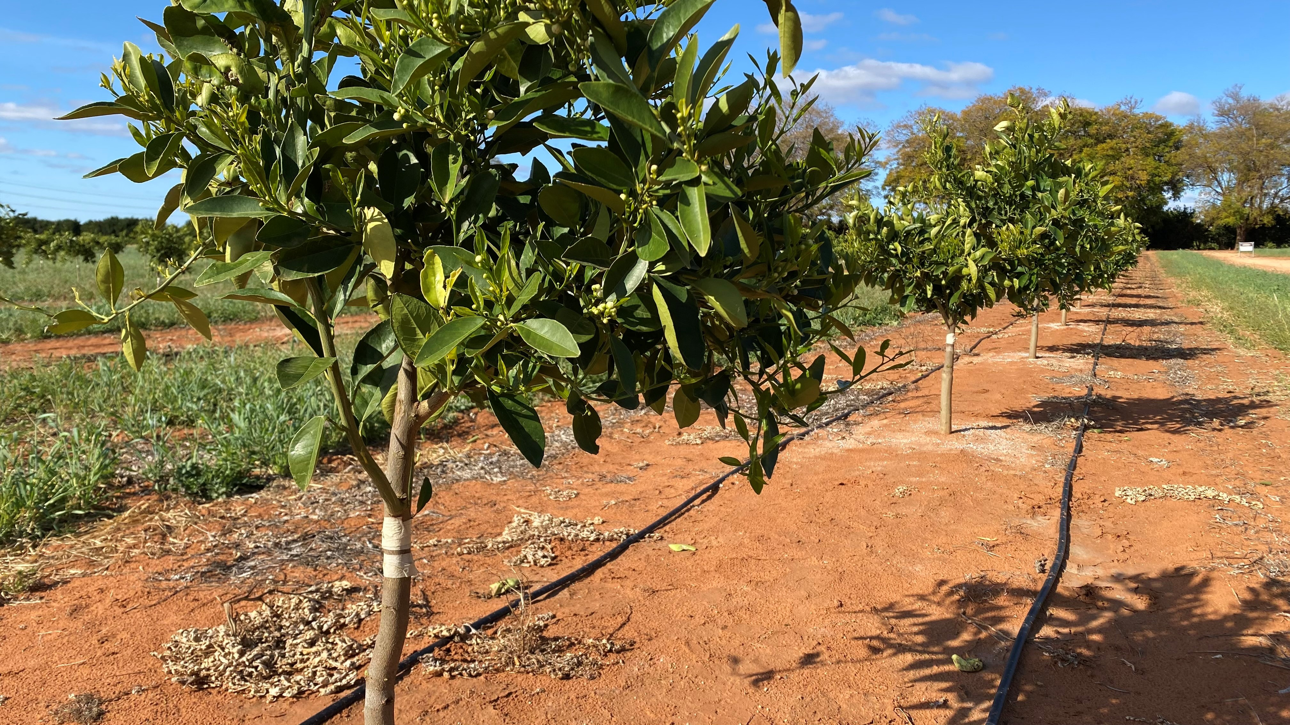

Final report

Project title:

National Tree Crop Intensification in Horticulture (Citrus)

Project leader:
Dave Monks

Delivery partner:
New South Wales Department of Industry and Regional Development

Report author/s:
Dave Monks

Project code:
AS18000

Date:
31 January 2025

Report sensitivity:
Does the report have any of the following sensitivities?
Commercialisation/IP considerations: No Yes
Intended for journal publication: No Yes
Embargo date: No Yes – Date: <Day, Month and Year e.g., 10 April 2021>
Please detail the reason for the embargo:
Confidentiality: No Yes (whole report) Yes (sections of report are confidential)
If sections of the report are confidential, list them here:

Disclaimer:
Horticulture Innovation Australia Limited (Hort Innovation) makes no representations and expressly disclaims all warranties (to the extent permitted by law) about the accuracy, completeness, or currency of information in this final report.
Users of this final report should take independent action to confirm any information in this final report before relying on that information in any way.
Reliance on any information provided by Hort Innovation is entirely at your own risk. Hort Innovation is not (to the extent permitted by law) responsible for, and will not be liable for, any loss, damage, claim, expense, cost (including legal costs) or other liability arising in any way (including from Hort Innovation or any other person’s negligence or otherwise) from your use or non-use of the final report or from reliance on information contained in the final report or that Hort Innovation provides to you by any other means.

Funding statement:
Hort Frontiers – R&D projects

This is a project of the National Tree Crop Intensification in Horticulture Program (AS18000) funded through Hort Innovation Frontiers with co-investment from NSW Department of Primary Industries and Regional Development, and contributions from the Australian Government.

Publishing details:
ISBN <Hort Innovation to add>
Published and distributed by: Horticulture Innovation Australia Limited
ABN 71 602100149
Level 7
141 Walker Street
North Sydney NSW 2060
Telephone: (02) 8295 2300
www.horticulture.com.au
© Copyright 2025 Horticulture Innovation Australia Limited

Contents

Contents 3
Public summary 4
Keywords 4
Introduction 5
Methodology 5
Results and discussion 7
Outputs 11
Outcomes 14
Monitoring and evaluation 15
Recommendations 19
Refereed scientific publications 20
Intellectual property 20
Acknowledgements 20
Appendices 21

Public summary
The Australian citrus industry continues to deliver excellent fresh fruit and juice to domestic and export markets, growing to more than $1billion in farmgate value in recent years. To continue to meet markets’ needs and manage rising costs, it is important to look to the future of production systems. This project aimed to contribute to increased productivity and profitability of Australian citrus through new cropping system intensification knowledge and extending our findings on advanced production systems in ways that can be deployed by growers. The New South Wales Department of Primary Industries and Regional Development (NSW DPIRD) has developed outputs that can be deployed by growers: those currently struggling to recover over-crowded orchard blocks, or thinking about planting a new block today, or looking to understand systems that may have relevance in 15 years’ time.
We conducted seven replicated experiments on pruning strategies to recover over-crowded orange blocks. This work was conducted on both NSW DPRID’s and growers’ properties. In each case we included a ‘local best practice’ treatment. To further describe technology to control tree vigour during the planting and establishment phase, we developed two replicated experiments using the citrus dwarfing viroid – a way of controlling tree vigour by inoculating young planted trees with a viroid known to slow growth. We measured tree growth and architectural features to describe the breadth within a large arboretum. We also laid down two replicated advanced production systems experiments – stumping an existing block of trees and training them in different ways on a trellis.
Our team has published papers and case studies in reputable journals and industry magazines, providing valuable insights into orchard intensification, viroid management, and pruning techniques. We also produced a literature review. Beyond immediately applicable material for growers to use today, our work provides a solid foundation for future experimentation and practical insights for improving citrus production.
Tailored workshops and field days have been conducted to meet growers’ needs, focusing on practical applications of our research. These events have been well-received, with participants reporting high satisfaction.
Factsheets and videos were developed to extend project findings nationally and show growers and their advisors specific methods they can use on their farms. We have produced case studies and ‘plain language’ videos to demonstrate a clear path between difficult orchard blocks and more advanced production systems on farm. Many of these outputs were shared through the Australian Citrus News industry magazine and through the NSW DPIRD citrus website.
We have actively engaged with the citrus community through regional forums, annual meetings, and webinars, fostering collaboration between researchers, growers, and industry stakeholders. The new knowledge and outputs developed in this project will help growers increase their knowledge and understanding of tree intensification and give them the confidence to adopt these advanced systems. Exposure to this information was valued by industry members, surveyed independently by RMCG for the mid-term review, and in survey- and written-feedback in the project’s final year.

Keywords
High density, vigour, growth rate, canopy efficiency, tri-state, productivity.

Introduction
Increasing productivity and canopy efficiency in citrus orchards is crucial for growers aiming to maximise their yield and profitability. By intensifying citrus orchards, growers can enhance the fruit-bearing portion of the canopy without compromising fruit quality or tree health. The volume of fruit-bearing foliage, rather than the number of trees, is key to per hectare yield. High-density orchard blocks are more efficient to manage and harvest, and they are better suited to automated management practices. Additionally, these systems are less susceptible to damage from cold temperatures and high winds.
Producing more citrus fruit per hectare helps meet the growing demand for fruits and vegetables, driven by their proven health benefits. Planting at high density generates more fruit without requiring additional land, which is essential for sustainable production. The benefits of intensifying citrus orchards can be realised by understanding tree growth and behaviour, improving orchard design, and controlling tree vigour using dwarfing rootstocks, viroids, or tree training techniques.
Both under- and over-exposure to light can decrease the efficiency of photosynthesis in an orchard canopy. Under-exposure limits the energy available for photosynthesis, while over-exposure indicates inefficiency in tree structure, where some leaves intercept more light than needed, depriving other leaves. Most light interception and fruiting occur in the outer 1 meter of the canopy. Computer models show that increasing leaf area beyond a certain point does not enhance the well-illuminated bearing volume, leading to reduced fruit size and colour due to intra-canopy shading.
To push production systems beyond this plateau, a combination of technologies is required. There is unlikely a future for commercial orchard production without hand pruning, but with an underlying vigour control technology each pruning-dollar spent becomes more efficient, promoting more refined pruning methods to maximise the number of fruiting sites. Understanding and implementing these technologies, considering establishment and maintenance costs, is essential for their mainstream adoption.
The NSW DPIRD project team was Dave Monks, Mahmud Kare, Steven Falivene, Andrew Creek and Nerida Donovan.

Methodology
This project was established to generate new information to address citrus growers’ needs. The research program considered three different situations our growers find themselves in:
Those with an existing, high density orchard that has become overcrowded, decreasing yield and increasing costs. For this group, we established a range of both replicated experiments and demonstration blocks across the Sunraysia and Riverina regions comparing both mechanical hedging and hand pruning, and an extreme option – converting a 12-year old block to trellis. We also wrote a review of the literature describing ways of intensifying citrus tree crops and modifying tree canopies. The review, presented at the 2022 International Horticultural Congress in France, was published in 2024.
- At the Dareton Primary Industries Institute, Sunraysia, four replicated experiments were established comparing different strategies to revive orchard blocks to productivity.
  - Different mechanical hedging and hand pruning treatments were chosen to represent common industry practice as well as more severe hedging and more detailed hand pruning treatments. This work was conducted in both Atwood and Hockney mid-season navel oranges and ran for the whole life of the project.
  - Different training systems were compared on navel orange trees with the canopy and branches completely removed by stumping with chainsaws to approximately 1200mm. This work compared espalier, cordon and palmate-style training, tying growing branches to a trellis structure to encourage flower and fruit formation over vegetative growth. This work was conducted in both Atwood and Hockney mid-season navel oranges and ran for the whole life of the project.
- Three demonstration blocks were established on a grower collaborator’s property in Sunraysia. Each involved five treatments, selected from different styles of hand pruning, with and without summer regrowth management, and hedging intensities. The three blocks on Brett Hullah’s property chosen were:
  - Chislett late-season navel orange
  - Cara Cara mid-season navel orange
  - And Barnfield late-season navel oranges inoculated with the citrus dwarfing viroid
- In the Riverina we established a range of both replicated experiments and demonstration blocks to compare different pruning and hedging strategies to recover over-crowded orange orchard blocks to productivity. All of these studies were conducted on grower collaborators’ blocks.
  - In Justin Davidson’s Salustiana common oranges we compared two hand pruning and three hedging strategies, incorporating the grower’s own best practice as a control in a replicated experiment.
  - In Tony Naimo’s Powell late-season navel oranges we compared two hand pruning and two hedging strategies, incorporating the grower’s own best practice as a control in a replicated experiment.
  - In Peter Ceccato of Superseasons’ Valencia oranges we compared two hand pruning and three hedging strategies, incorporating the grower’s own best practice as a control and a novel hedge ‘slot’ cut in the shoulder of the canopy in a replicated experiment.
  - In Frank Madaffari’s Valencia oranges we demonstrated four hedging and two hand pruning strategies.

For those wanting to plant a new orchard tomorrow we aimed to provide new information about citrus dwarfing viroids, available for use in establishing smaller-stature citrus orchards.
At Dareton Primary Industries Institute, two new experiments were established and another, 35-year old, block to measured anew to understand the longevity of this dwarfing technology.
- A newly planted block of Neilson mid-season navels was inoculated with a range of citrus viroids, included some known to be dwarfing, individually or in various combinations, to investigate the impact multiple, different, viroids have on the rate of canopy expansion.
- Additionally, a newly planted block of Neilson mid-season navels was inoculated with a similar combination of viroids, but the application of each individual viroid was separated within an individual treatment by six months. That is, each tree was allocated a treatment where one viroid was inoculated after 12 months and a second 6 months later.
- A 35-year-old viroid-inoculated Bellamy late-season navel block was also revisited, with new data collected to compare the performance of the treatments in a mature block.

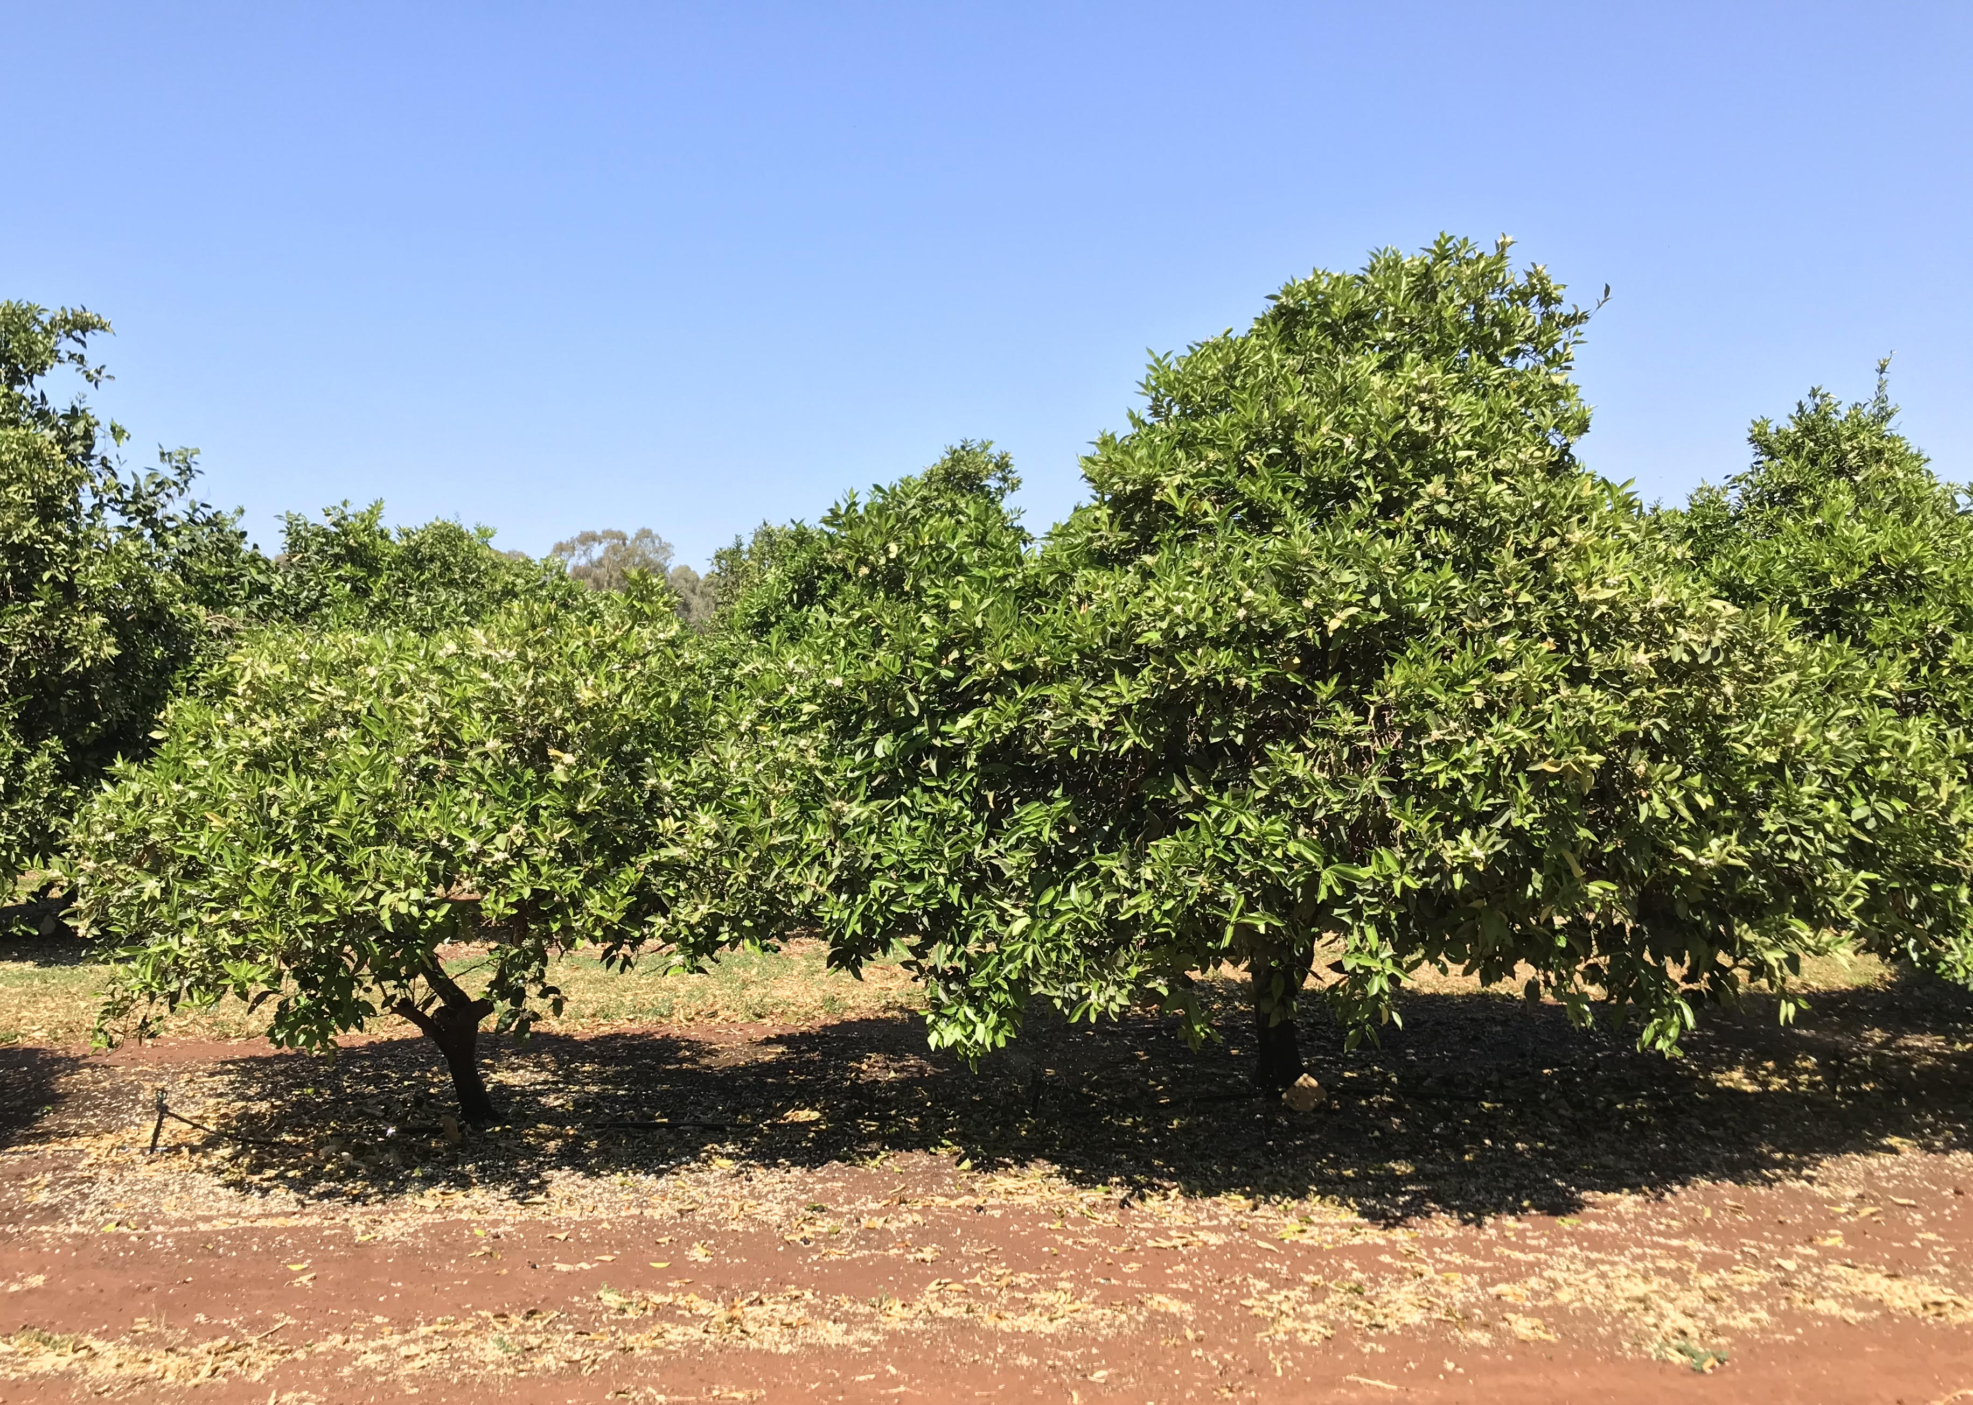
Plate 1. Two Bellamy navel oranges, inoculated with different viroids during their establishment, showing the different rates of canopy expansion 35 years after planting at Dareton Primary Industries Institute, NSW.

For those wanting to plant in 15-years’ time, we aimed to generate new information on the range of phenological responses in a large pool of citrus genetics. We observed canopy growth rates to describe upper and lower bounds in our environment, that could be used by breeders or researchers in their own work. This work could lead to outcomes for industry in new work, possibly generating new hybrids or selections for a breeding program or informing the direction of future research efforts.
- To do this, we hedged citrus trees and recorded their regrowth over time – both length from the cut surface and proportion of that cut surface that showed evidence of regrowth. The work was conducted in our arboretum collection at the Dareton Primary Industries Institute with 396 citrus varieties and selections, giving us a broad range of citrus, including 1 citron, 88 common oranges, 24 grapefruits, 2 kumquats, 17 lemons, 10 limes, 117 mandarins and mandarin hybrids, 47 miscellaneous citrus, 44 navel oranges, 21 pummelos (AKA shaddocks), 18 rootstocks, and 7 Seville oranges.
- From the early results of that work, we focused on 12 varieties with highly contrasting growth habits to aloe more detailed measurements at the growth unit level.

Results and discussion
This section discusses the results from each of the major areas of research: pruning, hedging and trellis strategies to recover an overcrowded orchard block to productivity, viroids to control the rate of canopy expansion, and the breadth of phenological responses in an arboretum collection.
Pruning, hedging
It is challenging to manage high vigour citrus trees in high-density plantings. The pruning work conducted at DPII and on grower collaborator properties showed no improvement in yield with any hand pruning strategy over the standard grower hedging practice. This work showed how important it is to choose a suitable plant spacing to accommodate the expected vigour of the tree. The hand pruning strategies in high-density plantings triggered vigorous canopy regrowth responses, which had to be removed in summer to allow light into the tree, maintain row access and tree height. Pruning can take time to take effect because the benefit of pruning arises from new shoot growth replacing old canopy. In conventional planting densities, the trees would have had enough space to accommodate this regrowth; the regrowth from the hand pruning would be managed successfully in the next season’s pruning, maintaining bearing wood between seasons.
Our work showed clearly however, that trying to reduce canopy size further using heavier hedging was very damaging to yield – be it a once-off ‘hair cut’ or maintaining a heavy hedging program for multiple seasons. In an attempt to bring the canopy in by 50cm on top and 15cm on the sides after the first recorded harvest, trees dropped yield in the following year to 200kg/ha only, on 1111 trees/ha. This treatment completely removed the layer of bearing wood that had been established through constant light hedging. This additional hedging led to an extremely low yield in Year 2 as the narrower side cut and lower tree top cut removed a disproportionate amount of fruiting wood. Similarly, a heavy hedge (0.95cm more removed from the western side) at the end of the 1st and 4th harvests has struggled to recover productive canopy and had reduced annual yields. All trees had been maintained at 2.7 m wide prior to out treatments
Information from a 2023 Spain and 2024 South Africa study tour on managing vigorous mandarins suggested managing regrowth a few times during the season can cause a compact canopy that does not require excessive pruning and will bear more fruit. Briefly, their findings were to remove water shoots that were greater than 1.5 m, or in areas of congested regrowth. The first regrowth management would occur when shoots were about 20-30 cm long, thinning out shoots to a hand-span apart and breaking the top one third of the remaining shoots (tipping), to retain about 4 - 5 buds. The tipped regrowth will then produce 3 new shoots and these shoots can be tipped again during summer. This results in a branch with 6 - 9 shoots that is complex, could bear fruit and is much shorter than unmanaged shoots. The complex branch will remain in the tree whilst a long water-shoot branch will probably be removed.
This work has been presented to growers through a number of field days, workshops, videos and written outputs. A summary of the treatments and a more in depth discussion of the findings can be found in a video produced for the project, focusing on Salustiana common orange: https://www.youtube.com/watch?v=d94F0wuVzOU, and an invaluable guide to hand pruning for profit https://www.dpi.nsw.gov.au/__data/assets/pdf_file/0003/1503246/Hand-pruning-citrus-for-profit.pdf. Additional results, including fruit quality an economic analysis, were presented at the 2024 International Citrus Congress in Korea, and again in person to growers at field days in Dareton, Leeton, Griffith and Yoogali.
A paper is in preparation for submission to Acta Horticulturae, and was presented at the 2024 International Citrus Congress in Korea. The abstract attached as Appendix 1: Five Different Pruning Strategies Were Not Able to Improve Productivity a Densely Planted Salustiana Common Orange Block in Short Term. Learning from our results in this area, the shoot tipping regrowth management concept will be integrated into new and ongoing work.
Trellis
In addition to the pruning treatments described above, we also stumped 105 trees in the adjacent rows and converted them to a trellis system. These trees were trained to the wire as palmate, espalier and cordon beginning in July 2021. We aimed to improve light use efficiency, fruit quality and yield. In 2024, yield within the pruning experiment was ~10 t ha-¹, with an average canopy volume of ~12,000 m³ ha-¹. Trees in this experiment intercepted an average of 53% of incident solar radiation. By comparison, in 2024 the trellis system yielded ~20 t ha-¹ with an average canopy volume of only ~4,000 m³ ha-¹ . The trellised trees intercepted an average of only 39% of incident solar radiation. This means the trellised system showed a much higher canopy efficiency compared with the pruning experiment. The trellis trees increased canopy efficiency from 0.80 kg m-3 to 5.0 kg m-3; over conventional trees. With a 300 g fruit, that is a difference of 14 more fruits m-3 resulting in double the number of fruit from 31,200 to 66,600 ha-¹. If, hypothetically, our trellis rows were 0.9 m narrower (4 × 3.5 m), the trellis trees’ yield and canopy volume would increase from 20 to 24.6 t ha-¹ and 4,000 to 4,900 m3 ha-¹, with the same tractor access. The trees have not yet filled their allotted space, so these numbers should only increase until canopy closure. Each season, however, we are moving into unknown territory, and the relationship between costs and yield, canopy volume and yield, and vegetative vs floral growth is unknown. In the 1960s and 1970’s, California researchers shown the system breaking down, as the vigour of the tree could not be contained by pruning. We wait to see how the massive increase in knowledge about trellis training systems since then will impact the success of this system in citrus in Australia.
Costing tool
There are various citrus production systems each with different costs and yields. Some intensive systems have a high initial costs and higher yields in the early years. The high early yields are very attractive, however it’s easy to forget the extra costs involved with intensive practices and to mentally calculate the costs, returns and profit over a 20-year cropping cycle. It’s also difficult to mentally calculate interest payments on borrowings which can be considerable if high initial input costs occur.
An economic citrus development analysis tool has been developed to assist growers to assess the comparative long-term profitability of different production systems. The tool comprises a report that presents the production scenarios and a downloadable excel spreadsheet and will be available via the NSW DPIRD citrus website. The tool presents orchard development budgets for various 20-year production cycle scenarios of high-density planting, tree dwarfing trellis production and robotic future orchard. Detailed budgets for each stage of the cropping cycle are presented in the report along with a 20-year summary budget to quickly assess long-term profitability. More information, including discussing converting an underperforming block to trellis, was presented at the International Citrus Congress, 2024. The abstract for which is attached as Appendix 2 and was published in Acta Horticulturae.
Viroids
Controlling vegetative growth and canopy size while maintaining productivity is important for high-density citrus plantings. This can be achieved by inoculating trees with dwarfing viroids, but understanding viroid interactions in mixed infections is crucial. A field trial started in 1989 to study the impact of citrus viroids on canopy volume, height, and fruit production of Bellamy navel orange on trifoliate orange rootstock. Trees were inoculated with hop stunt viroid, citrus dwarfing viroid, and two strains of citrus exocortis viroid, both singly and in combination. LiDAR was used to measure tree canopy volume, height, light interception, and fruit production, size, and quality from 2022. Results showed that, 35 years after inoculation, some viroid combinations significantly reduced canopy volume and tree height compared to the uninoculated control. However, there was no significant effect on total canopy light interception, and most viroid treatments did not affect yield per tree, fruit size, or quality. This long-term experiment demonstrated that viroids can impact tree size throughout the life of an orchard. Knowing which viroids are present in field trees is essential before inoculating with commercial dwarfing viroids to plan proper tree spacing and maximize yield per hectare. Some of this work was describe in a publication in Acta Horticulturae and presented at the International Citrus Congress, 2024 and is attached as Appendix 3.
Phenological responses
Future work in citrus intensification will rely on new genetics to increase canopy efficiency. To that end, we aimed to quantify the way citrus trees grow in a large arboretum collection – and to provide phenological data and genetic material to a global effort to develop a multi-variate genomic prediction model to improve understanding of the G×E relationship and predict performance of citrus in different environments. Currently there are 396 selections within the Dareton arboretum.
For all trees in the arboretum, the average rate of growth for the 217 days from hedging was 5.20 mm/day. Our large arboretum collection, drawn together from multiple sources over many years, has both very fast and very slow growing citrus trees. From this data, a sustained rate of growth exceeding 7 mm/day from early winter to mid-summer appears to be a reasonable description of a very vigorous citrus tree. This compares with 3.0 mm/day new shoot growth in sweet orange, as modelled by Brazilian researchers in 2021. Similarly, our data shows healthy trees growing at below 2 mm/day for the same period could be considered very low vigour. This work was presented to international colleagues at the XIII International Symposium on Integrating Canopy, Rootstock and Environmental Physiology in Orchard Systems in New Zealand, 2025, and will be published in Acta Horticulturae. The abstract is attached as Appendix 4.
Contributions toward global genomic prediction in citrus
Through the program, we also had a chance to contribute in a small way to a large piece of work defining genotype-by-environment interaction (G×E) in citrus. Craig Hardner, Centre for Horticultural Science, Queensland Alliance for Agriculture and Food Innovation, is working within a large USDA project “Enabling Genomics-Assisted Specialty Crop Breeding and Research through Advanced Database Resources” to accumulate citrus data sets from USA, Brazil, Australia and Japan. The description here is from our recent paper presented at the International Citrus Congress, 2024. The abstract of which is attached as Appendix 5.
“This phenomenon is not well understood in horticultural crops. Knowledge on the stability of cultivar performance across environments is important to optimise cultivar breeding and deployment through improved genotype-by-environment matching. Conventionally, G×E is studied using multi-environment trials of clonally replicated genetic material. However, establishment and assessment of these type of trials can be economically and logistically challenging in tree crops. Recently, multi-variate genomic prediction models (which track replication of alleles across individuals) have been used in sweet cherry, peach, apple, and strawberry to aggregate datasets from multiple environments to improve understanding of G×E and predict performance of individuals in environments in which they have not been tested.
As part of a large USDA project “Enabling Genomics-Assisted Specialty Crop Breeding and Research through Advanced Database Resources” we have started accumulating citrus data sets from USA, Brazil, Australia and Japan using the Breeding Information Management System in the Citrus Genome Database and are developing pipelines and workflows for standardisation and curation of these datasets.”
Coupled with the data collected in our arboretum, we also collected leaf samples for genetic analysis which will be used to build out the model. Our contribution will be used, in the first instance, as a test population to validate a model trained on international data. A description of this work was published in the upcoming proceedings of the International Citrus Congress with co-authors from USA, Brazil and Japan.
A citrus ideotyope
The idea of a citrus ideotype, a theoretical ‘best’ tree, is born and lives as a discussion topic. It is not a realistic expectation and often compromises on much of the practical realities of growing citrus trees profitably. What it does do, however, is describe a platform that would allow increased productivity driven by the tree’s natural habit – rather than the system we are forced to wrap around it. That is, a tree that establishes and fills its allocated space quickly, has no juvenile phase, carries the bare minimum leaf area on the least amount of scaffold wood, sets every flower and holds a first grade piece of fruit to maturity at a marketable size, would be most desirable. Digging within this ‘simple’ sentence reveals a number of areas that could underpin years of research and development – but, taken as a whole, highlights every element of orcharding we have to manipulate with cultural interventions to produce a profitable crop.
The concept of an ideotype is not new for citrus. In the 1960s and 1970s, Californian citrus researchers were describing a tree using a ‘dwarfing rootstock with a slow-growing, highly fruitful, old-line bud’. Being more specific, key architectural components would include reduced internode length and a more compact branching habit, similar to that seen when using the dwarfing Flying Dragon trifoliate orange rootstock. The ideotype should maintain a branching angle of approximately 45°, to optimise light penetration while providing structural support. A target height of ~2.5 m would improve harvest efficiency.
Leaves could increase chlorophyll content to maximize photosynthetic efficiency within a smaller canopy volume, and those leaves should be smaller to allow better light penetration through the canopy. Reproductive efficiency would be enhanced by promoting shorter flowering period, a low- to no- juvenile phase. Even fruit distribution throughout the smaller canopy would improve picker access and speed and minimise sun damage.
Root architecture should drive efficient nutrient uptake while maintaining drought tolerance and stability through a more fibrous system with increased lateral branching, similar to that seen in some semi-dwarfing citrus rootstocks.
Literature review
One of the highest impact outputs from the project will be our review of the way to modify citrus canopies. The paper, presented at the International Citrus Congress, 2024, and published in Acta Horticulturae the same year, reviews the literature on high density planting of citrus to understand the motivation for crop intensification and the different strategies for manipulating tree size such as dwarfing rootstocks, dwarfing viroids, pruning and trellis training. The abstract is attached as Appendix 6.
The paper explains in detail that “Citrus vigour can be manipulated during orchard block establishment and/or during the production phase. Prior to orchard establishment, the scion and rootstock combination is selected and the decision to use the dwarfing viroid is made, given there influence on tree spacing. If a trellis system is to be used, this needs to be decided prior to planting, too. Planting density is chosen to optimise the capture of incoming solar radiation based on expected tree size – that is, smaller trees will be planted closer together than larger trees. In the production phase, canopy- or root-pruning, girdling, and plant growth regulators can be used to control vigour. Both water and/or nutrient restrictions can also influence growth.” The paper goes on to describe each of these methods of citrus intensification, drawing on scientific principles driving whole-of-orchard productivity.

Outputs
Table 1. Output summary
Output | Description | Detail
Milestone reports | Annual reports were prepared to report on the project progress. | MS102, MS103, MS104, MS105, MS106 and MS107 were submitted to Hort Innovation as per contract agreement. These reports aligned with the project monitoring and evaluation plan.
Fact sheets | NSW DPIRD released factsheets giving detailed coverage to an issue | “Hand pruning for profit” – Primefact. This is provided as an attachment in Appendix 7 and is available online, here: https://www.dpi.nsw.gov.au/__data/assets/pdf_file/0003/1503246/Hand-pruning-citrus-for-profit.pdf
Presentations to industry | Invited presentations given at the behest of Citrus Australia, to inform and update members on progress and results. | Conferences, congress, forums etc.  “Citrus varieties and tree intensification project” - Citrus Australia’s Murray Valley Regional Forum. 2021.  “AS18000 project and citrus orchard intensification” – Citrus R&D Roadshows, Sunraysia and Riverland. 2022.  Tree Intensification – Citrus Australia’s Technical Forum. 2023. This is provided as an attachment in Appendix 7.
Presentations to the science community | Papers accepted for oral presentation. | Conferences, congresses, symposia etc.  International Horticulture Congress, France, 2022  “Estimating tree canopy growth and light interception using LiDAR-based methods in viroid-dwarfed oranges”  “Intensifying citrus tree crops and modifying tree canopies: a brief review”  International Citrus Congress, 2024  “W.Murcott mandarin canopy management: 3 year trials, grower experiences in Australia, South Africa and Spain” Falivene et al.  “Five Different Pruning Strategies Were Not Able to Improve Productivity a Densely Planted Salustiana Common Orange Block in Short Term” Mahmud et al.  “Trellis and high-density navel pruning; first three seasons of results” – Falivene et al.  “Effect of Dwarfing Viroids on Canopy Volume and Height, and Fruit Production of Bellamy Navel Oranges 35 Years After Inoculation” Mahmud et al.  International Symposium on Integrating Canopy, Rootstock and Environmental Physiology in Orchard Systems, New Zealand, 2025  “Canopy regrowth following mechanical hedging in a large arboretum collection” Monks and Mahmud. This is provided as an attachment in Appendix 7.
Field days/workshops | Events specifically organised by NSW DPIRD or other industry group to give growers access to field sites. | Discussion on the citrus tree intensification research with AS1800 Program Team Forums, 2021, 2022, 2023, 2024, 2025.  Tree Intensification update and field walk, Dareton, 2022.  Davidson’s pruning experiment update, Riverina, 2023, 2024.  Pruning high density trees for profit – workshop – Riverina, 2024.  Pruning workshop, Murrami, Riverina, 2024.  “Managing high density orange trees” – a series of four field days, 2024.  Two major field days held in Dareton and in Riverina covered results and applications from the project. The Dareton field day (2024) had a report written about it, summarizing the content and attendees’ responses. “DPIRD Dareton citrus field day report: 15 October 2024”. This is provided as an attachment in Appendix 7.
Industry articles/case studies | Articles accepted for publication in the Australian Citrus News magazine. | “High density plantings, intensive orchards to be tested” – Citrus Australia website. No longer accessible. 2021.  “Trellis systems could pave way for robotic harvesting” – Australian Citrus News, 2021 & https://citrusaustralia.com.au/latest-news/2021/08/trellis-systems-could-pave-way-for-robotic-harvesting/  AS18000 project overview – Australian Tree Crop magazine, 2021.  “Pioneering citrus dwarfing viroid use in the Riverina” – two case studies – Australian Cirtus News, Issue 2, 2023. Republished in the Australian Tree Crop magazine, 2023.  “Unlocking high-density citrus orchards in Sunraysia” – two case studies – Australian Cirtus News, 2024. This is provided as an attachment in Appendix 7.  “Combination or inoculation order of citrus dwarfing viroids: experiments on navels” – Australian Citrus News  “Challenges with high density orchards” – Australian Citrus News, June/July 2024.  “Citrus Intensification” – lead article in the Citrus plant protection guide 2023-24 – NSW DPIRD
Progress reports submitted to the Project Reference Group and AS18000 intra-project meetings. | Summaries of progress and specific points of discussion presented to the project’s industry reference group. | AS18000 Project Leadership Group presentations throughout the project --- giving an overview of each component of the project and highlighting specific experiments of broad interest. An example is provided as an attachment in Appendix 7, where we challenged team members to see our projects through different lens, appreciating the different priorities stakeholders have in our work.
Videos | Video outputs edited to give project updates, results and application advice. | “NSW DPI Citrus Trellising Trial” - an introduction and overview.  Industry produced: “Citrus tree intensification overview” – a video introducing the AS18000 project and the individual components – with a grower discussing their interest. I have used this video multiple times as a concise overview. https://twitter.com/CitrusAustralia/status/1407109399739437068?s=20  Industry produced: A broad overview of the Roadshows, including many Hort Innovation co-funded projects, can be seen in this short video produced by Citrus Australia. All shots in the field are from the Dareton field day. https://www.facebook.com/watch/?v=465710394662410  “Mandarin pruning practices” QLD mandarin pruning practices videos (nsw.gov.au)  “Pruning experiments” – overview and updates, Sunraysia and Riverina. This series of videos describes the treatments and ‘philosophy’ behind their inclusion. Linked through NSW DPIRD website. Navel orange pruning methods and trial (nsw.gov.au)  “Window layer pruning” – a technical guide to enacting the pruning method. https://www.youtube.com/watch?v=vsMXGVUdqi0&t=1s – this video has more than 6,000 views to date. Others in the series include technical demonstrations of Half-tree heavy hedging, light hedging and chunk pruning.  https://www.youtube.com/watch?v=OAx7WUqqGTg  https://www.youtube.com/watch?v=Wt8pXetLfgg  https://www.youtube.com/watch?v=G-nlOVCD2CI  and an introduction to the pruning experiments: https://www.youtube.com/watch?v=ZydzUDYjC2Q  “Citrus tree architecture” – an introduction and overview. NSW DPIRD website. Linked through NSW DPIRD website and https://www.youtube.com/watch?v=j87D6azhdRI  Overview of citrus pruning technics used in Spain and Morocco. A playlist of 18 videos developed under CT19002, Afourer best practice canopy management. https://www.youtube.com/playlist?list=PL4zlvcUKKUmXZ-tjKQzOp7D-NRnLasy2P  “High density trellis and non-trellis canopy management” – Youtube.com  “Pruning high density trees for profit – workshop – Riverina” Youtube.com  “Afourer grower Dean Morris pruning case study” - https://www.youtube.com/watch?v=Xr5I_2HGCpU  “Canopy management trial in high density oranges” – a comprehensive overview of findings in Salustiana oranges in https://www.youtube.com/watch?v=d94F0wuVzOU  “High density dwarfing in navel oranges – a grower shares his experiences” - https://youtu.be/hI1xKJlhINE
Non-industry articles | Articles accepted for publication in publications un-aligned with the horticulture sector. | “Research for the future” – Sunraysia Daily newspaper.
Journal papers | Peer reviewed science published internationally | “High-density espalier trained mangoes make better use of light” – 2023. Mahmud et al. Agronomy, #13
Financial tool | Costing scenarios for growers to use to compare financial viability. | This work was presented at the October 2024 Dareton field day and before an international audience at the International Citrus Congress, 2024. A draft report has been provided directly to Hort Innovation, and will be made available more broadly, once it has been published to our website. There will be a corresponding, editable spreadsheet released at the same time, updating the currently available budget costing model with relevant high density, trellis and dwarf-tree data.

Outcomes
Table 2. Outcome summary
Outcome | Alignment to fund outcome, strategy and KPI | Description | Evidence
Increase productivity and profitability of Australian horticulture through cropping system intensification and innovation programs targeting the whole of horticulture. | Hort Frontiers  Fund | Our work created the tools, shared them with growers and discussed how to use them to increase productivity and profitability on their farms. | Our work created new, robust information and tools and presented them to growers to make improved decisions. This work was generated from a series of well run experiments, designed to address the specific industry needs expressed in the RFP.  The industry has reported they have had access to a suite of outputs that will allow them to make a decision to adopt advanced production systems. When interviewed by RMCG during the mid-term review, released early 2023, growers valued our research – appreciating seeing these new systems in their region and through videos. When surveyed in 2024, industry members across the tri-state region indicated they would be able to apply our findings to their business (e.g. Yoogali, NSW post-field walk ‘dart board’ evaluation responses, Plate 5). The same was true of the Dareton 2024 field day, where 70% of attendees said the work was ‘highly useful’.  Peak industry body, Citrus Australia, continues to ask us to attend their outreach events to speak specifically about this work – indicating a desire to hear and be exposed to concepts and tools we have developed.  Industry has seen such value in our work that they have contracted new work to take many of the ideas developed within this project on in a Citrus Levy Fund project (CT23006).
End of project outcomes: New, robust information and tools available to growers to make improved production decisions  Adoptable advanced production system that can be deployed by growers  Plant morphology descriptions most suitable for intensive and productive cropping and harvesting | Project KPIs:  Measure the growth habit of a wide range of citrus varieties to identify architectural features  Measure different pruning management strategies for high density to maximise profitability  Measure different dwarfing viroids for their impact on canopy size and productivity. | These are the tangible outputs delivered that allowed us to meet the industry’s need.  These are the communication channels used to connect those outputs with growers.  These are the underlying experimental methods used to develop new information.  Measure the growth habit of a wide range of citrus varieties to identify architectural features | The Australian citrus industry is empowered to make an informed decision about planting and pruning high density orchards by the new materials we produced through this project. The cohesive body of work, specifically with video and field day support, has delivered an adoptable package of information for growers.  Growers with trees now will benefit from pruning advice. Growers planting tomorrow will benefit from costing scenarios and plant spacing discussions. Growers planting in 15 years’ time will see new information about viroids in combinations and the viability of trellis to increase yield and quality. That viroid work, generating two new replicated experiments (and leveraging an existing one) has sparked considerable discussion at field days regarding planting systems.  We have measured the growth habit of a range of contrasting citrus varieties and delivered key information to industry and the wider science community. Scientists are already seeing the advantage of this phenology work, using our data to validate international GxE models for citrus. Citrus physiologists and breeders will have a better understanding of the highest and lowest growth rates from our phenology work – helping design better experiments and drive better decisions.

Monitoring and evaluation
Table 3. Key Evaluation Questions
Key Evaluation Question | Project performance | Continuous improvement opportunities
To what extent has the project achieved its expected outcomes?  To what extent has the project given industry members the tools to increase productivity and profitability of their citrus operation through cropping system intensification? | Yes, the project delivered the tools to increase productivity and profitability through intensification. They have been brought together in an adoptable package, adding to the pre-existing materials developed, on the NSW DPIRD citrus website.  The NSW DPIRD website, https://www.dpi.nsw.gov.au/agriculture/horticulture/citrus, and youtube channel, https://www.youtube.com/@NSWAgriculture/videos are repositories of the tools delivered to increase productivity and profitability. More than 95,000 people have viewed the dwarfing viroid video produced under CT17007 and promoted throughout AS18000.  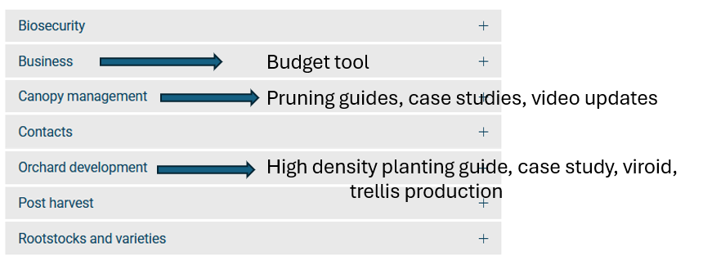  Plate 2. The outline of the NSW DPIRD citrus website, showing the major headings and the outputs within.  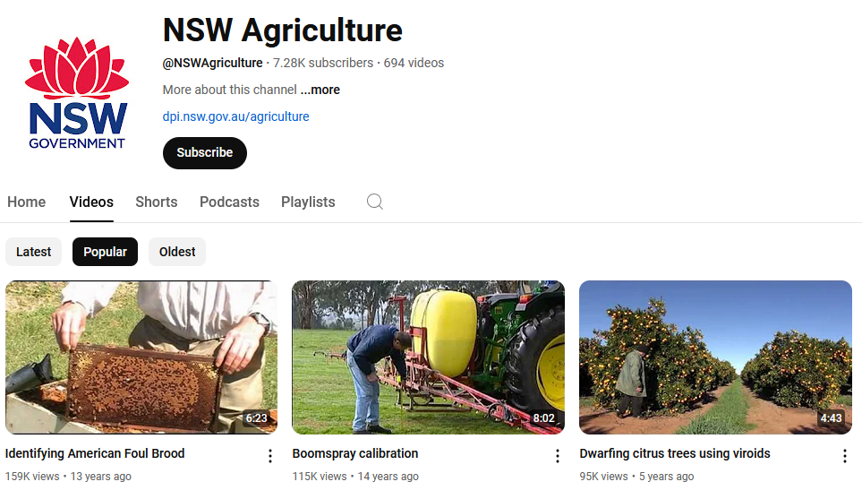  Plate 3. A screengrab of the NSWAgriculture Youtube channel.  The depth of knowledge available to growers to make on-farm decisions with confidence has increased through the life of AS18000. See Table 1., Outputs, for a comprehensive list – including scientific journals, industry magazines, field days, workshops, one-on-one discussions, forums, videos and conference presentations. | We have pursued the best growers in the tri-state to contribute their thoughts on productive orchards. I think expanding the scope to include QLD and WA are key to understanding shared pain points and innovations used in different regions.  Navigating our NSW DPIRD Citrus portal is not intuitive. Created to be an open bucket of information, as our projects have focused more directly on specific areas on grower interest, our systems of displaying that information needs to be updated.
How relevant was the project to the needs of intended beneficiaries?  Has the project provided direction to current growers about the best way to manage blocks planted at high density? Has the project developed tools for growers considering planting high density orchards that give them a better chance at making a good decision? | The project has provided direction to growers about the best way to manage their blocks planted at high density, and has developed tools to help growers considering the same.  For those with trees in the ground now, we delivered comprehensive information about pruning overcrowded blocks profitably, including in-person, hands-on workshops and field days, cases studies and a great series of videos – accessible to all growers. Costing models were presented to industry contrasting different scenarios.  For those considering planting at high density, we presented, through field days, case studies and videos, information to base their decisions on. We held field days highlighting the interaction between scion, rootstock and soil type to help growers understand planting density and showed them what that looks like so they could make the best choice for their farm.  For those planting in 15 years, we established new work understanding the interaction between citrus viroids and their impact on tree vigour, and growing citrus on trellis. This data has been shared through field days, case studies, videos and a costing model. Our work with phenotyping is already being used to understand how G x E impacts the expression of genotypes across the globe.  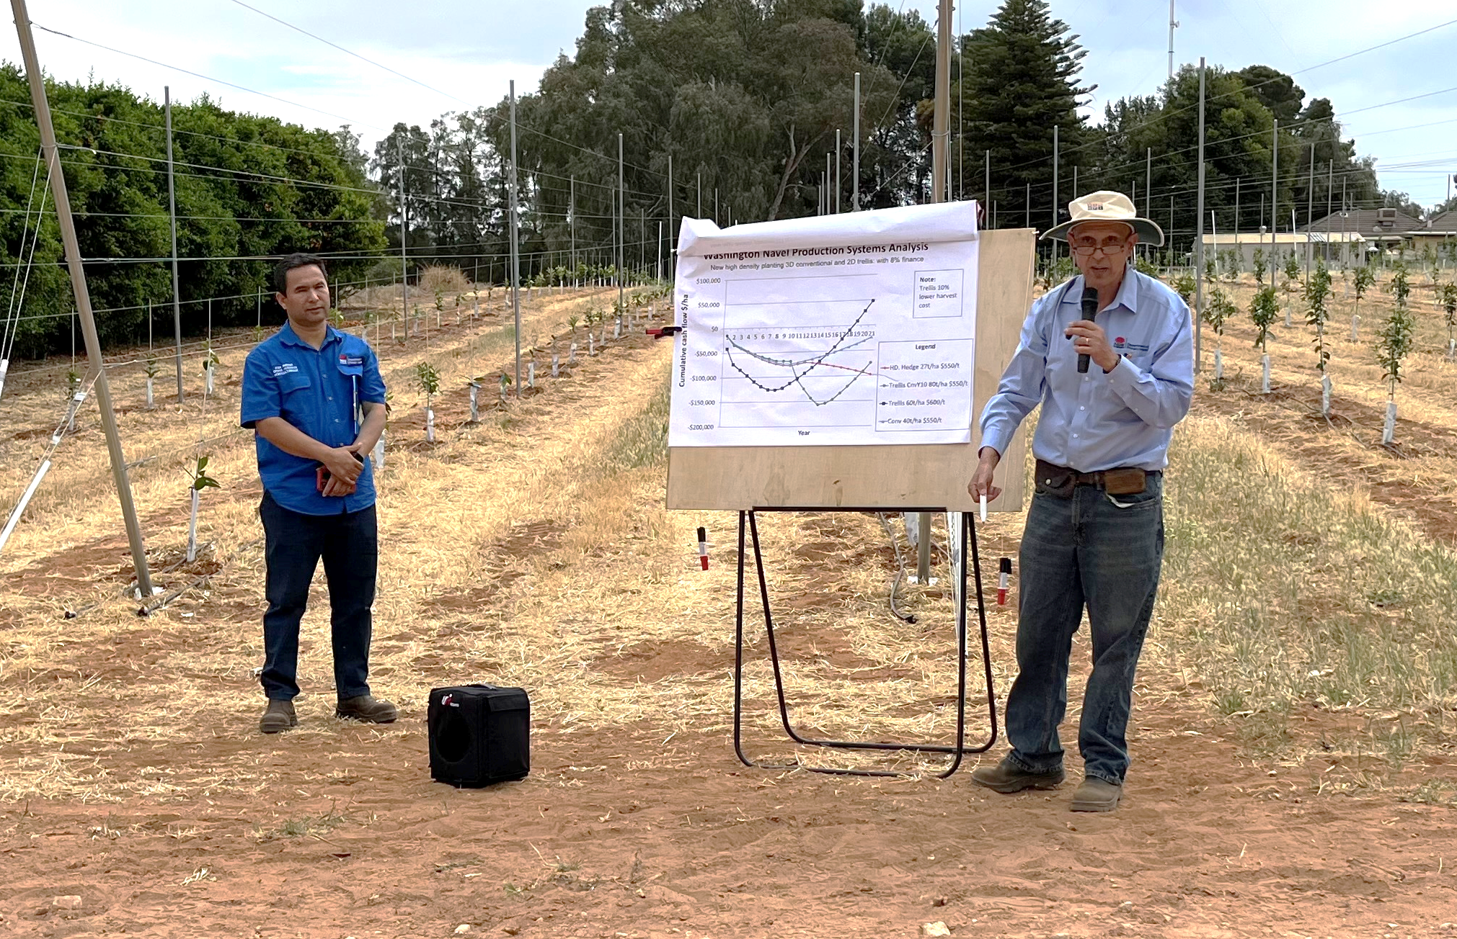  Plate 4. Dr. Mahmud Kare and Steven Falivene, of NSW DPIRD, presenting financial information on the ROI for trellis systems at a 15 October 2024 field day. Photographer: Dave Monks. | Managing input costs is a key part in remaining profitable. Having the foundation required to understand how changes to a production system will impact inputs and outputs is key to making an informed decision on farm. The messages developed within this project will underpin all our future communications with growers – including the synthesis of international experience to upskill Australian citrus growers.
How well have intended beneficiaries been engaged in the project?  To what extent have target members of industry been engaged? | We aimed throughout the project to engage with citrus growers through the citrus peak industry body, Citrus Australia, and through established NSW DPIRD channels.  We produced and published five articles for the Australian Citrus News magazine, with an estimated readership of 5,000/quarter, distributed across Australia. In the most recent ACN (#4, 2024), Dave Monks summarised their busy year highlighting the 190 people that came to the DPII site in to see and discuss advances in citrus productivity – 165 asking specifically about AS18000 content. In the last five years, 334 people attended field days at the site to see our outputs, and 242 came independently to see the work with AS18000.  AS18000 outputs have been presented at three Citrus Australia conferences, forums, field days and congresses. At the most recent congress in Queensland, Dave Monks spoke specifically on the tools developed within AS1800 available to growers to use when considering intensification (“Dave Monks, NSW DPI – Tree intensification – tools for making decisions” - https://citrusaustralia.com.au/uncategorized/2024/03/acc2024presenations/).  We have also partnered with Citrus Australia to speak at 8 of their Regional Forums, reaching growers from Western Australia to Queensland, and are scheduled to speak at 3 more this year (2025).  Using our own networks to extend the message, we have delivered face-to-face technical workshops on pruning, field days covering all of our work on intensification and multiple videos – engaging our intended beneficiaries from project establishment to project end, and in continuation through the Citrus Levy Fund (Competitive Citrus Orchards (CT23006). We have also reported through our CitrusConnect e-newsletter in the later stage of the project.  Of the 65 people attending our October 2024 field day at DPII, 90% self-reported as growers, packers and industry service providers. This was advertised through our own curated networks targeting industry members. | I think we did a very good job with extending the message to those in the tri-state and those connected to the Citrus Australian communications channels.  Delivery of materials in to WA and QLD have occurred on the back of other project – including speaking at conferences etc., but an occasional webinar may have value for growers to hear and see our work from outside the region.
To what extent were engagement processes appropriate to the target audience/s of the project?  How accessible were extension events, and written and digital outputs to targeted members of industry?  Where the intra-project interactions and activities beneficial to coordination and of mutual benefit to the program members? | We aimed to have our outputs reach our audience in multiple forms to ensure the maximum access to the materials. We were able to present in-person forums, discussions, one-on-ones, field days, workshops, and conference presentations to reach people in the broadest way. We also delivered videos that captures the same content, able to focus on specific points using supplementary still images, for an audience unable to attend in person – or who prefer to view the content in that way. We also wrote outputs: some able to bring more-data dense summaries and others the briefest of high-level concepts. It was very common to prepare ‘field notes’ when taking larger groups into the field, so the details could be described by presenters and viewed again by the audience.  Attendees at four recent farm walks in the Riverina, in May, March and December 2024, were asked to provide feedback. They were asked to comment on the degree  - to which the farm walk met their expectations  - to which their questions were answered  - how likely they would be to change orchard management practices based on the information provided on the day  - and how their knowledge of productive citrus canopy structures improved.  Feedback at all events was overwhelmingly positive, with most respondents indicating they would ‘certainly’ or ‘intend to’ change their on-farm practices based on what they learned on the day. A sample of the survey is presented here, from a Yoogali, NSW, field day in May 2024. 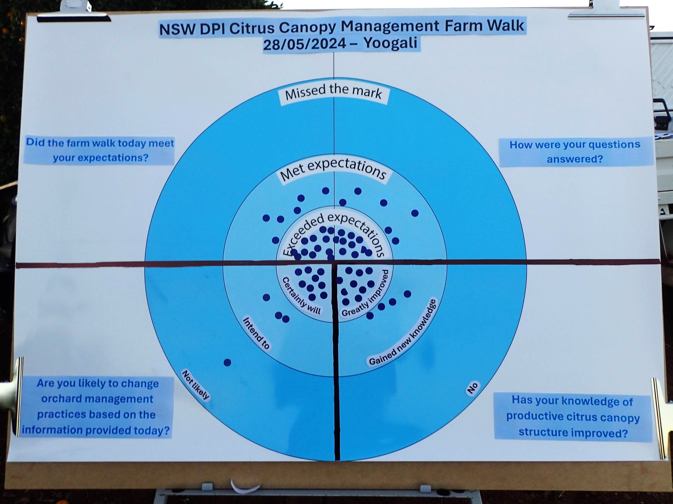  Plate 5. Yoogali, NSW post-field walk ‘dart board’ evaluation responses describing growers’ positive sentiment regarding the field walk, ability to have questions answered, knowledge of productive citrus system, and their likelihood to change orange management practices based on the information provided. Photographer: Andrew Creek, NSW DPIRD.  The intra-project interactions helped me see the wider issues in moving to intensive production and drew my attention to the shared problems – most of which were not production related, but process related. How do people measure light interception? What is the right way to handle data being passed to a functional-structural modeler? How do you keep a small, remote, team connected at the national and international level so the industry gets the best results? I’ve established professional relationships with the other crop leaders, but my technical team has not to any great extent. We we’re very pleased to host the first meeting and would happily do it again, if we were staying within the program. It was good to get our ducks in a row, preparing field notes and talking points – and with much greater detail and depth than is possible with industry events.  Speaking personally, I found the intra-project get togethers worthwhile and of high value. I appreciated meeting with the Queensland and Plant and Food teams, only a few of whom I knew before this Frontiers program. I have enjoyed forming a new network of like-minded colleagues tackling many of the same higher-level issues we are. I think the networks created will bring advances to Australian horticulture well beyond this piece of work.
What efforts did the project make to improve efficiency?  Most of the activities within the citrus project are actively pushing towards developing existing concepts, to leverage the work that has gone before in other crops and projects (e.g. apples). It is not in the scope of this project to further optimise those methods; although incidental efficiencies will likely be made through broader discussion with AS1800 program members. | We radically changed out canopy volume method when Mahmud Kare came on board the program. Mahmud, ex-QDAF (now QDPI), brought considerable knowledge and skill in collecting, manipulating and interpreting data collected for LiDAR devices. The project quickly pivoted from “eyeballing long bits of wood leaning on a tree” to a hand-held LiDAR able to collect accurate 3D point clouds across orchard blocks rapidly. The device allowed us to collect considerably more data per tree, and more quickly – which allowed us to measure more trees. It also eliminated the operator bias inherent with physically measurements. This new data has become a cornerstone in our extension materials, delivering visually striking images to communicate canopy shapes and sizes.  We were able to optimise our citrus research extension program because of the co-location of many projects at the DPII and Griffith Centre of Excellence. Because of this, we were able to consolidate the number of outreach events and increasing the value to industry. The October 2024 field day are DPII covered material funded through AS18000 (Frontiers Fund), Citrus Variety Evaluation (Citrus Levy Fund, CT26000), Citrus IPDM (Citrus Levy Fund), Citrus Rootstock Evaluation (Citrus Levy Fund), Citrus regulated deficit (Citrus Levy Fund, CT17000), Competitive Citrus Orchards (Citrus Levy Fund, CT23006) and Afourer mandarin canopy management (Citrus Levy Fund, CT19002). We have been able to provide similar efficiencies when delivering outputs throughout the Riverina and at Citrus Australia Regional Forum, conference and congress events. This has not only increased value to attendees, but also maximised financial efficiency – often having staff deliver work across multiple projects for the same travel budget, venue hire, etc.  In the same way, we have been able to develop multiple, overlapping, supporting, outputs that provide industry with a depth and breadth of knowledge when considering an on-farm business decision. Data generated within CT23006, the new Competitive Citrus Orchards project, will continue to leverage materials generated within AS18000 and other projects to maximise efficiency. | Continue to challenge our own assumptions – asking for input from outside our usual channels – to see new or different ways of doing things. Both technical and outreach.

Recommendations
The citrus industry is fortunate to have a new Citrus Fund project, CT23006 Competitive citrus orchard systems, with DPIRD as delivery partner, led by AS18000 alum Dr Mahmud Kare. This project picks up on elements of AS18000 Citrus and new priorities for industry. Many of the recommendations from AS18000 have been taken up by this new work.
The impact on the pest and disease presence within advanced production systems is not well understood and should be quantified. Smaller trees with higher canopy efficiency will have an impact on pests’ and beneficials’ habitats, spray penetration, air flow, localised humidity, and the portion of yield (and canopy) in proximity to the soil and soil borne pathogens, etc.
Right now it is assumed that smaller trees will provide a cost saving with picking (and other ‘at the tree’ activities) – but this isn’t the case in our limited experience speaking with contractors and growers using these systems. Picking is still the same cost/bin and we don’t have good data to quantify the cost of activities on a ladder vs. on the ground.
I think there is value is better describing the breadth of tree architecture/phenotypes in the current breeding pool, and those on the fringes of inclusion. It is my experience, as the leader of a major commercial and pre-commercial citrus variety evaluation program (CT22000), other than pathogen resistance, tree traits are very low on the priority list. I think this should include international breeding programmes and should start with a set of well thought out questions articulating the issues at hand.
Across all crops, I think there should be a better description of the data used to generate functional/structural model – so more of it can be collected within other projects. We’re often standing beside a tree with a clip board and ruler and could add a couple of the most useful data to the list, if only we knew what was required. Internode length? How many? How do you number them? Originating from where? I think Hort Innovation could prescribe some of these standardised methods and release them in plain English for other research teams to consider.

Refereed scientific publications

Journal article
“High-density espalier trained mangoes make better use of light” – 2023. Mahmud et al. Agronomy, #13

Chapter in a book or paper in conference proceedings
“Intensifying citrus tree crops and modifying tree canopies: a brief review” – Acta Hortic 1399. ISHS 2024. DOI 10.17660/ActaHortic.2024.1399.24
“W.Murcott mandarin canopy management: 3 year trials, grower experiences in Australia, South Africa and Spain” Falivene et al. Accepted for publication – Acta Hortic.
“Five Different Pruning Strategies Were Not Able to Improve Productivity a Densely Planted Salustiana Common Orange Block in Short Term” Mahmud et al. Accepted for publication – Acta Hortic.
“Trellis and high-density navel pruning; first three seasons of results” – Falivene et al. Accepted for publication – Acta Hortic.
“Effect of Dwarfing Viroids on Canopy Volume and Height, and Fruit Production of Bellamy Navel Oranges 35 Years After Inoculation” Mahmud et al. Accepted for publication – Acta Hortic.
“Canopy regrowth following mechanical hedging in a large arboretum collection” Monks and Mahmud. Accepted for publication – Acta Hortic.

Intellectual property
No project IP or commercialisation to report.

Acknowledgements
We wish to acknowledge the generous contributions of time and resources by our grower-collaborators and their businesses: Brett Hullah, Justin Davidson, Tony Naimo, Peter Ceccato and Frank Madaffari.

Appendices
Appendix 1
Five Different Pruning Strategies Were Not Able to Improve Productivity a Densely Planted Salustiana Common Orange Block in Short Term
Kare Mahmud, Andrew Creek, Dave Monks
Salustiana, a prominent common orange variety in Australia, can suffer from a decline in yield brought on by overcrowding due to its vigorous growth habit; this is further exacerbated when planted at higher densities. To assess the efficacy of hand and mechanical pruning to bring an overcrowded Salustiana orange block back into optimum production, five pruning treatments were carried out across four years in a commercial high-density orchard (1111 trees/ha). A basal treatment was applied across the experiment by hedging the sides of trees (light hedge) to give a canopy width to 270 cm. To this were applied two levels of hedging intensity treatments and two hand pruning treatments. All hand pruning treatments increased light penetration which stimulated new flush growth within the canopy. In all instances, however, none were better than the control (basal light hedging) in terms of yield (t/ha), number of fruit or fruit size, or by dollar returns when accounting for costs (of which mulching pruned material was considerable). The long-term value of the intensive hand pruning may yet to be realised, as new structural limbs are grown and begin to bare fruiting wood throughout the canopy, and the opportunity cost is discussed when comparing an attempt to regenerate a block with pruning or removing and replanting.
Appendix 2
Trellis and high-density navel pruning; first three seasons of results
Steven Falivene, Kare Mahmud, Dave Monks
A block of high-density Attwood navel oranges was planted in 2008 at 3.5 m x 4.9 m in Sunraysia, NSW, Australia. It has a mature tree average yield of 25 t/ha/year. Typical yields of mid-season navel oranges in this region are about 40-50 t/ha/year. The low yield was speculated to be caused by vigorous dense canopies resulting in over-shading and intense annual hedging to maintain row access removing viable fruiting sites. To quantify options to overcome this, two experiments were implemented in 2020 within the same block of trees: one comparing pruning treatments and one comparing trellis training systems. The pruning experiment included mechanical hedging, hand “chunk” pruning, hand “centre limb” pruning, hand “intensive” pruning, and hand “intensive” pruning with subsequent regrowth management. Each of these treatments decreased over-shading. Three contiguous years’ pruning treatments have not shown any differences in yield between treatments. It is possible that more time is needed for trees to adjust to their pruning regime, or the intensive vigour response of the trees is causing shading by mid-season. A trellis training systems experiment was implemented on trees adjacent to the pruning experiment three years ago. Regardless of training system, the trellised trees this season have set a significantly higher crop load than any of the pruning treatment trees (both yield/ha and yield/canopy m³). More data is needed to conclude if trellis production is a practical and economically viable option. A preliminary cost-benefit analysis indicates an increase of at least 10 tons per hectare is required for the trellis to account for increased capital and annual maintenance costs.
Appendix 3
Effect of Dwarfing Viroids on Canopy Volume and Height, and Fruit Production of Bellamy Navel Oranges 35 Years After Inoculation
Kare Mahmud, Nerida Donovan, Tahir Khurshid, Dave Monks, Steven Harden
Controlling vegetative growth and canopy size while maintaining productivity is of interest for high density citrus plantings. This may be achieved by inoculating trees with dwarfing viroids, although it is important to understand viroid interactions in case of mixed infections. A field trial was established in 1989 to investigate the impact of citrus viroids on canopy volume and height, and fruit production of Bellamy navel orange (Citrus aurantium var. sinensis (L.) on trifoliate orange (Citrus trifoliata L.) rootstock. Trees were inoculated with hop stunt viroid (CVd-IIa), citrus dwarfing viroid and two strains of citrus exocortis viroid, singly and in combination. LiDAR (light detection and ranging) was used to estimate tree canopy volume, height, and light interception, and fruit production, size and fruit quality for three seasons from 2022. The results showed that, 35 years after inoculation, some viroid combinations led to a significant reduction in both canopy volume and tree height compared with the uninoculated control but there was no significant effect on total canopy light interception (%) and most viroid treatments did not influence yield per tree, fruit size or quality. This long-term experiment showed that the impact of viroids on tree size can remain over the life of an orchard, and knowing which viroids are present in field trees is critical prior to inoculation with commercial dwarfing viroids in order to plan correct tree spacing and maximise yield per hectare.
Appendix 4
The influence of rootstock, scion type, and northern or southern side of the canopy on the rate and proportion of individual citrus tree regrowth following mechanical hedging in a large arboretum collection
Dave Monks, Kare Mahmud
The rate of canopy regrowth and proportion of canopy regrowing was measured four times in the six months following heavy mechanical hedging in an arboretum collection containing 410 citrus species, varieties and selections in 2020 in Sunraysia, Australia. Data are presented on the impact of rootstock on scion regrowth, for example, within 70 navel varieties and selections, those planted on Poncirus trifoliata rootstock had regrown 57.7cm six weeks after winter hedging, compared with 65.5 cm for citrange (Citrus sinensis × P. trifoliata) and 64.1 cm for Rough lemon (C. jambhiri). Data are provided for each variety ‘type’ (common oranges, grapefruit, lemons, limes, mandarins, pummelo, rootstocks, and Seville oranges), the northern and southern sides of the tree and by species.
Appendix 5
Development of databases for Global Genomic prediction in Citrus
Hardner, C, F Gmitter, D Main, S Jung, M Cristofani Yal, T Shimizu, M Minamikawa, D Monks
Genotype-by-environment interaction (G×E) is a common in genetic improvement; however, this phenomenon is not well understood in horticultural crops. Knowledge on the stability of cultivar performance across environments is important to optimise cultivar breeding and deployment through improved genotype-by-environment matching. Conventionally, G×E is studied using multi-environment trials of clonally replicated genetic material. However, establishment and assessment of these type of trials can be economically and logistically challenging in tree crops and can lead to breeding efforts focussing on local environments. Recently, multi-variate genomic prediction models (which track replication of alleles across individuals) have been used in sweet cherry, peach, apple and strawberry to aggregate datasets from multi-environments to improve understanding of G×E and predict performance of individuals in environments in which they have not been tested. Here, we propose evaluating this approach in citrus with a focus on fruit size and sweetness. As part of a large USDA project “Enabling Genomics-Assisted Specialty Crop Breeding and Research through Advanced Database Resources” we have started accumulating citrus data sets from USA, Brazil, Australia and Japan using the Breeding Information Management System in the Citrus Genome Database and are developing pipelines and workflows for standardisation and curation of multiple datasets. We also have made initial evaluation of opportunities for prediction of performance of untested material in new environments using models developed in Minamikawa et al (2017) validated against performance in Australia environments. These models also offer opportunities for improved accuracy of GWAS and genomic prediction studies using these large data sets. We welcome further collaborations.
Appendix 6
Intensifying citrus tree crops and modifying tree canopies: a brief review
K. Mahmud, D. Monks, N. Donovan, A. Warren-Smith
High-density citrus orchards have proven benefits for productivity but canopy management using conventional practices becomes problematic after trees reach their allocated space. This paper reviews the literature on high-density planting of citrus to understand the motivation for crop intensification and the different strategies for manipulating tree size such as dwarfing rootstocks, dwarfing viroids, pruning and trellis training.
Appendix 7.
A list of attachments to this document. These attachments are representatives of the various categories of output described in Table 1. Outputs.
1. A fact sheet. Hand-pruning citrus for profit.
2. A presentation delivered at the 2024 Citrus Congress. Tree Intensification making decisions.
3. A presentation delivered to the science community at the NZ Orchard Systems, 2025. AS18000 overview and growth rate of a range of citrus following hedging in a large arboretum collection.
4. A field day report, including attendee feedback. DPIRD Dareton citrus field day report: 15 October 2024.
5. A case study published in the citrus industry magazine, Australian Citrus News. Unlocking high-density citrus orchards in Sunraysia: Part II.
6. A presentation delivered to the AS18000 cross-crop team forum in Mareeba, 2024. 240912 MONKS Citrus FORUM Mareeba. Considering stakeholder priorities.
A draft copy of the Density Dwarfing Trellis economic analysis has been provided to Hort Innovation separately and will be made available, along with the corresponding spreadsheet, once published to the NSW DPIRD citrus website.

