
National Tree Crop Intensification in Horticulture (Almond) May 2025

  - Final report
Project title: National Tree Crop Intensification in Horticulture – Almond

Project leader:
Roberta De Bei

Delivery partner:
The New Zealand Institute for Plant and Food Research Limited (PFR)

Report author/s:
PFR Team: Roberta De Bei, Grant Thorp, Jill Stanley and Ken Breen.
SARDI Team: Tim Pitt, Paul Petrie, Nigel Fleming, Darren Graetz, Kavitha Shanmugam and Mark Skewes

Project code:
AS18000

Date:
30 May 2025

Report sensitivity:
Does the report have any of the following sensitivities?
Commercialisation/IP considerations: x No Yes
Intended for journal publication: x No Yes
Embargo date: No Yes – Date: <Day, Month and Year e.g., 10 April 2021>
Please detail the reason for the embargo:
Confidentiality: x No Yes (whole report) Yes (sections of report are confidential)
If sections of the report are confidential, list them here:

Disclaimer:
Horticulture Innovation Australia Limited (Hort Innovation) makes no representations and expressly disclaims all warranties (to the extent permitted by law) about the accuracy, completeness, or currency of information in this final report.
Users of this final report should take independent action to confirm any information in this final report before relying on that information in any way.
Reliance on any information provided by Hort Innovation is entirely at your own risk. Hort Innovation is not (to the extent permitted by law) responsible for, and will not be liable for, any loss, damage, claim, expense, cost (including legal costs) or other liability arising in any way (including from Hort Innovation or any other person’s negligence or otherwise) from your use or non-use of the final report or from reliance on information contained in the final report or that Hort Innovation provides to you by any other means.

Funding statement:
Retain the appropriate funding statement (no heading) below. If your project’s funding structure does not fit the two options below, please see the Hort Innovation Publication’s Guide or consult with the Hort Innovation Communications Team by emailing communications@horticulture.com.au. Delete the remaining funding statements and this instruction.
Hort Frontiers – R&D projects
National Tree Crop Intensification in Horticulture Project (AS18000) is funded by the Hort Frontiers Advanced Production Systems Fund, part of the Hort Frontiers strategic partnership initiative developed by Hort Innovation, with co-investment from The New Zealand Institute for Plant and Food Research, The South Australian Research and Development Institute and Hort Innovation using the Almond Research and Development Levy and contributions from the Australian Government.

Publishing details:
ISBN <Hort Innovation to add>
Published and distributed by: Horticulture Innovation Australia Limited
ABN 71 602100149
Level 7
141 Walker Street
North Sydney NSW 2060
Telephone: (02) 8295 2300
www.horticulture.com.au
© Copyright 2025 Horticulture Innovation Australia Limited

Contents
Public summary 5
Keywords 5
Introduction 5
Methodology 7
Results and discussion 9
Outputs 14
Outcomes 21
Monitoring and evaluation 23
Recommendations 24
Refereed scientific publications 25
References 26
Intellectual property 26
Acknowledgements 26
Appendices 27
Appendix 1. Results of the “Architectural studies” trial - Almond Centre of Excellence (ACE), Loxton SA 28
Appendix 2. Results of the “Regional trials” - multiple locations across Riverland, Sunraysia and Riverina 34
Appendix 3. Results of the “Pruning responses trial” – Almond Centre of Excellence (ACE), Loxton SA. 40
Appendix 4. Results of the “High density and 2D canopies trial” – Almond Centre of Excellence orchard (ACE), Loxton 43
Appendix 5. Results of the “rootstocks and cultivar performance trial” – Robinvale, Victoria 47
Appendix 6. Results of the “Model high-density trial” – Almond Centre of Excellence orchard (ACE), Loxton SA 57
Appendix 7. National Tree Crop Intensification in Horticulture – Almond (SARDI) 67
Appendix 8. Almond Stakeholder Impact Review 115

Public summary
The Australian almond industry has expanded from 5,000 hectares in 2001 to over 60,000 hectares in 2025. Almonds now stand as Australia's most valuable exported horticultural crop.
Traditionally, almonds are grown as low-density orchard systems characterised by large trees that can suffer from poor light distribution and inefficient resource allocation, limiting their potential yields. Recognising the need to improve yields beyond this model, the industry understood that changes in orchard design and management were needed, necessitating innovative approaches including new planting systems, cultivars, rootstocks, and tailored pruning and training techniques.
The AS18000 research program was launched, with the goals to evaluate cutting-edge orchard system designs and management strategies for intensifying production (by increasing tree numbers) that Australian growers could adopt and to boost the industry's productivity, sustainability, and profitability through enhanced production efficiencies.
This project was carried out through a partnership between the New Zealand Institute for Plant and Food Research Limited (PFR) and the South Australian Research and Development Institute (SARDI). A network of experiments across the primary Australian almond-producing regions was established at the dedicated research facility, the Almond Centre of Excellence in Loxton, and within commercial orchards. These trials explored novel, intensive planting systems, assessed cultivars and rootstocks new to Australia and specifically chosen for their suitability in high-density orchards, and pioneered new pruning and training methods. The scale of the evaluation involved over twenty scion cultivars and nine rootstocks tested across a wide spectrum of planting densities, ranging from conventional 350 trees/ha to 1,481 trees/ha. The project also developed and deployed a novel automated mobile orchard phenotyping platform designed for canopy assessments and included an economic analysis to understand the viability of intensive plantings.
The outcomes advanced the understanding of how new cultivars and rootstocks perform within intensive systems in Australian environments. The project delivered recommendations, suggesting specific cultivar and rootstock combinations better suited for narrower plantings and identifying the key architectural traits and characteristics that make these combinations more likely to succeed. The research demonstrated that intensive systems can unlock the potential for early and high yields per hectare, with trial results reaching as high as 5.5 tonnes per hectare in some combinations. Key findings from the trials also highlighted the crucial role of vigour-controlling rootstocks and specific pruning techniques for canopy management at high densities.
The program also created a platform to enable growers to directly observe and evaluate intensive systems. It provided a strong scientific basis for growers to understand and potentially implement these new methods, as well as identified areas for further research that, if achieved, would make their case more compelling.
Findings generated by this research were disseminated to industry stakeholders through an array of channels including publications in industry magazines and peer-reviewed scientific journals, field days and orchard walks, meetings and webinars, and importantly, by actively fostering collaboration between researchers, growers, and the broader industry stakeholders.
To ensure the research remained at forefront of global best practice and relevance, significant international collaborations were also established with the Almond Board of California and with Spanish research centres.

Keywords
Almond, high density, tree architecture, almond cultivars, almond rootstocks, canopy management, yield, profitability, vigour

Introduction
The "National Tree Crop Intensification in Horticulture" program (AS18000) aimed to transform productivity in several tree crop industries in Australia. While some temperate tree crops, like apples, have seen significant productivity increases through intensified production systems, many temperate deciduous crops, such as almonds, and most subtropical and tropical crops have not undergone similar transformations. These crops are often grown in traditional, low-density, large-tree orchard systems characterised by high vegetative vigour, poor light distribution, and low resource allocation to fruiting. Tree architecture in these crops is also often poorly understood, leading to unsophisticated canopy management.
The Australian almond industry has seen a rapid expansion, growing from around 5,000 hectares in 2001 to over 60,000 in 2025. Despite being a high-value export crop, typical almond yields from mature trees (3-4 tonnes of kernel per hectare) have remained relatively stable. The Australian almond industry has strategically recognised the opportunity for significant changes in orchard design and management to improve yields and profits, moving towards more intensive production systems with increased productivity and improved kernel quality (Anon, 2021).
The background rationale to some aspects of orchard intensification that were investigated within this program are reported below.
Orchard design
Traditional almond orchards in Australia feature wide spacing (approx. 350 trees per hectare) with large trees, based on Californian systems. These systems often result in poor light penetration to the lower canopy, potentially reducing productivity and causing uneven maturity. Traditional systems also require large orchard equipment and are slow to reach peak production, with low initial yields per hectare due to the time required to develop the tree structure and resulting in inefficient light interception.
In contrast, high- and super-high-density systems, such as those developed in Spain with 2,200 trees/ha, feature small trees, efficient canopies and probably early yields (Casanova-Gascón et al., 2019). These systems involve closer planting with narrower canopies and modified pruning/training, enabled by vigour-controlling rootstocks and the adoption of over-the-row continuous shake and catch harvesters. This approach has been shown to increase yield per hectare (Iglesias, I. (2019) in Casanova-Gascón et al., 2019), most likely greater light interception being partly responsible. Further progress in this area is supported by advances in rootstock breeding, over-row harvesting machines, and the selection of specific cultivar traits suitable for high-density planting.
Tree architecture
The almond species harbours a wide genetic diversity, which influences tree size, shape, vigour, branching, growth, and fruiting type (Kester and Gradziel, 1990). Characteristics like drooping or upright tree shape affect canopy spread (Gradziel, 2017), which in turn influences light penetration, spur longevity, and productivity, ultimately impacting suitability for different growing systems and technology choices. Understanding tree architecture - the natural growth habit of the tree and the way the tree responds to manipulation - is fundamental to orchard system design. The key is to work with the tree's natural habit with minimal interventions to increase productivity and quality specific to each scion/rootstock combination.
Traditional almond growing systems use a 'vase' structure with three to four primary basal scaffold branches, aiming for a fully covered, closed canopy by the seventh year. The vase structure suits the current suite of almond cultivars due to their strong basitonic growth with large scaffold branching, but it can lead to unstable fruiting canopies requiring significant pruning and training in heavy cropping cultivars (Gradziel, 2017). In contrast, intensive planting systems in other crops like apples have cultivars more suitable for use as central leader or monoaxial trees to improve light interception and distribution, increasing yield and quality.
For a shift towards more intensive growing systems for almonds, the evaluation of different cultivars is necessary to identify those with architectural features and fruit bearing characteristics better suited to such systems, including high productivity and precocity.
Cultivar selection
The success of high-density orchards relies on choosing cultivars with architectural traits more suited to narrow spacings. In many temperate tree crops, in particular apples, the selection of cultivars for high-density planting has focused on identifying genotypes with inherent architectural traits that facilitate the creation and maintenance of more slender, narrow, upright trees with controlled vigour, ultimately aiming for early and efficient production within closer plant spacing.
While studies, mainly in Spain, comparing different cultivars in high-density systems have provided insights into the characteristics above, none have focused on architectural traits. The ideotype for high-density orchards in Australia is yet to be defined.
Rootstock selection
The choice of rootstocks also significantly affects tree architecture and performance. The rootstock must be compatible with the chosen scion and many options are available in Australia that are adapted to various soil and climate conditions, including vigour control and tolerance to nematodes, leaf chlorosis, and waterlogging (Rubio Cabetas, 2016; Reig et al., 2020). Traditionally, seedling ‘Nemaguard’ rootstocks, a peach hybrid, were used for their strong root systems and tolerance to nematodes. Interspecific crosses (i.e. Garnem®) have proven successful in calcareous soils due to iron chlorosis tolerance (Jimenez et al., 2011), while low vigour plum rootstocks are used in poorly drained soils to resist root asphyxia (Edstrom, 2002).
The demand for high-density plantings, especially in Spain, has driven the development of low vigour rootstocks like the Rootpac® series from Spain and the Controller™ series from California (Reig et al., 2020). Lower vigour rootstocks have been associated with higher yield efficiency in other deciduous fruit species (Iglesias et. al. 2012, Robinson and Fazio, 2022). The rootstock can also influence precocity; hence material that might promote early bearing is also desirable (Maldera et al., 2021).
Harvest and handling
The Australian industry’s production is increasing, thus creating the need for improvements in harvesting and handling capacity. The almond industry has also recognised that some aspects of the existing Australian almond production system, which are based on Californian practices, are not well suited to local requirements. Predicted changes in rainfall patterns in south-eastern Australia in the next 70 years are expected to increase the chances of rain during harvest (Thomas and Hayman, 2019). This will restrict or delay harvesting and crop drying operations and likely increase food safety issues.
Moving away from a harvesting system based on the Californian technology of shaking the crop onto the ground, windrowing and sweeping the dry nuts from the orchard floor, to “shake and catch” systems will mitigate this risk. Not only will the shake and catch system reduce the need for large between-row spacing for windrowing, but the shake and catch system is more likely to be achievable, and the engineering solutions more readily available, using smaller trees planted closer together than large trees planted at a traditional spacing.
A major limitation to the implementation of shake-and-catch harvesting systems is that harvested fruit may be of mixed maturities. If trees are harvested too early, the lower fruit may not fall or may break away from the fruiting spurs; conversely if harvested too late, the upper fruit either may not come off or have a higher chance of pest infestation, moulds and discolouration (Gradziel, 2017; Fielke and Coates, 2018). Therefore, for a shake-and-catch system to be successful, tree designs need to result in more uniform fruit maturity, which is more likely achievable with smaller, more open trees.
To transform the almond industry, a series of changes are needed starting with a better understanding of tree physiology, new cultivars, and vigour-controlling rootstocks, leading to more trees per hectare with smaller canopies that optimise yield and quality, and are better suited to mechanisation. This project aimed to provide the knowledge, tools, and confidence to intensify orchard operations and focus on more efficient and sustainable resource utilisation.

Methodology
The partnership between the New Zealand Institute for Plant and Food Research Limited (PFR) and the South Australian Research and Development Institute (SARDI) within this program resulted in: i) a series of field trials aimed to explore new, more intensive planting systems, new cultivars with architectural attributes suited to high-density orchards and new pruning/training systems adapted for these, ii) the development of an automated canopy assessment platform and iii) an economic analysis of intensive almond plantings.
The orchard trials established and monitored throughout the program and their aims are detailed below:
• Architectural studies (PFR) - – Loxton, South Australia
AIM: to collect observations on the growth habit and canopy architecture of genotypes left unpruned to select ideotypes suitable for higher density 2D growing systems.
The trial was planted as part of the AL14007 program to develop methods to describe architectural traits for high productivity (Thorp et al., 2018) and continued within the AS18000 with the last harvest carried out in 2022. Fifteen almond genotypes, including Australian-bred cultivars (‘Carina’, ‘Capella’, ‘Maxima’, ‘Mira’, ‘Rhea’, ‘Vela’) and eight novel genotypes from the University of Adelaide breeding program, with ‘Nonpareil’ as a control, were budded on Garnem rootstock and planted in July 2018 at the Almond Board of Australia's Almond Centre of Excellence in South Australia. The trees were planted at a density of 741 trees per hectare in a randomised block design. The study recorded growth characteristics and yield performance for five seasons.
A parallel trial, with funding from the Almond Board of California, evaluated 14 advanced genotypes from the University of California and Burchell Nursery almond breeding programs. The report for this work is found here: https://rd.almondboard.com/files/2020.21%20HORT30%20Thorp%20Final%20Report.pdf#search=thorp.
• Pruning response trials (PFR) – Loxton, South Australia
AIMS: 1) to test various training/pruning systems, starting in the nursery with central axis trees, to produce upright and narrow canopies with minimal pruning interventions; 2) to identify almond varieties better suited to closer plantings.
Five cultivars: ‘Nonpareil’, ‘Maxima’, ‘Vela, ‘Carina’ and Shasta® budded on Garnem rootstock were planted in 2018 with 4.5 x 3 m spacing (741 trees/ha) at the Almond Board of Australia's Almond Centre of Excellence in South Australia. Five management and pruning strategies were implemented and compared. Measurements included yearly assessments of tree size, total kernel weight per tree and per hectare and kernel quality assessments.
• Model High Density (PFR) – Loxton, South Australia
AIMS: to assess the performance of new cultivars under increased planting density using central axis trees.
The trial was designed to test high-density growing systems compared with more traditional plantings. A 1.6 ha block was planted at the Almond Board of Australia's Almond Centre of Excellence in South Australia, in July 2018 with the new self-fertile cultivars Shasta and ‘Vela’ on ‘Nemaguard’ rootstock. These two varieties were chosen based on their different growth habits, one upright and narrow (Shasta) and the other spreading and weeping (‘Vela’). Trees were planted at 6.5 and 4.5 m between rows and either 2 or 3 m between trees to achieve four planting densities (513, 769, 741 and 1,111 trees/ha). Trees were grown as tall, narrow central axis trees. Measurements included yearly assessments of tree size, total kernel weight per tree and per hectare and kernel quality assessments.
• Large scale super-high density field experiment (SARDI) – Loxton, South Australia
AIMS: to evaluate the potential for almonds to be efficiently grown at super-high densities.
The 1.6 ha field experiment was planted in 2019 as a Randomised Complete Block design with four replicates of 18 treatments. Treatments tested the interaction between three planting densities (635, 889, and 1,481 trees/ha) and six cultivar-rootstock combinations (Shasta and ‘Vela’ grafted with ‘HBOK 27’ (Controller 6), ‘HBOK 32’ (Controller 7), and Rootpac 40). Various orchard performance metrics were collected, including water and nutrient inputs, soil water content and solutes, leaf nutrient content, plant water status, canopy development, trunk diameter, phenology, labour inputs, yield, and kernel quality.
Regional trials (PFR)
A series of regional trials in commercial orchards were established in 2014 or later as part of the previous Hort Innovation funded project “Almond productivity: tree architecture and development of new growing systems- AL14007”. Some of these trials were kept as demonstration sites within the AS18000 program.
• High density, Robinvale, Victoria
AIM: to evaluate the performance of new almond rootstocks combined with traditional and new cultivars in a high-density orchard.
Trees were planted in 2018 at 4.5 x 2 m spacing (1,111 trees/ha). The trial examined the performance of four cultivars: ‘Carina’, ‘Nonpareil’, ‘Vela’ and Shasta budded onto Controller 6, Controller 7 and ‘HBOK 50’ (Controller 9.5) rootstocks. Measurements were carried out on the 44 trees of each cultivar and included yearly measures of tree dimensions and yield performance.
• Pruning and rootstock combinations, Lindsay Point, Victoria
AIM: to investigate the ability of different cultivars to develop and maintain a strong central leader structure and to provide information on the interactions between tree vigour, productivity and the ability of young trees to carry heavy crops for different scion/rootstock combinations in a traditional planting.
‘Nonpareil’, ‘Monterey’ and ‘Price’ trees budded on ‘Nemaguard’, Bright’s Hybrid®, ‘Cornerstone’ and Garnem rootstocks were planted in 2016 with a spacing of 6.85 x 3 m between and within rows (487 trees per ha).
Two treatments were compared: i) Control trees, the traditional tree type planted by growers, received heading cuts at 90 cm and trimmed side branches in the nursery and ii) Central leader trees, left unpruned in the nursery, were planted with a single trunk (central leader) and multiple side shoots.
• Darlington Point and Hillston trials, New South Wales
AIM: to provide the almond industry with information on mature trees and orchard longevity in another region with different growing conditions.
The orchards for these trials were located near Darlington Point and Hillston in the Riverina region of New South Wales. Trees were planted at 7 x 3 m spacing (474 trees/ha) at Darlington Point and 5 x 3 m spacing (667 trees/ha) at Hillston. Cultivars included ‘Vela’, Shasta, ‘Nonpareil’, ‘Monterey’, ‘Maxima’ and ‘Carina’ grafted on ‘Cornerstone’ rootstock. All trees were planted as unpruned central leader trees. The applied pruning regimes included: i) unpruned control trees, ii) central leader – unpruned trees and iii) central leader – bare pole trees.
PFR also established field trials in California in 2014 (under AL14007) and some measurements were also carried out during the AS18000 in collaboration with Burchell Nursery and the Almond Board of California.
• An automated mobile orchard phenotyping platform (MOPP) (SARDI) – Loxton, South Australia.
AIM: To rapidly assess multiple canopy metrics within experimental field plantings. The MOPP was developed using an all-terrain vehicle equipped with a ceptometer and LiDAR to measure canopy light interception, tree height and trunk diameter. Geolocation and computing equipment enabled data collection for individual trees that were averaged within replicated experimental units. The MOPP was deployed every 6-8 weeks during the growing season, targeting key phenotypic stages such as dormancy, leaf expansion, hull-split, and post-harvest. A single MOPP survey typically took less than an hour to measure over 600 buffered experimental treatment trees. Automated canopy surveys were validated against physical measures of trunk diameter and canopy height as well as measurements of Leaf Area Index (LAI-2200C).
• Economic Analysis (SARDI) – Loxton, South Australia.
AIM: Costs and returns were compared between a range of super-high and industry standard planting densities (economic analysis of intensive almond plantings) using cost base inputs unique to each density and genotype combination and assuming standard orchard practices. Gross margins were calculated based on measured inputs and crop yields from SARDI’s super-high and traditional density plantings at the ACE experimental orchard, up to the sixth leaf (2025). In the absence of further data, expenditure and revenue figures were assumed to remain constant after this point. Cost-benefit calculations compared differences in orchard establishment costs, labour, irrigation, nutrition and machinery inputs, yield trends and almond price.

Results and discussion
This program has significantly advanced the Australian almond industry knowledge on the performance of new cultivars and rootstocks in alternative, more intensive, growing systems, adding clarity to the ongoing debate around orchard intensification and profitability.
The key learnings from the major areas of research are discussed below.
Planting material and nursery tree production
Different nursery tree types present trade-offs between tree characteristics, speed of establishment, precocity of production, and training or management costs in the orchard.
Central axis trees offer an alternative to traditional headed trees with the advantage of more uniform branching with reduced susceptibility to wind breakage.

Research into planting material and nursery tree production that began within the AL14007 program continued as part of the AS18000 program.
Work comparing different production methods of nursery trees found that dormant budding produced larger trees with larger root systems than spring budding, a consequence of a longer period in the nursery. Spring budding, which has become more common in the industry, can result in smaller trees as they spend less time in the nursery, but require additional training costs when in the orchard. Dormant-budding led to a quicker establishment in the orchard, and these trees were able to produce their first significant crop earlier than spring-budded trees. However, the higher nursery, transport, and handling costs must be considered with dormant budded trees. Container-grown trees offered greater flexibility in propagation and planting timing and, in the future, could be planted using machinery, but as with spring budded trees would involve additional training costs in the orchard.
The research also explored alternatives to the traditional method of planting which involves heading trees back to 90 cm and trimming side branches in the nursery. The alternative explored taller, central axis trees, which were characterised by more uniform branching over a longer trunk as opposed to the compressed branching zone found in traditional headed trees. The advantage of central axis on young trees is a lower susceptibility to wind breakage. However, central axis trees needed "leader release" pruning (cutting back competing subterminal shoots) in the first year to encourage the extension of the primary growth axis forming the trunk.
Scions, rootstocks and their combinations
Scions with more compact canopies, dwarfing rootstocks and the inclusion of architectural traits as breeding targets are key to the future of orchard intensification.
Cultivar-rootstock combinations that naturally develop a compact canopy with short and medium shoots that allow for better light distribution throughout the tree canopy and thus sufficient fruiting sites to produce high yields are better suited for intensive systems.
The early objectives were to seek cultivars that naturally produced narrow ‘slender’ trees with a strong central axis and multiple side branches that required less manual pruning during establishment. This approach was challenged as trees became larger and required mechanical hedging. It was found that cultivars such as 'Vela' and 'Carina', which tend to have a more spreading growth habit, responded better to the hedging required to maintain a narrower canopy. In response to mechanical pruning, this tree type produced multiple shorter shoots that were fruitful and remained viable.
Observations from older trees in the Robinvale trial indicated that some maintained an open, porous canopy, particularly those on the most dwarfing rootstock Controller 6. These trees showed a slow canopy growth while maintaining good light penetration even in lower zones. Moreover, the canopy porosity of these trees allowed for good airflow, which improved disease control and achieved a more uniform maturity. At the same site, trees on the more vigorous Controller 9.5 rootstock produced denser canopies, creating shading and areas of "dead canopy" in the middle.
These findings highlight the importance of understanding tree architecture in determining suitability to new orchard systems, and the need to evaluate genotypes over more than three seasons to be confident of their potential. Moreover, the motivation was to start the discussion around a shift in breeding targets to include tree architecture among current key selection criteria. While shell and kernel quality, self-fertility and pest and disease tolerance are undeniably important breeding targets, architectural traits that enable closer plantings while maintaining high productivity will accelerate a step change in intensification.
Tree architecture
Cultivars that are well-suited for higher density or two-dimensional (2D) orchard systems possess specific architectural characteristics: a narrow canopy shape, a porous, open canopy, a limited number of upright scaffold branches, and a combination of short and medium shoots.
The “architectural studies trial” at ACE in Loxton, in which unpruned trees were allowed to express their natural growth habit, was used to compare a range of commercial and non-commercial genotypes to identify types inherently more amenable to intensive systems. A parallel study was completed in California with co-investment from the Almond Board of California. While a range of growth habits from upright to spreading were immediately observed in the nursery, each showed a form of basitonic growth with strong scaffold branching characteristic of most current almond and peach cultivars. Only one of the tested genotypes (R36 T212, Australian Almond Breeding Program) continued on to develop a compact growth habit in the orchard. This genotype was identified as carrying desirable morphological traits for a narrow, 2D canopy system: narrow canopy shape, few scaffold branches, and a mix of short and medium shoots. Although producing moderate crops, its small footprint means yield per hectare could be increased by closer planting. This genotype is now planted in a new high-density, narrow 2D canopy trial at the ACE orchard to understand the suitability of this architecture in narrow-row systems.
Research in the previous AL14007 program and this AS18000 program aimed to help almond breeders develop methods to accelerate breeding and selection of cultivars with architectural features suitable for high-density orchards. Some attributes could be identified in the nursery, other attributes were apparent once the trees had started cropping. Positive attributes identified included weak basitony with consistent patterns of medium shoots along the trunk (as observed in the nursery), and numerous, short to medium shoots that remain productive in low light.
When grown on the vigorous rootstock Garnem, none of genotypes planted in the Australian trials within the AS18000 program naturally formed the ideal slender tree growth habit with a dominant central axis. One genotype, R36 T212, did show potential in that it had a narrower tree shape with an open canopy and relatively few, upright scaffold branches. However, observations in the PFR 2D canopy trial planted at ACE after 3 years of the combination of ‘Carina’ on the vigour-controlling rootstock Controller 6, with some minor early pruning, look promising for developing a central axis. In addition, observations from older trees in the Robinvale trial indicated that some maintained an open, porous canopy, particularly those on the most dwarfing rootstock. These trees showed less vigorous canopy growth while maintaining good light penetration even in lower zones. Moreover, the canopy porosity of these trees allowed for good airflow, which improved disease control and achieved a more uniform maturity. At the same site, trees on the more vigorous rootstock produced denser canopies, creating shading and areas of "dead canopy" in the middle.
Early evaluation of the genotypes studied in California demonstrated more options for the desired slender tree growth habit. Unfortunately, final evaluation of these was not possible once international travel was banned during the Covid-19 crisis. Data collected, however, confirmed the approach taken to screen for positive and negative architectural traits in young almond trees for use in plant breeding programs.
Pruning and hedging
High-density orchards require specific pruning and hedging to ensure long-term productivity and canopy control.
Pruning inspired by the Spanish “Poda Aragonesa" improved the internal canopy light environment and shows potential for improved long-term productive canopy volume.
Trees on less vigorous rootstocks and managed with repeated light hedging produced more consistent yields.
All orchard trials in this program were planted with tall, unpruned, central axis trees direct from the nursery. With this tree form, scaffold branches are spread over a longer trunk which make them stronger and better able to withstand limb breakages during strong wind events.
To ensure the maintenance of a central axis, some pruning was required each year to remove branches that could impede machinery access for harvesting or cause top dominance and shading of lower branches. Small cuts on young trees produced better results than removing large branches later in the life of the orchard. Making large cuts had a greater impact on yield and resulted in a vigorous growth response that required further pruning.
In the PFR High Density trial with Shasta and ‘Vela’ on ‘Nemaguard’ rootstock, the aim was to use unpruned trees from the nursery and apply minimal pruning. Yields in the early years were well above industry standards, however, in their fifth leaf the canopies in the closer 4.5 m wide row spacing had grown into the inter-row space and grown tall, causing overcrowding and making machinery and operator access an issue. To address this and improve light penetration and productivity over the longer term, a reconstructive mechanical pruning method, inspired by the Spanish "Poda Aragonesa" was implemented. Notwithstanding the fact that this pruning removed a significant portion of the reproductive canopy in order to achieve the reconstruction of the canopy, the results were very promising; the pruning appears to have improved the internal light environment and has potential to increase the productive canopy volume in the long term. However, as expected this was achieved at the cost of poor yields in the season following pruning. In commercial practice, this pruning style would be introduced a few seasons earlier and so the impact would be significantly less severe. In this trial, all trees were grafted on the industry standard ‘Nemaguard’ rootstock; pruning requirements would be different with less vigorous rootstocks. The SARDI high density trial, that was managed with repeated light hedging and lower vigour rootstocks (Rootpac 40 and Controller 6), demonstrated more consistent yields averaging 4t/ha across the 3rd to 6th leaf (Vela on R40). Not all cultivar x rootstock x density combinations were able to achieve this and the longer-term performance of the most promising combinations is yet to be seen. Observations through to the 6th leaf suggest ‘Vela’ would be easier to maintain within the high-density system providing shading of the interior of the canopy is carefully managed.
In a collaborative trial with CITA in Spain it was found that scion cultivar responses to hedging were similar across a range of dwarfing and non-dwarfing rootstocks. This means that growers can be confident that a scion/rootstock combination that naturally produces a densely branched productive canopy will produce the same canopy type in response to hedge pruning. Conversely, combinations that produce strong scaffold branching with minimal fruiting wood will remain sparsely branched and should be avoided in high density plantings.
Irrigation and nutrition
In situations where greater tree density resulted in individual trees receiving less water, increase in tree density did not result in increased yield. However, when more water per hectare was applied for higher densities, higher yields were achieved.
For earlier and higher yields in young, higher density orchards, irrigation rates might need to be increased above the standard levels used for conventional almond orchards, at least until canopy closure has been achieved.
Irrigation rates for all the trials carried out within this program were determined on a per-hectare basis, meaning that trees in higher density treatments received less water per tree. Where soil moisture was monitored it never decreased below 15% (equivalent to -60 kPa of tension) and stem water potential was not impacted by planting density. This might have somewhat negated the potential benefits of having more trees, as more trees per hectare did not produce more crop per hectare. When, in one of the trials, irrigation was adjusted to apply approximately the same amount of water per tree (i.e. more water applied per ha for the higher planting densities), a positive effect on kernel yields was found with more trees leading to a higher crop.
For young, high-density almond blocks, where trees are not yet crowded and light-limited, irrigation rates per tree might be more critical for orchard yield than rates per hectare. To achieve precocity of yield and higher yields in the early years, it will be necessary to increase irrigation rates above the standard used for conventional almond orchards.
Questions remain on the optimal amount of water to avoid root health issues and on when to transition from irrigation rates based on per tree to per hectare as the orchard matures and canopy closure occurs.
Moreover, in our trials, and generally in commercial orchards, it is not possible to untangle the effect of irrigation and nutrition because the bulk of the fertiliser is applied through irrigation.
Planting density
High-density orchards can increase yield and improve growth-yield balance when the right rootstock-cultivar combination is used.
Careful canopy management, understanding irrigation requirements and further machinery development are necessary to build confidence in these systems.
A range of tree spacings and planting densities as high as 1480 trees/ha were investigated and compared with more traditional orchard layouts.
While higher densities in some seasons and locations, resulted in increased yield per hectare, they also presented some challenges related to managing canopy growth especially when traditional non-dwarfing rootstocks were used. When dwarfing rootstocks, combined with specific cultivars, were planted, a better balance between growth and yield was achieved at higher densities (e.g. Robinvale trial), resulting in porous canopies that improved light penetration and sustained productivity in lower branches.
As mentioned in the previous section, managing irrigation at different planting densities is a critical factor influencing tree growth and yield responses, especially for the first years during tree and orchard establishment.
Intensive pruning or hedging techniques were necessary in narrower rows to manage canopy width, maintain machinery access, and ensure sufficient light penetration. Although such pruning significantly impacted yield in the short term, in the long term it seemed to have had a beneficial effect on both canopy and yield; yields as high as 5.5 t/ha were recorded in 'Vela' on ‘Nemaguard’ two years post pruning. Further developments in machinery design are required for efficient harvesting of trees in narrow rows.
The project has provided a series of examples and case studies for growers to evaluate a range of planting densities without the direct financial risk, building a foundation for future adoption as more long-term data becomes available and technological barriers are addressed.
Yield and profitability
'Vela’ was the highest and most consistent yielding cultivar and demonstrated earlier and stronger profitability than ‘Nonpareil’ grown at traditional spacing when the cost of the trellis was removed from economic modelling and a consistent nut price applied to all cultivars.
High density growing systems in Australia still face profitability and return on investment uncertainties, however, increasing knowledge about more suitable rootstock/scion/management combinations may reduce the uncertainty.
‘Vela’ was generally the highest yielding cultivar, ahead of Shasta, across all the high-density planting trials at ACE. The annual yield of ‘Vela’ reached 5.5 t/ha, two seasons after reconstructive pruning in the PFR trial, and it recorded the highest cumulative yield (14 t/ha) across four seasons at the SARDI site. In the SARDI managed trial, Rootpac 40 gave the most consistent yield and the highest cumulative yield for both Shasta and ‘Vela’. Planting density had a highly variable impact on yield across all experiments. Similar cumulative yields were recorded across SARDI’s range of 635-1481 tree/ha and 15-30% increase recorded from lower to higher densities for PFR’s range of 531-1111 tree/ha. A positive economic outcome for high density plantings would rely upon higher early yields that are then sustained to offset the increased establishment costs. In SARDI’s experiment, when the accumulated gross margin was compared with ‘Nonpareil’ at traditional densities (also using measured production figures from the ACE), the profitability of the super-high-density production systems was poor. In some cases (particularly with the scion Shasta) it appeared that these plantings would be unlikely to recoup their establishment costs. With the benefit of hindsight, the trellis system may not have been required to support tree establishment, and if these costs are removed from economic modelling and a consistent nut price is applied to all cultivars, then the higher yielding ‘Vela’ demonstrated earlier and stronger profitability than ‘Nonpareil’ grown at traditional spacing. This was driven by the higher yield of the high density ‘Vela’ compared with ‘Nonpareil’ at a traditional planting density.
The program examined the economic implications of intensive plantings based on the SARDI trial at ACE, including cost-benefit analyses that considered establishment costs, labour, resource requirements and yield trends. Although the research indicated that novel genotypes could produce earlier and higher yields within super-high-density (SHD) planting systems, widespread industry adoption faces significant barriers due to profitability uncertainties compared with current practices. The long-term return on investment (ROI) for the higher establishment and management costs is not encouraging based on the current SARDI trials, and there are knowledge gaps regarding the lifespan management of these systems. Cash flow simulations based on data from ACE SARDI trials suggested that significant changes are needed for SHD orchards to be cost-competitive with traditional ‘Nonpareil’ orchards. These changes include identifying or developing cultivars and rootstocks better suited to SHD systems that will also achieve kernel prices equivalent to Nonpareil. In addition, greater understanding of the water and nutrient requirements of SHD systems is needed. Orchard machinery and kernel processing technologies also need to be adapted to the new growing systems.
The highest kernel yield recorded within the project was 5.5 t/ha, achieved during the 2025 season in the PFR High Density trial at Loxton ACE, with 'Vela' on ‘Nemaguard’ rootstock, planted in 2018 at a density of 741 trees/ha (4.5 x 3 m spacing). This trial also saw 'Vela' yield 5.3 t/ha at a higher density of 1,111 trees per hectare (4.5 x 2 m) in the same year.
Another high yield was recorded in the Robinvale high-density trial also planted in 2018 with 1,111 trees per hectare, where the 'Carina' cultivar on Controller 6 rootstock yielded 4.7 t/ha in the 2025 season, marking the highest yield for that specific trial and across all cultivars and rootstocks tested there.
These results illustrate the potential for intensive systems to deliver high yields per hectare. However, achieving and maintaining these high yields is complex, influenced by factors like cultivar architecture and performance, rootstock vigour and its impact on canopy development and light penetration, management practices, irrigation, nutrition and canopy management, all of which are crucial aspects to achieve high yields. At the start of this program, trial decisions (cultivars, rootstocks, trellis systems, planting densities, management practices, irrigation and nutrients) were based on the knowledge and genotype availability at the time. During the program, significant new knowledge has been gained, and future investigations should build on this, whist addressing the outstanding knowledge gaps.
Improved orchard systems
The AS18000 program deepened the Australian almond industry understanding of orchard intensification and created a network of demonstration sites for almond growers to observe the outcomes directly, under real-world, local conditions and on a large scale.
The transition to intensive orchard systems demands a fundamental transformation in almond cultivation, including significant changes, not just to planting density, but also rootstock and scion combinations, tree training and pruning methods. These changes, combined with the current scarcity of suitable machinery, undeniably present barriers to immediate, widespread adoption. However, the AS18000 program was never merely about pushing specific outputs; instead, it was driven by the critical need to advance our understanding of intensification itself.
Research conducted under AS18000 has demonstrated numerous advantages that intensive systems offer for growing almonds. However, fully validating specific systems and building the necessary confidence for the majority of growers to undertake this transformation will extend beyond the 5-year timeframe of this program. Despite this, a crucial outcome of AS18000 has been the establishment of a network of demonstration trial sites. These sites provide growers with an opportunity to witness the research outcomes firsthand, experiencing them under real-world, local conditions and on a meaningful, large scale.
Conclusions
The Australian almond industry has shown a general positive interest in exploring alternative genetics and innovative production systems. This industry is demonstrating remarkable success, with current production systems achieving high yields under optimal growing conditions, where soil, water, and nutrients are not limiting factors.
While a full transition to new orchard models represents an exciting future development, the knowledge currently being generated through ongoing projects is building a robust foundation. The research carried out and the outcomes delivered through this program will empower the Australian almond industry to be prepared for any future shifts in environmental, economic, and social conditions. Furthermore, valuable insights from industries like the Spanish almond sector, which has navigated scenarios of resource constraints, further underscore the value of the Australian almond industry to focus on building knowledge and exploring new production systems for long-term resilience and sustainability.

Outputs

Table 1. Output summary
Output | Description | Detail
The monitoring and evaluation (M&E) plan | Prepared for Hort Innovation as part of the project application and delivered in Milestone 102. | A program logic and monitoring and evaluation plan developed with independent expert M&E input.
The project risk register | A project risk register outlining how risks will be managed
Stakeholder engagement/communication plan | A stakeholder engagement/communication plan with linkages to Hort Innovation and almond industry communication and extension programs | The project contributed to preparation and delivery of the AS18000 Program Communications and Engagement Plan (2021-2025).
Mid-term program review completed by external consultant | The mid-term review was completed by the “RMCG” consultants
Articles written for In a Nutshell. | Articles written for the leading almond industry publication. | Thorp G, Smith A. 2020. Pruning responses on medium and high-vigour rootstocks. In a Nutshell, Spring 2020 vol 3 p18-21. https://almondboard.org.au/wp-content/uploads/2020/12/Vol-20.3-Spring-2020.pdf?v=8bcc25c96aa5  Thorp G. 2021. Almond Farms of the Future – new Hort Innovation program on intensified orchard systems. In a Nutshell, Spring 2021 vol 3 p33-37. https://almondboard.org.au/wp-content/uploads/2021/11/In-A-Nutshell-Spring-21.pdf?v=8bcc25c96aa5  Thorp G, Smith A. 2022. Almond planting guides. In a Nutshell, Winter 23 (2): 33. In a Nutshell Winter 2022 Vol 23 Issue 2 (joomag.com)  Almond Board of Australia. 2022. ACE opens the gates. In a Nutshell, Summer 2022 vol 23 issue 4 p27. https://viewer.joomag.com/in-a-nutshell-summer-2022-vol-23-issue-4/0669599001670992129/p26  Almond Board of Australia. 2022. Progressing ultra-high-density orchards. In a Nutshell, Summer 2022 vol 23 issue 4 p40-41. https://viewer.joomag.com/in-a-nutshell-summer-2022-vol-23-issue-4/0669599001670992129/p40  Almond Board of Australia. 2022. Are almond rootstocks making a difference? In a Nutshell, Summer 2022 vol 23 issue 4 p38-39. https://viewer.joomag.com/in-a-nutshell-summer-2022-vol-23-issue-4/0669599001670992129/p38  Pitt, T., Skewes, M., Fleming, N., Graetz, D., Shanmugam, K., Thomas, and D. Petrie, P. (2022). Progressing ultra-high-density orchards. In a Nutshell, Summer 2022, p40-41. IAN Summer 2022  Pitt, T., Skewes, M., Fleming, N., Graetz, D., Shanmugam, K., Thomas, D. Petrie, P., and Phogat, V. (2022). Increasing planting density can increase kernel yield. In a Nutshell, Summer 2022, p34. IAN Spring 2022  Thorp G. 2023. Almond tree architecture – why does it matter? In a Nutshell, Winter 24 (2): 34-35. Almond Board of Australia. In A Nutshell In A Nutshell Winter 2023 (joomag.com)  De Bei R, Thorp G, Smith A. 2024. Irrigation key to getting value from almond trees planted at high density in the Riverland. In a Nutshell, Autumn 2024 vol 24 issue 3 p 30. https://viewer.joomag.com/ian-autumn-2024/0094752001710734346/p30  Almond Board of Australia. 2024. Celebrating 10 years of almond research with Plant & Food Research. In a Nutshell, Winter 2024 vol 25 issue 2 p35. https://viewer.joomag.com/in-a-nutshell-winter-2024/0768163001719368845/p34  Pitt, T., Skewes, M., Fleming, N., Graetz, D., Shanmugam, K., Thomas, D. Petrie, P., and Phogat, V. (2024). SARDI at ACE: Season 2024 Review. In a Nutshell, Winter 2024. IAN Winter 2024
Articles written for industry magazines | Articles written for nut industry magazines other than “In a Nutshell”. | Thorp G, Smith A. 2020. Central leader vs narrow pruning? Australian Nutgrower, Winter 2020 vol 34 issue 4 p19-21.  Pitt T. 2022. High density plantings increase almond yields. Australian Tree Crop, Dec/Jan 2022 p14-15. https://www.treecrop.com.au/magazine/38/  Almond Board of Australia. 2022. Are almond rootstocks making a difference? Australian Tree Crop, Dec/Jan 2022. https://www.treecrop.com.au/magazine/38/  Pitt, T., Skewes, M., Fleming, N., Graetz, D., Shanmugam, K., Thomas, and D. Petrie, P. (2022). High-density plantings increase yields during orchard establishment. Australian Tree Crop Magazine, Dec/Jan 2022. p14-15. Tree Crop Jan 2022  Thorp G, Smith A. 2022. Trunk girdling revisited. Australian Macadamia Society News Bulletin, Summer 2022 vol 50 issue 4 p59-61. https://australianmacadamias.org/industry/news/ams-news-bulletin-summer-2022-version1-version1  Phogat, V., Pitt, T., Petrie, P., Shanmugam, K., Skewes, M. & Thomas, D. (2023). Impact of tree density on water and nitrogen use. Australian Tree Crop Magazine, Aug/Sep 2023 p52-54. Tree Crop Jan 2023  Pitt, T., Phogat, V., Shanmugam, K. and Petrie, P. (2023). Soil water extractors aid nutrient application. Australian Tree Crop Magazine, Dec/Jan 2023 p14-15. Tree Crop Aug 2023  De Bei R, Thorp G, Smith A. 2024. Irrigation vital to getting better value from high-density plantings of young trees. Australian Nutgrower, Winter 2024 p33-34.
Conference presentations and participations | Oral presentations and posters delivered at industry and scientific conferences in Australia and overseas | Oral presentations to the Australian Almond Conference, Oct 2022: Harvesting Light. Breen K.  Oral presentations to the Australian Almond Conference, Oct 2022: Production research at the ACE experimental orchard. Pitt T.  Oral presentations to the ISHS VIII International Symposium on Almonds and Pistachios: Water use efficiency in high density planting trials with almond (Prunus dulcis (Mill.) D. A. Webb). Thorp G., Smith A., Coates M and De Bei R. 2023  Oral presentation to the ISHS VIII International Symposium on Almonds and Pistachios: Developing a phenotyping protocol to describe almond tree architecture traits influenced by rootstock genotype in commercial cultivars. Montesinos A., Grimplet J., Thorp T.G. and Rubio-Cabetas M.J. 2023.  Poster presentation to the ISHS VIII International Symposium on Almonds and Pistachios: Advancements in almond orchard intensification in Australia. De Bei R., Pitt T., Thorp G., Petrie P., Coates M., Breen K., Smith A., Fleming N., Graetz D., Shanmugam K., Skewes M and Stanley J. 2023.  HortConnections + Callaghan Innovation networking event. June 23 Adelaide. Engagement with numerous industry practitioners, scientists, students, ABA IDOs, and HortInnovation.  Poster presentation at the ABA R&D Forum, Robinvale 21-22 Aug 2023. De Bei R., Pitt T., Thorp G., Petrie P., Coates M., Breen K., Smith A., Fleming N., Graetz D., Shanmugam K., Skewes M and Stanley J. 2023. Advancements in almond orchard intensification in Australia.  2nd International Symposium on Precision Management of Orchards and Vineyards. Tatura (Victoria), 3–8 December 2023: De Bei R, Thorp G, Breen K, Stanley J, Collins C. 2023. Assessing vineyards and orchards variability through analysis of canopy images.  2nd International Symposium on Precision Management of Orchards and Vineyards. Tatura (Victoria), 3–8 December 2023: O’Brien P, Wang X, De Bei R, Collins C. 2023. Assessment of canopy development in almond trees with the use of fixed cameras.  2nd International Symposium on Precision Management of Orchards and Vineyards. Tatura (Victoria), 3–8 December 2023 SARDI?  Hort Connections + Callaghan Innovation networking events. 24 June 2024, Melbourne. Engagement with many industry practitioners, scientists, students, ABA personnel and Hort Innovation.  Australian Almond Conference, Oct 2-4, 2024: Darren Graetz gave an oral presentation on Rootstocks and Varieties: what’s promising in mallee environments.  Australian Almond Conference, Oct 2-4, 2024: Dr Roberta De Bei participated in an expert panel discussion on intensification with scientists from Spain and USA.  Oral presentation at the XIII International Symposium on Integrating Canopy, Rootstock and Environmental Physiology in Orchard Systems 2025: De Bei R., Stanley J., Breen K., Timbs N., Kiely W., Smith A. and Thorp G. Ten years of research on intensive growing systems to improve the productivity and profitability of the Australian almond industry.  Oral presentation at the XIII International Symposium on Integrating Canopy, Rootstock and Environmental Physiology in Orchard Systems 2025: Dickinson G., Grunennvaldt R., Falivene S., Bennett D., Carr B., Orr R., Haberman A., Monks D., De Bei R., Bally I. and White M. Assessing industry impact from an orchard systems research program in Australia.  Roberta De Bei has been invited to be a member of the Scientific Committee of the IX International Symposium on Almonds and Pistachios that will be held in Lleida, Spain in May 2026.
Articles for scientific journals | Scientific peer reviewed articles | Thorp, G., Smith, A., Traeger, D., Jenkins, B., Granger, A., van den Dijssel, C., Barnett, A., Blattmann, M., Périé, E., Mangin, V., & Snelgar, P. (2021). Selective limb removal pruning and reflective ground covers improve light and crop distributions in the lower zone of ‘Nonpareil’ almond trees but not total yield. Scientia Horticulturae, 289, 110508. https://doi.org/10.1016/j.scienta.2021.110508  Montesinos Á, Thorp G, Grimplet J, Rubio-Cabetas MJ. 2021. Phenotyping almond orchards for architectural traits influenced by rootstock choice. Horticulturae 7(7):159. https://doi.org/10.3390/horticulturae7070159.  Kämper W, Thorp G, Wirthensohn M, Brooks P, Trueman SJ. 2021. Pollen paternity can affect kernel size and nutritional composition of self-Incompatible and new self-compatible almond cultivars. Agronomy 11, 326. https://doi.org/10.3390/agronomy11020326.  Thorp, G., Smith, A., Coates, M., & De Bei, R. (2024). Water use efficiency in high density planting trials with almond (Prunus dulcis (Mill.) D.A. Webb). In VIII International Symposium on Almonds and Pistachios (Acta Hortic. 1406, pp. 145–152). https://doi.org/10.17660/ActaHortic.2024.1406.21  Montesinos, Á., Grimplet, J., Thorp, G. and Rubio-Cabetas, M.J. (2024). Developing a phenotyping protocol to describe almond tree architecture traits influenced by rootstock genotype in commercial cultivars. Acta Hortic. 1406, 35-42. https://doi.org/10.17660/ActaHortic.2024.1406.5  Pitt T., Thomas D., Skewes M., Fleming N., Graetz D., Shanmugam K., Phogat V and Petrie P. (2024). Early performance of Australian multi-cultivar density optimisation trial. VIII International Symposium on Almonds and Pistachios. Acta Hortic. ISHS-article/1406.28  De Bei, R., Thorp, G., Breen, K., Stanley, J., & Collins, C. (2024). Assessing vineyard and orchard variability through analysis of canopy images. In II International Symposium on Precision Management of Orchards and Vineyards (Acta Hortic. 1395, pp. 119–124). https://doi.org/10.17660/ActaHortic.2024.1395.16  Fleming, N., Fang, K., Shanmugam, K., Pitt, T. and Petrie, P.R. (2024). Assessing large-scale almond field experiments using a Mobile Orchard Phenotyping Platform. Acta Hortic. ISHS-article/1395.31  Montesinos Á, Maldera F, Thorp G and Rubio-Cabetas MJ. 2024. Scion–rootstock combination determines pruning responses in young almond trees. HortScience, 59(1), 1-7. Retrieved Mar 4, 2024, from https://doi.org/10.21273/HORTSCI17423-23  De Bei, R., Stanley, J., Breen, K., Timbs, N., Kiely, W., Smith, A., & Thorp, G. (submitted). Ten years of research on intensive growing systems to improve the productivity and profitability of the Australian almond industry. Submitted to Acta Hortic.  Dickinson, G., Grunennvaldt, R., Falivene, S., Bennett, D., Carr, B., Orr, R., Haberman, A., Monks, D., De Bei, R., Bally, I., & White, M. (submitted). Assessing industry impact from an orchard systems research program in Australia. Submitted to Acta Hortic.  Skewes, M., Thomas, D., Fleming, N., Shanmugam, K., Phogat, V., Graetz, D., Petrie, P., and Pitt, T (2025). Kc and the sunshine (band) – permanently installed cameras to measure almond canopy size and better estimate irrigation requirements. XIII International Symposium on Integrating Canopy, Rootstock and Environmental Physiology in Orchard Systems, Acta Hortic. (in press).
Factsheets | Factsheets written for publication on the Almond Board of Australia website | Thorp G, Smith A. 2022. All About Almonds — Almond Growth and Development: Planting and early tree establishment. Part 1: In the nursery. Almond Board of Australia, 2022. https://almondboard.org.au/wp-content/uploads/2022/05/Almond-planting-and-early-tree-establishment-In-the-nursery-Part-1.pdf?v=8bcc25c96aa5  Thorp G, Smith A. 2022. All About Almonds — Almond Growth and Development: Planting and early tree establishment. Part 2: In the orchard — tree staking and tying. Almond Board of Australia, 2022. https://almondboard.org.au/wp-content/uploads/2022/05/Almond-planting-and-early-tree-establishment-In-the-orchard-Part-2.pdf?v=8bcc25c96aa5  Thorp G, Smith A. 2022. All About Almonds — Almond Growth and Development: Planting and early tree establishment. Part 3: Establishing a strong fruiting canopy. Almond Board of Australia, 2022. https://almondboard.org.au/wp-content/uploads/2022/05/Almond-planting-and-early-tree-establishment-Establishment-of-canopy-Part-3.pdf?v=8bcc25c96aa5  Pitt, T., Graetz, D., Skewes, M., Shanmugam, K., Thomas, D., Fleming, N. and Petrie, P. (2023). SARDI Factsheet – Density Optimisation: Medium (H2) to Ultra-High (H3). Almond Board of Aust. H2-H3  South Australian Research and Development Institute (SARDI). 2023. SARDI at the Almond Centre of Excellence (ACE). Almond Board of Australia, 2023. https://almondboard.org.au/wp-content/uploads/2023/11/FactSheet1_SARDI-at-ACE.pdf?v=8bcc25c96aa5
Industry engagement and field walks | Individual or small group walks with almond industry practitioners in Australia and overseas. Occasionally practitioners from other industries and consultants, suppliers etc were present. | Thorp TG. AS18000 National Tree Crop Intensification in Horticulture. Presentation to the ABA Production Research Committee. Video Conference, 26 August 2020.  Industry field-walk at the Almond Centre of Excellence. Loxton, SA (13/10/22).  On May 13th 2023 Roberta De Bei, Tim Pitt (SARDI), Deidre Jensck and Anthony Wachtel (ABA) travelled to Fresno and spent the day with John Slaughter, breeder of the self- fertile cultivar Shasta®.  May 2023, Dr De Bei travelled to Spain and met with: Dr Maria Jose Rubio Cabetas (almond breeder and researcher at CITA), Roberto Poblador (nurseryman) from “El vivero de Abel” which is the biggest almond nursery in Spain and Dr Xavier Miarnau (almond physiologist from IRTA) who focuses his research on high density.  July 2023: project participants from NZ, Jill Stanley and Ken Breen, visited Australia and met with industry practitioners: Brendan Sidhu and Gemma Nunn, Century Orchards; Tim Jackson, Anthony Wachtel, Melissa Mcfarlane and Deidre Jaensch, ABA; Troy Richman, Almas almonds and Michael Coates, Nut producers Australia.  ACE Field Day (14 November 2023, Loxton SA). Almond Centre of Excellence Experimental and Demonstration Orchard official opening.  Extension and Facilitation training workshop. 7–8 March 2024: PFR’s Nick Timbs participated in the workshop organized by the ABA Industry Development Team to improve the way we work with almond growers.  PFR has hosted Spanish collaborator Dr Xavier Miarnau during his visit to Australia in early October 2024.  The Australian Almond Conference has allowed opportunities for discussions with international industry experts: Dr Roger Duncan (USA, production systems expert), Dr Sebastain Saa (California Almond Board Director), Dr John Slaughter (USA Breeder).  Dec 4th, 2024: field day at the PFR trial site in Robinvale to show and discuss the high-density trial in collaboration with Select Harvests Limited.  Roberta De Bei and Tim Pitt have been invited to join the Almond Board of Australia study to tour to Spain and Portugal (13-25 May 2025).  28 May 2021, Loxton, SA (LRC & ACE),29 AgTech entrepreneurs – field walk  25 Aug 2021, Loxton, SA (ACE), 20 Almondco growers, packers and IDO’s – field walk  12 Oct 2021, Loxton, SA (ACE), 20 viticulture growers, winemakers and IDO’s – field walk  05 Apr 2022, Loxton, SA (ACE), 6 PIRSA AgTech officers – field walk  08 Aug 2022, Loxton, SA (ACE), 16 Almond SIAP members – field walk  18 Sept 2022, Irymple, VIC (AVR), SARDI attended AVR field walk – maintain collaborative links  13 Oct 2022, Loxton, SA (ACE), +50 Almond conference delegates – field walk  26 Oct 2022, Loxton, SA (ACE), +50 viticulture growers, winemakers and IDO’s – field walk  08 Nov 2022, Loxton, SA (LRC & ACE), 6 state parliament NRM committee members – field walk  14 Nov 2023, Loxton, SA (ACE), +200 almond growers, packers, IDO’s and researchers – field walk  17 Jun 2024, Loxton, SA (ACE), 14 Berri/Barmera Ag Bureau members – field walk  13-14 Sep 2024, Barmera, SA, Riverland Field Days stall  17 Sep 2024, Loxton, SA (ACE), 8 Hort Innovation Board members – field walk  30 Sep 2024, Loxton, SA (ACE), 4 Californian Almond Board and Scientists – field walk  11 Oct 2024, Loxton, SA (ACE), 6 Spanish scientist, IDO’s and Hort Innovation – field walk  10 Apr 2025, Loxton, SA (ACE), +35 Almond growers, packers, IDO’s and researchers – field walk
AS18000 Milestone reports | MS102, MS103, MS104, MS105, 106, 107, 108, 109, 110. | All the program’s milestone reports and their attachments
Reports | Reports other than MS. | Thorp G, Breen K, Leitch T, Schurmann M, Coates M, Stanley J, Petrie P, Pitt T, Skewes M, Fleming N. October 2021. AS18000 - ALMOND Strategic Gap Analysis. Included in AS18000 – Almond Milestone Report (MS104) to Hort Innovation. SPTS No. 21741.  Thorp G, Smith A, Hedderley D. January 2021. Tree architecture and development of new growing systems. A Plant & Food Research report prepared for: Almond Board of California. https://rd.almondboard.com/files/2020.21%20HORT30%20Thorp%20Final%20Report.pdf#search=thorp
AS18000 Program team webinars | 16 attended and contributions made by the PFR and SARDI team | Whole-of-program webinars were conducted over the five-year duration to facilitate research exchange and increase knowledge and understanding of the science.  Examples are:  Thorp TG. Water use efficiency with high density almond plantings. Zoom Presentation to AS18000 Program Team Webinar 24 August 2021.  Thorp TG. Use of rootstocks and modified root systems to manage vigour in perennial tree and vine crops. Zoom Presentation to AS18000 Program Team Webinar 21 July 2021.  Thorp TG. Vigour management in tree and vine crops. Zoom Presentation to AS18000 Program Team Webinar 19 May 2021.  Thorp TG. Almond. Zoom Presentation to AS18000 Program Team Webinar 16 December 2020.  Breen K, Stanley J. Physiology of orchard intensification. Zoom Presentation to AS18000 Program Team Webinar. 10 February 2021.
Industry reference group meeting |  | Thorp TG. National Tree Crop Intensification in Horticulture – Almond (AS18000), Program Update. Presentation to Almond Crop Reference Group meeting, Loxton, May 2021.  Loxton North on 11 May 2021. The format for the meeting was an orchard walk through the various AS18000 projects at the ABA experimental orchard with a focus on yield data.  Thorp TG. National Tree Crop Intensification in Horticulture – Almond (AS18000), Program Update. Presentation to Almond Crop Reference Group meeting, Loxton, November 2021. Loxton, on 25 November 2021. Ken Breen and Jill Stanley from PFR New Zealand logged into the meeting via teleconferencing.  Thorp TG and De Bei R. National Tree Crop Intensification in Horticulture – Almond (AS18000), Program Update. Presentation to AS18000 – Almond Crop Reference Group meeting, Loxton, July 2022  The SARDI team presented to the third meeting of the AS18000 Crop Reference Group at the Loxton Research Centre of 11 July 2022. Project discussions were followed by a field walk at the Almond Centre of Excellence which highlighted activities being conducted by both SARDI and PFR  The second (not the fourth) meeting was held in conjunction with the Almond Board of Australia (ABA) production committee meeting on the 19th of September 2023. This was a new organization for the meetings that had been proposed by HI and agreed upon with the ABA in an effort to tailor the format to the needs of the members and to reduce the number of these engagements. Going forward, the aim is to hold these meetings every six months.  ABA production committee meeting, 7 February 2024: update on the project and addressed outcomes from the previous meeting where the Committee indicated their interest in discussing the issue of poor kernel filling as seen in Shasta®. Results of a literature review of poor filling and ‘pinched kernels’ were presented.  ABA production committee meeting, 27 August 2024: project overview
AS18000 Program Team Forums  2022- Dareton, NSW  2023- Bargara, QLD  2024- Mareeba, QLD  2025- Hawke’s Bay, NZ | The PFR and SARDI team contributed significantly to each of these annual events through presenting, participation in planning sessions, and facilitated discussion and site visits. | Thorp TG. Use of rootstocks and modified root systems to manage vigour in perennial tree and vine crops. Zoom Presentation to AS18000 Program Team Webinar 21 July 2021.  Thorp TG. Water use efficiency with high density almond plantings. Zoom Presentation to AS18000 Program Team Webinar 24 August 2021  Mildura from 12 to 14 July 2022 (the previous two meetings were held online due to Covid-19 travel restrictions). The meeting was attended by PFR New Zealand consultants/project participants Drs Ken Breen and Jill Stanley. PFR and SARDI contributed with a number of presentations at the forum. Field visits were made to both citrus and almond trial sites.  This was the second, in person, meeting for the AS18000 program. The 2023 Team Forum was held in April (18th-20th) in Bargara, Queensland and was organized/hosted by the QLD DAF team. Project leaders kicked off the meeting with short project updates for each of the five crops. Other session’s topics included: trial design, carbohydrate, plant growth regulators, genomics knowledge and industry and adoption. A full day of field visits to avocado and macadamia orchards was also carried out.  PFR participated strongly to this meeting with Drs Ken Breen, Jill Stanley and Junqi Zhu from PFR New Zealand attending the meeting in person and Dr Mark Wohlers delivering a live presentation via Zoom.  Aug 13–15, 2024, Mareeba, QLD, hosted by Queensland Department of Agriculture and Fisheries (DAF).

Outcomes
All outcomes aim to support sustainable orchard systems, including intensive ones, to drive productivity and profitability and align with the Almond Industry Strategic Investment Plan (SIP) as below:
SIP Outcome 1: Industry supply, productivity and sustainability. The research evaluated superior scion and rootstock varieties suitable for current and future climates and production systems (Horizon 2 and Horizon 3) (strategy 1) and delivered on the Key Performance Indicators (KPIs) for this strategy by generating new knowledge on the performance of superior scion and rootstock varieties under Australian conditions. The research also addressed Strategy 2 which aims to support further efficiencies in current (Horizon 1) orchards and the intensification of Horizon 2 and Horizon 3 orchards. The program has improved the understanding of the feasibility of intensification and generated "New knowledge for Horizon 2 and Horizon 3 production systems is available for early adopters" (Strategy 2 KPI).
SIP Outcome 6: Extension and capability, which focuses on building capability and an innovative culture within the Australian almond industry. The program supported Strategy 1 under this outcome which aims to "deliver extension and communication capabilities and business insights to support positive change in productivity and demand".

Table 2. Outcome summary
Outcome | Alignment to fund outcome, strategy and KPI | Description | Evidence
Existing growers will have the assistance needed to move with confidence to more intensive, higher yielding production systems. | Almond Industry Strategic Investment Plan (SIP) (as above) and Hort Frontier Fund. | The research generated new knowledge on more intensive production systems and actively disseminated it to growers and industry stakeholders.  This addresses the Fund objectives of: i) enhancing industry productivity and competitiveness by demonstrating that intensive systems could increase yields per hectare, leading to greater productivity; ii) Promoting innovation and modernisation by investigating new orchard designs and supporting the adoption of new practices such as pruning/hedging; iii) Building industry capability by providing growers with new knowledge on advanced, intensive systems and iv) Addressing future challenges: ultra-high-density systems can provide the industry with options for more efficient plantings if and when resource availability becomes more limited. | The outputs of the program are described in Table 1 of this final report. Numerous outputs are highly industry/growers focused to ensure stakeholders can used them as decision-making tools for orchard management and orchard replanting.  Appendices 1 to 10 attached to this report highlight the breath of the research and results achieved.  The mid-term review (2023) highlighted a greater understanding of the potential benefits and challenges of almond orchard intensification.  The Stakeholder Impact Review (SIR) (Appendix 8) emphasises that stakeholders valued the extension events at the trial sites because they allowed them to see the results and trees firsthand and interact with the researchers.  The project team engaged often with the peak industry body, the Almond Board of Australia (ABA) and spoke at the Australian Almond Conference and the R&D forum, the two main events of the ABA indicating a strong desire to expose the results of the researcher to both the industry and the scientific community.
Provision of a scientifically robust platform on which investors may plan orchard developments | Almond Industry Strategic Investment Plan (SIP) (as above) and Hort Frontier Fund. | The project generated robust scientific data on the performance of over 20 cultivars on nine rootstocks (and the combinations) and on a variety of orchard systems and designs with tree densities of up to 1450 trees/ha.  A network of research and demonstration sites across the main almond growing regions ensured that research hypotheses were tested in different environment and soil types and applicable for a wider range of stakeholders. | - Outputs in table 1, milestone reports and Appendices 1 to 8 attached to this report.  - The mid-term review reported that participants saw the program as a useful tool to help with orchard development or re-development planning.  - The expert panel discussion on intensification at the Australian Almond Conference signalled an industry appetite for alternatives to traditional production systems and has generated large discussions on the Australian industry readiness to these alternatives  - Stakeholder feedback in the SIR indicated that this type of research helps them "see and evaluate it without the risk".
Provision of support and information for the other temperate nut industries, and for subtropical and tropical fruit tree industries to transform production systems | Hort Frontier Fund | PFR consultants with long-term experience in developing new intensive planting and production systems for temperate and subtropical tree fruits crops contributed to this program with direct involvement in the research but also via industry meetings, seminars and publications.  The cross-industry nature of the AS18000 recognised that fruit industries have common issues and has provided a framework for broader impact to benefit the overall advancement of Australian horticulture. | -Project personnel and other PFR’s personnel have contributed to the program with webinars, oral presentations, engagement and participation in industry events, forums and orchard walks (Table 1).  The annual all-teams’ forums fostered cross-industry discussion and collaborations. Techniques used in the almond component of the AS18000 have proven relevant to other temperate fruit tree research (light sensing network).
Knowledge generated will lead to the adoption of intensive almond production systems by producers owning water assets in the established irrigation scheme districts | Almond Industry Strategic Investment Plan (SIP) (as above) and Hort Frontier Fund | By undertaking trials on both research and commercial sites in different irrigation districts, the project demonstrated various higher-density designs and managements that consider, and may have potential for, specific regional conditions and infrastructure assets.  While ultra-high-density systems are yet to feature in Australian almond orchards, the application of high (within row) density is becoming more widely accepted and partly informed by findings from this project. | Industry stakeholders from across irrigation scheme districts interviewed at mid-term reported that the project was providing improved understanding and confidence in genotypes, managements and intensification orchard designs that have potential for their growing conditions and profitability expectations.  The program was seen as an “opportunity to push the boundaries” and “see what's possible”.  The SIR highlighted that growers are interested in closer planting and see value in the research, one of the respondents commented that he is “already gone to mid-density (6m x 3m)”.

Monitoring and evaluation

Table 3. Key Evaluation Questions
Key Evaluation Question | Project performance | Continuous improvement opportunities
Production Systems  To what extent have high density systems been evaluated and what new understanding has been gained on the limitations and advantages of orchard intensification? | The research has delivered knowledge, tools and robust data that demonstrate the advantages and limitations of orchard intensification.  The end of project Stakeholder Impact Review (SIR) (Appendix 8) showed that industry stakeholders believed there were significant gains made in knowledge and understanding, with a rating of 3.9/5 compared with the program-wide result of 3.6/5. This successful rating was a result of the following activities:  - The network of orchard trials established both in a research setting and in commercial orchards has allowed growers to participate in action-learning and “to see and evaluate without the risk”.  - Experimental evidence that intensive systems can deliver high yields per hectare, with specific trials recording yields up to 5.5 tonnes per hectare. Potential for earlier yield production compared with traditional orchards has also been shown.  - The implementation of a “new-to-Australia” pruning approach based on the Spanish "Poda Aragonesa". Respondents of the SIR confirmed that this was very valuable for the industry and some growers are trialling this system in their orchards.  - New knowledge on how to train young trees for increased stability. Stakeholders acknowledged that this would result in less losses but also an increased uniformity of the orchard, which will allow for higher input efficiencies in the long term. | The end of project SIR showed that industry stakeholders believed that the research was relevant to the future needs of the industry, with a rating of 3.5/5. The respondents provided input into future needs and direction of research including:  - Growing relationships with Spanish genetics, systems and efficiencies compared with current practices.  - Profitability and potential efficiency gains in water, labour, and harvest.  - Need for more economic data, including return on investment for the higher establishment and management costs associated with intensive systems over the long term is still unclear.  - Irrigation and nutrition complexity: managing irrigation at different densities is critical and remains an area requiring more research.  - Knowledge on how to manage intensive systems long-term and overall longevity of these systems.  - Machinery: specialised machinery for hedging, spraying, and harvesting is required. The availability and cost of suitable machinery are significant barriers.  - Respondents of the SIR view very positively the collaborations established with Spanish and are keen to see this endure.
Varieties  To what extent have nurseries increased their understanding about nursery tree quality and responded to growers’ requests for stock for different planting densities and systems? | The research provided new information on the nursery tree characteristics suitable for different planting densities and systems. The findings on nursery tree production and early tree establishment have been disseminated to the industry through factsheets. Stakeholders in the SIR confirmed that these components of the project improved their knowledge about "strategies in training young trees to increase stability resulting in less losses" and increasing orchard uniformity. | - Further work with nurseries, not only in Australia, on identifying needs and barriers + economics of tree type and production for higher density plantings.
Morphology  To what extent have breeders been successfully engaged to increase their focus on architectural ideotypes which are optimal for intensification? | A recent engagement with the Australian almond breeder A/Prof Cas Collins has confirmed that the Australian Almond Breeding Program has started to place more emphasis on tree architecture, particularly traits that support more intensive orchard systems. There is now a greater focus on selecting progeny with compact, upright growth habits and reduced shoot vigour. The aim is to identify trees that are easier to manage in high-density systems and better suited to mechanised production, aligning with the industry's ongoing shift toward more efficient orchard designs.  Moreover, Spanish almond breeder Maria Jose Rubio Cabetas also contributed to this conversation, adding that the Spanish Almond Breeding Program has placed more emphasis on tree architecture and the rootstock scion interaction in the last five years; coinciding with the growing interest in planting super high-density almond orchards in Spain. | - Engage with breeders to increase the focus on tree architecture for more intensive orchards and support a shift in breeding targets to explicitly include architectural traits that enable closer plantings while maintaining high productivity.  - The evaluation of new genetics as they become available from breeding programs, this involves testing new cultivar-rootstock combinations that possess the desired architectural traits identified by this research.  - Future research should further explore the interaction of genetics and management, in particular water and nutrition to move towards a more cultivar-specific management.
Awareness  To what extent do growers understand the strength and weaknesses of more intensive growing systems? | The Australian almond industry was kept informed about the project's progress and outcomes from its inception and throughout its duration through numerous face-to-face industry engagements, seminars, webinars, field walks, industry magazine communications and via establishing field trials in grower’s commercial orchards. The stakeholder impact review reported that all these activities were rated highly by growers (4.4/5).  The stakeholder impact review specifically assessed the impact on knowledge and understanding, giving it a rating of 3.9 out of 5 which indicates a strong positive impact on what growers learned. | - Gaps in knowledge on how these systems need to be managed for the lifespan of the orchard, and the unknowns of that lifespan itself. Stakeholders stressed the need for long-term data.  - Concerns about machinery for narrower orchards, including hedging and spraying, and particular frustration regarding the lack of suitable harvesting machinery (shake and catch systems and sweepers) for narrow rows.

Recommendations
The program has created a platform to enable growers to explore intensive systems through practical trials and demonstration sites without direct financial outlay or risk, making innovation accessible and fostering industry growth. The outcomes of this work are providing critical information to the industry precisely when the industry needs it most as many ageing orchards need replanting.
Key findings and recommendations are reported below:
- Scion-rootstock combinations with lower vigour, compact or narrow canopies, more horizontal branching and more brindle or spur-bearing habits are better suited to intensive systems. Examples identified include 'Vela' and 'Carina', particularly when grafted onto more dwarfing rootstocks. Appraisal of these genotypes and scion-rootstock interaction over more seasons will confirm their potential productive longevity and responses to seasonal diversity.
- Pruning and training systems in high-density orchards are different from those in traditional orchards. Central axis trees performed well after some initial pruning requirements. Pruning or hedging techniques (and the right machinery to carry these out) are needed in narrower rows to manage canopy width, maintain machinery access, and ensure light penetration. These techniques could potentially increase long-term productive canopy volume, but this needs to be examined over a longer term. The Spanish-style pruning proved successful in improving the light environment inside the canopies, thus increasing the productive canopy volume in the second season after pruning, however testing this pruning system from planting is needed. New pruning and training systems need to be further developed and demonstrated in Australian conditions over the longer term.
- Irrigation and nutrition management in intensive systems requires careful consideration. For young, high-density trees, irrigation rates per tree may be more critical than rates per hectare, and higher rates might be necessary for precocity. Rootstock genotype is also likely to influence this. Fertigation needs for high-density orchards are likely different than traditional ones – they may be higher per hectare (above current rates) and lower per kernel output. However, these aspects remain largely untested. More targeted research is needed on irrigation and nutrition in high-density systems, specifically addressing optimal water use, timing of application and disentangling the effects of irrigation and nutrition.
- For breeding programs, the project has raised awareness around a possible future focus on architectural traits suitable for intensive systems. Continued integration between orchard systems research and breeding programs will be important in this regard.
- The program has demonstrated several characteristics needed for nursery trees to be suitable for different planting densities and systems. Further work, with nurseries, on identifying needs and the economics of producing different tree types for higher density is needed.
Adoption of these systems relies on the availability of machinery suitable for narrower rows; some of this machinery, including shake-and-catch harvesters, is entering the Australian market.
Assistance from industry bodies to disseminate project findings through various channels (factsheets, magazines, scientific publications, conference presentations, field days, workshops, webinars) will continue to build industry confidence and capability and support change.
Other aspects of intensification requiring further investigation include: i) the evaluation of new genetics (as they become available), ii) further explore the interaction of genetics and management, iii) collaborate with international stakeholders to learn from their experiences to avoid repeating or perpetuating mistakes and iv) integrate experimental results into economic models to support investor and grower development decisions.

Refereed scientific publications
Thorp, G., Smith, A., Traeger, D., Jenkins, B., Granger, A., van den Dijssel, C., Barnett, A., Blattmann, M., Périé, E., Mangin, V., & Snelgar, P., 2021. Selective limb removal pruning and reflective ground covers improve light and crop distributions in the lower zone of ‘Nonpareil’ almond trees but not total yield. Scientia Horticulturae, 289, 110508. https://doi.org/10.1016/j.scienta.2021.110508
Montesinos A, Thorp G, Grimplet J, Rubio-Cabetas MJ., 2021. Phenotyping almond orchards for architectural traits influenced by rootstock choice. Scientia Horticulturae 7(7):159. https://doi.org/10.3390/horticulturae7070159.
Kämper W, Thorp G, Wirthensohn M, Brooks P, Trueman SJ., 2021. Pollen paternity can affect kernel size and nutritional composition of self-Incompatible and new self-compatible almond cultivars. Agronomy 11, 326. https://doi.org/10.3390/agronomy11020326.
Thorp, G., Smith, A., Coates, M., De Bei, R., 2024. Water use efficiency in high density planting trials with almond (Prunus dulcis (Mill.) D.A. Webb). In VIII International Symposium on Almonds and Pistachios. Acta Horticulturae No. 1406, pp. 145–152. https://doi.org/10.17660/ActaHortic.2024.1406.21
Montesinos, A., Grimplet, J., Thorp, G., Rubio-Cabetas, M.J., 2024. Developing a phenotyping protocol to describe almond tree architecture traits influenced by rootstock genotype in commercial cultivars. Acta Horticulturae 1406, 35-42. https://doi.org/10.17660/ActaHortic.2024.1406.5
Pitt T., Thomas D., Skewes M., Fleming N., Graetz D., Shanmugam K., Phogat V and Petrie P. (2024). Early performance of Australian multi-cultivar density optimisation trial. VIII International Symposium on Almonds and Pistachios. Acta Horticulturae. ISHS-article/1406.28
De Bei, R., Thorp, G., Breen, K., Stanley, J., Collins, C. (2024). Assessing vineyard and orchard variability through analysis of canopy images. In II International Symposium on Precision Management of Orchards and Vineyards (Acta Horticulturae No. 1395, pp. 119–124). https://doi.org/10.17660/ActaHortic.2024.1395.16
Fleming, N., Fang, K., Shanmugam, K., Pitt, T. and Petrie, P.R. (2024). Assessing large-scale almond field experiments using a Mobile Orchard Phenotyping Platform. Acta Horticulturae. ISHS-article/1395.31
Montesinos A, Maldera F, Thorp G and Rubio-Cabetas MJ., 2024. Scion–rootstock combination determines pruning responses in young almond trees. HortScience, 59(1), 1-7. Retrieved Mar 4, 2024, from https://doi.org/10.21273/HORTSCI17423-23.
De Bei, R., Stanley, J., Breen, K., Timbs, N., Kiely, W., Smith, A., Thorp, G. (submitted). Ten years of research on intensive growing systems to improve the productivity and profitability of the Australian almond industry. Submitted to Acta Horticulturae.
Dickinson, G., Grunennvaldt, R., Falivene, S., Bennett, D., Carr, B., Orr, R., Haberman, A., Monks, D., De Bei, R., Bally, I., & White, M. (submitted). Assessing industry impact from an orchard systems research program in Australia. Submitted to Acta Horticulturae.
Skewes, M., Thomas, D., Fleming, N., Shanmugam, K., Phogat, V., Graetz, D., Petrie, P., and Pitt, T (2025). Kc and the sunshine (band) – permanently installed cameras to measure almond canopy size and better estimate irrigation requirements. XIII International Symposium on Integrating Canopy, Rootstock and Environmental Physiology in Orchard Systems, Acta Horticulturae (in press).

References
Anon. (2021). Almond Strategic Investment Plan 2022-2026. Horticulture Innovation Australia Limited (Hort Innovation) Almond Fund. Sydney, Australia
Casanova-Gascón, J., Figueras-Panillo, M., Iglesias-Castellarnau, I. and Martín-Ramos, P. (2019). Comparison of SHD and Open-Center Training Systems in Almond Tree Orchards cv. ‘Soleta’. Agronomy 9 10.3390/agronomy9120874.
Edstrom, J.P. 2002. (Almond hedgerow production on Marianna 2624 plum rootstock). p.97-99. In: I. Batlle, I. Hormaza and M. T. Espiau (eds.), Proceedings of the 3rd International Symposium on Pistachios and Almonds.
Fielke, J. and Coates, M.C. (2018). Lessons learnt from on-farm mechanical drying of almonds in 2017. Acta Horticulturae:273-280 10.17660/ActaHortic.2018.1219.42.
Gradziel, T.M. 2017. Almonds: botany, production and uses. Cabi.
Iglesias, I., Carbó, J. and Bonany, J. (2012). The effect of rootstock on agronomical performance and fruit quality of 'Elegant Lady®' peach cultivar. Acta Hortic. 962, 613-619 DOI: 10.17660/ActaHortic.2012.962.83
Jimenez, S., Pinochet, J., Romero, J., Gogorcena, Y., Moreno, M.A. and Espada, J.L. (2011). Performance of peach and plum based rootstocks of different vigour on a late peach cultivar in replant and calcareous conditions. Scientia Horticulturae 129:58-63 10.1016/j.scienta.2011.03.006.
Kester, D.E. and Gradziel, T. (1990). Growth habit trait nomenclature in almond and peach phenotypes. HortScience 25:1072e-1072
Maldera, F., Vivaldi, G. A., Iglesias-Castellarnau, I., & Camposeo, S. (2021). Two almond cultivars trained in a super-high density orchard show different growth, yield efficiencies and damages by mechanical harvesting. Agronomy, 11(7), 1406.
Reig, G., Garanto, X., Mas, N. and Iglesias, I. (2020). Long-term agronomical performance and iron chlorosis susceptibility of several Prunus rootstocks grown under loamy and calcareous soil conditions. Scientia Horticulturae 262 10.1016/j.scienta.2019.109035.
Robinson, T.L. and Fazio, G. (2022). Rootstock evaluation should not only measure yield efficiency but also potential yield and crop value at the optimum projected spacing. Acta Hortic. 1346, 775-782 DOI: 10.17660/ActaHortic.2022.1346.99
Rubio Cabetas, M.J. (2016). Almond rootstocks: overview. Options Méditerranéennes, A, no. 119: 133-143. (001-006) Indice GREMPA_MaquetaciÛn 1.
Thomas, D. and Hayman, P. (2019). Identifying and managing risks to Australian almond production in current and future climates. SARDI Plant Sciences, Climate Applications, Waite Research Precinct, Adelaide.
Thorp, G., 2018. Almond productivity: tree architecture and development of new growing systems. AL14007. Horticulture Innovation Australia, Final report.

Intellectual property
No project IP or commercialisation to report.

Acknowledgements
AS18000 Program Coordinator:
Marguerite White
Crop Reference Group members:
Dr Michael Treeby and Dr Zelmari Coetzee (AgVictoria)
Deidre Jaensch, Josh Fielke and Anthony Wachtel (Almond Board of Australia)
Peter Cavallaro, Lachie McKenzie, Troy Richman and Michael Ward (Growers)

Almond Centre of Excellence:
Anthony Wachtel, Melissa Macfarlane and Anna Eadie.

Collaborating Growers and Nurseries:
Australia
CMV Farms, Select Harvests Ltd, OLAM Edible Nuts, Rural Funds Management
Mossmont Nursery and GrowTek Nursery
California
Tom Burchell, Jeremy Bahne, Burchell Nursery
John Slaughter and Kaylan Roberts, Wawona Packing

Scientific collaborations:
Australia
Dr Michelle Wirthensohn, University of Adelaide
California
Dr Tom Gradziel and Dr Bruce Lampinen, University of California (UC) Davis
Dr Gurreet Brar and Madison Hedge, California State University (CSU) Fresno
Spain
Dr Maria Jose Rubio-Cabetas and Dr Álvaro Montesinos, CITA
Dr Xavier Miarnau and Dr Ignasi Batlle, IRTA

PFR Research Team:
Australia:
Dr Roberta De Bei, Dr Grant Thorp, Ann Smith, Nick Timbs, Wayne Kiely, Dr Michael Coates, Elsa Thorp, Martina Manfron, Scott Toms, Alex Lawlor, Jess Byrne and Aiyana Poe.
New Zealand:
Dr Jill Stanley, Dr Ken Breen, Duncan Hedderley, Tessa Leitch and Michelle Schurmann

SARDI Research Team:
Dr Tim Pitt, Paul Petrie, Dr Nigel Fleming, Darren Graetz, Kavitha Shanmugam and Mark Skewes

Appendices
Appendix 1. Results of the “Architectural studies” trial - Almond Centre of Excellence (ACE), Loxton SA
Appendix 2. Results of the “Regional trials” – multiple locations across Riverland, Sunraysia and Riverina
Appendix 3. Results of the “Pruning responses trial” – Almond Centre of Excellence (ACE), Loxton SA
Appendix 4. Results of the “High density and 2D canopies trial” – Almond Centre of Excellence orchard (ACE), Loxton SA
Appendix 5. Results of the “rootstocks and cultivar performance trial” – Robinvale, Victoria
Appendix 6. Results of the “Model high-density trial” – Almond Centre of Excellence orchard (ACE), Loxton SA
Appendix 7. SARDI SHD experiment results, automated canopy measures and economic assessment.
Appendix 8. Almond Stakeholder Impact Review.

Appendix 1. Results of the “Architectural studies” trial - Almond Centre of Excellence (ACE), Loxton SA
AIM: to collect observations on genotypes’ growth habits and canopy architecture to select ideo-type suitable for higher density 2D growing systems.
*The trial was planted as part of the AL14007 program to develop methods to describe architectural traits for high productivity and continued within the AS18000 with the last harvest carried out in 2022.
Methods
Selected scion genotypes (n=15) were observed and measured in the nursery and for their first 12 months in the orchard during the AL14007 with the aim to help almond breeders develop methods to accelerate breeding and selection of almond cultivars with architectural features associated with high productivity and that are suitable for planting in high density orchards. The main focus was on understanding whether the growth habits of young trees in the nursery and early orchard development could predict the mature tree's growth and the cropping potential of the mature orchard.
Australian-bred almond cultivars ‘Carina’, ‘Capella’, ‘Maxima’, ‘Mira’, ‘Rhea’, ‘Vela’ and eight advanced selections from the University of Adelaide almond breeding program, with ‘Nonpareil’ as a control, were planted in July 2018. All trees of the 15 genotypes were budded on Garnem® rootstock in mid-December 2017. The trees were planted at the Almond Board of Australia (ABA) Almond Centre of Excellence experimental orchard in Loxton in the Riverland region of South Australia at 4.5 x 3.0 m (741 trees per ha). There were five experimental blocks for each genotype extending across five rows with 60 trees per row (300 trees) in a randomised complete block design. Each genotype was planted in groups of four trees with data collected from the two middle trees.
The study focused on observations and metrics of growth characteristics in the nursery and in the orchard.
Results and highlights from the AL14007
In the nursery the 15 genotypes showed differences in architecture, mostly tree height, trunk diameter, and the number of axillary shoots. Data on the central-axis trunk development and its extension in the first season in the orchard highlighted differences in tree height and trunk diameter. The study also noted that almond trees lose their dominant central axis habit over time, indicated by the trunk diameter ratio across the transition zone between the first- and second-year’s growth, with some cultivars showing greater loss of dominance than others.
The trial highlighted good correlations between the field-grown and the nursery tree metrics, and the measures of branching patterns identified some potential selection criteria to assess the suitability of different cultivars to high density:
- a strong basitonic growth habit with long axillary shoots low on the trunk is useful for traditional multi-axis systems but potentially negative for central axis trees in high-density plantings.
- consistent patterns of medium-length shoots along the trunk are a positive trait.
- some genotypes are easier than others to train as central axis trees with minimal pruning. The production of too many sylleptic axillary shoots (dards) can be a negative trait. Numerous, strong dards that remain productive in low light would be a positive trait.
- trees producing relatively few axillary shoots with vigorous subterminal shoots competing with the central axis are considered negative.
- strong subterminal branching can lead to long barren sections of wood, another negative trait.
- numerous axillary shoots could delay the development of perennial fruiting structures like spurs.
- equal vigour among subterminal and terminal shoots might be more positive than a dominant terminal shoot with weak subterminals.
- some cultivars developed a wide, spreading, horizontal structure, accentuated with cropping, while others, produced decurrent shoots even when young.
- quantifying trunk stiffness (flexural rigidity) in nursery trees revealed that genotypes with high rigidity tended to have spreading canopies, while those with low rigidity were more upright. Flexible trunks with low flexural rigidity could be a positive trait identifiable in the nursery.
The study concluded that, while shell and kernel quality, self-fertility, and pest/disease tolerance remain important, new almond cultivars for high productivity necessitate a focus on architectural traits that enable high yields and suitability to more intensive orchards.
More detailed results can be found in the AL14007 “Almond productivity: tree architecture and development of new growing systems” final report at the link: al14007-final-report-complete.pdf
Results within the AS18000
Within the AS18000 program, trees in this orchard trial were left to grow without further pruning so that the trees could express their natural, unhindered growth habit. The aim was to help identify cultivars inherently more amenable to intensive production systems, naturally forming the desired tall “slender pyramid” shaped trees. In July (dormancy) and November 2020, trees of each genotype were imaged (Figure 1 and 2). None of the genotypes naturally formed the desired slender tree growth habit with a dominant central axis. Each cultivar showed varying degrees of strongly basitonic growth, with strong/dominant scaffold branches forming low down on the main trunk, typical of most almond and peach cultivars.
The most promising genotype, with the highest potential suitability to closer plantings, appeared to be R36 T212 which had a narrow tree shape with an open canopy and relatively few, upright scaffold branches. However, these branches were highly productive with numerous short and medium shoots. Although the trees produced a moderate 1.48 t/ha, they had a relatively small footprint which means that yield per ha could be increased by planting more trees (Table 2). Trees of this genotype were propagated for planting in a new high-density, intensively managed “fruiting wall’ type growing system at the ABA Loxton site. There were more productive genotypes in this study, such as R8b T58, and ‘Maxima’ that produced 3.14 and 2.98 t/ha yield, respectively, but with relatively large and spreading trees. R52 T204 was also of interest as it had a relatively small although densely branched canopy and a yield of 2.44 t/ha. This high yield could be a consequence of the numerous medium shoots (20–40 cm long) produced on the scaffold branches in this genotype.
Most genotypes had moderately upright scaffold branches akin to ‘Nonpareil’. However, R8b T58 was of note as these trees produced very flat, horizontal scaffold branches that easily supported their high crop loads, as did ‘Maxima’ but with shorter branches. In contrast, ‘Vela’ trees exhibited classic decurrent branching with new shoots growing out and down. New vertical shoots then formed along the top of these downward-growing shoots and these upright shoots subsequently also turned and grew downwards producing a very complex layered canopy. R52 T202 trees had very upright branches with a compact growth habit and short internodes which should be of interest for high density growing systems. In 2020 the trees produced sufficient flowers for a good crop but most of these flowers appeared to be sterile with undeveloped ovaries and so produced practically no crop (data not presented). Yields were still relatively low in this genotype in 2021.

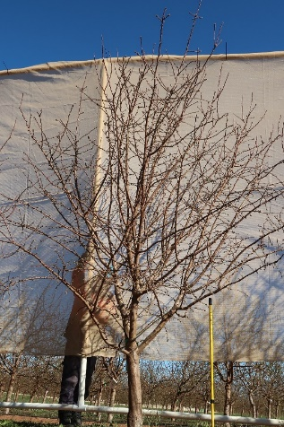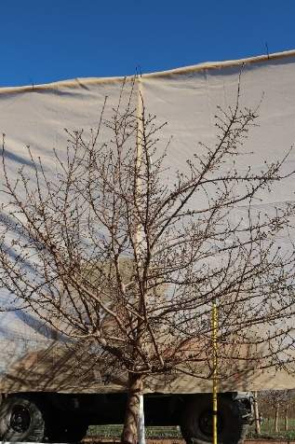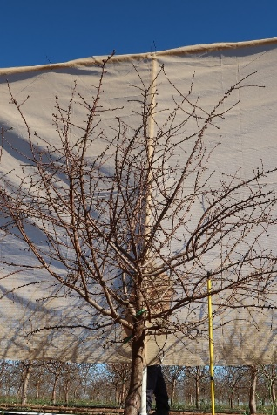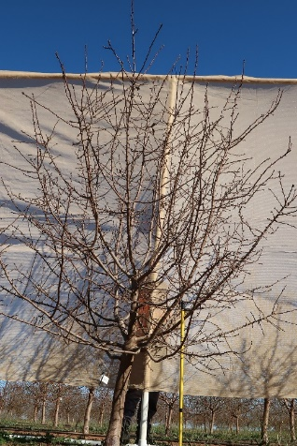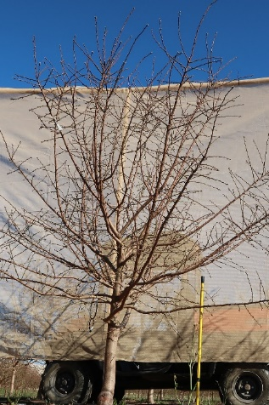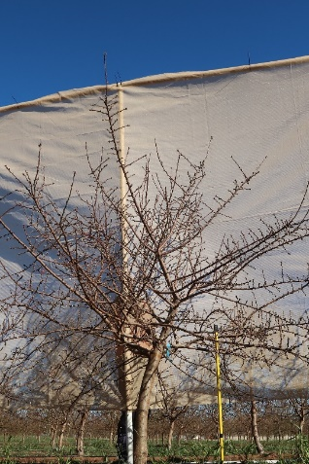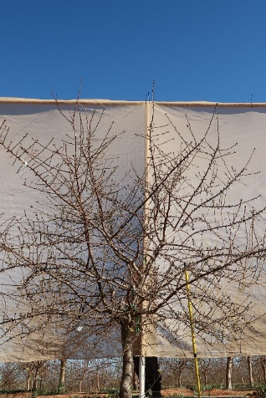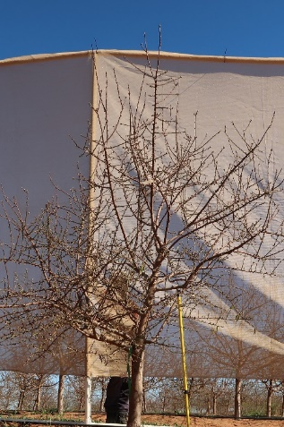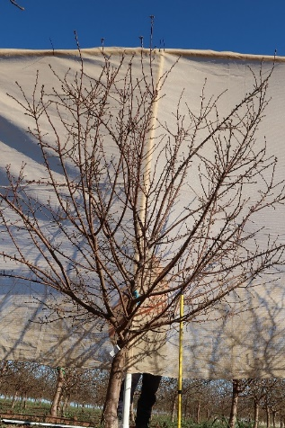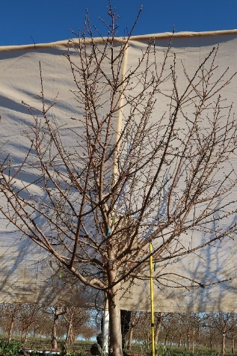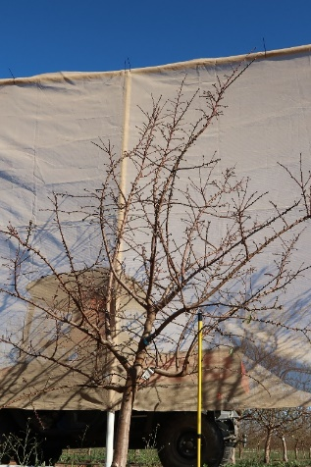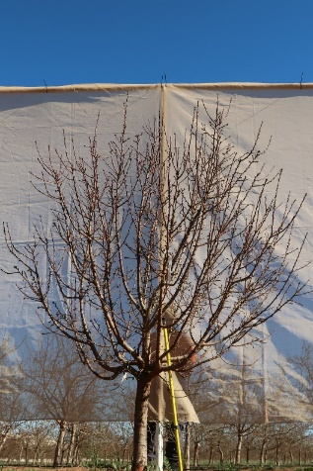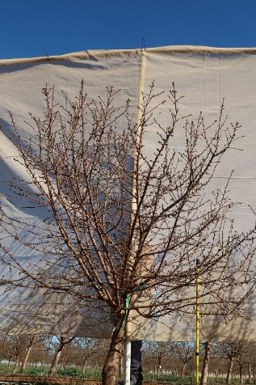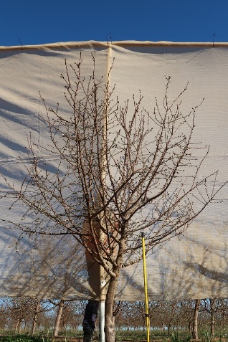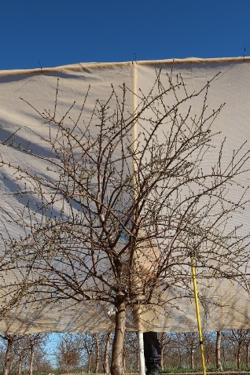
‘Capella’ ‘Carina’ ‘Maxima’ ‘Mira’
‘Nonpareil’ R8b T58 R19a T166 R20a T101
R30a T25 R36 T195 R36 T212 R52 T202
R52 T204 ‘Rhea’ ‘Vela’

Figure 1. Genotypes used in the architecture studies at the Almond Centre of Excellence (ACE) orchard in Loxton. Images taken in July 2020. Trees planted July 2018.
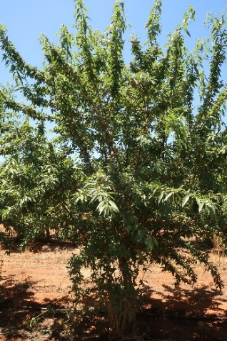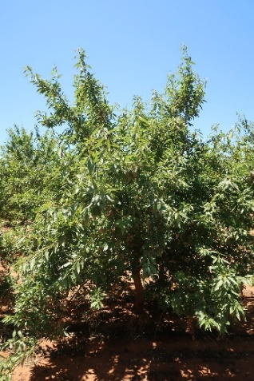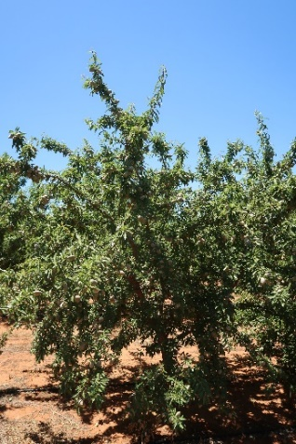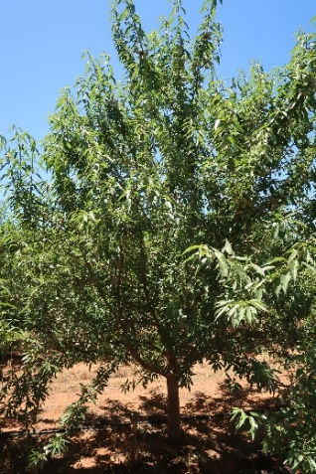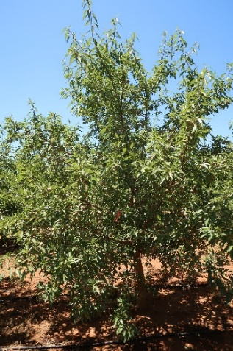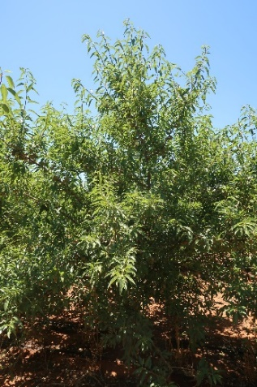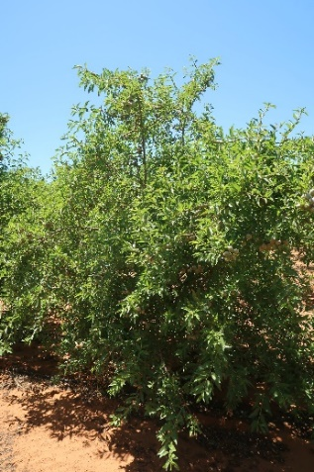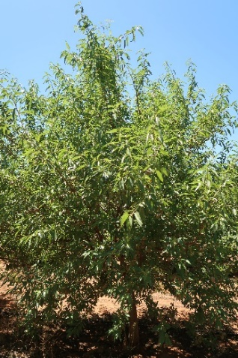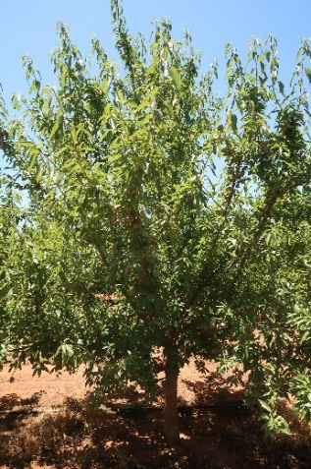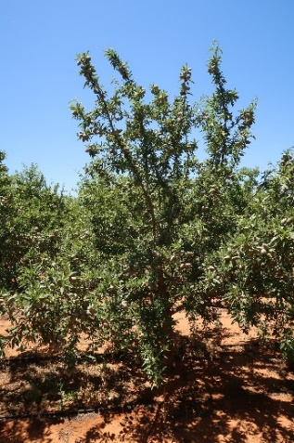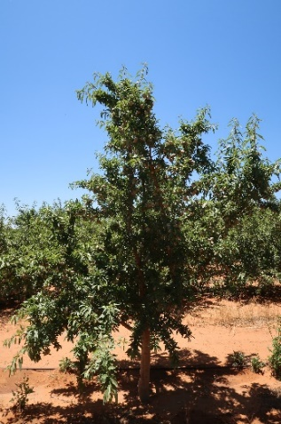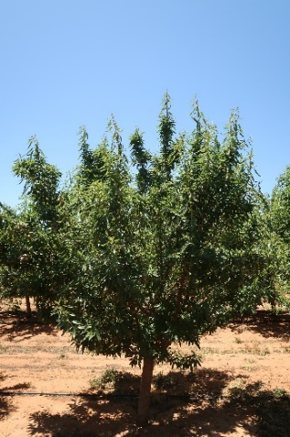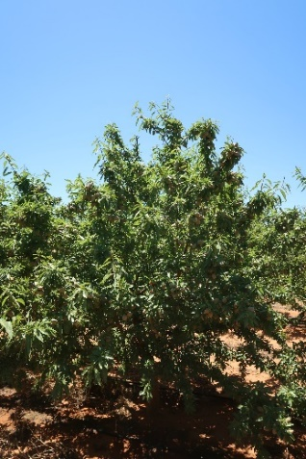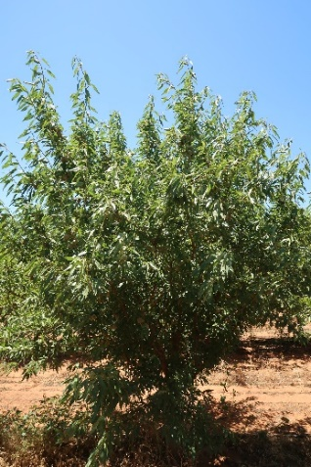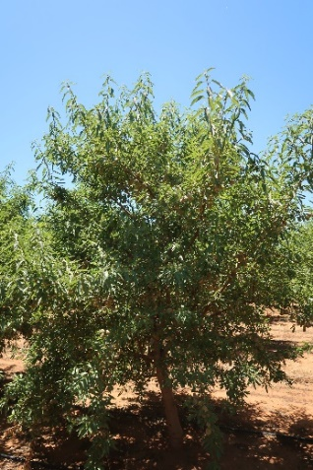
‘Capella’ ‘Carina’ ‘Maxima’ ‘Mira’
‘Nonpareil’ R8b T58 R19a T166 R20a T101
R30a T25 R36 T195 R36 T212 R52 T202
R52 T204 ‘Rhea’ ‘Vela’

Figure 2. Genotypes used in the architecture studies at the Almond Centre of Excellence (ACE) orchard in Loxton. Images taken in November 2020. Trees planted July 2018.
The most productive genotypes in 2022 were ‘Rhea’, R30a T25 and R8b T58, each of which produced more than 2.6 t/ha on fourth-leaf trees (Table 1). While ‘Rhea’ and R30a T25 had only modest crops in 2021, with 1.34 and 1.94 t/ha (respectively), the R8b T58 genotype was also one of the highest yielding genotypes in 2021, with 3.14 t/ha. Tree shape in this genotype was very flat with strong, horizontal scaffold branches that easily supported high crop loads. While highly productive, it is unlikely to be suitable for high-density plantings systems unless trained as an espalier. R36 T195 also has the desired narrow, upright tree shape and was one of the most productive genotypes in 2021 producing 2.41 t/ha. However, yields in 2022 were among the lowest with just 0.25 t/ha. A similar, surprising drop in productivity was found with ‘Maxima’ which produced 2.98 t/ha in 2021 but just 0.59 t/ha in 2022. This large drop in productivity was also recorded with this cultivar in the Pruning Responses trial (Appendix 3). This could be attributed to unfavourable environment conditions, possibly around flowering. The message from these results is that genotypes need to be appraised over more than three seasons to be confident of their productive potential.

Table 1: Axillary shoot production in July and fruiting in December 2020 on 2-year-old scaffold branches on 15 genotypes of almond trees in the Architectural study at the Almond Centre of Excellence (ACE) orchard, Loxton. Trees were spring-budded on Garnem® rootstock in 2017 and planted in 2018. Trees were planted with a central axis and then left without pruning. Values are genotype averages (n = 10 trees with one branch per tree per genotype).
Genotype | 2-year-old wood |  | 1-year-old extension of terminal shoot
(3rd leaf) | Diameter at base (mm) | No. of 2-year-old axillary shoots | Diameter at base (mm) | Short  shoots¹ | Medium shoots² | No. of  fruit
‘Capella’ | 34.1 | 1.7 | 21.6 | 8.2 | 21.2 | 82.0
‘Carina’ | 39.2 | 2.7 | 24.9 | 12.1 | 28.7 | 74.3
‘Maxima’ | 26.8 | 2.3 | 17.9 | 17.1 | 10.2 | 59.5
‘Mira’ | 31.2 | 2.2 | 22.7 | 8.0 | 22.5 | 102.6
‘Nonpareil’ | 29.9 | 1.9 | 20.6 | 0.2 | 27.1 | 81.6
R19a T166 | 28.1 | 2.0 | 19.8 | 17.1 | 33.8 | 67.1
R20a T101 | 27.8 | 1.8 | 17.7 | 14.1 | 20.7 | 44.1
R30a T25 | 31.8 | 1.3 | 22.3 | 5.4 | 24.1 | 77.7
R36 T195 | 33.7 | 2.9 | 23.3 | 7.9 | 32.3 | 101.2
R36 T212 | 32.7 | 2.1 | 22.5 | 18.3 | 20.1 | 109.9
R52 T202 | 34.5 | 3.5 | 21.0 | 11.6 | 19.9 | 64.4
R52 T204 | 28.8 | 2.8 | 18.2 | 7.9 | 29.8 | 69.5
R8b T58 | 33.7 | 1.1 | 21.4 | 6.8 | 25.7 | 66.7
‘Rhea’ | 32.1 | 1.2 | 21.1 | 5.2 | 19.4 | 48.6
‘Vela’ | 31.1 | 1.2 | 21.9 | 8.9 | 15.4 | 66.9
¹ Short shoots = number of spurs (1–5 cm long with minimal internode extension)
² Medium shoots = number of shoots < 21 nodes (approx. 20–40 cm long with internode extension)

Table 2: Kernel yield in 2021 and 2022 of 15 genotypes of almond trees in the Architectural study at the Almond Centre of Excellence (ACE) orchard in Loxton. Trees were spring-budded on Garnem® rootstock in 2017 and planted in 2018. Trees were planted with a central axis and then left without pruning. Values are genotype averages (n = 10 trees) ranked according to kernel weight (kg/tree) in 2022. Significance: *** = <0.001. Values in each column followed by the same lower-case letters were not significantly different (p<0.05).
 | Kernel weight¹ (kg/tree) |  | Kernel weight (t/ha; 741 trees/ha)
Genotype | 2021 (3rd leaf) | 2022 (4th leaf) | 2021 (3rd leaf) | 2022 (4th leaf)
‘Rhea’ | 2.41 def | 4.06 a | 1.78 | 3.01
R30a T25 | 3.48 bcd | 3.62 ab | 2.58 | 2.68
R8b T58 | 5.65 a | 3.57 ab | 4.19 | 2.65
R19a T166 | 1.76 ef | 3.11 bc | 1.31 | 2.30
‘Carina’ | 2.27 def | 2.97 bc | 1.68 | 2.20
‘Nonpareil’ | 3.11 bcde | 2.94 bc | 2.30 | 2.18
R52 T204 | 4.39 ab | 2.85 bc | 3.25 | 2.11
‘Mira’ | 4.14 abc | 2.73 c | 3.06 | 2.02
‘Vela’ | 2.84 bcdef | 2.69 c | 2.10 | 2.00
R36 T212 | 2.66 cdef | 2.32 cd | 1.97 | 1.72
R20a T101 | 1.93 def | 1.90 de | 1.43 | 1.41
‘Capella’ | 3.31 bcde | 1.37 ef | 2.45 | 1.01
‘Maxima’ | 5.36 a | 0.79 fg | 3.97 | 0.59
R52 T202 | 1.45 f | 0.58 g | 1.07 | 0.43
R36 T195 | 4.33 ab | 0.33 g | 3.21 | 0.25
Significance | *** | ***
p-value | <0.001 | <0.001

Key findings
- A genotype carrying the morphological traits sought in an ideal tree type suitable for a narrow, 2D canopy system was identified. The characteristics of this genotype were: i) narrow canopy shape, ii) few scaffold branches and a iii) mix of spurs and short shoots.
- This genotype is now planted in the high-density, narrow 2D canopies trial (planted in Aug 2022) at the ACE orchard in Loxton. More details on the new trial are presented in Appendix 4.

Appendix 2. Results of the “Regional trials” - multiple locations across Riverland, Sunraysia and Riverina
A series of regional trials in commercial orchards were established since 2014 as part of the Hort Innovation funded project “Almond productivity: tree architecture and development of new growing systems - AL14007” (Thorp, 2018). Some of these trials were kept as demonstration sites within the AS18000 (Table 1).
AIMS: i) to provide almond producers with opportunities to observe firsthand the research outcomes under local conditions ii) to support the early adoption of new systems and iii) to provide the Australian almond industry with long-term information (trees are now mature) on cultivars and rootstocks performance.
*Note: the COVID-19 pandemic and related travel restrictions impacted the ability to manage these trials and after restrictions were lifted, it was assessed that only the trials shown in Table 1 were still suitable for the collection of scientific information.

Table 1: Location and general information on the regional trials established as part of the “Almond productivity: tree architecture and development of new growing systems - AL14007” program and where data collection continued within the AS18000 program.
Location | Planting distance | Cultivars | Rootstocks | Treatments
Lindsay Point - Victoria | 6.85 x 3 m | ‘Nonpareil’  ‘Monterey’  ‘Price’ | ‘Nemaguard’  Brights Hybrid®  ‘Cornerstone’  Garnem® | pruning
*Robinvale - Victoria | 4.5 x 2 m | ‘Nonpareil’  ‘Carina’  ‘Vela’  Shasta® | Controller™ 6  Controller™ 7  Controller™ 9.5 | -
**Darlington Point – New South Wales | 7 x 3 m | ‘Nonpareil’  ‘Vela’  Shasta®  ‘Monterey’  Independence®  ‘Supareil’ | ‘Cornerstone’ | pruning
*The results from the Robinvale trial are reported as a separate appendix (Appendix 5)
** The Darlington Point trial’s data collection ceased with the 2023 harvest

Lindsay Point trial
AIM: to provide information on the interactions between tree vigour, productivity and the ability of young trees to carry heavy crops for different scion/rootstock combinations in a traditional planting.
Materials and methods
‘Nonpareil’, ‘Monterey’ and ‘Price’ trees budded on ‘Nemaguard’, Bright’s Hybrid®, ‘Cornerstone’ and Garnem® rootstocks were planted in 2016 in a commercial orchard in Lindsay Point in the Riverland region of Victoria, Australia.
Trees were planted with a spacing of 6.85 x 3 m between and within rows (487 trees per ha).
Two treatments were compared: i) Control planted with the traditional industry tree type which received heading cuts at 90 cm and trimmed side branches in the nursery and ii) Central axis trees, left unpruned in the nursery, planted with a single trunk (central axis) and multiple side shoots.
Treatments were replicated in four blocks of three trees each per cultivar/rootstock combination, in a systematic design with pruned central axis and control unpruned tree replicates alternating along each row. Unless otherwise indicated, data were taken from the centre tree in each three-tree plot. It was possible to have just one cultivar per row to meet the requirements of the collaborating grower.
All information about the initial stages of this trial can be found in the AL14007 final report (Thorp, 2018).
Results
The AS18000 program continued to collect measurements from this trial for four more seasons (2020-fourth leaf to 2023-seventh leaf). No yield differences were found, in any year, in response to the original pruning/training system and so data are here combined to compare the performance of scion/rootstock combinations in this commercial orchard.
An unusually high yield was measured in 2020 with ‘Price’ trees budded on Bright’s Hybrid rootstock (Table 2). This yield increase was a consequence of the unusually high number of medium axillary shoots produced on the scaffold branches in these trees, a response we did not see with any of the other scion and rootstock combinations. This difference in yield was not significant in the 2021 harvest for fifth-leaf trees, possibly because these axillaries had become shaded and less productive in the second harvest year.
By their fifth leaf, yields on these trees had increased to 2.06, 2.82 and 3.38 t/ha for ‘Price’, ‘Nonpareil’ and ‘Monterey’ respectively. Average yield across all rootstocks was 4.41, 3.60 and 2.98 t/ha for ‘Monterey’, ‘Nonpareil’ and ‘Price’ respectively, with substantial yield increases from 2021 to 2022 across all cultivars and rootstocks (Table 2). Yields were similar across all rootstocks when grafted with either ‘Monterey’ or ‘Nonpareil’. However, for trees with ‘Price’ scions, yields were significantly higher when grafted on Bright’s Hybrid rootstock than on Garnem or ‘Cornerstone’, with ‘Price’ on ‘Nemaguard’ intermediate.
The 2023 harvest marked the final season of the trial. Average yield across all rootstocks was 3.9, 2.5 and 1.2 t/ha for ‘Monterey’, Nonpareil’ and ‘Price’ respectively, compared with 4.4, 3.60 and 2.98 t/ha for the same cultivars the previous year. A generally lower yield was harvested in 2023 from ‘Price’, showing the greatest drop.
Within each cultivar, no differences in yield were measured between rootstocks for ‘Monterey’ and ‘Nonpareil’, while for ‘Price’ a greater yield was harvested from trees grafted on ‘Cornerstone’.

Table 2: Effect of rootstock on kernel yield of ‘Nonpareil’, ‘Monterey’ and ‘Price’ almonds at CMV Farms in 2020, 2021, 2022 and 2023. Trees were planted in July 2016 at 6.85 x 3 m spacing (487 trees per ha). Values are treatment averages (n = 8 trees). Values in each column followed by the same lower-case letters were not significantly different (p<0.05)
Scion | Rootstock | Kernel weight (t/ha)
Scion | Rootstock | 2020 (4th leaf) | 2021 (5th leaf) | 2022 (6th leaf) | 2023 (7th leaf)
‘Nonpareil’ | Bright’s Hybrid^{®2} |  | 3.02 | 3.74 | 2.40
 | ‘Cornerstone’ |  | 2.74 | 3.52 | 2.43
 | Garnem® |  | 2.70 | 3.25 | 2.20
 | ‘Nemaguard’ |  | 2.81 | 3.88 | 2.78
 | p-value |  | 0.39 | 0.46 | 0.141
‘Price’ | Bright’s Hybrid^{®2} | 2.57 a | 2.32 | 3.47 a | 1.15 b
 | ‘Cornerstone’ | 1.74 b | 1.94 | 2.53 b | 1.52 a
 | Garnem® | 1 96 b | 2.15 | 2.87 b | 1.10 b
 | ‘Nemaguard’ | 1.63 b | 1.86 | 2.99 ab | 1.04 b
 | p-value | <0.001 | 0.517 | 0.001 | 0.026
‘Monterey’ | Bright’s Hybrid^{®2} | 2.50 b | 3.52 | 4.5 | 4.19 ab
 | ‘Cornerstone’ | 2.60 ab | 3.53 | 4.25 | 3.26 b
 | Garnem® | 3.29 a | 3.35 | 4.75 | 3.75 ab
 | ‘Nemaguard’ | 2.56 ab | 3.14 | 4.13 | 4.54 a
 | p-value | 0.024 | 0.443 | 0.63 | 0.05

Darlington Point trial
AIM: to provide the almond industry with information on mature trees and orchard longevity.
Methods
The orchard for this trial was located near Darlington Point in the Riverina region of New South Wales. Trees were planted at 7 x 3 m spacing (474 trees/ha). All trees were planted as unpruned central axis trees. The plan to apply three different pruning regimes to produce trees suitable for high-density orchards did not eventuate for all cultivars, so the following were implemented: i) control trees available for all cultivars, ii) central axis – unpruned trees available for ‘Carina’ and ‘Nonpareil’ and iii) central axis – bare pole trees available for ‘Monterey’ and Shasta®.
On control trees the number of scaffold branches was reduced in winter 2017, leaving five scaffold branches, but making no more than four cuts per tree, plus cutting out the centre of each tree to create an “open vase”. Control trees were also narrow-pruned to emulate mechanical hedging which was standard orchard practice at this site.
The central axis trees were pruned in August 2017 using leader-release pruning. All trees were then narrow-pruned when dormant in May 2018, followed by an in-season prune in late-November 2018. In late-December 2018, the orchard staff also used a hedge-trimming machine to apply a slight topping cut across all trees, cutting back 5 to 10 cm of shoot growth, as per their standard orchard practice.
Results
Early in the program, COVID-19 restrictions meant that some late cultivars could not be harvested. In Table 3 harvest results from the Darlington Point trial are reported. The first harvest, in 2020, showed low yields across all pruning treatments within a cultivar. This was also the only harvest of Independence.

Table 3: Fresh weight of whole fruit (hull + shell + kernel) at harvest, kernel moisture content and yield per hectare of third leaf ‘Vela’, Shasta®, ‘Nonpareil’ and Independence® almond trees at Darlington Point in the Riverina region of New South Wales. Trees were budded in January 2017 on ‘Cornerstone’ rootstock and planted in 2017. Trees were planted at 7 x 3 m spacing (476 trees/ha). Values are replicate averages ± SE (n = 6 groups of 2 trees each). Significance: n.s. = not significant
Cultivar | Pruning treatment | Fresh weight (kg/tree) | Kernel moisture¹  (%) | Kernel weight² (kg/tree) | Kernel weight  (t/ha)
‘Vela’ | Control – no pruning | 7.9 ± 0.8 | 4.7 | 1.67 ± 0.20 | 0.796 ± 0.09
‘Vela’ | Narrow prune x1 | 6.8 ± 1.7 | 4.5 | 1.42 ± 0.36 | 0.677 ± 0.17
‘Vela’ | Narrow prune x2 | 7.2 ± 0.5 | 4.4 | 1.63 ± 0.11 | 0.777 ± 0.05
‘Vela’ | Significance | n.s. |  | n.s. | n.s.
Shasta® | Control – no pruning | 5.9 ± 1.3 | 4.4 | 1.55 ± 0.35 | 0.738 ± 0.17
Shasta® | Narrow prune x1 | 7.6 ± 0.4 | 4.3 | 1.97 ± 0.10 | 0.938 ± 0.05
Shasta® | Narrow prune x2 | 5.4 ± 0.5 | 4.3 | 1.61 ± 0.15 | 0.767 ± 0.07
Shasta® | Significance | n.s. |  | n.s. | n.s.
'Nonpareil' | Control – no pruning | 4.6 ± 0.6 | 4.9 | 1.23 ± 0.82 | 0.587 ± 0.09
'Nonpareil' | Narrow prune x1 | 4.2 ± 0.3 | 4.6 | 1.10 ± 0.07 | 0.523 ± 0.03
'Nonpareil' | Narrow prune x2 | 3.8 ± 0.6 | 4.6 | 1.01 ± 0.16 | 0.483 ± 0.08
'Nonpareil' | Significance | n.s. |  | n.s. | n.s.
Independence^{®3} | Control – no pruning | 7.2 ± 0.9 | 4.5 | 2.26 ± 0.27 | 1.074 ± 0.13
Independence^{®3} | Narrow prune (Aug 2019) | 5.1 ± 0.3 | 4.4 | 1.65 ± 0.12 | 0.787 ± 0.06
Independence^{®3} | Significance | n.s. |  | n.s. | n.s.
¹ Kernel moisture determined from one pooled sample per cultivar and pruning treatment
² Kernel yield data adjusted to 5% moisture
³ Independence® trees only pruned once, in August 2019

In 2021 no yield differences were found in response to the original pruning/training system (Table 4). However, there was a consistent trend for the trees pruned in 2018 and 2019 (Narrow prune x2) to be narrower across the rows, which indicates the potential to have smaller trees in narrower rows without compromising yield.

Table 4: Kernel yield per tree and per hectare in 2020 and 2021 and tree canopy width across rows in November 2020 of ‘Vela’, Shasta®, ‘Nonpareil’ and Monterey’ almond trees at Darlington Point in the Riverina region of New South Wales. Trees were budded in January 2017 on ‘Cornerstone’ rootstock and planted in 2017. Trees were planted at 7 x 3 m spacing (476 trees/ha).
Cultivar | Pruning treatment | Kernel weight¹  (kg/tree) |  | Kernel weight (t/ha)  7 x 3 m (476 trees/ha) |  | Canopy width  (m)
Cultivar | Pruning treatment | 2020  (3rd leaf) | 2021  (4th leaf) | 2020  (3rd leaf) | 2021  (4th leaf) | November 2020
‘Vela’ | Control – no pruning | 1.67 | 4.35 | 0.80 | 2.07 | 3.1 a
‘Vela’ | Narrow prune x1 | 1.42 | 4.33 | 0.68 | 2.06 | 3.0 ab
‘Vela’ | Narrow prune x2 | 1.63 | 4.07 | 0.78 | 1.94 | 2.7 b
‘Vela’ | Significance | n.s. | n.s. | n.s. | n.s. | *
‘Vela’ | p-value | 0.719 | 0.789 | 0.719 | 0.789 | 0.030
Shasta® | Control – no pruning | 1.55 | 2.46 | 0.74 | 1.17 | 3.2
Shasta® | Narrow prune x1 | 1.97 | 2.34 | 0.94 | 1.12 | 3.1
Shasta® | Narrow prune x2 | 1.61 | 2.13 | 0.77 | 1.01 | 2.8
Shasta® | Significance | n.s. | n.s. | n.s. | n.s. | n.s.
Shasta® | p-value | 0.615 | 0.741 | 0.615 | 0.741 | 0.094
'Nonpareil' | Control – no pruning | 1.23 | 2.46 | 0.59 | 1.17 | 3.1
'Nonpareil' | Narrow prune x1 | 1.10 | 2.21 | 0.52 | 1.05 | 3.0
'Nonpareil' | Narrow prune x2 | 1.01 | 1.871 | 0.48 | 0.89 | 2.8
'Nonpareil' | Significance | n.s. | n.s. | n.s. | n.s. | n.s.
'Nonpareil' | p-value | 0.632 | 0.418 | 0.632 | 0.418 | 0.166
'Monterey' | Control – no pruning | No data | 3.84 | No data | 1.83 | 3.1 a
'Monterey' | Narrow prune x1 |  | 3.70 |  | 1.76 | 3.1 a
'Monterey' | Narrow prune x2 |  | 3.55 |  | 1.69 | 2.7 b
'Monterey' | Significance |  | n.s. |  | n.s. | **
'Monterey' | p-value |  | 0.675 |  | 0.675 | 0.005
¹ Adjusted to 5.0% moisture content.
Values are treatment averages (n = 6–10 trees). Significance: n.s. = not significant; * = p<0.05; ** p<0.01. Values within cultivar in each column with the same letters were not significantly different (p<0.05).

The 2023 harvest concluded the trial and only Shasta and ‘Nonpareil’ were harvested. Overall kernel yields remained low at this orchard compared with industry standards for the trees of the same age (Table 5). It is a difficult site because of heavy soils and high rainfall. With our trial block, yields were lower in 2022 compared with 2021 for ‘Vela’ and ‘Monterey’ and there were slight increases for Shasta and ‘Nonpareil’.

Table 5: Kernel yield per hectare in 2020, 2021 and 2023 Shasta® and ‘Nonpareil’ almond trees at Darlington Point in the Riverina region of New South Wales. Trees were budded in January 2017 on ‘Cornerstone’ rootstock and planted in 2017. Trees were planted at 7 x 3 m spacing (476 trees/ha).
Cultivar | Pruning treatment | Kernel weight (t/ha)  7 x 3 m (476 trees/ha)
Cultivar | Pruning treatment | 2020  (3rd leaf) | 2021  (4th leaf) | 2022  (5th leaf) | 2023  (6th leaf)
Shasta® | Control – no pruning | 0.74 | 1.17 | 1.39 | 1.61
Shasta® | Narrow prune x1 | 0.94 | 1.12 | 1.34 | 2.02
Shasta® | Narrow prune x2 | 0.77 | 1.01 | 1.33 | 2.05
Shasta® | Significance | n.s. | n.s. | n.s. | n.s.
'Nonpareil' | Control – no pruning | 0.59 | 1.17 | 1.70 | 1.82
'Nonpareil' | Narrow prune x1 | 0.52 | 1.05 | 1.48 | 1.83
'Nonpareil' | Narrow prune x2 | 0.48 | 0.89 | 1.46 | 1.71
'Nonpareil' | Significance | n.s. | n.s. | n.s. | n.s.

Key findings
- The cultivars’ growth habits could be early indicators of their pruning requirements. For example, Monterey, with its spreading canopy and numerous long shoots is likely to require frequent pruning in a high-density planting. ‘Price’, with an upright growth habit and narrow (acute) branching angles should require minimal pruning.
- While establishing central axis trees in the nursery was generally successful, the basitonic growth habit of the cultivars in the trials made it difficult to distinguish central axis trees from control trees by the end of the first orchard season.
- In central-axis trees, scaffold branches were spread over a longer trunk which could be considered a structural advantage.
- The further information collected up to 2023 confirmed that in the Riverland soils, the clonal rootstocks Bright’s Hybrid, Garnem and ‘Cornerstone’ when budded with ‘Nonpareil’ showed no advantage or disadvantage over the traditional seedling ‘Nemaguard’ rootstock.
- An early narrow prune helped maintain a narrower canopy without effect on yield.
- Biennial bearing was observed for some combinations.

Appendix 3. Results of the “Pruning responses trial” – Almond Centre of Excellence (ACE), Loxton SA.
AIMS: i) to test various training/pruning systems, starting in the nursery with central axis trees, to produce upright and narrow canopies with minimal pruning interventions and ii) to identify almond varieties better suited to closer plantings.
Methods
Five cultivars: ‘Nonpareil’, ‘Maxima’, ‘Vela, ‘Carina’ and Shasta® budded on Garnem® rootstock were planted in 2018 with 4.5 x 3 m spacing (741 trees/ha). Starting in the nursery, trees were selected to have a single dominant trunk with multiple side branches, then grown in the field with different training/pruning methods to produce the desired narrow tree shape. An additional “low cost” option included planting trees that were dormant budded in May 2018, planted in July 2018 with a “sleeping eye” bud, then trained during spring and summer to produce the final tree.
Five management/pruning treatments were implemented:
- Control unpruned, planted as a central axis tree
- Bare Pole: all the side branches were trimmed after planting
- Narrow Pruned
- Small, late-budded trees
- Dormant budded trees; budded at 70 cm high on the trunk of the rootstock and planted with two “sleeping eye” buds. Once the buds had started to grow in spring they were thinned to the strongest shoot and then left to grow unpruned.
Results
Only ‘Carina’, ‘Maxima’ and Shasta produced a crop in 2020 (Table 1). ‘Maxima’ had the highest yields ranging from 422 to 457 g/tree on the central axis trees. No treatment effects were revealed within cultivars.
The first tree size (trunk circumference and height) measurements were collected in November 2021, on third- leaf trees. Trunks were thinner in ‘Carina’ followed by ‘Nonpareil’ while the other cultivars were all similar (p<0.0001). The shortest trees were measured in Shasta. The dormant budded trees were the shortest and with the smallest trunks, all the other treatments were somewhat similar (data not reported) (p<0.01).
Average yields from third-leaf trees, in 2021, ranged from 1.61 to 3.5 t/ha for Shasta and ‘Vela’ respectively, with pruning treatments combined (Table 2). There were no yield differences (p>0.05) between the pruning treatments, even with the dormant budded trees that were planted with just a single “sleeping eye” bud (data not reported). However, the general growth habits of the trees were observed to differ among the treatments.
Average yields from fourth-leaf trees, in 2022, ranged from 1.76 t/ha for ‘Maxima’ to 3.71 t/ha for ‘Vela’, with pruning treatments combined (Table 2). Note that ‘Maxima’ was the highest yielding cultivar in 2021 producing 3.5 t/ha so a yield of just 1.76 t/ha for this cultivar in 2022 was lower than expected and possibly indicates issues with reduced cropping following previous heavy crops.
The 2023 harvest marked the final data collection for the trial, at the fifth leaf. Within each variety, as expected, no differences between the different pruning methods were found, in line with findings from previous seasons (data not reported).

Table 1: Kernel yield per tree and per hectare of 'Carina', 'Maxima' and Shasta® almond trees harvested in 2020 at the Almond Centre of Excellence (ACE) orchard, Loxton. Trees were budded on Garnem® rootstock in 2017/18 and planted in 2018 at 4.5 x 3.0 m spacing (741 trees/ha). Values are replicate averages (n = 9 groups of 2 trees each). n.s.= not significant at p<0.05
 |  | Kernel weight
Cultivar  (tree age) | Treatment | kg/tree | t/ha
'Carina' | Control unpruned | 0.17 | 0.13
(2nd leaf) | Bare Pole | 0.16 | 0.12
 | Narrow Pruned | 0.17 | 0.13
 | Small, late-budded | 0.15 | 0.11
 | Dormant budded | 0.15 | 0.11
Significance |  | n.s. | n.s.
'Maxima’ | Control unpruned | 0.43 | 0.32
(2nd leaf) | Bare Pole | 0.45 | 0.33
 | Narrow Pruned | 0.42 | 0.31
 | Small, late-budded | 0.46 | 0.34
 | Dormant budded | 0.26 | 0.20
Signifcance |  | n.s. | n.s.
Shasta® | Control unpruned | 0.41 | 0.30
(2nd leaf) | Bare Pole | 0.32 | 0.24
 | Narrow Pruned | 0.33 | 0.24
 | Small, late-budded | 0.29 | 0.21
 | Dormant budded | 0.29 | 0.22
Significance |  | n.s. | n.s.

The trial provided interesting differences in yield amongst varieties over the four seasons. ‘Carina’ and ‘Vela’ showed increasing yield from 2020 to 2023, with ‘Vela’ yielding as high as 4.4 t/ha in this last 2023 season. ‘Maxima’s’ yield was depressed in 2022 but it almost doubled in 2023 (from 1.75 t/ha in 2022 to 3.32 t/ha in 2023). ‘Nonpareil’, in a trend that was reported across the whole Australian industry, produced very low crops in 2023. When talking with growers throughout the season, it was speculated that, for this variety, the cold and wet weather during flowering and fruit set could be to blame. The self-fertile varieties did not seem to have been impacted by the weather conditions as much as ‘Nonpareil’. However, Shasta, despite being self-fertile, did show a moderate drop in yield in 2023 compared with 2022.

Table 2: Kernel yield per hectare of ‘Carina’, ’Maxima’, ‘Nonpareil’, Shasta® and 'Vela’ almond trees planted in July 2018 at 4.5 x 3 m spacing (741 trees/ha) at the Almond Centre of Excellence (ACE) in Loxton. Values in each column followed by the same letter are not significantly different (p<0.05).
Cultivar | Yield (t/ha)
Cultivar | 2020  (2nd leaf) | 2021  (3rd leaf) | 2022  (4th leaf) | 2023  (5th leaf)
‘Carina’ | 0.12 | 2.12 c | 2.72 b | 3.32 b
‘Maxima’ | 0.30 | 3.50 a | 1.76 c | 3.32 b
‘Nonpareil’ | 0 | 2.30 b | 3.46 a | 2.47 c
Shasta® | 0.24 | 1.61 d | 2.34 b | 2.10 c
‘Vela’ | 0 | 2.39 b | 3.71 a | 4.45 a

The trial ensured the delivery of pruning recommendations for growers to maintain high productivity in higher density orchards, together with information on early tree establishment from the nursery to the orchard; the information is summarised in three fact sheets available at the links below on the Australian Almond Board website (almondboard.org.au):
https://almondboard.org.au/wp-content/uploads/2022/05/Almond-planting-and-early-tree-establishment-In-the-nursery-Part-1.pdf?v=8bcc25c96aa5
https://almondboard.org.au/wp-content/uploads/2022/05/Almond-planting-and-early-tree-establishment-In-the-orchard-Part-2.pdf?v=8bcc25c96aa5
https://almondboard.org.au/wp-content/uploads/2022/05/Almond-planting-and-early-tree-establishment-Establishment-of-canopy-Part-3.pdf?v=8bcc25c96aa5

Key findings
- Control-unpruned trees and the narrow-pruned trees produced trunks with scaffold branches evenly spaced over a zone from 70–120 cm
- Small, late-budded trees had a more condensed zone of scaffold branches over a zone from 70–90 cm as these trees were relatively small when planted
- Bare pole trees also produced scaffold branches evenly spaced over a zone from 70–120 cm above the ground, but these branches were more horizontal than those on the unpruned trees
- Dormant budded trees grew well but practically all of the scaffold branches developed from or in close proximity to the “sleeping eye” bud, which will be a point of weakness as the trees get older
- Garnem is a vigorous rootstock, it was a challenge to manage these trees with minimal pruning within the allocated space in 4.5 m wide rows and without suitable machinery for narrow rows
- Yield differences between cultivars were significant. It is worth noting that in this trial all varieties were managed the same with the same nutrition and irrigation irrespective of potential differences in tree size and crop load
- ‘Vela’ continued to increase its yield every year throughout the trial period
- ‘Maxima’ seemed prone to biennial bearing when planted at high density
- It was also noted that self-fertile varieties might have shown an advantage in more environmentally challenging years (wet and cold springs).

Appendix 4. Results of the “High density and 2D canopies trial” – Almond Centre of Excellence orchard (ACE), Loxton
Knowledge, data and observations gathered from 2014, with the AL41007 first and within the AS18000 later, together with industry and collaborator consultations, have resulted in PFR conceptualizing and planting a high density, narrow rows, planar canopy trial in Loxton at the Almond Centre of Excellence (ACE).
AIMS: i) to understand the impact of tree architecture diversity on suitability for 2D canopy systems and narrow rows and ii) to advance the Australian almond industry understanding of the suitability and challenges of growing almond genotypes and rootstocks combinations in 2D narrow orchard growing systems.
Methods
The first trees were planted in August 2022 with the cultivars ‘Carina’ on ‘HBOK 27’ (Controller™ 6) rootstock and UA102 (R36 T212) on ‘Nemaguard’. The trial originally planned to compare two growing systems, each at two densities:
• tall, narrow central axis trees at densities of 1,111 (4.5 m x 2 m) and 1,428 (3.5 m x 2 m) trees/ha
• an informal “planar cordon”-type trees at densities of 740 (4.5 m x 3 m) and 952 (3.5 m x 3 m) trees/ha.
The ‘Carina’ trees were grown in the nursery as tall central axis for effectively two seasons prior to planting (over 2.5m tall at the time of planting). All trees destined for the planar 2D system were headed back at 1m height shortly after planting to encourage shooting and then select the two “cordons” that will form the planar system.
The UA102 trees, at the time of planting were one-year old, unbranched trees (40-70 cm tall trees). These were allowed to grow for the first season and headed back in March 2023.
In August 2024 an additional genotype was added to the trial, the Spanish cultivar ‘Marinada’. These were grown in the nursery as central axis trees and planted as one year old trees, over 1 m tall with some side branches.
The planted genotypes are characterised by architectural features considered to be better suited to high-density growing systems, in particular:
- ‘Carina’ (Figure 1, left), produces multiple upright shoots with few lateral shoots. Lateral shoots may be produced sylleptically, but more commonly off one-year-old wood, have much narrower crotch angles (more upright). The genotype exhibits fruiting on ‘lateral’ buds on long lengths of one-year-old wood, as well as on brindles, and in older trees spurs.
- UA102 (R36 T212) (Figure 1, right), produces few upright shoots with many short to medium lateral shoots. These shoots are produced off one-year old wood and have very wide crotch angles (almost horizontal). The genotype exhibits fruiting on ‘axillary’ or ‘lateral’ buds on long lengths of one-year-old wood, but primarily on the short to medium shoots. As trees age, spur flowering becomes prominent. This results in an open canopy with a ‘columnar’ type branch habit, which suggests it may suit a planar canopy system.
- ‘Marinada’ has an upward growth habit, medium vigour and fruit location mainly on spurs.

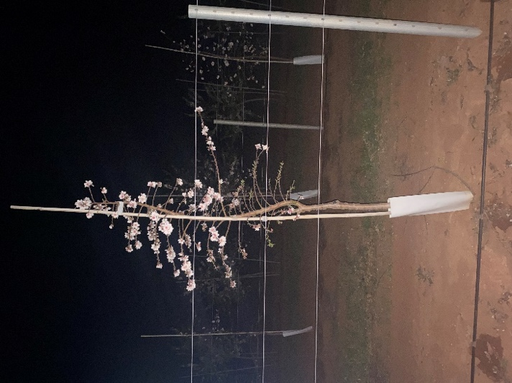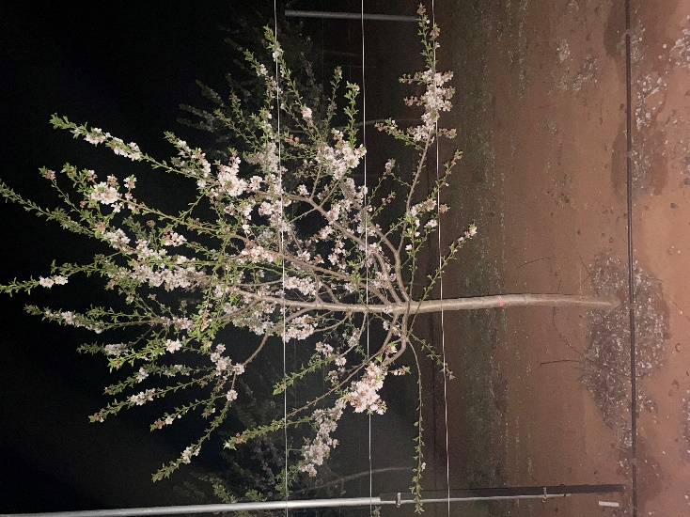

Figure 1: Young ‘Carina’ on Controller™ 6 (left) and UA102 on ‘Nemaguard’ (right) trees planted at high-density and trained as central axis at the Almond Centre of Excellence (ACE) orchard in Loxton, Australia. The images were taken at night in July 2024. Trees were planted in winter 2022
The cultivars were planted in separate blocks (instead of interspersed) for ease of management. The trial occupies eight rows, row 1-4 are planted at a distance of 3.5 m and rows 5-8 at 4.5 m. Row 1 and row 8 are all ‘Carina’ and are used as border rows and all trees are trained as tall, central axis trees. The first section is all Carina, the top three trees are used as border trees, from tree four the training system changes every five trees starting with the central axis trees planted 2 m apart and alternating with the informal planar system with trees 3 m apart (Figure 2, right).
The second section was planted with the cultivar UA102 with three blocks of six trees trained as central axis tress 2 m apart alternating with two blocks of nine trees of the informal planar system, with trees 1.5 m apart.
The cultivar ‘Marinada’ was planted the following year in two blocks of five trees trained as central axis alternated with two blocks of five trees trained as informal planar system. All trees are spaced at 2m.
Learnings from previous high-density trials on irrigation requirements at different tree densities have been addressed in this new trial by dividing the block so that the different genotypes (different age and size) could be irrigated differently. Moreover, the irrigation allows for different water discharge based on the distance between trees so that each tree of the same variety will receive the same amount of water independently from the spacing between trees.
The trellising infrastructure removed from the SARDI high-density trial was recycled and used in this orchard (Figure 2 left).
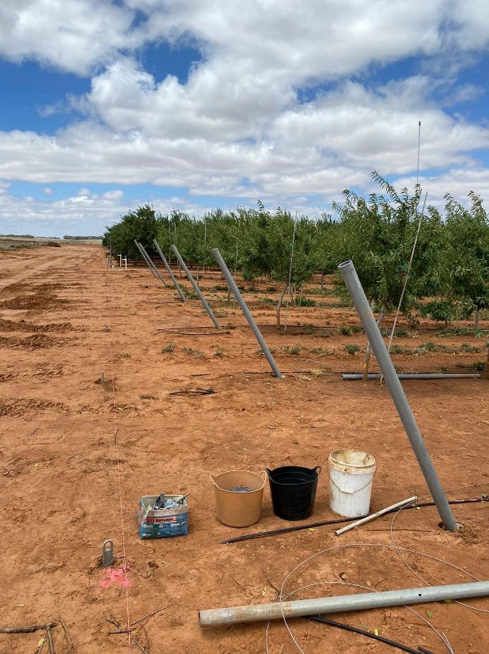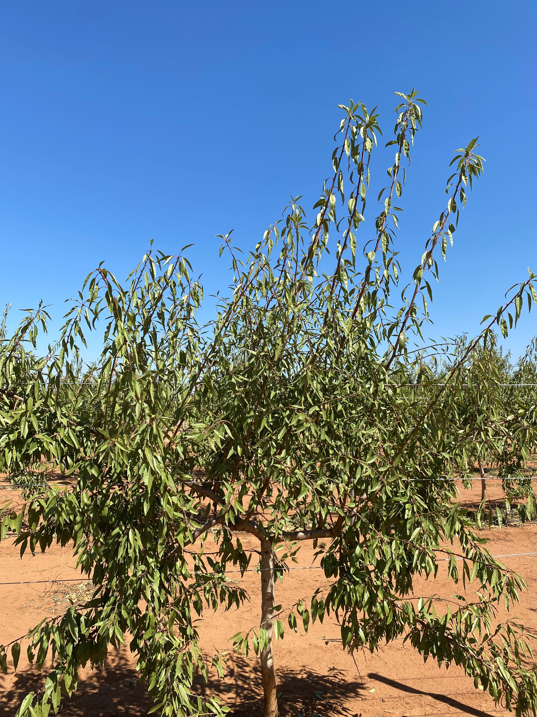

Figure 2: High-density and 2D almond orchard with trellis system installed (left) and ‘Carina’ on Controller™ 6 rootstock planted at high-density and trained on a 2D planar cordon type system at the Almond Centre of Excellence (ACE) orchard in Loxton, Australia (right). The image was taken in February 2024 after the installation of the trellising for the orchard and the green pruning to select uprights. Trees were planted in winter 2022
The trunks of all the trees in the trial, which was planned with a focus on mechanisation of orchard operations, were feathered up to 1 m. A condition for mechanised harvest, for example, with shake-and-catch-type machines is to have a trunk height above 80-90 cm. The planar trees were topped at 1 m and this allowed for the selection of the two branches to train to become the future “cordons” of the planar system.
Results
Early observations noticed that the ‘Carina’ trees on the 2D systems showed a tendency for the upright branches selected closer to the trunk to display higher vigour compared with the more distal ones. This was expected and already observed in similar experiences from colleagues training almonds on a 2D cordon system, and indeed also in pome fruit, stonefruit, avocados and citrus. It was then decided to bend the previously selected “cordon” to fill the space below the cordon itself and use the vigorous first upright as the new cordon. Figure 3 was taken in early October 2023 and it shows that the new cordon produced some good growth and an even distribution of uprights that was let grow for the season and the permanent structures/uprights were selected after harvest.
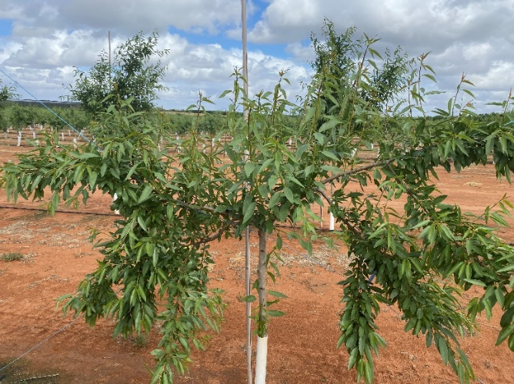 | Figure 3: ‘Carina’ on Controller™ 6 rootstock planted at high density and trained on a 2D planar cordon type system at the Almond Centre of Excellence (ACE) orchard in Loxton, Australia. The image was taken in October 2023 after retaining was implemented in August to select new cordons. Trees were planted in winter 2022.

The UA102 genotype in the 2023 growing season displayed strong budbreak however the elongation of the produced shoots was quite weak. This led the team to forecast that this growth would have been inadequate to fill the 1.5 m space (3 m between trees). It was then decided that an extra tree would be planted between each existing tree to space the planar cordon UA102 at 1.5 m (‘Carina’ remained at 3 m).
After observing the almond cultivar ‘Marinada’ in Spain and also during a visit to the Almas almond orchard in Robinvale, the PFR team noted its interesting growth and fruiting habit. This led the team to decide that ‘Marinada’ could be a suitable genotype for a planar cordon-type training system. To make space for planting this new variety, trees required for interplanting the UA102 cultivar, which had been located at the southern end of the orchard, were moved. This action created the necessary empty area where the ‘Marinada’ variety was planted in winter 2024.
In 2025 the first harvest was carried out, only for the ‘Carina’. Yield per tree was the highest in the central axis trees in the 3.5 m rows and the lowest was recorded in the 2D planar trees in the 4.5 m rows. The kernel yield per hectare increased with increasing tree density; the central axis trees at 1428 trees/ha yielded 1.33 t/ha which is high as a first ever crop.

Table 1: Kernel yield per tree and per hectare, kernel weight and number of kernels per tree of 'Carina' almond trees on Controller™ 6 rootstock at their first harvest in 2025. Trees were planted in 2022 at the Almond Centre of Excellence (ACE) in Loxton. The row spacing was either 3.5 or 4.5 m and trees were trained as either central axis trees spaced 2 m apart or as 2D planar cordon-type trees at 3m apart.
Row spacing | Trees/ha (number) | Treatment | Kernel yield (kg/tree) | Kernel yield (t/ha) | Kernel weight (g) | Kernels/tree (number)
3.5 x 2.0 | 1428 | Central axis | 0.93 | 1.33 | 1.46 | 639
3.5 x 3.0 | 952 | Planar | 0.68 | 0.65 | 1.45 | 469
4.5 x 2.0 | 1111 | Central axis | 0.80 | 0.89 | 1.41 | 572
4.5 x 3.0 | 740 | Planar | 0.57 | 0.42 | 1.45 | 396

Key findings
- The central axis tree form so far maintained an open, porous canopy which could be promising for a narrow canopy/rows system. Hedging of these trees was carried out to encourage the formation of a narrow canopy with branches growing along the row rather than into the row.
- The ‘UA10’2 is producing a slimmer canopy than ‘Carina’, suggesting a closer tree spacing may be required to achieve row-fill.
- Both genotypes on the planar system produce dense canopy walls.
- ‘Carina’s’ basitonic behaviour seems positive for the central axis tree form but is detrimental in maintaining a 2D cordon system because it produces vigorous proximal uprights which out-compete the cordon extension.
- The vigour of the uprights in the cordon system is uneven along the cordon with the uprights in the distal portion of the cordon displaying very limited vigour. This is less pronounced in UA102.
- The decision to position the cordon on a 30-35° angle rather than at 15° as in other planar cordon systems i.e. apples was not sufficient to overcome the loss of distal vigour
- So far, the ‘Carina’/Controller 6 combination seems suitable for a hedged central-axis system but not for a planar system with cordons and uprights.
- The UA102 seems to easily maintain a central axis and a narrow canopy both within and in the row. A closer tree spacing could be considered for this genotype (<1.5m).
- It is too early to make observation on the suitability of the ‘Marinada’ to these growing systems.

Appendix 5. Results of the “rootstocks and cultivar performance trial” – Robinvale, Victoria
AIM: to evaluate the performance of new almond rootstocks combined with traditional and new cultivars in a high-density orchard.
Methods
Trees were planted in 2018 at 4.5 x 2 m spacing (1,111 trees/ha). The trial examined the performance of four cultivars: ‘Carina’, ‘Nonpareil’, ‘Vela’ and Shasta® budded onto ‘HBOK 27’ (Controller™6), ‘HBOK 32’ (Controller 7) and ‘HBOK 50’ (Controller 9.5) rootstocks. All trees had been dormant-budded in March 2017 and grown for a full season in the nursery before planting into the field in winter 2018 as unpruned central axis trees.
The trial design was dictated by nursery availability of the planting material (rootstocks mostly) and the need to keep management operations suitable for being undertaken within a commercial orchard. The block is 1.62 ha, with 44 rows planted (32 rows of trees on Controller 6, 6 rows on Controller 7 and 6 rows on Controller 9.5) (Figure 1). Due to low Controller 7 and Controller 9.5 rootstocks availability, Shasta could only be planted on Controller 6. Moreover, trees on the Controller 9.5 were insufficient to fill the rows (green section in Figure 1) In total the trial included 10 rows of Shasta, 13 rows of ‘Carina’, 11 of ‘Vela’ and 10 of ‘Nonpareil’. A total of 44 trees were measured/observed per cultivar throughout the experiment.
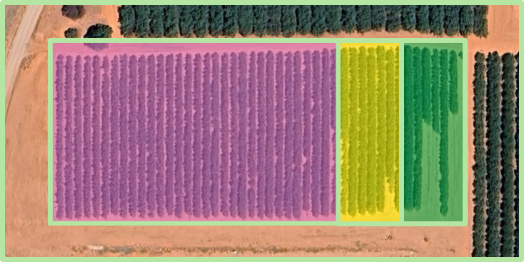 | Figure 1: Aerial view of the 1.62 ha trial site with highlighted the surface established with the three rootstocks: ControllerTM 6 (pink), ControllerTM 7 (yellow) and ControllerTM 9.5 (green). Trees on the Controller 9.5 rootstock were insufficient to fill the rows, hence the missing trees in the green rectangle.

Irrigation (and nutrition) were decided by the orchard manager and all trees received the same amount of water and nutrients (data not available) irrespective of cultivar and tree size as per Table 1.

Table 1: Irrigation, in ML/ha) applied to the orchard in Robinvale from 2019 to 2025.
Season | Irrigation (ML/ha)
2019-20 | 5.6
2020-21 | 6.9
2021-22 | 12
2022-23 | 12.5
2023-24 | 10.9
2024-25 | 10.6

Measurements were carried out on the 44 data trees of each cultivar and included yearly measures of tree size/dimensions in late November, when the weight of the fruit on the trees is at its highest and hence the maximum spread/canopy width could be captured. These measures included tree height, trunk circumference and tree width (perpendicular to the row direction). For ease of comparison, trunk cross-sectional area (TCA) was calculated and selected as the measure of tree size reported in the results. Harvest followed the advice from the orchard management and generally ‘Carina’, Shasta and ‘Nonpareil’ on Controller 6 rootstock were harvested first followed by the same cultivars on Controller 9.5 and ultimately ‘Vela’ (late ripening cultivar). The last harvest for the project was nominally 2024, however, it was decided to carry on with one more harvest for the trees on Controller 6 rootstock in 2025 since it was considered useful to record the high crop loads. Trees on Controller 7 and Controller 9.5 were deemed too large for this orchard design and considered unsuitable for a high-density setting hence data collection concluded in 2024. Trees were harvested individually, by machine (2021 and 2022) or by hand (2020, 2023,2024,2025) with nets placed beneath the tree to collect the fruit.
The fruit collected was weighed in the orchard and a subsample for each row was collected for future analysis. The subsample was weighed in the orchard (fresh weight) and then weighed again at the time of hulling (dry weight). Hulling was carried out using a mechanical huller; every sample was hulled, the kernels collected and their weight and moisture percentage measured. The data collected through the hulling process were then used to calculate the total kernel weight per tree and per hectare. For the last three seasons, each kernel subsample was also subjected to quality assessments; a subsample of 100 kernels was randomly collected, weighed and each kernel inspected for defects such poor filling and pepper spotting.
Results
Results are firstly reported ‘per variety’ and later ‘per rootstock’.
‘Carina’
Tree dimensions, reported as trunk cross-sectional area (TCA), followed the expected trend of being generally lower in Controller 6 and higher in Controller 9.5. Controller 7 was somewhat intermediate or similar to Controller 6. The TCA was the smallest in Controller 7 until 2023 and from that year on, no differences were observed between Controller 6 and Controller 7. Controller 9.5’s trees TCA was larger than the other two rootstock but in 2021, when it was comparable to Controller 6. A larger variation in the data collected from trees on the Controller 9.5 was observed (Figure 2).
Second-leaf tree yields increased as the nominal rootstock vigour increased with Controller 6 yielding the lowest and Controller 9.5 the highest in a range from 0.61 to 0.96 t/ha (Table 2).
In 2021 yields were high for the age of the trees, 2.57 t/ha on average with the highest yield, 3.49 t/ha, recorded on Controller 9.5 (Table 2). Trees produced on average 2.37 t/ha in 2022 and although there were substantial yield reductions recorded with trees on Controller 6 and Controller 9.5 rootstocks, there was an increase in yield on the Controller 7 with 2.48 t/ha in 2022 compared with 1.52 t/ha in 2021. An increase in yield across all rootstocks was observed in 2023, however no differences among rootstocks were measured.
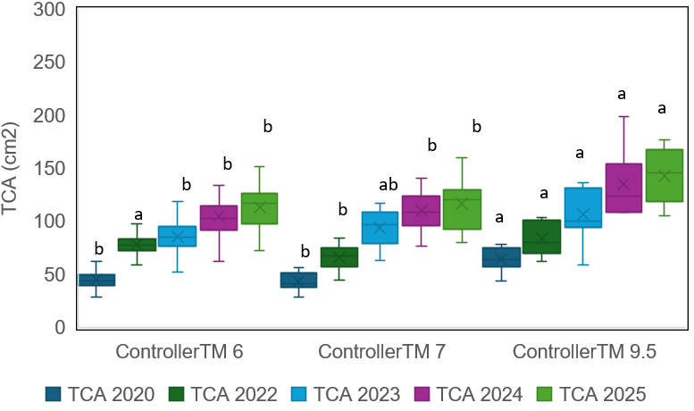

Figure 2: Box and whisker plot illustrating the distribution of the trunk cross-sectional area (TCA) measured for four seasons: 2020 (dark blue), 2022 (dark green), 2023 (light blue), 2024 (pink) and 2025 (light green) on ‘Carina’ trees grafted on ControllerTM 6, ControllerTM 7 and ControllerTM 9.5 rootstocks. Trees were planted in 2018 at 4.5 x 2 m spacing (1,111 trees/ha) in a commercial orchard near Robinvale, Victoria, Australia. Within the same season (same colour box), average TCAs with different letter are different at p<0.05.
In 2024, ‘Carina’ showed an increase in yield when on Controller 9.5 but a decrease in the other two combinations. In general, ‘Carina’ yielded consistently well on Controller 7 and Controller 9.5 over the years while on Controller 6 year to year fluctuations (biennial bearing) could be observed. The yield results in the last season, 2025, confirmed the possible biennial bearing behaviour of Controller 6 with a yield of 1.95 t/ha in 2024 followed by a 4.67 t/ha in the last season, the highest yield recorded for this trial and all cultivars. The kernel weight appeared highly influenced by yield, the higher the yield, the lower the kernel weight (R²=0.67) confirmed by the 2025 results.
Nonpareil
The TCA measures revealed an expected increase with the rootstock vigour with the smallest TCAs measured in Controller 6 and Controller 7 and the largest in Controller 9.5. Interestingly, the variation in TCA data also increased in a similar fashion with Controller 9.5 trees displaying a wider data spread and hence higher variability in tree size amongst trees in the orchard (Figure 3).
b
a
b
a
c
a
a
a
b
b
a
b
b
b
b

Figure 3: Box and whisker plot illustrating the distribution of the trunk cross-sectional area (TCA) measured for four seasons: 2020 (dark blue), 2022 (dark green), 2023 (light blue), 2024 (pink) and 2025 (light green) on ‘Nonpareil’ trees grafted on ControllerTM 6, ControllerTM 7 and ControllerTM 9.5 rootstocks. Trees were planted in 2018 at 4.5 x 2 m spacing (1,111 trees/ha) in a commercial orchard near Robinvale, Victoria, Australia. Within the same season (same colour box), average TCAs with different letter are different at p<0.05.
Second-leaf yields were not different (Controller 7 was not harvested as there was not enough crop) in Controller 6 and Controller 9.5 (Table 2). In 2021 and 2022, Controller 7 was the lowest yielding rootstock. Trees on Controller 6 and Controller 7 had substantially more crop in 2022 than 2021 while yields did not increase over this time for trees on Controller 9.5. In 2023 and 2024 no differences were observed between rootstocks despite the differences in tree size (TCA). The average yield was 2.6 t/ha in 2023 and 4.1 t/ha in 2024. A small yield reduction was measured in Controller 6 in 2025 compared to previous year. Kernels were lighter in Controller 6 and Controller 7 and heavier in Controller 9.5 (up to 1.5 g).
The number of kernels per tree, extracted from the yield and kernel weight measurements, varied between seasons but only moderately so between rootstocks within the same season (Table 2). In 2023 trees matured 1500 and ~1600 kernels in Controller 6 and Controller 7 respectively while more than 2000 kernels per tree were harvested from Controller 9.5 trees. In 2024 no differences were measured with the number of kernels per tree ranging from 2551 to 2956 (Table 2).
‘Vela’
Regrettably, a miscommunication with the grower meant we missed the 2022 and 2023 harvests for some of the ‘Vela’ trees so that the yield for Controller 6 and Controller 7 in 2022 and the yield of Controller 9.5 in 2023 are estimated by averaging the yield of the previous and following year. Also, tree dimensions were measured only in 2020 and 2025 for this cultivar. TCA was the lowest in Controller 6 in both seasons when it was measured while Controller 7 and Controller 9.5 showed very similar average values and no differences in 2025. Similarly to what was observed for ‘Carina’, for ‘Vela’ too the trees in the Controller 9.5 displayed a higher variation in TCA between trees (wider spread of data) (Figure 4).
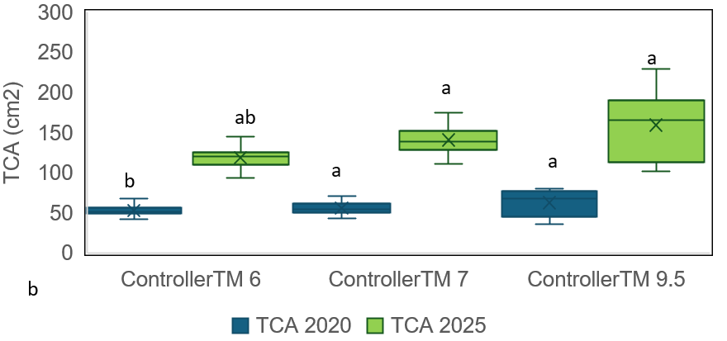

Figure 4: Box and whisker plot illustrating the distribution of the trunk cross-sectional area (TCA) measured for two seasons: 2020 (dark blue) and 2025 (light green) on ‘Vela’ trees grafted on ControllerTM 6, ControllerTM 7 and ControllerTM 9.5 rootstocks. Trees were planted in 2018 at 4.5 x 2 m spacing (1,111 trees/ha) in a commercial orchard near Robinvale, Victoria, Australia. Within the same season (same colour box), average TCAs with different letter are different at p<0.05.
The first crop for ‘Vela’ on Controller 6 was 0.86 t/ha followed by 3.33 t/ha in 2021 (Table 2). In 2021 trees produced over 3t/ha on all rootstocks, which was remarkable for third-leaf trees. Some of the results for 2022 and 2023 are estimates; 2024 confirmed the consistent good performance of the Controller 6 trees (also the smallest trees) while the other two rootstocks recorded a yield reduction compared to the previous year. The highest yield was recorded in the last season, 2025, when trees on Controller 6 yielded 4.3 t/ha. The kernel weight was not different between rootstocks in 2023 while it was lower on the Controller 9.5 in 2025. Interestingly, the Controller 6 trees continued to produce the highest number of kernels per tree with the highest number recorded ion 2025 (2627 kernels/tree) (Table 2).
Shasta
Due to insufficient numbers of many of the rootstocks, Shasta was only planted on Controller 6 rootstock.
In 2020, Shasta’s first yield was the highest in the whole trial with 1.4 t/ha followed by 2.7 t/ha in 2021 (Table 2). Yields in 2020 were large for second leaf trees however, in 2021, Shasta’s yield on Controller 6 doubled compared to previous year (from 1.55 t/ha in 2020 to 2.96 t/ha in 2021) while the other cultivars growing on Controller 6 rootstocks increased by almost four-fold. The relatively large crop produced by second-leaf trees could have restricted the cropping ability in the subsequent year. Yields did not increase from 2021 to 2022, a small decrease was measured in 2023 and in 2024 the trees only yielded 1.4 t/ha, the lowest yield recorded for the whole trial that year. Shasta’s yields for 2025 were expected to be low across the industry due to observations of low flower numbers on this variety across regions and orchards. However, in this trial the yield was the highest so far with 3.34 t/ha (Table 2). Kernel weight varied from 1.55 (in 2024) to 1.2 (in 2025), somewhat in line with yield (highest yielding years produced lighter kernels). The number of kernels per tree was as low as 813 in 2024 while in 2025 more than 2500 kernels per tree were harvested.
Cumulative yield comparisons
When comparing cumulative yields of sixth-leaf trees (up to season 2023-24 since in 2025 on Controller 6 was harvested), for ‘Carina’ the bigger trees on the Controller 9.5 outperformed the yield of the other two rootstocks however, the excessive growth of Controller 9.5 at the tight row and tree spacing, also created management issues and overcrowding. For ‘Nonpareil’ the differences between rootstocks were not great and the lowest yielding rootstock was Controller 7 while Controller 6 and Controller 9.5 achieved a very similar cumulative yield. ‘Vela’ was on average the highest yielding cultivar and, surprisingly, Controller 6 the highest yielding rootstock within this cultivar. Shasta’s results on Controller 6 were very comparable to the ‘Carina’s on the same rootstock.

Figure 5: Sixth-leaf cumulative yield (2020-2024) of ‘Carina’, ‘Nonpareil’, ‘Vela’ and Shasta® almond trees planted in a commercial orchard in Robinvale. The average cumulative yield for the whole trial is reported in the black histogram. Trees were planted in winter 2018. Error bars represent the standard errors of the means.

Table 2: Kernel yield per hectare (t/ha), kernel weight (g) and number of kernels per tree of ‘Carina’, ‘Nonpareil’, 'Vela’ and Shasta® almond trees budded onto Controller™ 6, Controller™ 7 and Controller™ 9.5 rootstocks at Carina Farm in 2020, 2021, 2022, 2023, 2024 and 2025. Trees were budded in March 2017 and planted in August 2018 at 2 m x 4.5 m spacing (1,111 trees per ha).
Season |  | ‘Carina’ |  |  | ‘Nonpareil’ |  |  | ‘Vela’ |  |  | Shasta®
 |  | Controller™6 | Controller™7 | Controller™ 9.5 | Controller™6 | Controller™ 7 | Controller™ 9.5 | Controller™6 | Controller™7 | Controller™ 9.5 | Controller™ 6
Kernel yield (t/ha) | 2020 | 0.61 b | 0.75 b | 0.96 a | 0.63 a | - | 0.62 a | 0.86 a | 0.73 a | 1.05 a | 1.55
 | 2021 | 2.71 b | 1.52 c | 3.49 a | 2.41 b | 2.01 b | 3.30 a | 3.33 a | 3.60 a | 3.81 a | 2.96
 | 2022 | 1.84 b | 2.48 ab | 2.81 a | 3.12 a | 2.42 b | 3.23 a | 3.59 a | 3.48 ab | 3.00 b | 2.84
 | 2023 | 3.32 a | 2.89 a | 3.06 a | 2.74 a | 2.4 a | 2.66 a | 3.85 a | 3.37 b | 3.05 b | 2.39
 | 2024 | 1.95 b | 2.3 b | 4.00 a | 3.95 a | 4.32 a | 3.95 a | 4.00 a | 2.81 b | 2.57 b | 1.40
 | 2025 | 4.67 | - | - | 3.33 | - | - | 4.30 | - | - | 3.34
Kernel weight (g) | 2023 | 1.03 c | 1.19 a | 1.18 b | 1.36 c | 1.44 b | 1.50 a | 1.66 b | 1.75 a | 1.76 a | 1.46
 | 2024 | 1.41 a | 1.19 b | 1.18 b | 1.36 b | 1.32 c | 1.39 a | 1.68 a | 1.72 a | 1.47 b | 1.55
 | 2025 | 0.85 | - | - | 1.31 | - | - | 1.50 | - | - | 1.2
Kernels/tree | 2023 | 2927 a | 2197 b | 2551 ab | 1807 a | 1500 b | 1597 ab | 2097 a | 1729 b | 1559 b | 1471
 | 2024 | 1258 b | 1749 b | 3055 a | 2610 a | 2956 a | 2551 a | 2203 a | 1471 b | 1573 ab | 813
 | 2025 | 5252 | - | - | 2308 | - | - | 2627 | - | - | 2522
For each cultivar and year, values followed by different letters are different at p<0.05. In 2025 measurements were carried out on Controller™ 6 trees only.

When comparing the yields of all varieties on the same rootstock, some interesting observations can be made:
- ‘Vela’ shows a consistent upward trend on Controller 6 while the other two rootstocks peaked in 2021 and never yielded more. This could be an effect of the poor light conditions within the canopies on the big trees obtained with Controller 7 and Controller 9.5 while Controller 6 seems to still be maintaining a balanced and porous canopy which allows good light penetration.
- ‘Carina’ shows a clear alternate bearing on Controller 6, confirmed by the incredibly high yield of 2025. No clear pattern emerged from the other two rootstocks.
- ‘Nonpareil’ on Controller 6 performed well for the first three years and then the yield was depressed in 2023, recovered slightly in 2024 and decreased again in the last year of data collection in a pattern that might start to show a slight biennial bearing. The variations observed in the other two rootstocks are not as large though in 2024 both Controller 7 and Controller 9.5 yielded high.
- Shasta was only planted on Controller 6 and the yield was the lowest of the whole trial despite the first crop being the highest in the whole trial. From 2021 the yield slightly decreased year after year however in 2025 the highest yield was recorded.
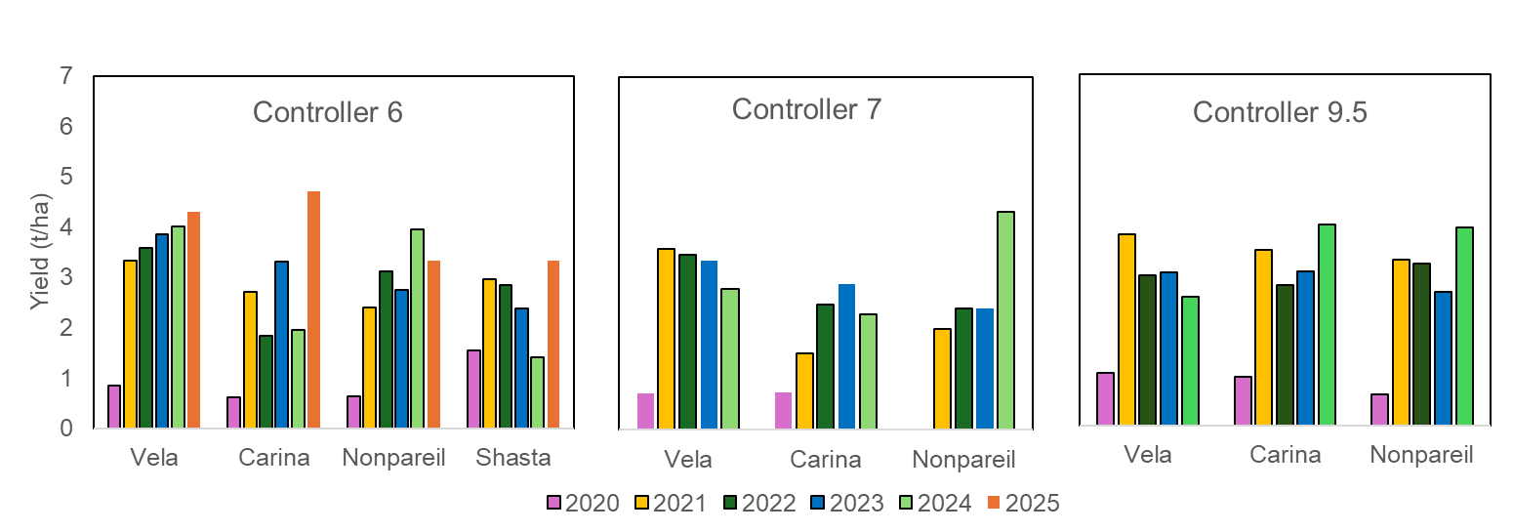

Figure 6: Yearly average yields (2020-2025) of ‘Carina’, ‘Nonpareil’, ‘Vela’ and Shasta® almond trees grafted with ControllerTM 6, ControllerTM 7 and ControllerTM 9.5 rootstocks and planted in a commercial orchard in Robinvale. Trees were planted in winter 2018.

Tree architecture considerations and machinery access
Tree architecture was not measured during the experiment however observations were made on the visual appearance of the trees (Figures 7, 8, 9 and 10). In general, all trees in the experiment grew more slowly than trees planted at the same time and spacing in other orchards but with different rootstocks (not dwarfing). The trees in this trial retained the central axis structure intended at planting with a degree dependant on the variety, with Shasta mostly keeping it followed by ‘Vela’, ‘Carina’ and ‘Nonpareil’. Pruning only involved some mechanical hedging on one side of the canopy in winter each year but 2024. Trees on the dwarfing rootstock Controller 6 seemed to have achieved a “balance” between canopy (growth) and yield; it was observed that canopies grew during the spring flash at the beginning of the season but then seemed to stop when the trees started allocating resources to the fruit and kernels. This allowed for a “compact” foliage distribution on the trees that created a very porous canopy. We speculate that these trees/canopies enabled light to better penetrate through the whole canopy, even the lower zones. Our observations have been confirmed by the orchard managers who, in recent interactions and during a grower field day (December 2024), confirmed that the trees showed a very slow canopy growth. These trees maintained a good light interception that allowed light to penetrate to the renewal zones for bud differentiation and high flower numbers. The manager also noted that the canopy, being porous, allowed for good airflow and hence easier disease control, even maturity, and, since the trees were small, they shook very easily with one short shake and one pass.
The results obtained so far also confirm that trees on the most vigorous Controller 9.5 rootstock grew faster and produced denser canopies which created shading to the middle and lower canopy zones and formed that common area of “dead canopy” in the middle of the tree that is often seen in traditional plantings. The yield outcomes are evidence of this phenomenon, showing a decline in yield in all varieties from the third- or fourth-leaf harvest.
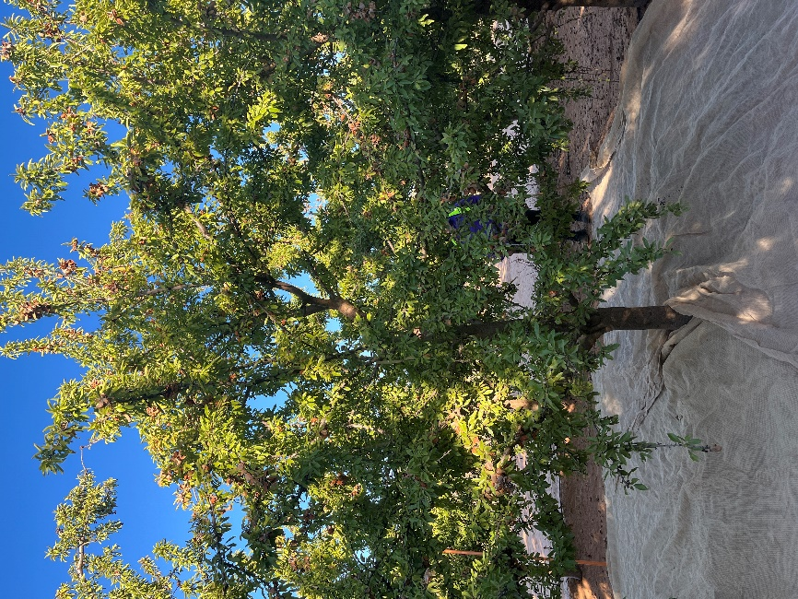 | Figure 7: Shasta® grafted on ControllerTM6. The photo was taken at harvest 2025 (February 2025). Trees were planted in 2018 as central axis trees. Note that the tree has maintained the central axis, branches are evenly distributed throughout the available footprint, no excessive vigorous growth can be seen on the branches and a good porosity has been maintained. It can be seen that, although most of the fruit is located on the well-lit canopy tops, numerous almonds are also located in the lower branches.
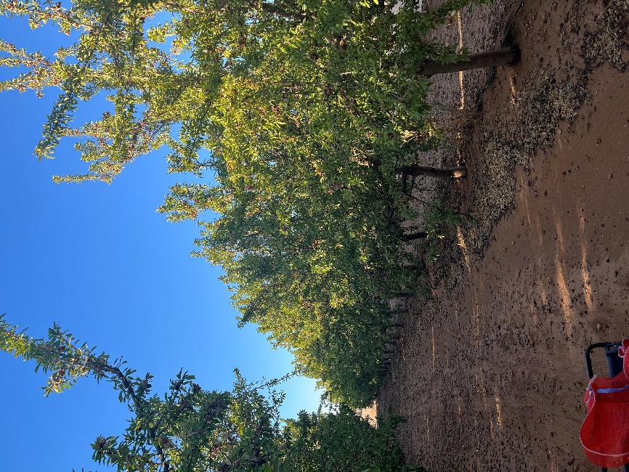 | Figure 8: Shasta® grafted on ControllerTM6. The photo was taken at harvest 2025 (February 2025). To note the small size of these seventh-leaf trees. The 4.5m row is still fully accessible with narrow machinery.

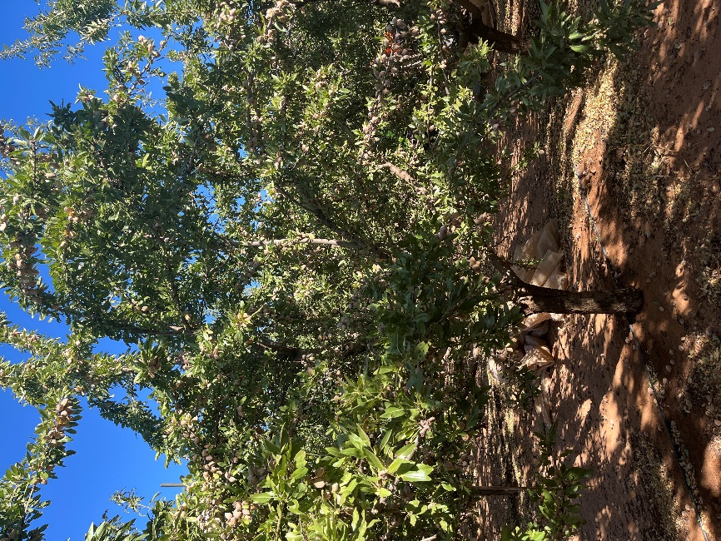 | Figure 9: ‘Carina’ grafted on ControllerTM 6. The photo was taken at harvest 2025 (February 2025). Trees were planted in 2018 as central axis trees. Unlike the Shasta®, ‘Carina’ shows a more procumbent canopy. The central axis is visible, and there is a vast amount of fruit located throughout the whole canopy.
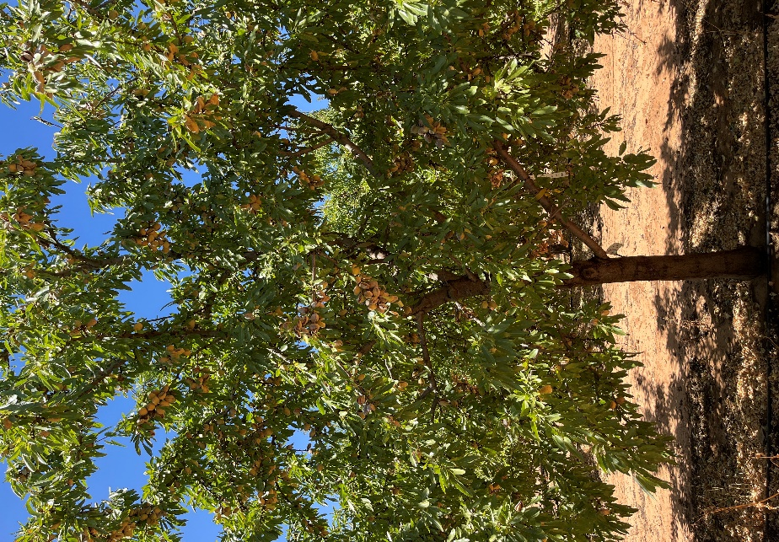 | Figure 10: ‘Vela’ grafted on ControllerTM6. The photo was taken at harvest 2025 (February 2025). Trees were planted in 2018 as central axis trees, the central axis is still present. In this photo note the presence of healthy leaves and fruit all though the canopy, a good canopy porosity, and the complete absence of “dead” areas that are so common in ‘Vela’’s canopies when planted on vigorous rootstocks at wide spacings.
Machinery issues
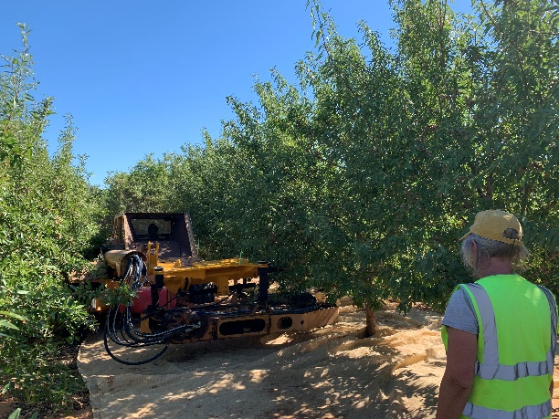
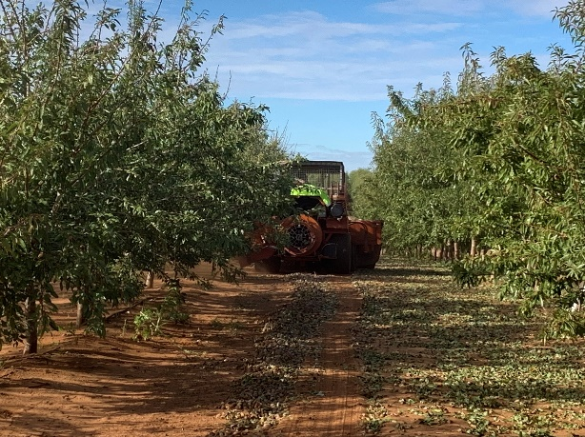
Access to orchard machinery suitable for working in blocks with 4.5 m wide rows is still a challenge at this orchard and across the industry. A modified Shockwave tree shaker with a boom arm and right-angle shaker head as well as a modified sweeper were partial solutions when trees were not harvested by hand (Figure 11), but there is room for considerable improvement if growers are to be convinced of the benefits of high-density growing systems.

Figure 11: New orchard machinery is needed for 4.5 m rows. A modified tree shaker (left) with a boom arm and the shaking head at right angles and a modified sweeper (right) were a useful start.

Key findings
- The trial has provided information on the performance of rootstocks and cultivars that could better suit high and ultra-high production systems for Australian conditions.
- The central axis tree architecture used in this trial, combined with dwarfing rootstocks, resulted in maintenance of a narrower growth habit in the row. Trimming was only minimal and carried out on alternate sides of the trees each season for machinery access.
- Different genotypes performed differently under similar conditions, providing insights into their suitability for high-density systems.
- Machinery availability is currently a barrier for managing this type of orchard.
- The yield of the Australian cultivar ‘Vela’ in this trial outperformed the others especially when grafted on the dwarfing rootstock Controller 6.
- From a grower point of view, implications are:
- Cultivar and rootstock selection: cultivar/rootstock combinations with lower vigour, less vertical growth and more horizontal branching, and more spur-bearing habit (e.g. ‘Vela’/Controller 6) were more suitable for closer planting as they were easier to manage in narrow canopies.
- Genotype combinations with greater vigour, stronger vertical growth (e.g. ‘Vela’/Controller 9.5) especially when combined with flowering on lateral buds (e.g. ‘Nonpareil’/Controller 9.5), generally produced higher yields in earlier seasons but these declined and became irregular (alternate bearing) in later seasons.
- Spreading cultivars might require extra management such as hedging, to optimise their performance.
- Vigour-controlling rootstocks are crucial to minimise the need for canopy management and pruning.
- Pruning and training: high-density orchards demand pruning and training systems that are “novel” to the Australian industry but are in use in other industries, and that aim to produce narrow tree forms that allow for machinery access and efficient light interception and distribution.
- Machinery and harvesting: high-density planting may require specialised machinery, such as narrow tractors and hedgers (available from other industries or from overseas), to operate efficiently within the reduced row spacing. High-density plantings suit alternative harvesting methods like "shake and catch".

Appendix 6. Results of the “Model high-density trial” – Almond Centre of Excellence orchard (ACE), Loxton SA
AIM: to assess the performance of new cultivars under increased planting density using central axis trees
Methods
The trial was designed to test high-density growing systems compared with more traditional plantings. The approach incorporated i) increased planting density by reducing the row and tree spacing, ii) new cultivars with architectural attributes that are more suited to closer planting and iii) new pruning/training systems.
The combination of the three resulted in a 1.6 ha block, planted in July 2018 at the Almond Board of Australia’s (ABA) Almond Centre of Excellence (ACE) in Loxton, with the new self-fertile cultivars Shasta® and ‘Vela’ on ‘Nemaguard’ rootstock. These two varieties were chosen based on their different growth habits; Shasta has an upright, narrow growth habit and ‘Vela’ a spreading and weeping growth.
Trees were planted at four planting densities (achieved by planting at different row and tree spacings):
- 513 trees/ha achieved by planting at 6.5 x 3 m
- 769 trees/ha achieved by planting at 6.5 x 2 m
- 741 trees/ha achieved by planting at 4.5 x 3 m
- 1,111 trees/ha achieved by planting at 4.5 x 2 m
The trial was planted in 16 rows, eight rows of Shasta and eight of ‘Vela’, in four blocks of four rows each, where the border rows of each block were used as guard rows and the two middle rows were used for measurements. The distances between trees changed down the row every nine trees. Nine blocks of five trees in each row were used as data trees.
Trees were grown as tall, narrow central axis shaped trees with minimal pruning to maintain a 2.0 m wide gap between the rows for machinery access.
All trees were spring-budded in December 2017. To facilitate development of tall narrow canopies they were selected in the nursery in winter 2018 to have a single dominant trunk (central axis) with multiple side branches and planted with no pruning of these branches. The trunk was then cut back to the first strong bud above the topmost lateral shoot to encourage extension growth of the central axis. The alternative “industry standard” (not included in this work) involves heading back the trunk to 90 cm and cutting back all side branches before planting to force the growth of numerous, very vigorous scaffold branches, and produce large, wide canopies unsuited to high-density plantings.
Measurements included yearly assessments of tree size/dimensions (tree height, trunk circumference and tree width) in late November when the weight of the fruit on the trees was at its greatest and hence the maximum spread/canopy width could be captured. Trunk cross-sectional area (TCA) was calculated from the trunk diameter measured at 20cm above the graft union.
Harvest timing followed advice from the orchard management team at ACE. Trees were harvested in blocks of five with traditional harvesting techniques using ABA’s machinery adapted to narrow row operations: skid-steer mounted shaking head and the Monchiero pick-up machine. The fruit collected from the five-tree blocks were weighed using load cells integrated into a bin platform at the rear of the pickup machine. A subsample of fruit for each group of five trees was collected for future analysis. The subsample was weighed in the orchard (fresh weight) and then weighed again at the time of hulling (dry weight). Hulling was carried out using a mechanical huller. Every sample was hulled, the kernels collected, and their weight and moisture percentage measured. The moisture content of the subsample was determined using a Burrows DMC-750 moisture meter and this information used to adjust the total kernel yield data to kg of kernel at 5.0% moisture content. The data were then used to calculate the total kernel weight per tree and per hectare. For the last three seasons, each kernel subsample was also subjected to quality assessments; a subsample of 100 kernels was randomly collected, weighed and each kernel inspected for defects (including poor filling).
The irrigation dilemma
Should trees planted at different densities within the same orchard be irrigated on a per hectare or per tree basis?
The initial irrigation design was based on a per hectare strategy, as is normal practice in trials of this type. Thus, while the two row spacings were initially irrigated to a similar level per hectare (9.6-9.7 ML/ha in 2020-21, Table 1), irrigation at a per tree level differed considerably (8.7 – 18.7 kL/tree). This irrigation design was achieved by keeping emitter spacing at a constant 600 mm, but using emitters with a flow rate of 1.6 L/h on the 4.5 m rows compared with 2.3 L/h on the 6.5 m rows. Early yield results from the trial seemed influenced by this irrigation design showing that trees that received more water had greater yields. To test this, the irrigation settings were adjusted for the 2021-22 and 2022-23 seasons to increase the water applied in the narrow rows (Table 1). Unfortunately, due to having to retrofit a system to an existing one, it was not possible to achieve the exact same irrigation, as L/tree, for all treatments. The full description and results of this modification have been published in Thorp et al., 2023.

Table 1: Irrigation rates per hectare (ML/ha) and per tree (kL/tree) of 'Vela' and Shasta® almond trees at the Almond Centre of Excellence, Loxton, from 2020 to 2025.
Season | Irrigation (ML/ha)
Season | 4.5 x 2  1111 trees/ha | 4.5 x 3  741 tree/ha | 6.5 x 2  769 trees/ha | 6.5 x 2  531 trees/ha
2020-21 | 9.7 | 9.7 | 9.6 | 9.6
2021-22 | 17.1 | 17.1 | 11.3 | 11.3
2022-23 | 16.5 | 16.5 | 10.9 | 10.9
2023-24 | 14 | 14 | 14 | 14
2024-25 | 13 | 13 | 13 | 13
 | Irrigation (kL/tree)
2020-21 | 8.7 | 13.1 | 12.5 | 18.7
2021-22 | 15.4 | 23.1 | 14.7 | 22.0
2022-23 | 14.9 | 22.3 | 14.2 | 21.2
2023-24 | 12.6 | 18.9 | 18.2 | 27.3
2024-25 | 11.7 | 17.5 | 16.9 | 25.3

Results
Yield and yield components
Shasta
Trees produced a crop in 2020, and the results were similar for the four densities (Table 2).
The first substantial crops were harvested in 2021 with an average of 1.98 t/ha of kernel with no differences in yield per hectare among the four treatments (Table 2). However, there was a strong trend for lower tree densities to have higher yields per tree, especially within the 4.5 m row spacing. This suggests that at higher tree densities there may have been some resource limitation or competition among trees at higher densities. Irrigation and/or nutrition may explain this result as trees at lower densities (531 trees/ha, 6.5 x 3 m) received more than twice the amount of fertigation per tree as those at higher densities (1111 trees/ha, 4.5 x 2 m) (Table 1).
In 2022 the new irrigation design was implemented and the total water discharged per ha and per tree is reported in Table 1. Average kernel yields per hectare were ~50% greater in the 4.5 m rows than in the 6.5 m rows, although this was primarily the result of a decrease in yields in the 6.5 m rows from the previous season. Although industry reported lower yields in this season, possibly a consequence of cooler weather, especially at flowering, it is possible that these lower yields may also be related to heavier yields/tree in the 6.5 m rows in the previous season. The new irrigation design supplied approximately 33% more water (kL/tree) to trees spaced 3 m apart than to trees spaced 2 m apart. This was reflected in the yield per tree, which was higher in the 3 m spacing, especially in the 4.5 m rows. Although changes in the irrigation system did mitigate some differences in irrigation/nutrition, there was still a strong positive relationship between yield per tree and irrigation/nutrition per tree, especially at higher planting densities, supporting the hypothesis that water or nutrition may be a limitation to full production in high density systems. In fact, this strong relationship continued through to the 2024 harvest.
In 2023, yields per tree were higher than in 2022 and the highest yield was recorded in the 4.5 x 3 m density. At orchard level and with the adjusted irrigation, a benefit of higher density was clear, with yields in the 4.5 m rows of almost 4 t/ha while the 6.5 m rows only yielded about 1.5 t/ha irrespective of the tree spacing.
The applied adjustment to the irrigation, since it was implemented on third leaf trees, could only be carried out by adding an extra irrigation line in the narrow rows. With this extra line in the 2022-23 season the trees received between 14.2 and 22.3 kL of irrigation per tree in a very similar trend to the previous year (Table 1). It could be speculated that the very high number of kernels per tree observed in the 4.5 x 3 m spacing could be related to a better water and/or nutrition status of the trees during floral bud formation in the previous year. However, a tree density effect could also be observed since trees in the 4.5 x 2 and 6.5 x 2 received very similar water per tree but the number of kernels and yield of the lower density were much lower.
A “negative” effect of the new adjusted (increased) water application in the narrow rows was an excessive tree growth observed during the season with trees in the 4.5 m rows growing into the row to completely close the gap (Figure 4 and 5). To overcome the issue, in winter 2023 an intensive pruning was carried out, inspired by a Spanish pruning system called “Poda Aragonesa” (see pruning paragraph). The effect of this pruning on yield was evident in the 2024 results, both much lower than those in 2023. These yield differences were primarily determined by differences occurring prior to the 2024 harvest, because, as expected, the new trimming method reduced the yield in the 4.5 m rows in 2024 by almost half compared with 2023. The pruning that was carried out in the 2023 winter contributed to these results. It is well known that in mature almond trees, if tree architecture is not managed to ensure good light penetration, most fruiting buds are carried on the most external part of the canopy. Hence trimming is likely to remove a significant portion of such buds and their potential yield. Moreover, in 2023, trees in the 4.5 m rows were very crowded and filled the mid-row, thus creating a very shady canopy environment that did not favour the differentiation of floral buds.
These assumptions were somewhat confirmed when the 6.5 m row results were compared. In this case, despite the pruning, yield almost doubled in the wider spacing. These trees were not light limited even before the pruning and were probably already carrying a higher yield potential than trees in the 4.5 m rows. However, since the irrigation in 2024 reverted to the same amount per ha, trees in the 4.5 m rows did receive, per tree, less fertigation and this might also have contributed to the lower yield. These speculations are supported by the numbers of kernels per tree, which were almost halved in the narrow spacing from 2023 to 2024 but increased in the 6.5 x 2 m layout and more than doubled in the 6.5 x 3 m layout.
Yields generally increased in 2025 except for the 6.5 x 2 m treatment. Yields per tree were much higher in the narrower rows, possibly due to the pruning that might have achieved the desired effect of increasing light penetration into the middle of the canopy and hence “regenerating” it into a fruitful zone.
From the 2023 harvest some kernel quality assessments were carried out. Kernel weight did not differ among treatments (or seasons) despite the differences in fertigation and yield.
An issue that has been reported and discussed often within the industry is the poor filling (‘pinching’) of the kernels, particularly in Shasta. Examining samples of 100 kernels showed differences among seasons, with the 2024 season, on average, being the year when the most pinching occurred. However, tree spacing effects were not consistent; kernels from narrow rows presented less pinching than the wide rows in 2023 but more in 2024, while in 2025 the tree spacing had no effect on. Similarly, the results showed no relationship between poor fill and other collected metrics such as the number of kernels per tree or water and nutrition.
Tree dimensions measured in November each year showed clear differences for both trunk diameter and canopy width between treatments, tree height (not reported) was not different among treatments in any season (p>0.05). Trunk diameter decreased with increasing density suggesting some degree of competition among trees at higher density, while the canopy width, given the level of subjectivity of the measure, showed a trend of wider canopies in the wider rows, as expected.

Table 2: Kernel yield per hectare and per tree from 2020 to 2025 and kernel quality metrics (weight and poor filling) for 2023 to 2025 of Shasta® almond trees in the high-density trial at the Almond Centre of Excellence (ACE) in Loxton. Trees were spring-budded on ‘Nemaguard’ rootstock and planted in 2018 at four planting densities. Values are treatment averages (n = 9).
 |  | Tree spacing
 | Season | 4.5 x 2  1111 trees/ha | 4.5 x 3  741 tree/ha | 6.5 x 2  769 trees/ha | 6.5 x 3  531 trees/ha | p-values
Kernel yield (t/ha) | 2020 | 0.14 | 0.11 | 0.11 | 0.08 | n.s.
 | 2021 | 1.96 | 1.83 | 2.05 | 2.08 | n.s.
 | 2022 | 2.09 a | 2.10 a | 1.44 b | 1.44 b | <0.0001
 | 2023 | 3.80 a | 3.69 a | 1.49 b | 1.58 b | <0.0001
 | 2024 | 1.83 b | 1.74 b | 2.15 ab | 2.43 a | 0.05
 | 2025 | 3.31a | 3.53 a | 2.01 b | 2.65ab | 0.05
Kernel yield (kg/tree) | 2020 | 0.12 | 0.15 | 0.17 | 0.13 | n.s.
Kernel yield (kg/tree) | 2021 | 1.77 c | 2.47 b | 3.26 a | 3.30 a | 0.001
 | 2022 | 1.88 b | 2.84 a | 2.24 b | 2.35 ab | 0.016
 | 2023 | 3.33 b | 4.98 a | 2.44 c | 2.44 c | <0.0001
 | 2024 | 1.64 c | 2.35 bc | 2.79 b | 4.75 a | <0.0001
 | 2025 | 2.98b | 4.77 a | 2.62 b | 5.18a | 0.01
Kernel weight (g) | 2023 | 1.47 | 1.49 | 1.48 | 1.51 | n.s.
 | 2024 | 1.47 | 1.46 | 1.37 | 1.40 | n.s.
 | 2025 | 1.50 | 1.38 | 1.51 | 1.39 | n.s.
Poorly filled kernels (%) | 2023 | 32.67 b | 30.33 b | 40.67 a | 39.22 a | <0.0001
Poorly filled kernels (%) | 2024 | 48.78 a | 42.22 ab | 37.89 b | 36.78 b | 0.018
 | 2025 | 16.56 | 20.67 | 17.00 | 20.56 | n.s.
Kernels/tree (number) | 2023 | 2275 b | 3358 a | 1655 c | 1617 c | <0.0001
Kernels/tree (number) | 2024 | 1122 c | 1625 bc | 2100 b | 3497 a | <0.0001
 | 2025 | 3577 a | 3541 a | 1784 c | 2172 bc | 0.023
n.s. = not significant; Values within cultivar in each column with the same letters are not significantly different (p<0.05).

Figure 1: Trunk diameter (left) and canopy width (right) measured from 2021 to 2025 of Shasta® almond trees in the high-density trial at the Almond Centre of Excellence (ACE) in Loxton. Trees were spring-budded on ‘Nemaguard’ rootstock and planted in 2018 at four planting densities. Values are treatment averages
(n = 9).
** significant at p < 0.01 and ***significant at p < 0.001.
‘Vela’
Unlike Shasta which produced ~0.1 t/ha in 2020, ‘Vela’ did not produce a crop in 2020, however very high yields of about 2.4 t/ha in all treatments were harvested in 2021 (Table 3). As in Shasta, there was a strong trend for lower tree densities to have greater yields per tree, especially within the 4.5 m row spacing.
As discussed previously, these results possibly reflect the fact that trees in the 6.5 m wide rows received more water and fertiliser per tree than trees in the 4.5 m rows due to the irrigation discharging the same amount of water per hectare and not per tree. These trees in the 6.5 m rows also grew larger and produced more crop than trees in the 4.5 m rows which negated the benefit of having more trees per ha. To confirm this, tree size data (canopy width and trunk diameter) follow the same trend as the yield most likely also due to the different rates of water/fertiliser applications (Figure 2).
Irrigation settings were adjusted for the 2021/22 season, as previously discussed.
Slightly higher orchard yields were measured in 2022 compared with 2021 in all treatments but the lowest density where only 1.5 t/ha were collected. On a tree scale, yield was lowest in the highest density, although the level of statistical significance for this varied. The per hectare was not different amongst treatments in 2023 and tended to be greater in the 6.5 m rows in 2024 and 2025, though not always significant for the lowest density.
The 2024 yields were expected to be affected by the hedging/trimming method that was implemented for the whole trial in winter 2023 based on the “Poda Aragonesa” concept. The 2024 harvest had a lower yield/ha and yield/tree across all treatments. However, the trees in the 6.5 m rows consistently outperformed those in the 4.5 m rows. No differences in yield/ha were observed between tree spacings within the same row spacing; however, yield per tree was greater in the 4.5 x 3 m layout than in the 4.5 x 2 m, presumably because the trees had a slightly bigger footprint. It is likely that for ‘Vela’, because of its more weeping growth, the pruning removed a higher portion of productive canopy than in Shasta, especially in the lower limbs. Also, ‘Vela’ in this trial (on ‘Nemaguard’) tended to form a dense round canopy that became quite impenetrable to light, thus reducing the productivity in the middle of the tree.
2025 was the highest yield ever recorded for the trial, with the narrow (4.5 m) rows both achieving yields in excess of 5 t/ha.
The kernel weights varied from year to year but they did not differ amongst treatments within a year except in 2025 when the higher yielding narrow rows produced lighter kernels. In 2025 in ‘Vela’, with the very high yields recorded, up to 15% of the kernels were pinched and in general the pinching observed in this season was the highest ever recorded in this variety.
Unlike Shasta, in ‘Vela’, treatments only showed differences in tree diameter in the first two years and thereafter no differences in trunk diameter amongst treatments were observed. The canopy width responded to the pruning applied much more than in Shasta with ‘Vela’ showing a dramatic drop in canopy width from 2024 and with the canopies in the 6.5 m row being wider than those in the 4.5 m rows, as expected.

Table 3: Kernel yield per hectare and per tree from 2021 to 2025 and kernel quality metrics (weight and poor filling) for 2023 to 2025 of ‘Vela’ almond trees in the high-density trial at the Almond Centre of Excellence (ACE) in Loxton. Trees were spring-budded on ‘Nemaguard’ rootstock and planted in 2018 at four planting densities. Values are treatment averages (n = 9).
 | Tree spacing and density
 |  | 4.5 x 2  1111 trees/ha | 4.5 x 3  741 tree/ha | 6.5 x 2  769 trees/ha | 6.5 x 3  531 trees/ha | p-values
Kernel yield (t/ha) | 2021 | 2.46 | 2.45 | 2.39 | 2.45 | n.s.
 | 2022 | 2.58 a | 2.54 a | 2.67 a | 1.50 b | 0.001
 | 2023 | 4.04 | 3.92 | 3.62 | 3.65 | n.s.
 | 2024 | 1.73 b | 1.54 b | 2.98 a | 2.28 ab | 0.004
 | 2025 | 5.33 a | 5.49 a | 4.43 b | 3.99 b | 0.001
Kernel yield (kg/tree)
 | 2021 | 2.21 b | 3.31 a | 3.90 a | 3.95 a | 0.001
 | 2022 | 2.33 b | 3.43 a | 4.18 a | 2.41 b | <0.0001
 | 2023 | 3.64 b | 5.29 a | 5.93 a | 5.86 a | 0.001
 | 2024 | 1.55 b | 2.08 b | 4.62 a | 3.97 a | <0.0001
 | 2025 | 4.80 b | 7.42 a | 7.43 a | 6.46 ab | 0.009
Kernel weight (g) | 2023 | 1.67 | 1.67 | 1.68 | 1.65 | n.s.
 | 2024 | 1.81 | 1.82 | 1.74 | 1.81 | n.s.
 | 2025 | 1.39 b | 1.40 b | 1.48 a | 1.48 a | 0.001
Poorly filled kernels (%) | 2023 | 7.0 | 7.3 | 5.5 | 8.6 | n.s.
 | 2024 | 4.8 | 6.2 | 5.7 | 4.6 | n.s.
 | 2025 | 14.8 | 12.8 | 12.7 | 10.5 | n.s.
Kernels/tree (number) | 2023 | 1244 c | 1326 b | 1572 a | 1575 a | <0.0001
 | 2024 | 867 b | 1156 b | 2665 a | 2253 a | <0.0001
 | 2025 | 3460 b | 5308 a | 5051 a | 4363 ab | 0.016
n.s. = not significant; Values within cultivar in each column with the same letters are not significantly different (p<0.05).

Figure 2: Trunk diameter (left) and canopy width (right) measured from 2021 to 2025 of Shasta® almond trees in the high-density trial at the Almond Centre of Excellence (ACE) in Loxton. Trees were spring-budded on ‘Nemaguard’ rootstock and planted in 2018 at four planting densities. Values are treatment averages (n = 9). n.s. = not significant, ***significant at p < 0.001

Cumulative yield
Cumulative yield of Shasta showed an advantage of the narrow row spacing up until the 2024 harvest, however, the yield results of 2025 (after the corrective pruning in autumn 2024) confused this trend. The row spacing seemed to play less a role for ‘Vela’, but the widest row and tree spacing always produced amongst the lowest cumulative yield. These differences between genotypes may be the consequence of the differing tree forms of the two genotypes. The spreading habit of ‘Vela’ allows it to encroach into the rows more than the upright habit of Shasta. The consequence of which is that the canopy volume (i.e. productive area) per hectare in ‘Vela’ was less affected by row spacings than in Shasta. These results illustrate the importance of understanding the interaction of genotype and management in new planting systems.
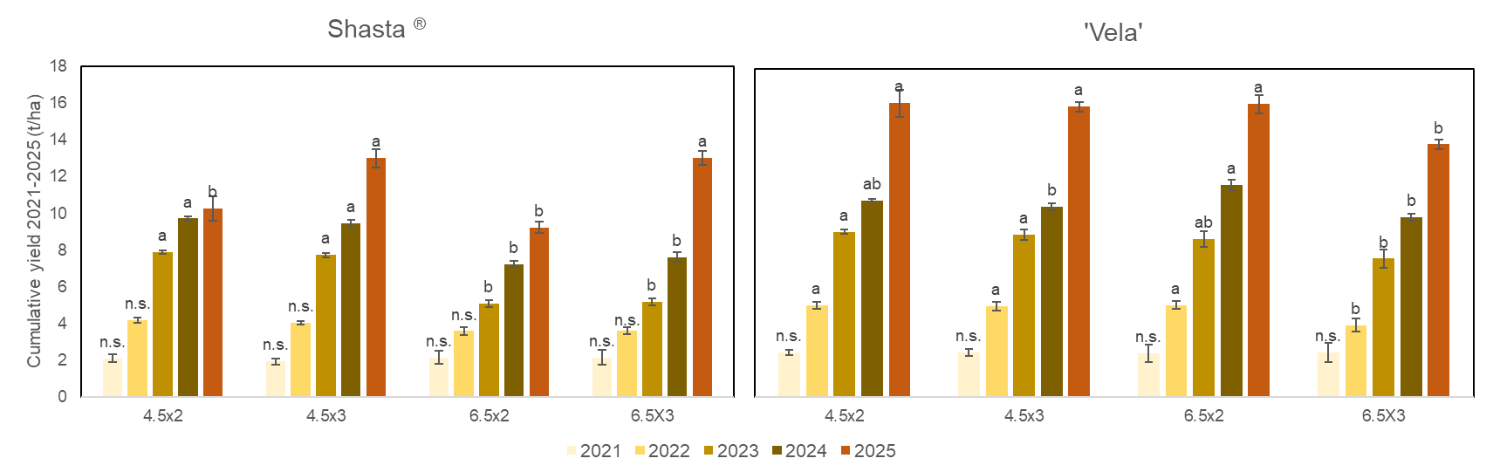

Figure 3: Cumulative yield (2021-2025) of Shasta® (left) and ‘Vela’ (right) almond trees in the high-density trial at the Almond Centre of Excellence (ACE) in Loxton. Trees were spring-budded on ‘Nemaguard’ rootstock and planted in 2018 at four planting densities. Values are treatment averages (n = 9). Within the same year (same colour histogram) bars with different letters are different at p<0.05. n.s.= not significant.
Pruning
The images in Figure 4 were taken in February 2023 and show the Shasta and ‘Vela’ trees at their maximum of canopy width for the season in both the 6.5 m rows (left) and 4.5 m rows (right). These clearly show that canopies in the 4.5 m rows grew into the inter-row space to make it over-crowded and machinery and operator access became an issue.
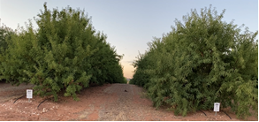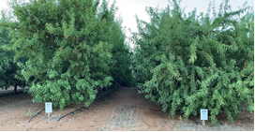

Figure 4: High-density almond planting trial at the Almond Centre of Excellence (ACE) orchard in Loxton, Australia, with 6.5 (left) and 4.5 (right) m wide rows. Both figures show Shasta® on the left and ‘Vela’ on right, on ‘Nemaguard’ rootstock. Images were taken during summer in February 2023. Trees were planted in winter 2018.
Based on learnings from a trip to Spain in May 2023, a pruning inspired by the “Poda Aragonesa” method (Text Box 1) was trialled. Figure 5 shows the planned cuts that were carried out in July 2023.
Text Box 1: The "Poda Aragonesa" (Aragonese Pruning) is a pruning technique used in almond orchards in the Aragón Region of Spain. This method aims to optimise almond production while ensuring the longevity and health of the trees using the principles listed below:
- shaping the tree in its early years to develop a strong trunk and branch framework with no strong branches left to grow into the row to ensure ease of harvest.
- opening up canopy, allowing better light penetration and air circulation, reducing the incidence of diseases.
- for older almond trees, remove unproductive branches, encouraging new growth to sustain yield.
- limiting excessive vegetative growth to direct resource allocation toward yield
This pruning technique was developed by the nursery “El Vivero de Abel”, located in the town of Caspe in the Aragon Region of Spain. Information provided on the nursery’s website (https://www.elviverodeabel.com/metodo-4-0-poda-aragonesa/) tells the story of the method being applied as a response to the prevailing wind problem in the area where the nursery is located. Pruning was implemented to slow down the growth of the tree and therefore attempt to reduce wind resistance until the tree was strong enough to withstand it. According to the developer, Mr Antonio Poblador, the cuts “induce the production of new shoots in each cutting point, which cause the branches to multiply, thus creating a tree with much more vegetation than those cultivated until that moment. All those branches were growing and multiplying with each cut. So, over time the tree had a lot of vegetation, with many fine branches and a lot of almonds, which is what is important to ensure the crop is profitable”. According to the developers, after four to five years of applying their method, pruning becomes minimal or even non-existent. Nowadays more than 100 orchards located in the south of Spain and in the south of Portugal are using this method. The method is simply described by the two drawings in the figure below. The diagram on the left shows what can be identified as a traditionally pruned orchard which, once the trees grow past their 4th-5th leaf, tend to become crowded, limit the access space between rows and light exposure is limited to the upper canopy. With the Poda Aragonesa trees are pruned by carrying out a 10-12 degrees side cut topped off with a cut at a 30-40 degrees angle to almost look like a roof. This ensures that light can reach the whole canopy perimeter.
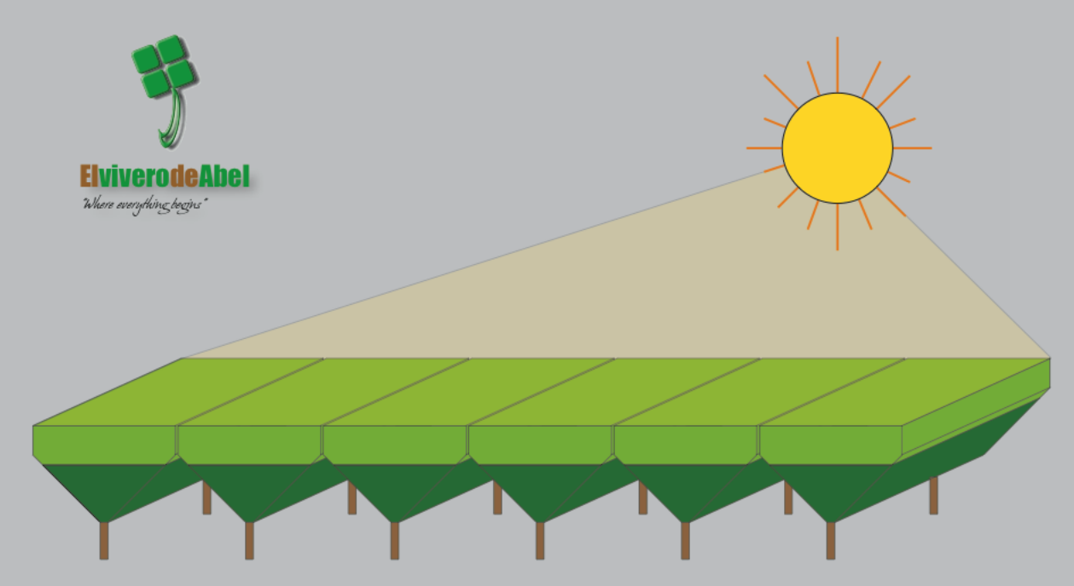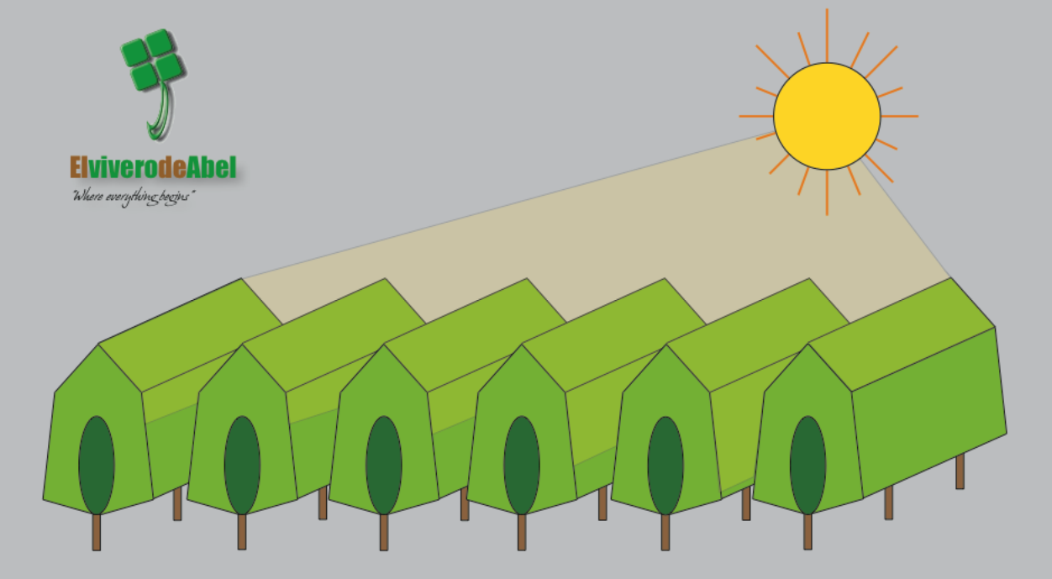
Infographic of the concept for the “Poda Aragonesa 4.0” pruning method. Figure on the left shows a traditionally pruned high-density orchard in Spain, Figure on the right shows a high-density orchard pruned using the “Poda Aragonesa 4.0”. Source : https://www.elviverodeabel.com/metodo-4-0-poda-aragonesa/
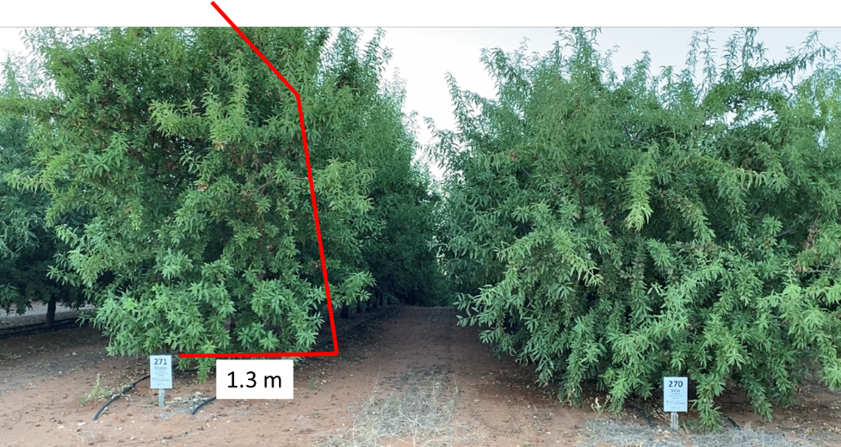

Figure 5: High-density almond planting trial at the Almond Centre of Excellence (ACE) orchard in Loxton, Australia, with 4.5 m wide rows. Shasta® on the left and ‘Vela’ on right on ‘Nemaguard’ rootstock. Images were taken during summer in February 2023. Trees were planted in winter 2018. The red lines indicate the planned pruning cuts, with the distance from the trunk at the base of 1.3 m.

The pruning that was carried out achieved the desire aim to obtain a 2 m gap between canopies (Figure 6). The differing growth habit of the two cultivars was expected to produce very different results in response to this type of pruning. Activities aimed to measure the light transmission inside the canopy and the potential “rejuvenation” in response to the pruning are underway. The vegetative response to the pruning will also be noted.
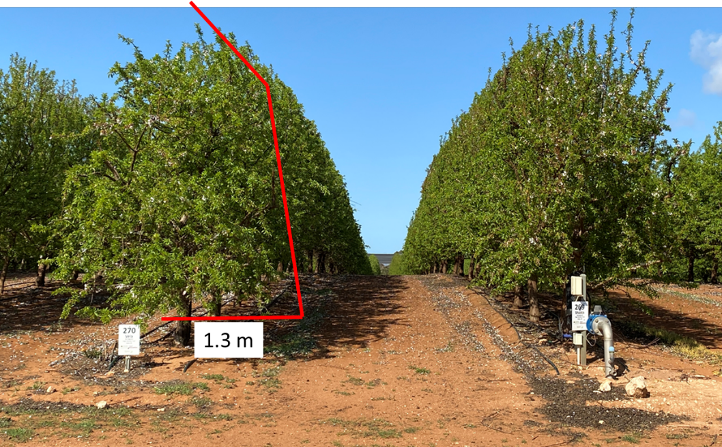

Figure 6. High-density almond planting trial at the Almond Centre of Excellence (ACE) orchard in Loxton, Australia, with 4.5 m wide rows after pruning. ‘Vela’ on the left and Shasta® on right on ‘Nemaguard’ rootstock. Images were taken in August 2023. Trees were planted in winter 2018.

Key Findings:
- Higher yields were obtained from higher density plantings by increasing irrigation, suggesting that irrigation requirements of young trees planted at high density could be higher per ha than for trees at conventional tree spacing. The question remains as to how much water is too much before an over-supply of water causes problems of root health. This will be particularly important in sites with heavier soils that have a greater water holding capacity than the sandy soils in this study. Other questions will be “when is the best time to revert to more standard irrigation rates based on ML/ha rather than L/tree”, and “are there critical periods during the growing season that are essential for high yields and others that are less important”?
- An irrigation dilemma was faced within this trial: had all trees received the same amount of water during early canopy development, the higher density treatments may have had higher yields than those reported here. The response in the year following the change in irrigation quantities per tree suggested that water per tree is a critical component to consider.
- Given the complexity of this trial, it is difficult to disentangle the water/tree density responses, however this should be investigated in the future.
- Another difficulty faced within this trial, but applicable to other trials too, is linked to the impossibility of disentangling the irrigation from nutrition as the two are carried out together.
- In the combination Shasta/’Nemaguard’, the intended central axis tree form was difficult to retain because of the production of strong proximal water shoots from basal branches as soon as canopy closure occurred. This may have been initiated by low light conditions inside the canopy.
- In the ‘Vela’/‘Nemaguard’ combination, water shoot production was less evident and a more defined central axis was retained. In ‘Vela’ the weeping habit produced when branches bent under the weight of fruit may have opened the canopy sufficiently to prevent strong water shoot development in mature trees.
- Although there was a strong positive trend between irrigation/fertigation per tree and kernel yield per tree, this was not visible when examining yield/ha. This was probably the consequence of a lower impact of row spacing on ‘Vela’ compared with Shasta. The reduced impact of row spacing on yield in ‘Vela’ compared with Shasta is probably the consequence of the differing tree architecture of the two genotypes. At increased planting densities such as those investigated in this work, understanding the interaction of cultivar/rootstock genotype with environment and developing suitable specific management processes will be critical to ensuring successful outcomes.
- The Spanish-style pruning reduced the yields in the following year, as a result of removal of fruiting sites from the pruning. The 2025 yield results suggest that this pruning might have improved the light environment inside the canopies, thus increasing the productive canopy volume in the second season after pruning. These high yields in 2025, reaching up to 5.5. t/ha for the 4.5 m row spacing treatments for ‘Vela’, highlight the possibility for higher yields earlier if the canopy had been kept more open from the beginning.

Appendix 7. National Tree Crop Intensification in Horticulture – Almond (SARDI)
SARDI Final Report – AS18000 (PFR Subcontract No. 38923)
Report authors:
Tim Pitt, Kavitha Shanmugam, Mark Skewes, Darren Graetz, Nigel Fleming, Dane Thomas and Paul Petrie
Project code:
SARDI AS18000 – PFR Subcontract No. 38923
Date: 30 May 2025
SARDI AS18000 Summary
The South Australian Research and Development Institute (SARDI) was subcontracted to The New Zealand Institute for Plant and Food Research Limited (PFR) to support the almond component of the National Tree Crop Intensification in Horticulture research program (AS18000). SARDI’s contributions were entirely resourced through South Australian government co-investment into the Hort Frontiers strategic partnership initiative (Hort Innovation) and did not make use of almond levy funds. SARDI’s AS18000 project contributions were developed from experimental activities at the Almond Board of Australia’s (ABA) Almond Centre of Excellence (ACE) situated north of Loxton, South Australia. Deliverables included:
- AS18000 program planning and extension activities.
- The maintenance of a large scale super-high density almond field experiment.
- The development of an automated canopy assessment platform.
- An economic analysis of intensive almond plantings.
A summary of SARDI’s AS18000 project learnings, centred around these four deliverables, is reported herein.
Outputs
Extension products
SARDI contributed various program planning and industry extension activities through the AS18000 program. Including:
- 12 program planning and industry governance meetings
- 18 ACE focussed field walks
- 8 industry focussed magazine articles, posters and factsheets
- 3 oral presentations to Australian industry conferences
- 3 oral presentations to international technical symposia
- 3 scientific journal articles.
Replicated field experiment and associated datasets
A fully replicated field experiment investigated the potential of ‘Nonpareil’-like cultivars and size-reducing rootstocks to efficiently produce commercial quantities of marketable yields across planting densities ranging from 635 to 1481 trees per hectare. Yield, kernel quality, and canopy development datasets from this experiment highlighted the production traits of two self-fertile cultivars, ‘Buralmondtwo’ (BA2, which is marketed as Shasta®) and ‘Vela’. The field research platform is still young and remains available to industry as a test-bed suited to additional research questions such as those related to alternate harvest technologies, matching irrigation and nutrient inputs to tree size, and various plant physiology investigations to better understand genotype production habits.
Automated canopy assessment platform
SARDI developed and refined an automated canopy assessment platform (known as the MOPP: mobile orchard phenotyping platform) as part of its AS18000 contributions. This development was invaluable for producing rapid, non-destructive and repeatable measurements of canopy size, trunk diameter and light interception on a scale previously unavailable to researchers at the start of AS18000. The MOPP has significantly increased the volume and accuracy of canopy data from ACE field experiments and continues to support other field experiments at the Almond Centre of Excellence and other field sites.
Economic analysis
SARDI conducted an economic assessment comparing super-high-density and conventional planting systems. Key findings highlighted that increasing planting density and/or reducing row spacing significantly raised orchard establishment costs. The analysis also underscored the importance of strong planting material and early yield performance in recouping these upfront investments. Ultimately, for super-high-density systems to achieve rapid positive cumulative net cash flow and outperform conventional systems, transformational changes are required, particularly in canopy management, harvest operations, and achieving price parity with ‘Nonpareil’ for alternative cultivars.
Outcomes
The almond AS18000 project has successfully identified rootstocks and cultivars suited to closer planting systems. Whilst industry’s move toward super-high-density is not yet widespread in Australia, learnings from AS18000 have supported growers to move towards more productive medium density orchards. Greater uptake of super-high-density plantings may occur if/when resource availability becomes more limited, and harvest and processing systems are better developed, resulting in a more efficient production system. Research therefore needs to progress in this space so that systems are available to apply when the need arises.
SARDI’s super-high-density orchard accumulated locally relevant and objective performance metrics for a production system concept that, until recently, was viewed by most commercial producers as an unrealistic and high-risk investment option. It has facilitated conversations amongst orchard managers around their own experiences with alternate densities and perceived difficulties in moving away from traditional production systems.
While super-high-density systems are yet to feature in Australian almond orchards, the application of higher (within-row) density is becoming more widely accepted. Informed by AS18000 and other Australian investigations, these increased densities will lead to earlier returns on investment, reduced limb breakages, improved spray efficiencies etc. but will likely require more management and inputs.
Key Findings and Recommendations
Australia’s strength remains in low–medium density almond production
Australia consistently achieves some of the highest almond yields per hectare globally under low–medium planting densities. This is despite challenging conditions such as low rainfall and poor soils. This success is largely driven by intensive management practices including water and fertiliser inputs that push trees to achieve vigorous growth and strong productivity.
Moderate increases in planting density have delivered yield benefits without significantly increasing input costs. However, the case for super-high-density systems remains economically difficult to justify under current conditions.
Challenges of super-high-density systems
The primary economic barrier to super-high-density planting systems lies in the substantial upfront investment required. Higher tree numbers significantly increase costs related to planting material, support structures and tree training. Super-high-density systems also demand more frequent light pruning to maintain canopy structure and light penetration to develop and condition fruiting positions that sustain regular strong yields.
Unlike crops such as apples, where super-high-density systems have delivered dramatic yield increases, almond yield gains, to date, have been relatively modest. These gains have mostly been realised in the early years, when increased canopy coverage from more trees leads to a higher number of fruiting positions. Over time, the yield advantage diminishes, making it increasingly difficult to offset the higher establishment costs.
Lessons from Spain may take time to match Australian expectations
The Spanish almond industry operates under fundamentally different production conditions to those experienced in Australia. Farms are generally smaller due to land competition, and growers rely on lower levels of supplementary irrigation and fertiliser. As a result, they accept lower average yields per hectare.
Spain’s early adoption of off-ground harvest systems and the use of harder-shell varieties better suited to hedgerow systems have allowed growers to meet stringent food safety and regulatory standards. However, Spanish trees are not pushed to grow or yield at the same intensity as those in California or Australia. Therefore, direct efficiency comparisons between Spanish and Australian systems should be approached with caution.
Market limitations and cultivar perception
A significant challenge for super-high-density systems in Australia is the market perception and pricing of alternative cultivars. Despite promising agronomic performance, cultivars other than ‘Nonpareil’ face a price penalty, limiting their economic competitiveness. This pricing disparity is a major barrier to the adoption of novel genotypes that would be better suited to closer plantings than ‘Nonpareil’.
Although AS18000 has identified genotype combinations with potential for super-high-density systems, including self-fertile varieties, the lack of price parity with ‘Nonpareil’ remains a critical obstacle. Until this issue is addressed, the economic case for super-high-density systems will remain weak.
Pathways to viability
Super-high-density systems may only become a realistic option for Australian growers if several key developments occur:
- Price parity for non-‘Nonpareil’ cultivars
- Reliable single-pass harvest machinery specifically tailored to super-high-density orchard configurations
- Processing infrastructure and techniques capable of handling nuts harvested at higher moisture contents
- Agronomic research to optimise tree physiology and management practices for novel planting systems
Additional drivers may come from regulatory or environmental pressures, such as:
- Soil health and organic production standards
- Food safety requirements
- Water use efficiency and dust management regulations
If these factors gain greater importance, the potential benefits of super-high-density systems, such as improved hygiene, reduced dust and improved soil health, may become more valuable.
Performance of ‘Vela’ in super-high-density systems
Among the cultivars trialled, ‘Vela’ grafted to Rootpac® 40 and planted at 889 trees/ha emerged as the most promising super-high-density combination in the SARDI experiment. It outperformed all combinations of Shasta in cumulative yields and consistency, with a more manageable growth habit and fewer performance fluctuations. This cultivar also outperformed ‘Nonpareil’ for yield (not price) at the traditional spacing of 308 trees/ha.
While ‘Vela’ on Controller 6® achieved the highest single-season yield (5.26 t/ha), it exhibited a biennial bearing pattern, producing high yields one year and significantly lower yields the next. In SARDI’s experiment, this inconsistency reduced its cumulative yield and economic potential compared to ‘Vela’ on Rootpac 40.
Upcoming research (due for reporting in December 2026) may show even greater performance from ‘Vela’ when grafted to Garnem® and planted in a more traditional free-standing system, which could influence future recommendations.

SARDI AS18000 - Deliverable 1 of 4: Program planning and extension activities
SARDI contributed to AS18000 program planning and extension activities through collaborator workshops and industry-focussed field walks, symposiums and publications. These activities included:

12 program planning and almond industry governance meetings:
Date | Location | Audience / AS18000 activity
11 May 2021 | Loxton, SA (ACE) | Crop Reference Group (ABA Production Committee)
06 Apr 2022 | Loxton, SA (ACE) | Collaborator meeting
10 May 2022 | Online | Project leadership group meeting
11 Jul 2022 | Loxton, SA (LRC & ACE) | Crop Reference Group (ABA Production Committee)
12-14 Jul 2022 | Dareton, NSW | Project consortium forum
18-20 Apr 2023 | Bargara, QLD | Project consortium forum
19 Sep 2023 | Loxton, SA (ACE) | Crop Reference Group (ABA Production Committee)
07 Feb 2024 | Loxton, SA (LRC & Online) | Crop Reference Group (ABA Production Committee)
15 Feb 2024 | Online | Project leadership group meeting
12 Aug 2024 | Mareeba, QLD | Project consortium forum
27 Aug 2024 | Online | Crop Reference Group (ABA Production Committee)
29 Jan 2025 | Loxton, SA (ACE) | Crop Reference Group (ABA Production Committee)

16 almond industry field walks:
Date | Location | Audience / AS18000 activity
28 May 2021 | Loxton, SA (LRC & ACE) | 29 AgTech entrepreneurs – field walk
25 Aug 2021 | Loxton, SA (ACE) | 20 Almondco growers, packers and IDO’s – field walk
12 Oct 2021 | Loxton, SA (ACE) | 20 viticulture growers, winemakers and IDO’s – field walk
05 Apr 2022 | Loxton, SA (ACE) | 6 PIRSA AgTech officers – field walk
08 Aug 2022 | Loxton, SA (ACE) | 16 Almond SIAP members – field walk
18 Sept 2022 | Irymple, VIC (AVR) | SARDI attended AVR field walk – maintain collaborative links
13 Oct 2022 | Loxton, SA (ACE) | +50 Almond conference delegates – field walk
26 Oct 2022 | Loxton, SA (ACE) | +50 viticulture growers, winemakers and IDO’s – field walk
08 Nov 2022 | Loxton, SA (LRC & ACE) | 6 state parliament NRM committee members – field walk
14 Nov 2023 | Loxton, SA (ACE) | +200 almond growers, packers, IDO’s and researchers – field walk
17 Jun 2024 | Loxton, SA (ACE) | 14 Berri/Barmera Ag Bureau members – field walk
13-14 Sep 2024 | Barmera, SA | Riverland Field Days stall
17 Sep 2024 | Loxton, SA (ACE) | 8 Hort Innovation Board members – field walk
30 Sep 2024 | Loxton, SA (ACE) | 4 Californian Almond Board and Scientists – field walk
11 Oct 2024 | Loxton, SA (ACE) | 6 Spanish scientist, IDO’s and Hort Innovation – field walk
10 Apr 2025 | Loxton, SA (ACE) | +35 Almond growers, packers, IDO’s and researchers – field walk

Six oral presentations to almond industry and technical conferences:
Date | Location | Audience / AS18000 presentation topic
10-12 Oct 2022 | Adelaide, SA | 2022 Australian Almond Conference | SARDI research at ACE
7-12 May 2023 | Davis, USA | VIII Int. Symposium on Almonds and Pistachios | ISHS | SARDI research at ACE
22 Aug 2023 | Robinvale, VIC | 2023 Almond R&D Forum | Density optimisation
03 Dec 2023 | Tatura, VIC | II Int. Symposium on PMOV | ISHS | Mobile Orchard Phenotyping Platform
2-4 Oct 2024 | Adelaide, SA | 2024 Australian Almond Conference | Rootstock x Cultivar compatibility
19-24 Jan 2025 | Napier, NZ | XIII Int. Symposium on Orchard Systems | ISHS | Canopy size and water use

Nine industry-focussed magazine articles, posters, videos and factsheets:
Pitt, T., Skewes, M., Fleming, N., Graetz, D., Shanmugam, K., Thomas, D. Petrie, P., and Phogat, V. (2024). SARDI at ACE: Season 2024 Review. In a Nutshell, Winter 2024. IAN Winter 2024
De Bei, R., Pitt, T., Thorp, G., Petrie, P., Coates, M., Breen, K., Smith, A., Fleming, N., Graetz, D., Shanmugam, K., Skewes, M. and Stanley, J. (2024). Advancements in almond orchard intensification in Australia. PFR Poster/Factsheet – ISHS VIII International Symposium on Almonds and Pistachios.
Pitt, T., Graetz, D., Skewes, M., Shanmugam, K., Thomas, D., Fleming, N. and Petrie, P. (2023). SARDI Factsheet – Density Optimisation: Medium (H2) to Ultra-High (H3). Almond Board of Aust. H2-H3
Petrie, P.R., Pitt, T., Skewes, M., Fleming, N., Graetz, D., Shanmugam, K., Thomas. and Phogat, V. (2023). Improving climate resilience by matching irrigation to almond canopy size and water use. SARDI Video. Canopy size and water use
Pitt, T., Phogat, V., Shanmugam, K. and Petrie, P. (2023). Soil water extractors aid nutrient application. Australian Tree Crop Magazine, Dec/Jan 2023 p14-15. Tree Crop Aug 2023
Phogat, V., Pitt, T., Petrie, P., Shanmugam, K., Skewes, M. & Thomas, D. (2023). Impact of tree density on water and nitrogen use. Australian Tree Crop Magazine, Aug/Sep 2023 p52-54. Tree Crop Jan 2023
Pitt, T., Skewes, M., Fleming, N., Graetz, D., Shanmugam, K., Thomas, and D. Petrie, P. (2022). High-density plantings increase yields during orchard establishment. Australian Tree Crop Magazine, Dec/Jan 2022. p14-15. Tree Crop Jan 2022
Pitt, T., Skewes, M., Fleming, N., Graetz, D., Shanmugam, K., Thomas, D. Petrie, P., and Phogat, V. (2022). Increasing planting density can increase kernel yield. In a Nutshell, Summer 2022, p34. IAN Spring 2022
Pitt, T., Skewes, M., Fleming, N., Graetz, D., Shanmugam, K., Thomas, and D. Petrie, P. (2022). Progressing ultra-high-density orchards. In a Nutshell, Summer 2022, p40-41. IAN Summer 2022

Three scientific journal articles:
Skewes, M., Thomas, D., Fleming, N., Shanmugam, K., Phogat, V., Graetz, D., Petrie, P., and Pitt, T (2025). Kc and the sunshine (band) – permanently installed cameras to measure almond canopy size and better estimate irrigation requirements. XIII International Symposium on Integrating Canopy, Rootstock and Environmental Physiology in Orchard Systems, Acta horticulturae (in press).
Fleming, N., Fang, K., Shanmugam, K., Pitt, T. and Petrie, P.R. (2024). Assessing large-scale almond field experiments using a Mobile Orchard Phenotyping Platform. Acta hort. ISHS-article/1395.31
Pitt T., Thomas D., Skewes M., Fleming N., Graetz D., Shanmugam K., Phogat V and Petrie P. (2024). Early performance of Australian multi-cultivar density optimisation trial. VIII International Symposium on Almonds and Pistachios. Acta horticulturae. ISHS-article/1406.28

SARDI AS18000 - Deliverable 2 of 4: Super-high-density field experiment
Introduction:
In 2019, SARDI established a 1.6 ha field experiment to evaluate the potential for almonds to be efficiently grown at super-high densities. This experiment became the central component of SARDI’s contribution to the AS18000 almond program. Located at the Almond Centre of Excellence, the experimental orchard followed a Randomised Complete Block design with four replicates of 18 treatments. Treatments tested the interaction between three planting densities (635, 889, and 1,481 trees/ha) and six cultivar-rootstock combinations (Shasta and ‘Vela’ grafted onto Controller 6, Controller 7, and Rootpac 40). Various orchard performance metrics were collected, including water and nutrient inputs, soil water content and solutes, leaf nutrient content, plant water status, canopy development, phenology, labour inputs, yield, and kernel quality.
This experimental planting served as a companion trial to SARDI’s H1 to H2 optimised density planting, with both trials including the almond cultivars Shasta and ‘Vela’. Visitors to ACE could therefore observe the performance of both cultivars at nine planting densities, ranging from 308 to 615 trees/ha (H1 to H2) and from 635 to 1,481 trees/ha (H2 to H3). Notably, the super-high-density experiment included in this AS18000 report does not include the industry standard cultivar ‘Nonpareil’ as, at the time of orchard establishment, it was thought that this non-self-fertile cultivar may be more prone to crop fluctuations making vigour control problematic. The performance of ‘Nonpareil’ across the H1 to H2 density transition will be reported by SARDI, alongside other cultivars and experimental treatments, in December 2026 as part of Hort Innovation project AL21001.
The H1 to H2 optimized-density trial mentioned above reduced the distance between trees while maintaining current row width and industry tree training practices. In contrast to Spanish hedging systems, SARDI’s super-high-density orchard aimed to test the response to even closer spacings without adopting the high-input Spanish model of continuous early hedging. Instead, exploring the potential for a range of cultivar rootstock combinations to provide a lower-input orchard system option that achieved strong yields in a canopy form supporting alternate harvesting technologies.
Orchard establishment and training
SARDI’s super-high-density experiment was established through Hort Innovation’s Advanced production for temperate nut crops program. Details on planting material, temporary trellising and early tree training can be found in Section 8 of SARDI’s ST16003 Final Report (Pitt et al., 2021). Briefly, Agromillora ‘Smart Trees’ were planted in 2019 to three densities (635, 889, and 1481 trees/ha) across six genetic combinations comprising two cultivars, Shasta and ‘Vela’, grafted to three rootstocks, Controller 6 (C-6), Controller 7 (C-7) and Rootpac 40 (R-40). Tree rows were planted 4.5 m apart with each plot being four rows wide and 7-14 trees long (21-24.5 m) depending on density. The nine treatments were replicated four times in a Randomised Complete Block design (Figure 1).
Trees were trained to a central leader form using an Eco-Trellis® semi-permanent support structure that was installed in July 2020. The trellis consisted of metal posts and anchored strainers, supporting two wires at 700 and 1700 mm above the ground. At each tree a 3 m long bamboo pole was affixed to the wires so that it extended from 0.5 m to 3.5 m above the ground (Figure 2 and Figure 3). Trees continued to be trained to this pole targeting a dominant single leader from which laterals could develop to ultimately fill a hedge row.
The Agromillora ‘Smart Trees’ are relatively small compared to conventional trees that are budded during dormancy in the winter prior to the planting year. This meant that the 1st leaf (2019/20) effectively acted as an additional nursery year and the 2nd leaf (2020/21) could be considered equivalent to the first year for an orchard planted with conventional trees. Throughout 2020/21 (2nd leaf) and 2021/22 (3rd leaf), trees received (approximately) monthly tipping to increase branching, reduce branch calliper and encourage growth along the row. The most significant training input during this season was the removal of thick, poorly directed laterals (mostly pointing into the row) in early summer followed by a light hedging operation.

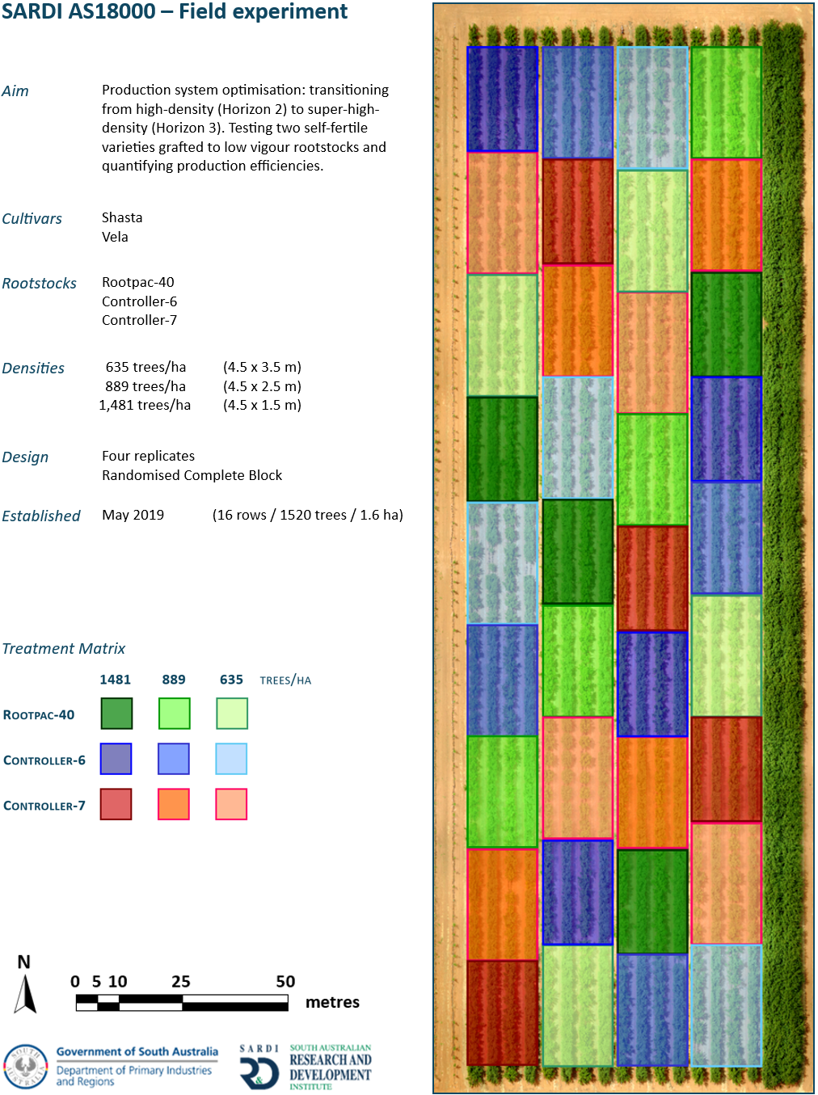

Figure 1. Treatment map of SARDI’s AS18000 super-high-density field experiment, planted in 2019 using planting material from Agromillora known as ‘Smart Trees’, (ACE experimental orchard, South Australia).

In subsequent seasons, as canopies filled their space, mechanical hedging was introduced to limit the growth of canopy into the inter-row space. This maintained access for orchard equipment and encouraged the infiltration of light into the lower canopy of the trees to maintain fruiting sites (Figure 2).

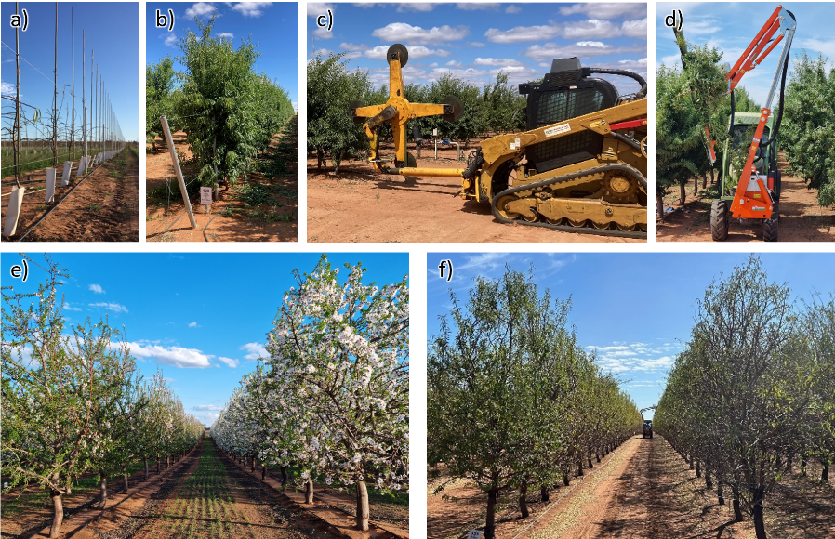

Figure 2. Temporary Eco-Trellis® support structure in August 2020 (a) and December 2021 (b). Contractor and SARDI hedging equipment (c) and (d) conducting within-season tipping/shaping operations in 2023 and 2024. Bloom (e) and post-harvest (f) canopies in season 2024/25 for Shasta® (left of images) and ‘Vela’ (right of images).

Hedging operations included regular tipping of the sidewall and (from the 4th leaf) an angled cut that peaked the upper canopy to encourage fruiting points without developing heavy calliper extension growth that would subsequently be cut off and wasted. Peaking the upper canopy had the effect of reducing the overall height of trees to reduce shading effects on adjacent rows and allowing more light inside the canopy.
The cultivars selected for SARDI’s super-high-density experiment were chosen to evaluate how differing growth habits perform under high-density planting conditions. ‘Vela’, characterised by its weeping form, and Shasta, known for its upright growth, were deliberately chosen to explore how contrasting tree architectures influenced adaptability to high-density systems. Trees were planted across a three-step density transition to optimise High (H2) to Super-high (H3) planting density for these contrasting tree habits.
Early training requirements were greater for ‘Vela’ as it needed frequent re-tying of its central leader during development. In contrast, Shasta’s naturally vertical growth demanded significantly less intervention, needing only occasional support to maintain a straight form. ‘Vela’ rapidly presented as more effective at filling the space between trees, thanks to its flatter branch angles and outward-arching lateral branches, even when trained vertically. Shasta maintained a narrower profile, with vertical branch development that left more unfilled space within the canopy and between trees. ‘Vela’s spreading nature also led to increased encroachment into the mid-row, necessitating more frequent sidewall tipping/pruning to preserve access (Table 1). Shasta required less mid-row maintenance.
As trees developed through their first two growing seasons, it became evident that the widest in-row spacing of 3.5 meters was excessive—particularly for Shasta. Even after two years, significant gaps remained between Shasta trees, and to a lesser extent, between ‘Vela’ trees at this spacing. This delay in canopy closure represented a missed opportunity for early yield, which would be critical for the commercial success of such a planting. Over time, both cultivars adapted to the hedging operations (performed biannually for ‘Vela’). ‘Vela’ tended to present a softer lateral growth habit and produced more short, fine branches, resulting in a naturally shorter and wider canopy. Shasta, by contrast, developed longer, thicker branches and a taller, more sparse canopy structure. ‘Vela’s internal bearing habit allowed for mechanical tipping without significant crop loss in season, unlike Shasta, whose tip-bearing nature and heavy laterals often drooped into the inter-row space under crop load, complicating pruning. At the highest planting density (1.5 m spacing), ‘Vela’ adopted a more upright form, a behaviour not observed at wider spacings.

Table 1. Summary of training/hedging operations at SARDI’s super-high-density experiment (ACE, SA)
Date | Cultivar | Hedging/training operations | Comments
May-2020 | Shasta® & ‘Vela’ | Remove/tip misdirected growth & train required growth to trellis/bamboo | Manual operation
Dec-2020 | Shasta® & ‘Vela’ | Sidewall tipping | Contractor hedger
Dec-2021 | Shasta® & ‘Vela’ | Sidewall tipping | Contractor hedger
Oct-2022 | Shasta® & ‘Vela’  ‘Vela’  Shasta® | Targeted skirting  Sidewall & flat top-cut  Flat top-cut only | Manual operation  Contractor hedger  Contractor hedger
Apr-2023 | Shasta® & ‘Vela’ | Sidewall tipping | Contractor hedger
Oct-2023 | ‘Vela’ | Sidewall tipping | Contractor hedger
Apr-2024 | Shasta® & ‘Vela’ | Sidewall tipping & peaking of upper canopy | Contractor hedger
Nov-2024 | ‘Vela’ | Sidewall tipping | SARDI hedger
Apr-2025 | Shasta® & ‘Vela’ | Sidewall tipping & peaking of upper canopy | SARDI hedger

Rootstock selection also influenced tree architecture. Controller 6 and Controller 7 (peach genotypes) promoted dense, upright branching with tight angles, while Rootpac 40 (peach x almond hybrid) encouraged a more open, spreading structure. These rootstock traits, combined with scion characteristics, shaped overall tree form and cropping potential.
Overall, ‘Vela’ appeared better suited to the ultra-high-density hedge system at ACE due to its internal bearing, weeping growth habit, and ability to fill lateral space early, contributing to higher early yields. However, its lower and internal branches have shown signs of shading sensitivity and may die if canopy thickness and light interception is not managed. Continued monitoring of these ‘Vela’ trees will help characterise this cultivar’s productive longevity.
Shasta’s upright form initially seemed ideal for narrow hedgerows, and early yield results (2022–2024) on Controller 6 were promising. However, a strong 2025 yield from ‘Vela’ on the same rootstock ultimately demonstrated its superior performance for the density and pruning strategy examined in this system.
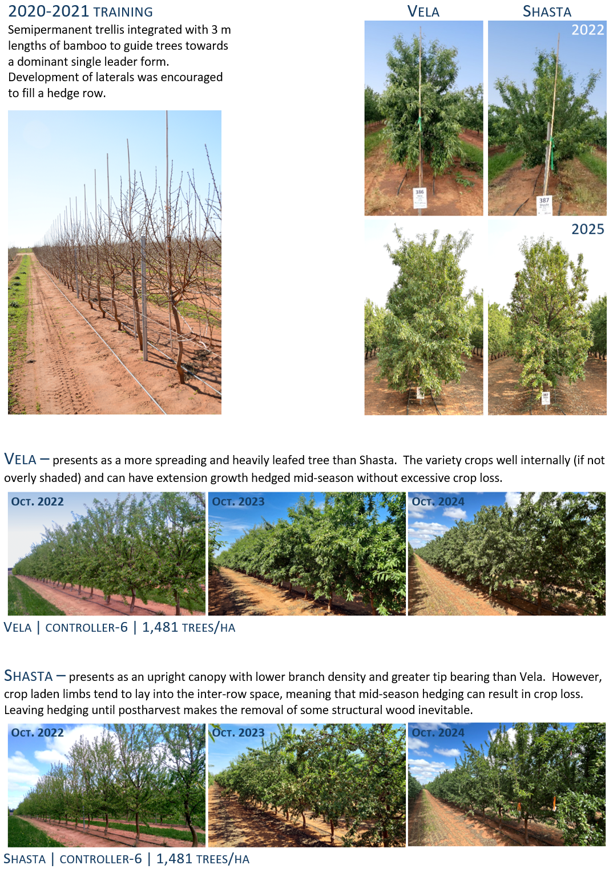

Figure 3. Canopy training and habit for Shasta® and ‘Vela’ on Controller 6® at 1,481 trees/ha (2020 - 2025).
Orchard growing conditions
Weather
Weather at the trial site was monitored by the NRM Weather Station Network - Loxton Almond Board Research Site that was situated 600 m from SARDI’s field experiment. Local weather was also available from the Bureau of Meteorology (BoM) weather station at the Loxton Research Centre (station 24024) located 5km south of the field site. Those daily data were sourced from SILO - longpaddock.qld.gov.au. The SILO data includes “patched” data with interpolated estimates where values are missing in the partial time series. Evapotranspiration was calculated using the FAO56 methodology (Allen et al., 1998) using observed wind speed sourced from the Bureau of Meteorology. When weather elements were not observed at the LRC BoM station, evapotranspiration was calculated from SILO ‘patched’ values and a wind speed of 2 m/s. Daily data from the NRM Loxton Almond Board Research site were incomplete (missing days). No attempt was made to interpolate those missing values.
Weather sourced from the different stations (NRM and BoM) differed slightly (Table 2). This was likely due to location differences, but also to localised site differences such as area of bare land surrounding the weather stations. Those differences probably contributed to a lower wind speed (about 40% less) observed at the NRM station than at the BoM station and, together with occasional missing observations, would also have produced the lower evapotranspiration measured at the NRM station. Similar rainfall and daily maximum temperature were observed at both weather stations, although the NRM weather station often recorded slightly lower daily minimum temperatures (data not shown).

Table 2. Climatic data from NRM weather station at the Almond Centre of Excellence (ACE) orchard and from the nearest official Bureau of Meteorology (BoM) weather station (site 24024) at the Loxton Research Centre (LRC)
 | BoM LRC |  | NRM ACE#
 | Rainfall  (mm) | Evapotranspiration (mm) | Rainfall  (mm) | Evapotranspiration (mm)
2019/20 | 201 | 1,681 | 191 | 1,326
2020/21 | 170 | 1,629 | 174 | 1,276
2021/22 | 282 | 1,631 | 279 | 1,274
2022/23 | 472 | 1,479 | 466 | 1,160
2023/24 | 181 | 1,650 | 175 | 1,423
2024/25* | 144 | 1,535 | 145 | 1,251
# Some missing data.
* 2024/25 data partial season (July to March)

Phenology
Full bloom dates
Date of full bloom was evaluated for each scion/rootstock combination across four seasons (2021/22 to 2024/25) and the results expressed relative to ‘Nonpareil’ on ‘Nemaguard’ within another experimental orchard at the ACE site (Figure 4).
In general, date of flowering was similar between the two varieties with Shasta and ‘Vela’ averaging 5.8 and 4 days earlier than ‘Nonpareil’ respectively. Flowering for trees grafted to Controller 7 tended to be later than those grafted to both Controller 6 and Rootpac 40. Trees grafted to Rootpac 40, particularly for Shasta, tended to flower earlier than those grafted to the other rootstocks (Figure 4). Flowering advancement has been noted with stone fruit cultivars grafted to Rootpac 40 (pers comm John Slaughter, Fresno USA). The delay in flowering for trees grafted to Controller 7 as compared to those on Controller 6 may be a side-effect of the rootstock’s observed sensitivity to higher pH soils and associated extended juvenility in affected trees, previously discussed in Section 8 of SARDI’s ST16003 Final Report (Pitt et al., 2021).

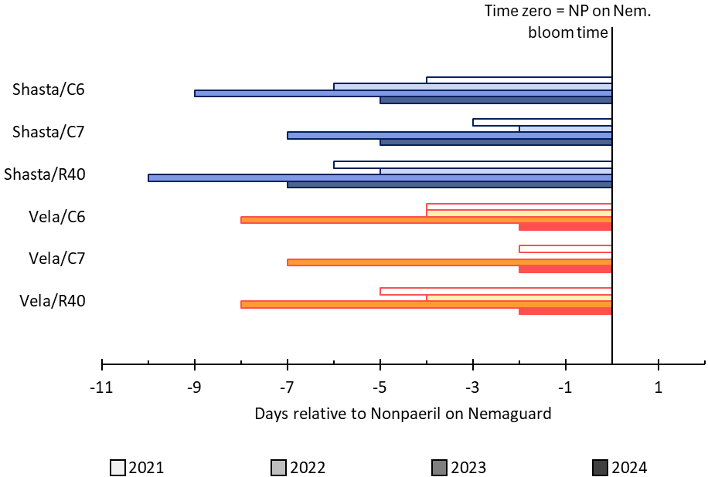

Figure 4. Timing of full bloom relative to ‘Nonpareil’ trees on ‘Nemaguard’ rootstock at the same property. Negative numbers indicate earlier flowering than NP/Nem.

Hull split and harvest dates
The progression of hull-split in SARDI’s super-high-density experiment was closely monitored during the 2025 season, commencing early in January and continuing weekly until the 2025 harvest (Figure 5). The same three replicates of three rootstocks and two densities (635 and 1,481 trees/ha) were evaluated for each variety on each occasion using the methodology of Thomas and Hayman (2018). Only five Shasta measurements were collected before it was harvested on 6 February 2025, while ‘Vela’ being harvested later allowed for nine measurements prior to harvest on 6 March 2025.
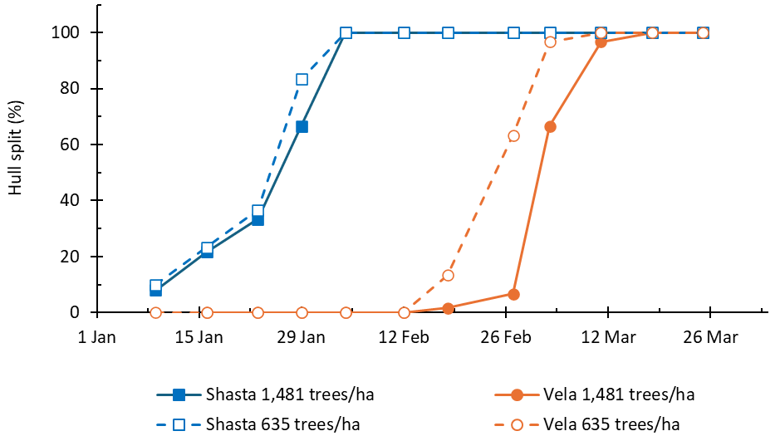

Figure 5. Representative progress of hull split for Shasta® and ‘Vela’ at different planting densities (2025)

SARDI’s AS18000 harvest dates are shown in Table 3 alongside those of ‘Nonpareil’ x Garnem growing in a companion experimental planting at the ACE orchard in every season, providing a clear record of both annual variation and the relative difference in maturity dates between these two varieties. In 2025, hull split occurred about 1 month earlier in Shasta and, unlike ‘Vela’, was not affected by planting density (Figure 5). This difference was reflected in the date of harvest (Table 3). Shasta tended to be harvested 1-2 weeks earlier than ‘Nonpareil’, and ‘Vela’ was harvested 2-3 weeks later than ‘Nonpareil’.

Table 3. Harvest dates for Shasta® and ‘Vela’ relative to ‘Nonpareil’ on Garnem® in companion trial at the Almond Centre of Excellence (H1-H2)
Harvest Dates (± days from Nonpareil)
 | Nonpareil | Shasta® |  | Vela
2022 | March 9th | February 24th | (-15) | March 31st | (+22)
2023 | March 15th | March 1st | (-14) | April 3rd | (+19)
2024 | March 4th | February 27th | (-6) | March 18th | (+14)
2025 | February 20th | February 6th | (-14) | March 6th | (+14)

Irrigation
Trees were irrigated with a dual drip line system with laterals positioned <0.5 m either side of the tree trunk. 1.6 L/hr emitters were spaced at 0.5 m along the laterals, giving an application rate of 1.42 mm/hr. All experimental plots received the same depth of irrigation (the valve unit watered to area rather than to demand of the individual plots). Irrigation events were scheduled using SWAN Systems software that monitored irrigation and nutrition across the ACE targeting soil water contents between 15 and 30 % volumetric soil water (greater than -60 kPa soil tension) in the top 0.6 m of the rootzone. During the growing season, rootzone water content was monitored using capacitance probes (Sentek EnviroSCAN) that were installed in multiple experimental plots. Average irrigation (River Murray) water quality was generally good with electrical conductivity (EC) below 0.3 dS/m through the assessment period. A summary of the experimental site’s seasonal rainfall and irrigation records is provided in Table 4.

Table 4. Seasonal rainfall and irrigation rates for SARDI’s super-high-density almond experiment. †
 | Rainfall  (mm) | Irrigation  (mm) | Total  (mm)
2019/20 | 191 | 362 | 553
2020/21 | 174 | 766 | 940
2021/22 | 279 | 1,087 | 1,366
2022/23 | 466 | 1,200 | 1,666
2023/24 | 175 | 1,453 | 1,628
2024/25* | 145 | 1,337 | 1,482

Nutrition
Nutrients were largely applied using fertigation, with all experimental plots receiving the same quantity of nutrient regardless of genotype or density. Nitrogen (N), phosphorus (P) and potassium (K) were applied at rates of approximately 220, 50 and 280 Units (kg/ha) respectively through each of the last three seasons. A summary of the experimental site’s nutrient program is provided in Table 5.

Table 5. Seasonal nutrient application rates for SARDI’s super-high-density almond experiment. †
 | Nutrient (kg/ha)
 | NO3-N | Other N | Total N | P | K | Ca | Mg | S
2019/20 | 39 | 24 | 63 | 20 | 62 | 8.1 | 0.5 | 2
2020/21 | 46 | 56 | 102 | 33 | 131 | 13.3 | 1.4 | 32
2021/22 | 78 | 100 | 178 | 36 | 215 | 10.8 | 1.6 | 53
2022/23 | 79 | 105 | 184 | 40 | 224 | 15.4 | 3.2 | 59
2023/24 | 112 | 133 | 245 | 58 | 306 | 18.6 | 4.5 | 67
2024/25* | 114 | 120 | 234 | 48 | 319 | 18.0 | 5.0 | 67
* 2024/25 data partial season (July to March)
† Data adjusted to exclude the two rows of ‘Maxima’ border trees to the east of experimental valve unit

Leaf nutrient analysis
Leaf tissue samples were collected and analysed from Shasta and ‘Vela’ trees on all three rootstocks and two densities (635 and 1,481 trees/ha) from three replicates. Samples were analysed for macro- and micro-nutrients. Leaf sampling and analysis were carried out three times during each growing season targeting the growth stages of leaf emergence, pit-hardening and hull split (late January). Samples collected at the first two growth stages were bulked into one sample per treatment. Samples collected from the hull split (January) timestep were analysed separately as individual replicates.
Leaf tissue analysis suggests the ACE nutrient program was meeting the needs of the crop during the period of investigation for both extremes of the density range, 635 and 1,481 trees/ha (Figure 6 and Table 6). Plant nutrient status measured early in season 2023/24 reflected the high concentration of nutrients available when the orchard was still managing its nutrient schedule on a cycle of 75% applied pre- pit-hardening and 25% applied post-harvest. At this time, leaf tissue concentrations of nitrogen were above 3.5% in October 2023 regardless of planting density. In season 2024/25, the orchard manager distributed the same nutrient budget (234 units of N) more evenly through the season and the early season leaf nitrogen spike was more subdued. Interestingly, season 2024/25 was the first time that leaf nitrogen concentrations dipped below the almond industry’s standard adequate range of 2 – 2.5 % by late January.
At no time were there notable differences in leaf tissue nutrient concentrations between the upper and lower planting densities (Table 6). Minor separation between varieties at the beginning of the 2023/24 season (Figure 6) aligns with ‘Vela’ coming out of a high-crop and Shasta coming out of a light crop in season 2022/23.
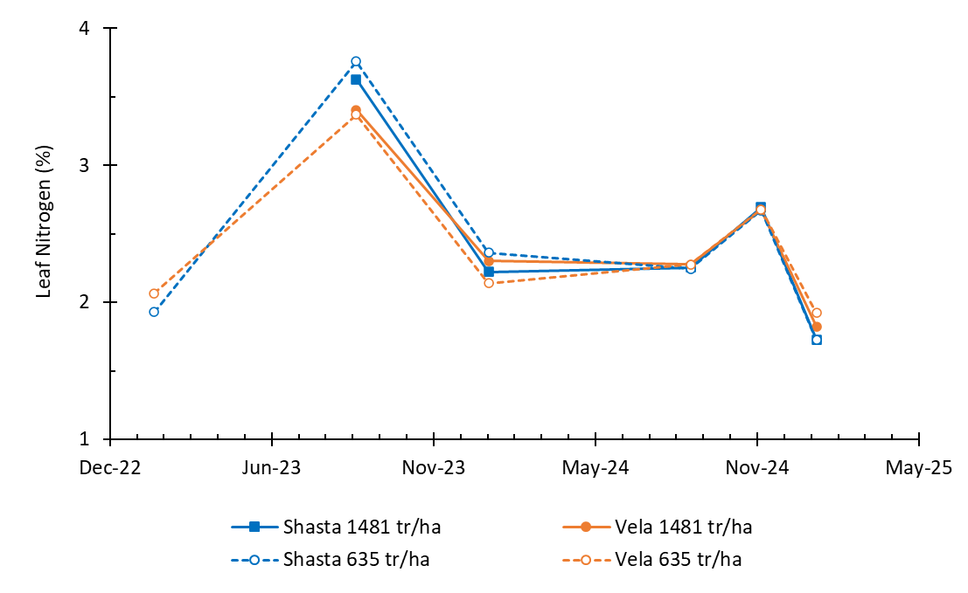

Figure 6. Impact of density on concentration of leaf nitrogen (%) for Shasta® and ‘Vela’ (2023 to 2025). *Note that the January 2023 data was sourced from SARDI’s H1 to H2 companion planting (@ 615 trees/ha).

Table 6. Seasonal almond leaf tissue analysis sampled in January as per (Reuter and Robinson, 1997)*
Season | Cultivar | Density | N | P | K | Ca | Mg | Na | S | B | Cu | Zn | Mn
 |  | Trees/ha | % | % | % | % | % | % | % | mg/L | mg/L | mg/L | mg/L
2023/24 | Shasta® | 635 | 2.2 | 0.1 | 2.2 | 5.3 | 0.8 | 0.0 | 0.2 | 35.7 | 5.7 | 55.0 | 230
 |  | 1,481 | 2.1 | 0.1 | 2.5 | 4.9 | 0.8 | 0.0 | 0.2 | 39.2 | 5.5 | 55.5 | 222
 | Vela | 635 | 2.2 | 0.1 | 2.6 | 4.9 | 0.8 | 0.0 | 0.2 | 34.2 | 5.7 | 49.8 | 215
 |  | 1,481 | 2.1 | 0.1 | 3.0 | 4.5 | 0.8 | 0.0 | 0.2 | 36.0 | 5.7 | 49.3 | 212
2024/25 | Shasta® | 635 | 1.7 | 0.1 | 1.9 | 4.3 | 0.7 | 0.0 | 0.2 | 36.2 | 4.0 | 61.0 | 157
 |  | 1,481 | 1.7 | 0.1 | 2.3 | 4.5 | 0.8 | 0.0 | 0.2 | 38.5 | 4.4 | 60.2 | 140
 | Vela | 635 | 1.9 | 0.1 | 2.2 | 4.5 | 0.8 | 0.0 | 0.2 | 31.2 | 4.6 | 66.8 | 180
 |  | 1,481 | 1.9 | 0.1 | 2.5 | 4.5 | 0.8 | 0.0 | 0.2 | 34.7 | 4.4 | 64.0 | 198
* Recommended concentrations |  |  | 2-2.5 | >0.1 | 1.4-1.7 | >2 | >0.25 | <0.25 |  | 25-65 | >4 | 25-30 | >20

Rootzone soil water and solutes
Rootzone soil moisture was monitored in both Shasta and ‘Vela’ plots for Rootpac 40 grafted treatment plots at 635 and 1481 tree/ha density. This gave a total of four sensor arrays (1 replicate of each genetic combination and tree density). The installations were EnviroSCAN® sensor arrays, with individual soil water sensors at 10, 20, 30, 40, 60, 80, 100 and 150 cm soil depths. These sensors were attached to stand-alone loggers to monitor soil water contents every hour.
Soil moisture sensors were complemented by nests of in-situ soil solution samplers (Sentek SoluSAMPLER) at both 635 tree/ha and at 1481 tree/ha (Figure 9 c and d). SoluSAMPLER’s were installed at depths of 30, 60 and 90 cm in each location beneath the dripline and soil solution samples collected approximately monthly across the growing season (and more often during fertigation campaigns). Successful sample collection was determined by soil water content. Some samplers did not produce samples very often; others produced samples almost every time.
Soil water samples were measured for Electrical Conductivity (EC_{SW}), pH and nitrate (NO₃) concentration. EC was measured using a temperature compensated conductivity meter (model CON510, Eutech, Singapore). NO₃ was estimated using semi-quantitative nutrient test strips (Quantofix® Nitrate/Nitrite test strips) validated against DUMAS and colorimetry methods at a third-party laboratory.
Measures of soil water EC_{SW} and NO₃ concentrations were aggregated into five average values per season aligning with dormancy (Jun-Aug), leaf emergence (Sep-Oct), pit-hardening (Nov-Dec), hull-split (Jan-Feb) and post-harvest (Mar-May). Rootzone EC and NO₃ data are summarised alongside irrigation and climatic data in Figure 8.
While some soil water samples reported NOx-N concentrations greater than 250 mg/L, these tended to be early in the life of the orchard when canopy and root systems were relatively small and fertigated nutrients could easily move beyond the active rootzone. Also at this time, the ACE fertigation program aligned to a schedule of 75% of nutrient budget being applied early in the season and 25% of budget being applied post-harvest (note seasons 2020 and 2021 in Figure 8). The ACE orchard does not yet have the valve and dosing tank infrastructure to irrigate/fertigate to demand and so these young trees were receiving a higher dose fertigation schedule that aligned more closely to the demands of older, larger, free-standing trees that were planted elsewhere in the orchard. Hence the spikes of nutrients moving beyond the rootzone in 2020 to 2021. Most soil water nutrient measures collected after 2021 were less than 10 mg/L with spikes of only 50 mg/L or less. Very little nutrient was moving beyond the rootzone of either planting density at this site.
What should be noted though, is the gradual but consistent trend for rootzone soil water salinity (EC_{SW}) to increase over the investigation period. In 2024/25, average readings for some plots approached 6dS/m EC_{SW} with only the shallow soils in the lower density plantings showing a lesser effect. At this stage, these salinity levels remain manageable if salts are flushed from the rootzone during the winter rainfall period. Measures of EC_{SW} tend to be approximately double the measure reported when using the saturated paste technique (EC_{e}) meaning that these soils are currently equating to 2-3 dS/m EC_{e}. Previous almond studies have suggested that the predicted almond yield loss associated with increasing salinity equates to 19% for every 1 S/m increase above a soil salinity of 1.5 dS/m EC_{e} (Maas and Hoffman, 1977).
Soil water data measured in the top metre of the soil profile (Figure 7) shows minor differences between the two varieties across 5 seasons. At times, ‘Vela’ appears to use more water (drier soil) than Shasta, while at other times the opposite appears to be true. The differences likely correspond to different canopy cover due to differences in growth rate in the early development of the site, and different hedging intensity as the trees developed.
Data for 30-60 and 60-90 cm depths at 635 and 1481 trees/ha (Figure 8c) suggest that during the initial season (2020/21) the high-density plots used more water (drier soil) than the low-density plots, as a result of the higher number of trees in these plots and the consequently higher leaf area. However, this difference disappeared after 2021/22 season as the trees filled their allocated space. From this time, the individual trees in the high-density plots were smaller than in the low-density plots, but the total leaf area was very similar between densities, and water use was driven by total canopy size rather than the number of trees.
At no point did the water content of the soil dip significantly below 15%, indicating that the trees were never in a highly water-stressed state, and the comparison of soil water traces in both Figure 7 and Figure 8 indicate that the high-density trees did not suffer any growth penalty from restricted water availability compared to the low-density trees.

Figure 7. Comparison of soil water content between Shasta® and ‘Vela’. 30 days rolling average measured in the upper 1 m of the rootzone (2020-2025).
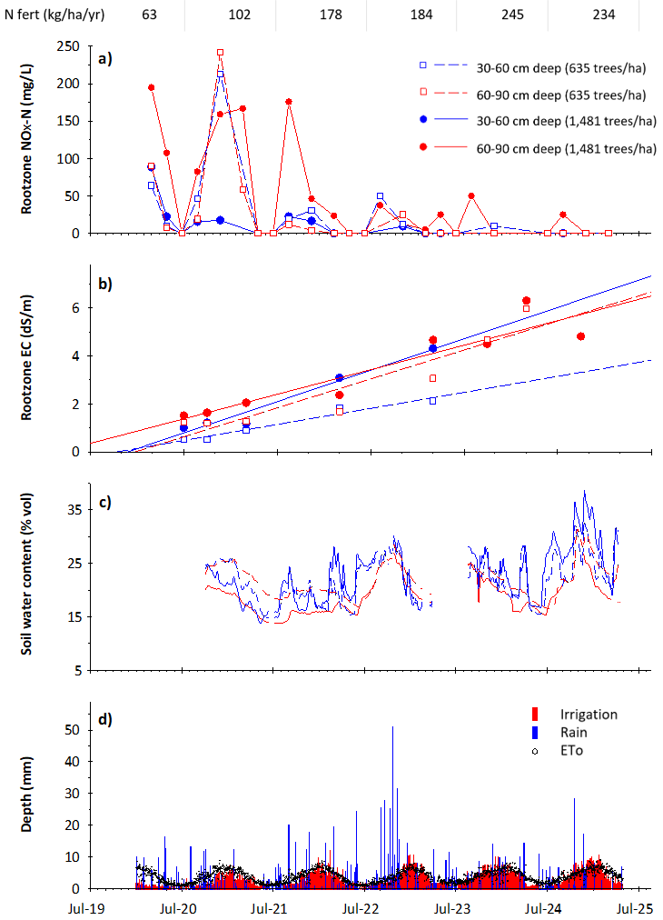

Figure 8. Five seasons of rootzone solute and soil water dynamics for two densities in SARDI’s super-high-density almond experiment. Temporal distribution of soil water nitrate concentrations measured at multiple depths (a), gradual accumulation of EC (salinity) over time (b), seasonal volumetric soil water contents (c) and rainfall, irrigation and reference evaporation records (d).
Tree water status
Genotype and planting density effects on plant water relations were investigated using measures of stomatal conductance and stem water potential. Stomatal conductance was measured with the LI-COR LI-6100® porometer. Measurements were taken during different growth stages throughout the growing season, commencing in January 2024 and continuing through to February 2025 (five measures per season). Measurements were conducted on fully expanded leaves in full sunlight, and the leaves were measured in their natural position. A minimum of 1 leaf on each of 2 trees per plot were measured, although often 3 leaves per tree were measured. Three plots of each treatment (2 cultivars x 3 rootstocks x 2 density combinations) were measured within the trial.
Stem water potential (SPW) was measured using a Scholander Pressure Chamber (3000 Desktop Plant Water Potential Console from SoilMoisture Equipment). Measurements were collected on the same days as stomatal conductance. Measurements were usually taken between noon and mid-afternoon, on two leaves in each of three of the four experimental replicates at 635 and 1,481 tree/ha density treatments.
Data presented in Figure 10 and Figure 11 are averages of multiple replicates in each measurement period and suggest similar trends for both cultivar and density. Rootstock effects were more variable, with higher stomatal conductance measured early in the season for Rootpac 40 and later in the season for Controller 6. Plants grown at higher density tended to have lower stomatal conductance (a sign of greater stress) than plants grown at low density (Figure 10). There were few other consistent differences in stomatal conductance. ‘Vela’ and Shasta differed in stomatal conductance on many occasions but there was a lack of consistency to which variety was higher. Stomatal conductance of trees grafted to Rootpac 40 were often, but not always, lower than those grafted to other rootstocks.
These findings contrast to those for stem water potential (Figure 11) where there were only occasional effects of planting density and/or rootstock on leaf water potential. In 2025, ‘Vela’ generally presented a more negative (stressed) SWP than Shasta, a possible artifact of large crop load differences that season with average yields of 2.4 and 4.7 t/ha for Shasta and ‘Vela’ respectively.
Overall stomatal conductance was positively related to SWP (more stressed plants presenting lower stomatal conductance and more negative SWP), as seen in Figure 10 and Figure 11. However, it should be noted that these indicators of stress were not excessive and only approached levels associated with almond stress during the harvest period. At no time did any individual combination of cultivar x rootstock x density present as being adversely affected by the growing conditions, especially water availability.
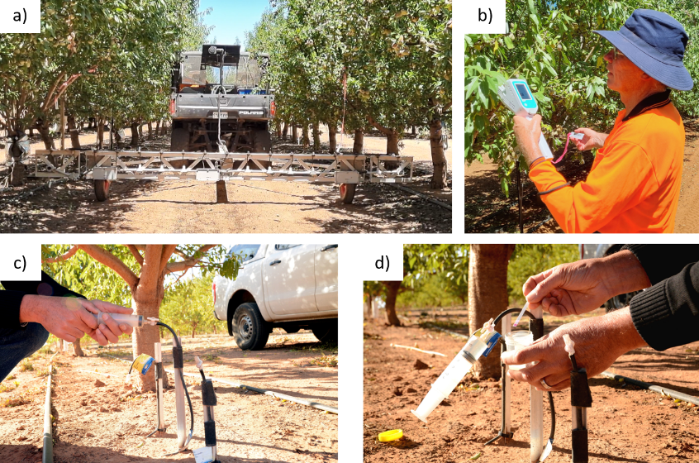

Figure 9. Mobile orchard phenotyping platform – MOPP (a) collection of stomatal conductance measures using porometer (b) collection of soil water samples measuring rootzone EC and NOx-N (c and d).
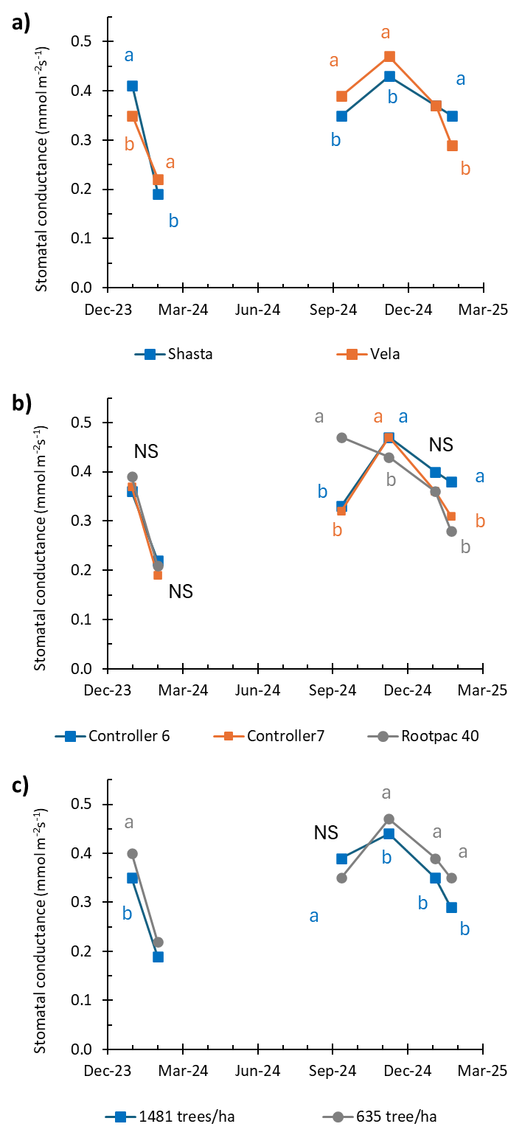

Figure 10. Stomatal conductance as impacted by almond variety (a) rootstock (b) and tree density (c). Data points with the same letter are not significantly different at P = 0.05, “NS” indicates no significant differences in the data.

Figure 11. Stem Water Potential as impacted by almond variety (a) rootstock (b) and tree density (c). Data points with the same letter are not significantly different at P = 0.05, NS indicates no significant differences in the data.
Canopy development
Tree size was measured manually in May 2020 and then, through the following five seasons, using SARDI’s automated canopy assessment platform. This automated platform, referred to as SARDI’s Mobile Orchard Phenotyping Platform (MOPP) was used to assess canopy growth across the life of the project by measuring trunk diameter, tree height and light interception. Further MOPP details are provided in the following section (SARDI AS18000 deliverable 3 of 4). Canopy assessment surveys were carried out at intervals of around 6-8 weeks, including at key phenotypic stages of dormancy, canopy expansion, full-canopy and post-harvest. All MOPP based measurements involved traversing the entire experimental planting and collecting data from every treatment tree (>600 trees).
Aligned measures of Leaf Area Index (LAI) were also collected to assist in validating MOPP output. LAI readings were collected at least five times each season and targeted the growth stages mentioned above using a plant canopy analyser (LAI-2200C, LI-COR, Inc., Nebraska, USA). In the early years of the experiment, measurements were collected more often to capture the rapid changes in tree growth.
LAI measures were collected using a modified version of the protocol described by Ollat et al. (1998). In the case of SARDI’s canopy assessments, two sets of readings, one above (A) and one below (B) canopy, were taken using two wands, each fitted with a 45° view cap. One wand was set to automatically collect continuous A readings (above canopy) while the other wand was connected to the console and triggered manually to collect B (below canopy) readings. B readings for each treatment plot were taken at 0.3 m lens height, at ~0.5 m intervals along the row for the distance of four trees. Three sets of readings were collected across the row at 0.5 m offset from the tree row, and at quarter and half row width, respectively. Measurements were collected with lens facing away from sun and scatter corrected when necessary while processing. LAI was calculated using the Li-Cor LAI processing software FV2200, integrating the difference between A and B readings.
Figure 12 and Figure 13 show tree trunk diameter and tree height as influenced by cultivar, rootstock and density. ‘Vela’ had larger diameter trunks than Shasta but tended to have shorter, more dense/compact canopies through to season 2024/25 when annual hedging operations normalised canopy height between the two cultivars.
Rootstock affected trunk diameter with trees grafted to Controller 7 tending to produce the smallest diameter. The sensitivity of Controller 7 has previously been discussed in Section 8 of SARDI’s ST16003 Final Report (Pitt et al., 2021) and is likely to be a contributing factor to reduced canopy vigour.
Trees planted at lower density (wider spacing) tended to have the largest diameter trunks and those planted closer together were the smallest. These differences did not translate to significantly tree height differences, although this would likely be due to the annual hedging treatments imposed to the upper shoulder of the canopy. Control of canopy height was important to prevent shading of lower portions of the adjacent row canopy and prevent associated crop loss.
Light interception through the canopy was measured in November of each season and increased as the experimental orchard aged. The willowy growth habit and more heavily leaved nature of ‘Vela’ trees steadily increased their light interception and, whilst starting below that of Shasta, ultimately produced full canopies with little open space between trees (Figure 14a). This resulted in light interception values slightly higher than those of Shasta in the latest measurements. Post-harvest mechanical pruning operations that removed significant lengths of Shasta (tip-bearing) shoots will also have influenced this result.
Light interception of trees growing on Controller 7 rootstock was less than that of trees grafted to the other two rootstocks (Figure 14b). This result mimics that of trunk diameter and tree height and is likely an artifact of reduced vigour, early in the life of these trees, before growing through their intolerance to the moderately alkaline soils.
The effect of planting density on light interception was less obvious than that of genotype combinations but by the end of the assessment period the trees grown at increasing densities had higher light interception (62%, 66% and 67%, respectively).
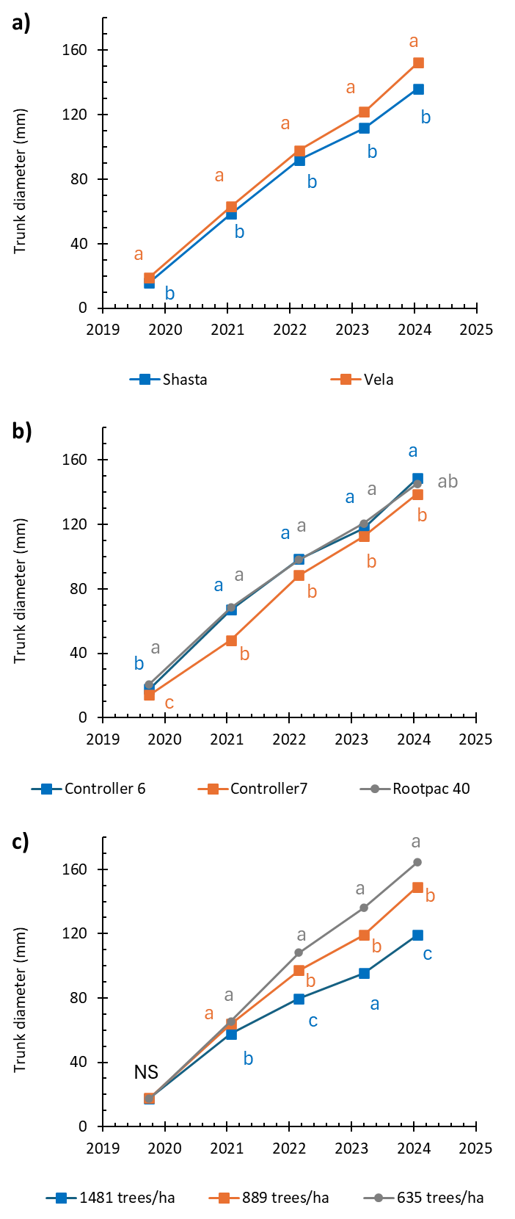

Figure 12. Trunk diameter (MOPP LiDAR) of +600 experimental almond trees in SARDI’s ACE super-high-density trial (2020 to 2025). Data displayed by cultivar (a), rootstock (b) and density (c). Letters indicate significant differences.
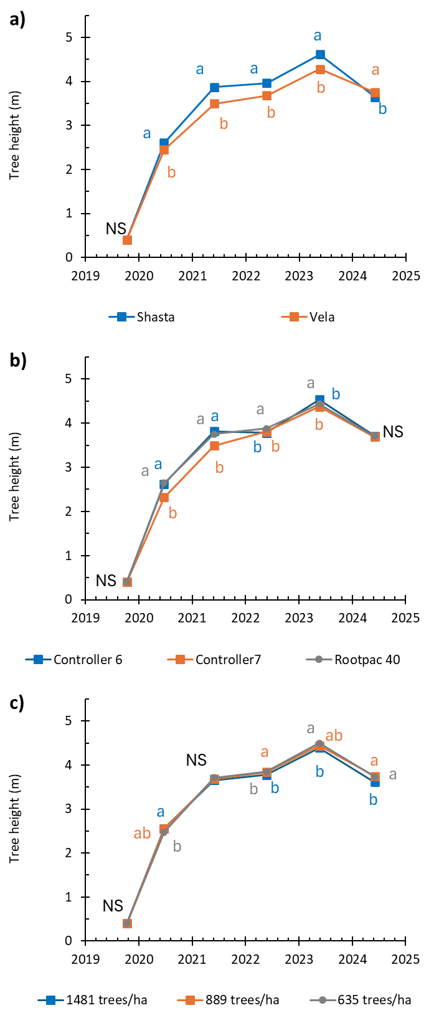

Figure 13. Tree height (MOPP LiDAR) of +600 experimental almond trees in SARDI’s ACE super-high-density trial (2020 to 2025). Data displayed by cultivar (a), rootstock (b) and density (c). Letters indicate significant differences.
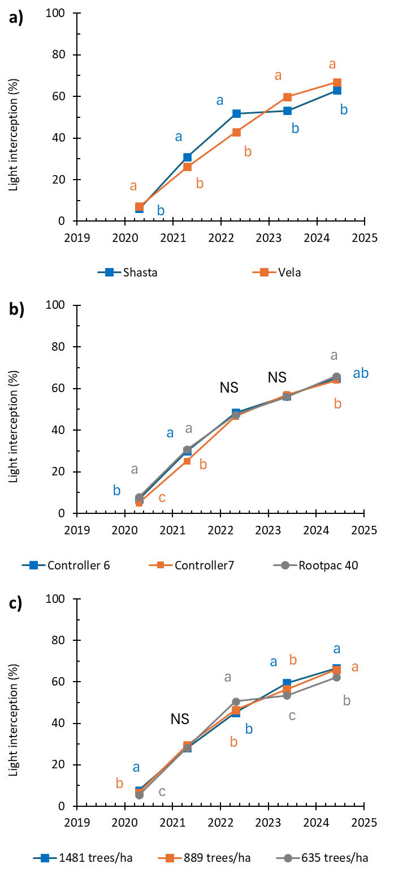

Figure 14. Light interception (MOPP ceptometer) of +600 experimental almond trees in the super-high-density trial (2020 to 2025). Data displayed by cultivar (a), rootstock (b) and density (c). Letters indicate significant differences.
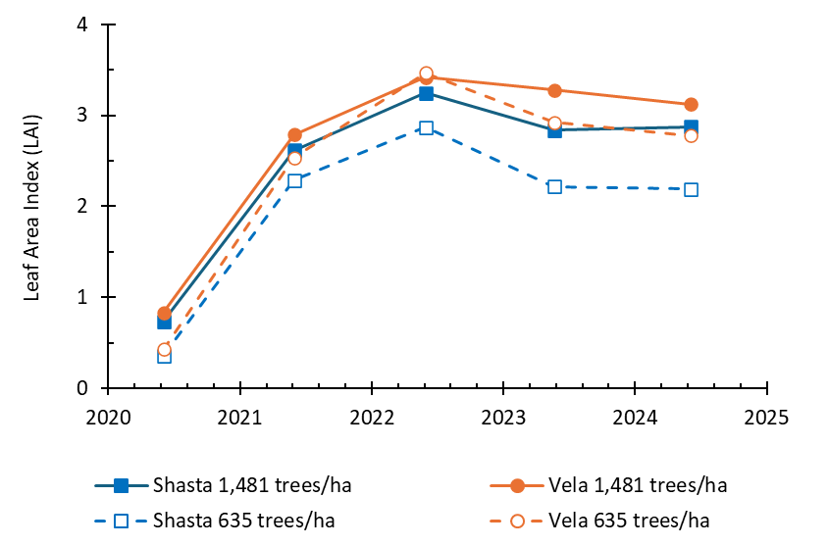

Figure 15. Mid-season (January) Leaf Area Index measures of Shasta® and ‘Vela’ at highest and lowest densities across 5 growing seasons. Data reflect the average of all three rootstocks.

LAI measures (Figure 15) collected in January of each season describe a rapid canopy development phase through the orchard’s first three seasons that aligns with trends described by MOPP measures of trunk diameter and light interception. LAI data support the light interception trends measured by the MOPP ceptometer in the final two seasons in that ‘Vela’ has higher LAI and light interception than Shasta and that this is especially the case at higher densities where there was practically no unfilled space between trees in ‘Vela’. LAI was higher in higher density plantings which agreed with the general findings from the light interception studies that higher density plantings had higher light interception.
‘Vela’ consistently exhibited higher LAI than Shasta, particularly as the orchard matured, which mirrored the trends observed by the MOPP’s ceptometer array (particularly in the latter years of the investigation). These findings also aligned with visual assessments of tree architecture: ‘Vela’s weeping habit allowed it to fill hedgerow space more effectively, while Shasta’s upright growth remained narrow, with occasional long leaders tipping into the mid-row.
Shasta’s vertical structure always posed challenges for early-season hedging as tip-borne nuts would drag shoots into the mid-row, increasing the risk of crop loss from traffic if not from hedging operations. In contrast, ‘Vela’ tended to bear fruit internally, allowing for an easy containment of the canopy and increase of light penetration through minor trimming of extension growth with minimal impact on yield.
In the first two seasons, it became clear that the widest within-row planting spacing (3.5 m) was too great for a hedgerow system, particularly for the cultivar Shasta. Large gaps remain, even now, between Shasta trees planted to this density. Gaps were less pronounced for the ‘Vela’ cultivar. These canopy gaps significantly reduced early productivity, a crucial period for achieving the rapid returns expected from high-density orchard systems. Yield data confirmed that these gaps negatively affected Shasta’s performance, highlighting the importance of optimal spacing in maximizing early orchard efficiency.
Looking ahead, a key question is whether ‘Vela’ can be managed to maintain its productivity in a hedged system, given its susceptibility to internal shading as the canopy thickens.
Yield performance and kernel quality
Yield data was collected annually from 2022 (3rd leaf) to 2025 (6th leaf). Nuts were shaken from continuous runs of >20 m of experimental trees (36 plots per cultivar) onto the ground using a hydraulic shaker head and raked into windrows, leaving a blank area between each adjoining treatment block. Nuts (hull, shell and kernel) were picked up using a Monchiero self-propelled nut harvester in 2022 – 2024, which fitted down the narrow rows more easily than a standard almond harvester (Figure 16b). However, this machine failed to pick up all the nuts on the first pass and required repeated pass that produced a sample contaminated with dirt and stones. A correction factor was calculated from samples that were screened to remove contaminants, and these cleaned samples were processed for kernel crack-out and quality metrics (see below). In 2025, a Flory almond pick-up machine was used with much better nut pick-up performance and cleaner samples. In each case the pick-up machine stopped after each treatment block to unload the nuts into a plastic bin on pallet scales towed behind the machine, allowing the wet field weight of nuts from each treatment block to be recorded.
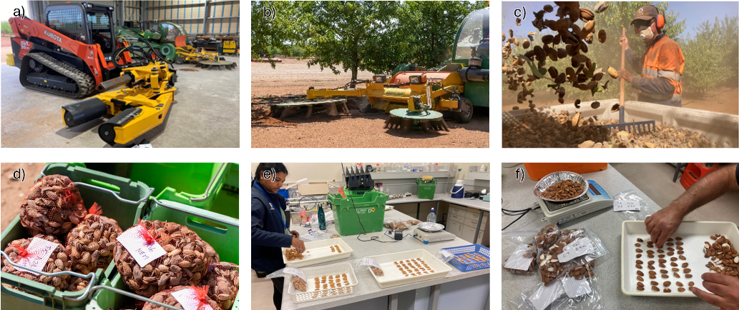

Figure 16. Experimental almond harvest operations including shaker (a) pick-up (b) weighing of >20m long experimental plots (c) subsamples (d) and kernel quality assessments (e and f).

A subsample of nuts (1.5-2 kg) was collected from each treatment block during the harvest operation (6-8 kg/treatment/season). The wet field weight of each sample was recorded before the samples were dried in ovens at 40°C until weight stabilised. The dry sample weight was then recorded, and the samples passed through a Jesse Mini-Huller to separate the kernels from the hulls and shells. All kernel weights were normalised to 5% moisture content.
Kernel weights for each sample were used to determine crack-out percentage relative to the wet sample weight, and this percentage was applied to the wet field weight to estimate kernel yield from each treatment block. Kernel yield per treatment block was divided by the area of each block to determine kernel yield per hectare.
Kernel samples collected from this trial were evaluated for discolouration, gumming, shrivel, pepper spotting, doubles and insect damage (Figure 16 e/f and Figure 19). These parameters are important determinants for kernel price grading, with excessive defects leading to reduced returns. Yield and kernel defect values, aligned to genotype and/or density, informed the economic analysis summarised in the final section of this report (SARDI AS18000 deliverable 4 of 4).
Annual and cumulative yields from SARDI’s super-high-density experiment are summarised in Figure 17 and show year-to-year yield variation related to both cultivar and rootstock. In general, yields of ‘Vela’ exceeded those of Shasta regardless of density or rootstock. Shasta and ‘Vela’ trees grafted to Controller 7 produced the lowest 6th leaf cumulative yields (9.2 t/ha) and those grafted to Rootpac 40 produced the highest (11.9 t/ha).

Figure 17. Kernel yield (t/ha) in 2022 to 2025 (3rd to 6th leaf*) and cumulative total yields for two almond cultivars grafted to three rootstocks and planted to densities ranging from 635 to 1,481 trees/ha. Bars indicate SEM. *Small planting material resulted in 1st leaf being a nursery year, season 2025 effectively equating to 5th leaf yields.
Yield benefits related to density tended to diminish with time. The positive benefit of higher density on annual yields was clear during the 2022 and 2023 harvests (3rd and 4th leaf) when the closer planting density of smaller canopy trees (2.2 t/ha) outperformed those at wider spacings (1.7 t/ha). But harvests in subsequent years showed little interaction with planting density, and consequently, in most genetic combinations, the cumulative yields have shown limited benefit to higher density planting through later years. The exception are plantings on Rootpac 40 where not only do higher yields occur, but also the yield benefit of higher density plantings can be seen in the 6th leaf cumulative yield. This is particularly the case for Shasta, but also occurs in ‘Vela’. Part of this response may be due to the more porous canopy habit of Shasta on Rootpac 40 that may benefit from the closer planting. Other combinations, which are better able to fill the space between stems regardless of planting distance, do not present the same yield advantage from closer spacings.
Caution is warranted when interpreting yield results, as the trees in this trial are still young, have heavily modified canopies, and were provided with uniform, and non limiting, irrigation and nutrition regardless of planting density. This uniform resource allocation may mask the true performance potential of different density treatments. When yield is assessed relative to irrigation water applied per tree, the lowest planting density (largest tree) received the greatest amount of water and also produced the highest yields (Figure 18).
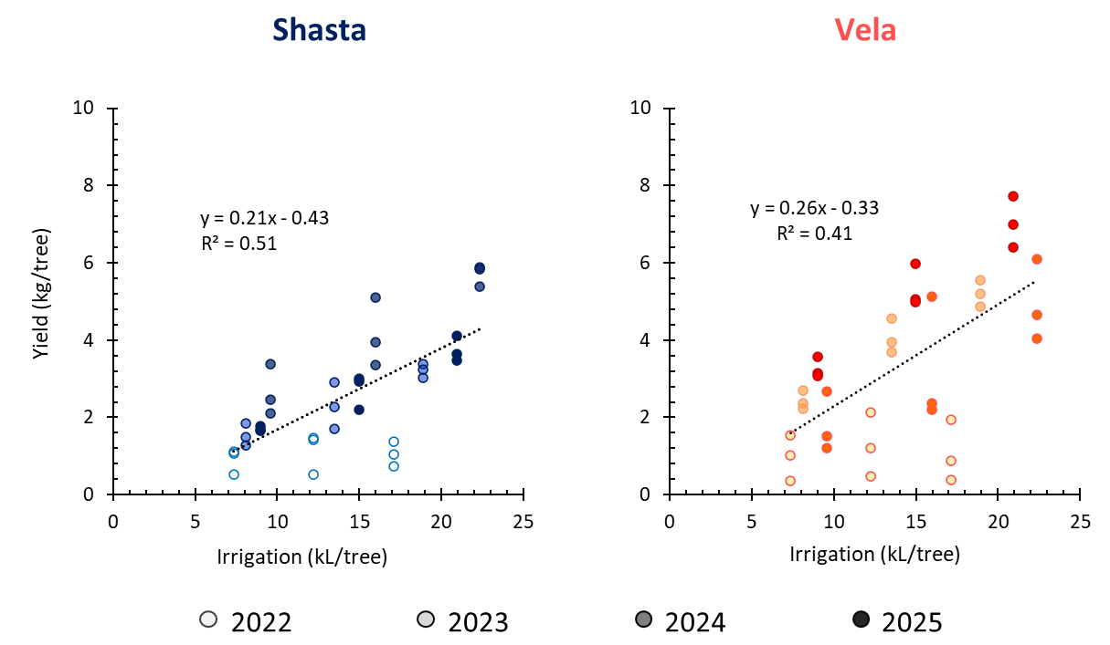

Figure 18. Relationship between yield (kg/tree) and water applied (kL/tree) for almond cultivars Shasta® (a) and ‘Vela’ (b) for 2022 to 2025. Weak trend of increased production with increased resource availability.

Another way of presenting the data shown in Figure 18 is to infer water use efficiency by relating grams of kernel produced for each litre of irrigation applied (Table 7). This suggests that ‘Vela’ was approximately 33% more productive than Shasta for the irrigation water applied (confirming the higher aggregate yields of ‘Vela’). Results suggest little improvement over the density cline aside from Shasta grafted to Rootpac 40 which offered a 20% improvement at the highest density compared to the same genetic combinations at lower densities. The impact of planting density on Shasta grafted to Rootpac 40 is more clearly displayed in Figure 17.
Each component of the system, canopy structure, tree age and resource distribution introduces its own limitations that can complicate direct comparisons between treatments. The carry-over effects of high early yields may also be more pronounced in young, intensively managed trees than in larger, more established trees in less intensive systems, which may be better equipped to buffer against resource constraints.
Controller 7 is known for its sensitivity to elevated soil pH and associated chlorosis symptoms. Nonetheless, tree performance on this rootstock generally improved over time, likely due to the development of more extensive root systems. As roots expanded into the upper soil layers, they provided a buffer against the more hostile carbonate-rich layers at depth.

Table 7. Impact of rootstock genotype, cultivar and planting density on the average weight of almond kernel produced per litre of irrigation applied (g/L) (2023 to 2025)
 | SHASTA® |  |  | VELA
 | 635  (trees/ha) | 889  (trees/ha) | 1,481  (trees/ha) | 635  (trees/ha) | 889  (trees/ha) | 1,481  (trees/ha)
Rootpac® 40 | 0.20 | 0.20 | 0.24 | 0.30 | 0.31 | 0.30
Controller 6 | 0.21 | 0.22 | 0.22 | 0.28 | 0.29 | 0.29
Controller 7 | 0.19 | 0.19 | 0.19 | 0.25 | 0.25 | 0.25

Yields from trees grafted onto Controller 7 did not appear to be influenced by planting density. However, there was a clear cultivar effect: ‘Vela’ on Controller 7 produced approximately 22% more yield than Shasta on the same rootstock. Interestingly, Shasta’s lower yields were more stable across years, while ‘Vela’ showed significant fluctuations—high yields in 2023 and 2025 were interrupted by a notable off-crop in 2024.
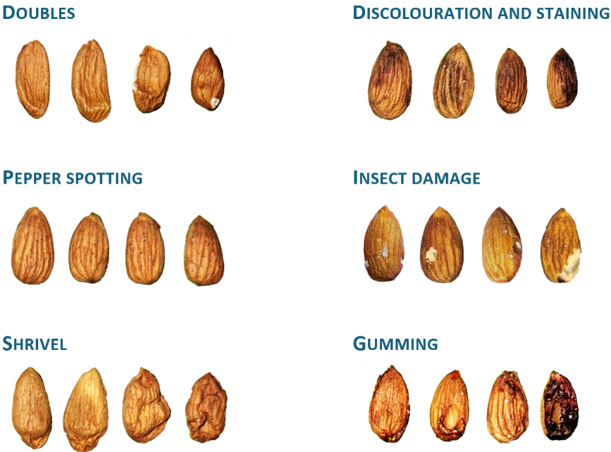

Figure 19. Kernel defects assessed during SARDI’s AS18000 kernel quality assessments (2022-2025)

The 2024 season marked Shasta’s highest yield on Controller 7 to date. This followed a challenging 2023 season, during which Shasta on pH-sensitive rootstocks like Controller 7 experienced substantial nut drop in November 2022. This was likely triggered by unseasonal heavy rainfall and a presumed spike in soil pH, effectively thinning the crop. The reduced crop load in 2023 may have allowed the trees to accumulate more carbohydrate researves, setting the stage for a strong yield rebound in 2024—nearly 4 t/ha. However, this bumper crop appears to have imposed limitations, resulting in a reduced yield again in 2025.
Trees grafted to Controller 6 exhibited modest yield improvements with increasing planting density. Among the two cultivars tested, ‘Vela’ grafted to Controller 6 consistently outperformed Shasta, yielding approximately 22% more at comparable densities. From the start of the trial until 2025, relative yields for both cultivars on Controller 6 were similar. However, in 2025 ‘Vela’ experienced a significant yield surge (likely a return crop following a light year in 2024) that surpassed Shasta across all densities. Shasta on Controller 6 showed a steady increase in yield until a heavy crop in 2024 led to a yield decline in 2025. ‘Vela’, on the other hand, maintained strong early yields until a lighter crop in 2024 that was followed by a robust rebound in 2025. Notably, yields exceeding 5 t/ha from ‘Vela’ on Controller 6 were the highest recorded across all combinations during the experimental period.
Controller 6 demonstrated good tree growth across the ACE environment and appeared more tolerant of high pH-induced chlorosis. However, it shares the same breeding background with Controller 7 which is known to be susceptible to moderately high soil pH.
Despite yield fluctuations due to alternate bearing, kernel weights remained strong on Controller 6: 1.41 g for Shasta and 1.61 g for ‘Vela’. In comparison, the same cultivars grafted to Controller 7 produced lower yields and smaller kernels, averaging 1.39 g for Shasta and 1.56 g for ‘Vela’.
Rootpac 40 is known to promote earlier bloom in stone fruit, a trend that was also observed in this experiment (Figure 4). Overall, trees grafted to Rootpac 40 performed well, suggesting that this rootstock is tolerant of the moderately high pH soils typical of the ACE site. For Shasta, early yields on Rootpac 40 were poor at lower planting densities but became comparable to other rootstock combinations at higher densities. In contrast, ‘Vela’s density response was strong early but the yield benefits of increased density quickly diminished as trees rapidly filled their available space along the row.
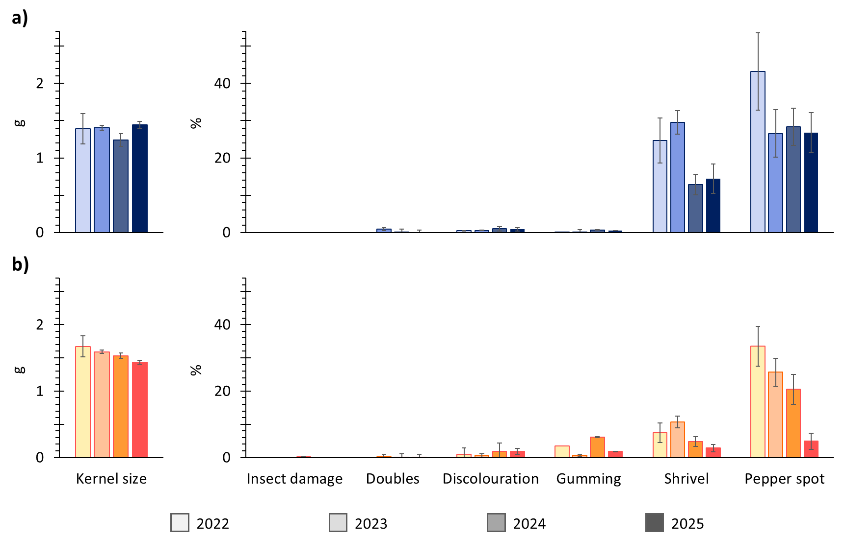

Figure 20. Kernel quality metrics measured in SARDI super-high-density experiment for Shasta® (a) and ‘Vela’ (b). No significant interaction between kernel quality metrics and density or rootstock. Error bars signify SEM.

‘Vela’ grafted to Rootpac 40 achieved the highest cumulative yield by the 6th leaf, nearing 15 tonnes of kernel per hectare at a density of 889 trees/ha. Yields did not increase further at the closer spacing of 1.5 m (1,481 trees/ha). These trees did, however, present with a significant shift in growth habit toward a narrow, upright form. In these high-density plantings, trees appeared more sparse, which is a characteristic associated with the Rootpac 40 rootstock. Consequently, the pruning requirements of this combination was less than for other rootstocks.
‘Vela’ yields on Rootpac 40 showed a steady upward trend from the 4th to 6th leaf, averaging around 4 tonnes of kernel/ha, with no major fluctuations. This consistency suggests that Rootpac 40 is well suited to support ‘Vela’ in high-density production systems. For Shasta, however, an unusual fruitlet drop early in 2023, possibly linked to a wet season, led to elevated yields in 2024, followed by a sharp decline in 2025. This pattern highlights a less stable performance compared to ‘Vela’ on the same rootstock.
Kernel size and quality defects were assessed across four harvests from 2022 to 2025 (Figure 20). There was very little difference in kernel weight across all densities averaging 1.3 g for Shasta and 1.5 g for ‘Vela’. When considering the incidence of kernel quality metrics, there were no significant interactions with either rootstock or planting density. However, some cultivar-specific differences were observed in certain defect categories.
Neither Shasta nor ‘Vela’ showed notable susceptibility to insect damage or doubles under the growing conditions at the ACE site. Kernel discolouration, typically associated with water staining or fungal issues, was very low overall but slightly higher in ‘Vela’ (Figure 20b), which also exhibited a higher incidence of gumming. In contrast, gumming was not a measurable issue for Shasta kernels, although gum-related stick-tights had been observed remaining in the tree followinng harvests early in the orchard’s life. This issue diminished over time, possibly due to the introduction of remedial boron applications, starting in the 2023 season, that had been introduced following ABA discussion with researchers in the USA.

Figure 21. Four seasons (2022 to 2025) of kernel defect incidence (shrivel) in Shasta® and ‘Vela’ almond cultivars as related to irrigation (a & b) and crop load (c & d).
The most significant kernel quality concern was the high incidence of kernel shrivel in Shasta. Although shrivel rates declined over time, they consistently remained above 5%, a level that could negatively impact processor grading. ‘Vela’ was less prone to shrivel but did exhibit pepper spotting, which decreased from 30% in 2022 to around 5% by 2025. Shasta’s pepper spotting remained relatively stable at over 20% throughout the trial period.
When looking for potential causes for the high incidence of kernel shrivel, SARDI found no interaction with water availability (Figure 21a and b) or with crop load (Figure 21c and d).
Conclusions
SARDI’s super-high density field experiment has been ongoing for six years (four harvests), and all treatments continue to produce viable quantities of nuts. Initially, yield differences were observed between planting densities (635-1481 trees/ha) across most cultivar and rootstock combinations. However, as the trees matured, these differences disappeared, and the impact of tree density is no longer apparent in aggregate yield values. Despite differences in canopy porosity and fill, lower planting densities generally performed as well as higher ones. All treatments received the same volume of irrigation and fertiliser per meter of row, and no symptoms of water or nutrient deficiencies were observed, even at the highest planting densities. Frequent trimming maintained canopy size and allowed light penetration, sustaining productivity without shading out of fruiting positions. However, the long-term viability of this production system remains uncertain (see SARDI AS18000 deliverable 4 of 4).
Two self-fertile cultivars with contrasting growth habits, ‘Vela’ and Shasta, were selected for the trial, as they were expected to suit super-high-density production systems. ‘Vela’ yielded better than Shasta across most seasons, rootstocks, and planting densities, except for one season where Shasta cropped well (2024) following a poor performance the previous year. ‘Vela’'s superior and more consistent performance may be due to its spreading habit and ability to fill inter-tree space, thus intercepting more light. ‘Vela’ has outperformed Shasta at various planting densities at this trial site, suggesting it may be inherently more productive in this region. Shasta was also impacted by a high incidence of kernel defects, particularly shrivel, but no association with yield or water availability was found. Understanding carbohydrate partitioning and its relationship to kernel development could provide critical insights for future breeding or management strategies.
Rootpac 40 was the best-performing rootstock across all planting densities and cultivars, characterised by consistent yields relative to Controller 6. Controller 7 was impacted by moderate to high pH levels at the site, and although it appeared to recover early in the orchard's life, its performance lagged behind other rootstocks.
A significant limitation in achieving rapid return on investment in SARDI’s super-high-density orchard experiment was the use of undersized planting material, with trunk diameters often less than 10 mm. This effectively turned the orchard into a nursery during the first season, delaying potential early returns by at least a year. To mitigate this, using full-sized, dormant-budded nursery stock should be considered essential for future plantings. The inclusion of a temporary trellis system supported early vegetative growth, particularly in the absence of frequent hedging. This support structure helped maintain tree form and stability while promoting more uniform canopy development. However, the trellis represented a substantial cost in the establishment phase and may not be economically viable without strong early yields. If the experiment were repeated, pruning treatments that avoid extensive trellis through early and consistent tipping of canopy growth (similar to those used in Spain) would be warranted.
To fully capitalize on the efficiency gains offered by higher-density plantings, changes in almond harvest mechanization will be essential. These adjustments would allow for more streamlined operations and better integration with modern orchard systems. Future experimental opportunities remain promising, such as overlaying irrigation or pruning treatments on existing plots. Exploring the use of plant growth regulators may help fine-tune the balance between canopy vigour and yield potential. Additionally, a detailed assessment of fringe benefits from changed harvest operations, such as alternate orchard floor management, reduced hygiene risks, and potential challenges to kernel quality from alternate processing requirements, could provide valuable insights.

SARDI AS18000 - Deliverable 3 of 4: Automated canopy assessment platform
Introduction
Canopy light interception is a key factor in orchard productivity (Jackson, 1980, McFadyen et al., 2004, Robinson et al., 1991, Wagenmakers and and Callesen, 1995) and water use (Goodwin et al., 2006, Williams and Ayars, 2005). However, measuring thousands of trees across extensive experimental orchards can be extremely time-consuming. Traditionally, this has involved manual methods like trunk callipers, measuring tapes, rulers, leaf area indexing sensors, or even whole canopy defoliation. Even digital systems such as a plant canopy analyser or ceptometer can be time-intensive. While units like dendrometers and under-tree cameras offer greater temporal resolution, they only provide data for individual trees. Aerial imagery, though powerful, cannot detect all tree growth parameters.
When SARDI’s almond experiments began at the Almond Centre of Excellence (ACE) in 2017, there was a need for a ground-based platform to quickly assess light interception and other canopy metrics across SARDI’s >16 ha of experimental plots. As no suitable off-the-shelf technology existed at the time, SARDI commenced development of its Mobile Orchard Phenotyping Platform, also known as the MOPP. This portable sensor platform was adapted from the mobile light bar used by Lampinen et al. (2012, 2014) in almond and walnut orchards in California.
The MOPP, initially developed for almond (Prunus dulcis) orchards, can be easily adapted for other orchard crops. It is adjustable for orchard row spacings from 4.5 to 7.0 meters. A LiDAR sensor measures either tree height or trunk diameter, depending on its orientation. For positional accuracy, the MOPP uses a GPS-enabled inertial measurement unit (IMU). Data are logged at 20 Hz and stored in a dedicated computer. A custom database program accepts and allocates data to individual trees in real-time based on pre-programmed geofences. Using GPS input, the program tracks the MOPP's location, tree locations, and allocates data to each tree in real-time. The current location, tree locations, and LiDAR sensor output are displayed on a screen in the RTV during the survey. After the survey, GPS data are post-processed to update the raw GPS data in the database, achieving a final horizontal precision of ±10 mm. Once updated, results are exported as a ‘.csv’ file. The data are revised according to the updated GPS locations during export, producing average light values for each tree, along with minimum, maximum, mean, and median values from LiDAR and NDVI sensors. The MOPP has been used in almond orchards primarily for density, canopy architecture, and variety trials.
Development of automated canopy assessment platform (MOPP)
The MOPP integrates an all-terrain vehicle (Polaris Ranger, Medina, Minnesota, USA) fitted with a sensor array to measure light intercepted by the orchard canopy, and a LiDAR sensor to measure tree height and trunk diameter (Figure 22). Geolocation and computing equipment were installed to allow data collection for plots or individual trees via geofencing.
The light sensor array was in three sections: a 3.5-m-wide section in the middle with two, 1-m-wide side extensions (one on each side). The extension sections were removed for narrow row spacing (4.5 m) such as SARDI’s AS18000 field experiment or installed for wider row spacing (6.5–7.0 m). The extensions and the central section were spring loaded and could swing back upon contact with an obstruction to avoid damaging the trees and the instruments. The sensor array comprised photodiodes (PDB-C139, Advanced Photonics, Camarillo, California, USA) with 1mm thick TeflonTM diffuser mounted in a 3D printed casing (based on http://www.thingiverse.com/thing:196191). A shortcoming of photodiode light sensors is that their response is strongly peaked in the near infrared and is thus sensitive to changes in water vapour as well as sunlight. Despite this, their performance relative to other types of pyranometer has been studied extensively and they are used widely in meteorological, environmental and agricultural monitoring. The sensors were mounted 0.2 m apart and produced up to 26 light values across the tree row. An additional sensor was mounted on top of the all-terrain vehicle to provided full sun reference readings. A series of 8-channel (16-bit) Analogue Data Acquisition Modules (ADAM) collected sensor output and transmitted it to a computer through an RS485 network. There were three ADAM units on the central section and one on each extension. The light sensors were positioned 0.3 m above ground level.
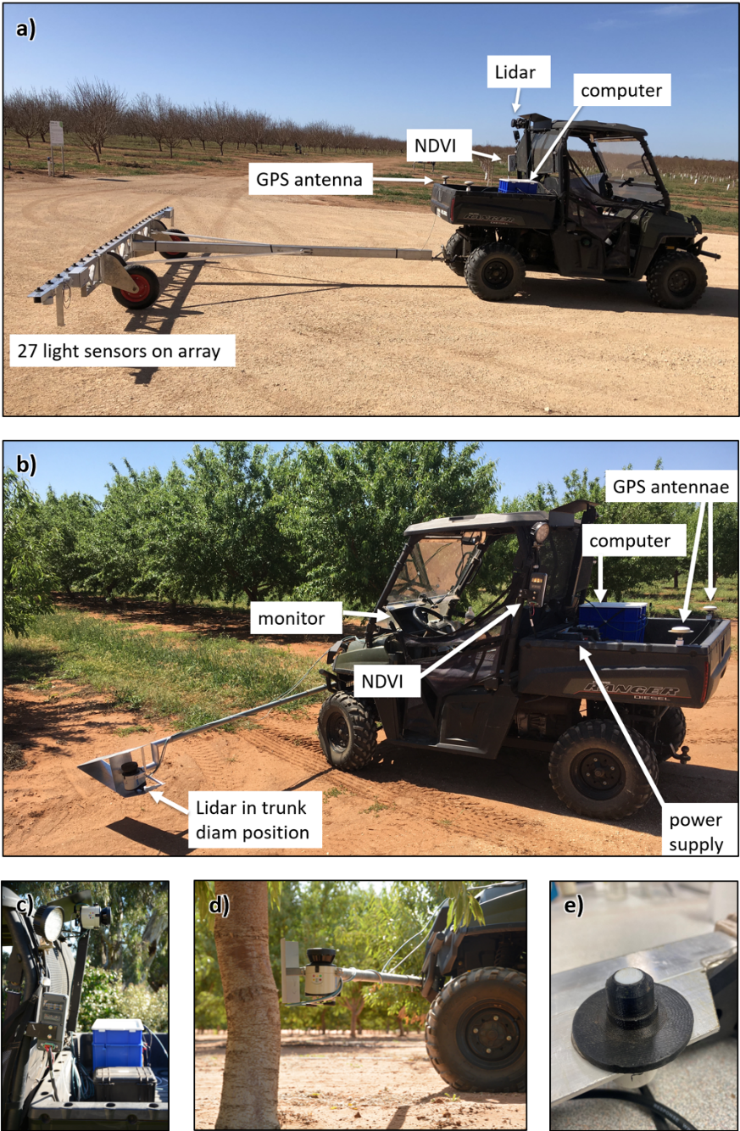

Figure 22. Mobile Orchard Phenotyping Platform (MOPP) system showing set-up for under-canopy light interception and measurement of canopy height (a) set-up for measurement of trunk diameter (b and d), NDVI (c) and photodiode light sensors (e).
A LiDAR sensor (LMS111 2D sensor, SICK, Breisgau, Germany) was used to measure tree height by subtracting the lowest value (ground level) from the highest value (maximum tree height) for each scan. In an alternate orientation the LiDAR sensor measured trunk diameter at 30 cm above ground level, as the largest contiguous object within the field of view of each scan (Figure 23). The LiDAR unit had an aperture of 270°, which was restricted to 135° for tree height or 60° for trunk diameter measurement. For trunk measurement the field of view was further restricted to a maximum of 1.5 m to reduce extraneous readings. LiDAR specifications were ± 30 mm systematic error and 12 mm statistical error, and scanning rate was 25 Hz.
For positional location, the MOPP was fitted with a GPS-enabled Inertial Measurement Unit (Certus, Advanced Navigation, Sydney, Australia). The Inertial Measurement Unit was used to monitor the real-time location of the MOPP during measurement. GPS post-processing was used to increase accuracy of the dual frequency GNSS unit from 1.2 to 0.01 m and update the original data.
Data were collected and processed by a dedicated computer and database program. A field computer designed for vehicle use (ARK2250V, Advantech Co. Ltd, Taipei, Taiwan) ran a custom database program which received and integrated data from a GPS enabled Inertial Measurement Unit (IMU), LiDAR, light sensors, and other attached sensors (e.g. NDVI). Current location, travel path and LiDAR output was displayed in real time. Geofences were defined in the program from surveyed tree locations, using the real-time GPS data that was allocated to plots or individual trees as it was collected. Light readings from each sensor were allocated to the relevant tree in their individual positions. While recording survey data, locations of the MOPP and trees in the survey area were shown in real time, along with the current output of the LiDAR sensor.
Data from all sensors were reported separately on an individual tree basis, allowing comparison based on applied treatments such as tree spacing and genotype. Light readings were generally taken within one hour of solar noon to minimise errors associated with the position of the sun. The MOPP was operated at around 5 km/h. Measurements were taken under clear skies where possible and the reference sensor was used to calculate light interception.
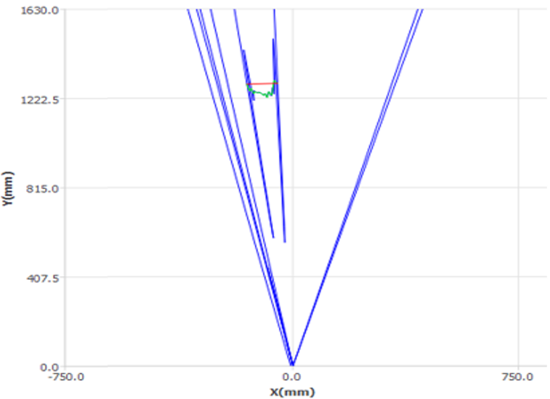

Figure 23. Display of LiDAR sensor in trunk diameter mode, showing top view of trunk shape in green and calculated diameter in red. Peripheral blue lines are from detected objects which are outside the defined field of interest and thus excluded from calculations. Chart axes are distance from the LiDAR sensor.

Application of the MOPP in SARDI’s AS18000 field experiment
The MOPP system was deployed every 6-8 weeks during the growing season for the collection of measures from more than 600 buffered experimental trees that were then averaged to detail canopy metrics for 72 replicated experimental units. Measurement timesteps targeted key phenotypic stages such as dormancy, leaf expansion, hull-split, and post-harvest. A single MOPP survey typically took less than an hour to measure multiple canopy metrics from more than 600 experimental trees. MOPP measurements from SARDI’s super-high-density almond field experiment are detailed in the previous section of this report. The below datasets and schematics represent examples of validations against physical measures of canopy height and trunk diameter (Figure 24 and Figure 25) as well as measurements of light interception (Figure 26 and Figure 27).
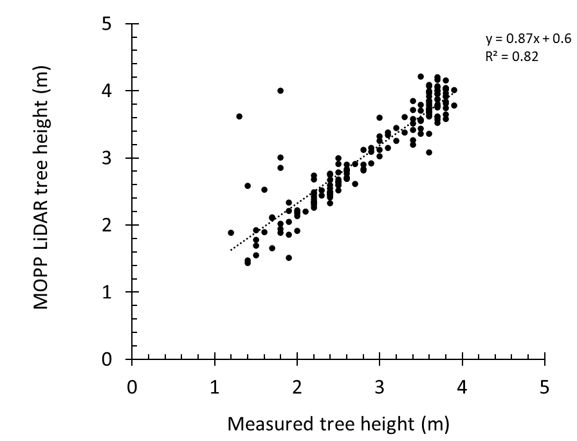

Figure 24. Calibration of MOPP LiDAR tree height to manual measures of tree height.

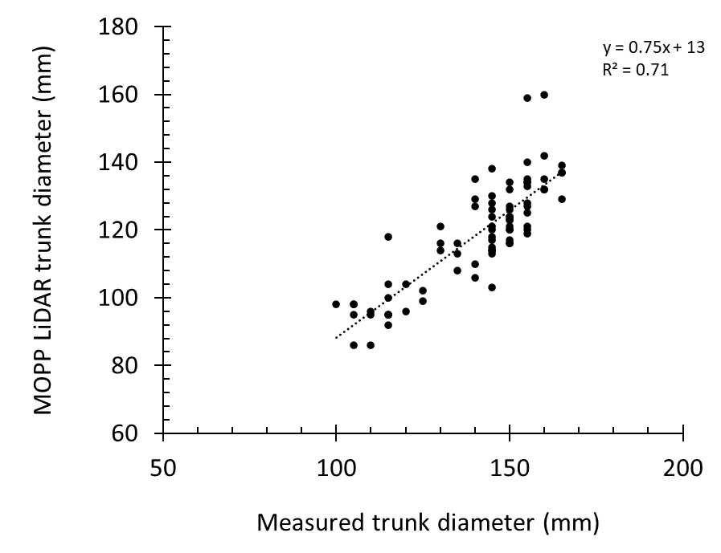

Figure 25. Calibration of MOPP LiDAR trunk diameter to manual measures of trunk diameter.

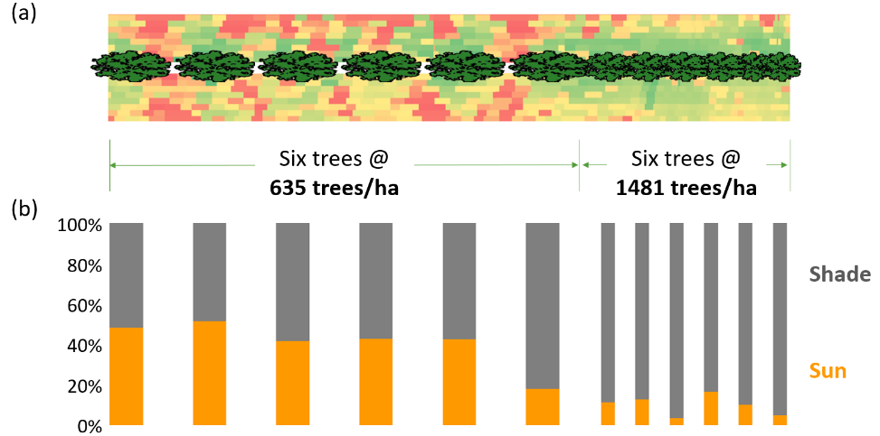

Figure 26. Schematic of differences in the MOPP ceptometer output when driven beneath canopies of almond trees planted at 635 and 1481 trees/ha. Aerial view of tree row where red pixels equate to sunlit orchard floor, green pixels equate to under-canopy shade (a). Orange/grey bars describe average measures of light interception along low- and high-density experimental plots (b).

Figure 26 shows a greater proportion of sunlight reaching the orchard floor (red shading) in the open spaces between trees at 635 trees/ha compared to the more shaded orchard floor beneath trees planted at 1,481 trees/ha. This pattern can be seen in both individual pixels and for the overall colouring of the entire experimental plot. Pixels within the geofence for each tree have been allocated to either sun or shade and the proportion integrated into the orange/grey bar chart (Figure 26b) to give a summary representation of the same data. Light interception at a single timestep is presented for Shasta and ‘Vela’ trees across the three densities transition being assessed in SARDI’s super-high-density planting (Figure 27). Datasets, such as this, from multiple timesteps per season have been integrated into canopy development charts in the previous section of this report.

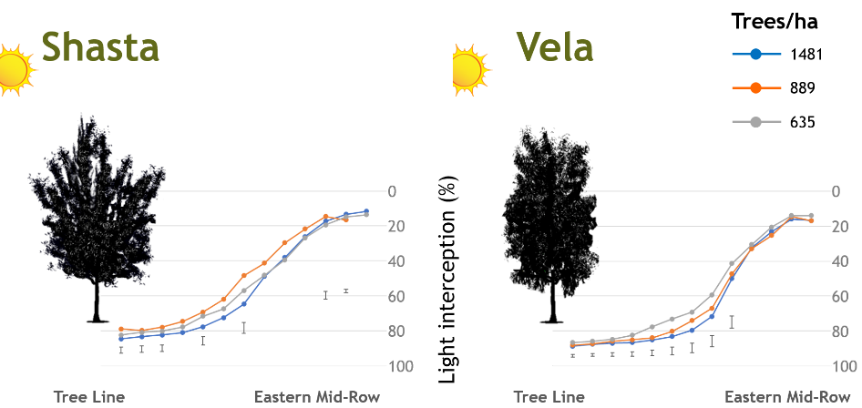

Figure 27. Example of canopy light interception for almond cultivars Shasta® and ‘Vela’ planted to three densities. As measured across a 1.5 ha experimental orchard by the MOPP’s ceptometer array. Error bars reflect significant difference at P<0.05.

Conclusions
Previous studies have shown variable relationships between light interception and the kernel yield of almond trees (Lampinen et al., 2014, Zarate-Valdez et al., 2015). However, the data collected by SARDI’s MOPP, which rapidly measures light interception and canopy size metrics from large experimental plantings, is proving invaluable for SARDI’s investigations at the ACE experimental orchard. Data from the MOPP help explain treatment differences in multiple almond field experiments and provide context for cultivar, density, and pruning treatments in relation to canopy size, yield metrics, and resource use. Other methods used by SARDI to estimate canopy size and infer water use and/or light interception dynamics include aerial imagery and static camera sensors positioned beneath the tree canopy. Each method has its complications, such as interference from ground covers in the mid-row (aerial imagery) or the low spatial resolution from fixed-position sensors (under-tree cameras). The MOPP, therefore, proves to be a versatile platform for SARDI’s experimental measures.
Automated canopy assessment systems like the MOPP represent a significant advancement in orchard sensing. By integrating various sensors and leveraging GPS technology, the MOPP provides rapid, large-scale and precise data that can improve decision-making and optimise the characterisation of experimental treatments. The ability to quickly and accurately measure light interception, tree size, and other critical metrics helps researchers and growers better understand the factors influencing yield and tree health, ultimately leading to more efficient and sustainable orchard practices.
In commercial practice, the rapid availability of such data could assist in optimising orchard management decisions. Commercial providers of similar, modular, mobile monitoring units now offer almond growers data collection at more than 40 km/hr (for almonds) together with rapid post-processing. SARDI’s MOPP has not been developed to operate in this space, but still represents a significant advance for research scientists wishing to quickly measure the effects of large-scale experimental treatments.
The GPS-enabled IMU and mobile computer system that form the basis of the MOPP have potential to be connected to a variety of other sensors, enhancing its data collection and processing capabilities. These sensors could include EM38 for measuring soil variability, thermal cameras to infer canopy stress and load cells such as those fitted to harvest bin trailers. Ongoing development of the MOPP could allow for the rapid and efficient measurement of a range of other useful parameters.

SARDI AS18000 - Deliverable 4 of 4: Economic analysis of intensive plantings
Operating costs and returns were compared between a range of super-high and industry-standard planting densities, using cost base inputs unique to each density and genotype combination (e.g. tree costs) and assuming standard orchard practices (e.g. spraying). The cumulative cash flow was calculated based on measured inputs and crop yields from SARDI’s super-high and traditional-density plantings at the ACE experimental orchard through to the 2025 harvest. In the absence of further data, expenditure and revenue figures were assumed to remain constant after this point. Cost-benefit calculations compared differences in orchard establishment costs, labour, irrigation, nutrient, machinery inputs and yield trends including pricing impacts due to differences in kernel qualities. Multiple economic scenarios were assessed using a mix of measured data from SARDI field experiments, benchmarked against and augmented with industry data, from consultation with private and corporate almond growers. The four cash flow simulations presented include:
Two scenarios using input data from ACE field experiments
- Shasta at three super-high-densities compared to ‘Nonpareil’ and Shasta at one traditional density
- ‘Vela’ at three super-high-densities compared to ‘Nonpareil’ and ‘Vela’ at one traditional density
- Scenarios 1 & 2 contain high establishment costs from the inclusion of temporary steel trellis structure
- Scenarios 1 & 2 reflect the price differential experienced with cultivars other than ‘Nonpareil’
Two hypothetical scenarios
- Shasta at three super-high-densities compared to ‘Nonpareil’ and Shasta at one traditional density
- ‘Vela’ at three super-high-densities compared to ‘Nonpareil’ and ‘Vela’ at one traditional density
- Scenarios 3 & 4 exclude steel trellis and instead use bamboo stakes and high-intensity hedging
- Scenarios 3 & 4 assume price parity with Nonpareil
Variables included in the cash flow simulations are summarised through the following tables.

Table 8. Density scenarios assessed in economic analysis
 | Traditional density* | Super-high-density†
 | (H1) | (H2-H3)
Cultivar | ‘Nonpareil’ | Shasta® | ‘Vela’ | Shasta®| ‘Vela’
Architecture | Free-standing | Central leader hedge
Density (trees/ha) | 308 | 635 | 889 | 1,481
Row spacing (m) | 6.5 | 4.5
Tree spacing (m) | 5.0 | 3.5 | 2.5 | 1.5
* Traditional density based on measured data from SARDI density optimisation trial H1-H2 (ACE)
† Super-high-density based on measured data from SARDI density optimisation trial H2-H3 (ACE)

Cost and return datasets were sourced from the ACE orchard management records and supplemented with SARDI operational records, which was heavily weighted to the canopy establishment phase. Experimental yield datasets were sourced from replicated largescale plots (reported elsewhere in this report). Data gaps were addressed using input from industry experts including price per kilogram of kernel, transport and processing costs etc.

Estimates of orchard establishment and tree training costs (1st and 2nd leaf)
Orchard establishment costs were assessed during the SARDI project ST16003 (Table 9). A key factor contributing to cost differences across planting densities was not only the additional expense of extra trees but also the inclusion of a temporary steel post trellis system that supported the canopy through the first three seasons. In the super-high-density trial, the use of low-vigour rootstocks incurred proprietary fees, raising the per-tree cost to $30. For this economic analysis, tree performance data from those grafted onto Rootpac 40 rootstocks (which showed the most consistent yield) were used to evaluate the super-high-density scenarios.

Table 9. Almond orchard establishment and tree training costs (up to 2nd leaf). Scenarios 1 & 2 include steel trellis structure for H2-H3 trees. Scenarios 3 & 4 use bamboo stakes for H2-H3 trees and include additional hedging operations (captured in annual management costs).
 | H1 | H2-H3
 | 308  (trees/ha) | 635  (trees/ha) | 889  (trees/ha) | 1,481  (trees/ha)
Tree costs ($/ha) | 5,544 | 11,430 | 16,002 | 26,658
Planting | training ($/ha) | 2,152 | 4,288 | 5,832 | 9,715
Irrigation ($/ha) | 4,692 | 5,889 | 5,889 | 5,889
Scenarios 1 & 2
Hardwood stakes | ties ($/ha) | 2,051 | - | - | -
Steel trellis | bamboo | ties | - | 14,775 | 15,595 | 20,208
Scenarios 1 & 2 Total ($/ha) | 14,439 | 36,382 | 43,318 | 62,470
Scenarios 3 & 4
Hardwood stakes | ties ($/ha) | 2,051 | - | - | -
Bamboo stakes | ties ($/ha) | - | 1,393 | 1,950 | 3,248
Scenarios 3 & 4 Total ($/ha) | 14,439 | 23,000 | 29,673 | 45,510

Estimates of annual orchard management costs (3rd leaf onwards)
Categories of orchard management activities were based on those published by Pocock (2008) and informed by ACE orchard management costs plus input from both private and corporate almond growers. Average annual orchard management costs were estimated to be $19,125/ha for traditional 308 tree/ha ‘Nonpareil’ almond. This value varied year to year based on water inputs, yield performance etc. Generally, irrigation and nutrition were the most significant costs equating to 29% and 12% of annual running costs respectively. The cost of labour was captured as a component in each orchard operation. Table 10 shows a summary of annual orchard management costs for each density presented in scenarios 1 to 4.

Estimated yield and returns
Yields from SARDI field trials were incorporated into the cash flow simulations. These trials included free-standing ‘Nonpareil’, Shasta, and ‘Vela’ (308 trees/ha) from SARDI’s H1 to H2 density optimisation trial, as well as super-high-density, modified central leader hedge-formed Shasta and ‘Vela’ (635, 889, and 1,481 trees/ha) from the H2 to H3 density optimisation trial.
The 2025 yields from the H1 to H2 experiment represented that orchard’s 7th leaf dataset. In contrast, the 2025 yields from the H2 to H3 experiment represented the 6th leaf. However, because the first season of the H2 to H3 trial effectively served as a nursery year, due to the use of small proprietary planting material, the economic simulation adjusted the yield timeline forward by one season. As a result, the 2025 data from the H2 to H3 orchard was treated as 5th leaf in the simulation.
Predicted yields were used in the simulation from the 7th leaf onward for the 308 trees/ha plantings, and from the 5th leaf onward for the 635 to 1,481 trees/ha plantings. For the 308 trees/ha configuration, predicted yields were informed by experience at ACE and other Riverland orchards, with expected yields of 3.8 t/ha for ‘Nonpareil’ and Shasta, and 4.4 t/ha for ‘Vela’. For the higher-density plantings, predicted yields were based on the average performance over the previous three seasons, ranging from 3.0 to 3.8 t/ha for Shasta and 4.0 to 4.8 t/ha for ‘Vela’.
Kernel prices attributed to each cultivar were informed by industry records. The average prices used across the simulation period were $7.20/kg for ‘Nonpareil’, $6.12/kg for Shasta, and $5.70/kg for ‘Vela’. The price for Shasta included downgrade penalties to reflect the higher proportion of shrivel observed in this cultivar within the experimental planting.

Table 10. Proportion of orchard management activities* contributing to annual production cost per hectare for producing almonds in traditional (H1) and super-high-density (H2-H3) production systems.
 | H1 |  | H2-H3 |  |  | Proportion
 | 308  (trees/ha) |  | 635  (trees/ha) | 889  (trees/ha) | 1,481  (trees/ha) | (average)
Disease management ($/ha) | 697 |  | 913 | 913 | 913 | 4%
Pest management ($/ha) | 170 |  | 223 | 223 | 223 | 1%
Nutrition ($/ha) | 2,259 |  | 2,494 | 2,494 | 2,494 | 12%
Herbicide ($/ha) | 1,020 |  | 1,266 | 1,266 | 1,266 | 6%
Application costs ($/ha) | 1,469 |  | 1,776 | 1,776 | 1,776 | 9%
Birds ($/ha) | 622 |  | 622 | 622 | 622 | 3%
Ground maintenance ($/ha) | 513 |  | 672 | 672 | 672 | 3%
Pruning ($/ha) | 805 |  | 1,632 | 1,632 | 1,632 | 7%
Irrigation ($/ha) | 6,455 |  | 5,460 | 5,460 | 5,460 | 29%
Bee hire ($/ha) | 1,510 |  | 1,510 | 1,510 | 1,510 | 8%
Harvest ($/ha) | 1,016 |  | 1,445 | 1,570 | 1,852 | 7%
Freight ($/ha) | 913 |  | 666 | 623 | 670 | 4%
Cracking ($/ha) | 1,676 |  | 1,182 | 1,116 | 1,230 | 7%
TOTAL COSTS ($/ha/yr) | 19,125 |  | 19,861 | 19,877 | 20,320
* Hypothetical scenarios (without the use of steel trellis) assumed additional hedging costs (16% of total) and reduced harvest costs (4% of total).

Simulated cumulative cash flow curves
Hypothetical cumulative cash flow curves Figure 28 to Figure 30 were generated based on the assumed orchard establishment costs, the assumed variable orchard management costs and the yields measured from SARDI’s large-scale experimental plantings supplemented by forecast estimates of yield performance through to the 12th leaf.

Figure 28. Cash flow simulation #1 – Comparison of Shasta® (@$6.12/kg kernel) at various densities against a traditional ‘Nonpareil’ orchard (@$7.20/kg kernel). Trees at densities from 635-1,481 trees/ha in this simulation are trained to a steel post trellis.

Figure 29. Cash flow simulation #2 – Comparison of ‘Vela’ (@$5.70/kg kernel) at various densities against a traditional ‘Nonpareil’ almond orchard (@$7.20/kg kernel). Trees at densities from 635-1,481 trees/ha in this simulation are trained to a steel post trellis.

Figure 30. Cash flow simulation #3 – Comparison of Shasta® at various densities against a traditional ‘Nonpareil’ almond orchard. Assumes price parity for Shasta and ‘Nonpareil’ (@$7.20/kg kernel), no trellis, additional hedging and discounted harvest costs.

Figure 31. Cash flow simulation #4 – Comparison of ‘Vela’ at various densities against a traditional ‘Nonpareil’ almond orchard. Assumes price parity for ‘Vela’ and ‘Nonpareil’ (@$7.20/kg kernel), no trellis, additional hedging and discounted harvest costs.

Economic Insights from Simulated Cash Flow Models
The simulated cash flow models revealed several key insights and system sensitivities, particularly in Scenarios 1 and 2, which reflected actual production conditions from SARDI’s super-high-density experiment at the ACE orchard (see Figure 28 and Figure 29). In these scenarios, all high-density treatments—regardless of cultivar or rootstock—were found to be uneconomic.
A primary factor contributing to this outcome was the significant increase in tree numbers used at higher planting densities. The highest density trialled (1,481 trees/ha) involved nearly five times as many trees as the Horizon 1 orchard (308 trees/ha). This alone added over $20,000/ha to establishment costs. Additionally, the temporary steel trellis system used to support trees in the experiment contributed a further $15,000–$20,000/ha depending on density. These combined costs significantly delayed the time to break even, rendering super-high-density systems uncompetitive compared to traditional free-standing orchards. The financial gap would be even wider when using small, expensive planting material, such as proprietary low-vigour genetics from some suppliers.
Beyond the cost of the trees themselves, the increased tree count also raised the cost of associated operations, including planting, staking, and training. These compounding factors further undermined the economic viability of high-density systems under current conditions.
The cultivar and the resulting yield and value of the nuts produced also impacted on orchard economics. The higher yields of traditionally grown ‘Vela’ (308 trees/ha) were sufficient to compensate for the lower price relative to ‘Nonpareil’ (308 trees/ha), but this was not the case for Shasta. Note that the upright form of the ‘Nonpareil’ and non-self-fertile nature was deemed unsuitable for testing in super-high-density planting systems and so was only available for comparison at the lower density of 308 trees/ha.
Exploring Hypothetical Improvements
To explore whether these limitations could be overcome, Scenarios 3 and 4 modelled hypothetical improvements based on potential future research outcomes. These included:
- Eliminating the cost of formal trellis structures and increasing early-life hedging frequency
- Reducing harvest costs by adopting off-ground, reduced-pass systems (shake-and-catch)
- Removing price penalties applied to non-‘Nonpareil’ cultivars
While these assumptions are ambitious and not yet commercially viable, they help identify where future research and industry development should focus to make super-high-density systems feasible for Australian growers.
Trellis Alternatives and Tree Architecture
The cost of formal trellis structures emerged as a major barrier. A more viable alternative may involve replacing trellis structures with simple staking systems that support upright growth while encouraging a compact canopy through regular tipping and hedging. Bamboo stakes, being low-cost and scalable, could replace traditional hardwood stakes, especially as tree numbers increase. However, the adequacy of bamboo for long-term support remains to be validated.
Higher-density plantings offer the advantage of smaller trees—both in height and trunk diameter—which allows for the use of smaller, less powerful machinery for pruning and harvesting. Achieving optimal tree form will likely require more frequent hedging to increase fruiting points and maintain canopy compactness. Smaller trees may also reduce the need for structural support, reinforcing the feasibility of eliminating trellising altogether.
The reduction in tree size could also facilitate the adoption of alternative shake-and-catch harvest technologies. However, these systems must be purpose-built for tree crops, rather than adapted from other industries such as viticulture, which involve different plant structures and growth habits.
If successful, this shift could transform harvest operations from a costly, multi-pass process into a streamlined, single-pass system. It would also enable improvements in inter-row maintenance, dust and heat reduction, soil health, nut hygiene, and handling efficiency.
Sensitivity Analysis and Economic Implications
A sensitivity analysis that tested options between scenarios 1 and 2 and scenarios 3 and 4 (data not shown) tested the impact of removing trellis costs and introducing improved hedging and harvest practices, whilst maintaining the price penalty for non-preferred cultivars. While these changes improved the economic outlook, they were not sufficient to make super-high-density systems cost-competitive. Even under these improved conditions, all super-high-density scenarios remained cash-flow negative until at least the 14th season.
Cultivar Pricing and Market Dynamics
In addition to agronomic challenges, the use of self-fertile varieties introduces a significant marketing and pricing issue. Currently, all cultivars other than ‘Nonpareil’ attract a price penalty, giving ‘Nonpareil’ a persistent economic advantage. This pricing disparity is a critical factor when evaluating the viability of alternative production systems.
For example, ‘Vela’ has demonstrated 20% higher cumulative and more consistent yields compared to ‘Nonpareil’. However, these yield advantages are often insufficient to offset the price premium ‘Nonpareil’ commands in the market.
When modelling scenarios that retain the trellis structure but assume price parity across cultivars, the economic picture shifts. Under these conditions, ‘Vela’ and Shasta at 308 trees/ha break even four and one year earlier, respectively, than ‘Nonpareil’ at the same density. ‘Vela’ at 635 and 889 trees/ha breaks even one year earlier than ‘Nonpareil’ at 308 trees/ha, and ‘Vela’ at 1,481 trees/ha breaks even in the same year. However, none of the Shasta super-high-density scenarios break even before the 14th season.
Combined Scenario Modelling
Scenarios 3 and 4 (Figure 30 and Figure 31) modelled a best-case scenario combining four key (ambitious) assumptions:
- Trellis costs are largely eliminated, except for bamboo stakes
- Pruning costs are doubled to support improved tree architecture
- Harvest costs are reduced by 50% to reflect alternate, off-ground, harvest system
- Variety prices achieve parity with ‘Nonpareil’
These combined changes represent a significant departure from the current commercial situation. However, they illustrate the potential for super-high-density systems to become economically viable if multiple industry-wide transformations occur simultaneously.
Pathways to Viability
Under these best-case conditions, the economic outlook for high-density plantings becomes far more attractive. This model not only improves financial viability but also opens the door to a range of agronomic and operational benefits. However, achieving this vision will require coordinated efforts across the industry:
- Marketers must work to achieve price parity for alternative cultivars
- Agricultural engineers must develop machinery tailored to compact, high-density orchards
- Agronomic researchers must optimise tree physiology and management practices for novel planting systems
Only through such transformational change will Australian growers gain the confidence to invest in super-high-density systems. Until then, the stepwise learnings from field experiments and associated modelling will continue to inform and improve both ambitious production targets and traditional orchard systems.

References
Allen, R. G., Pereira, L. S., Raes, D. & Smith, M. 1998. Crop evapotranspiration: Guidelines for computing crop water requirements, Rome, Italy, Food and Agriculture Organisation of the United Nations.
Goodwin, I., Whitfield, D. M. & Connor, D. J. 2006. Effects of tree size on water use of peach (Prunus persica L. Batsch). Irrigation Science, 24, 59-68.
Jackson, J. E. 1980. Light Interception and Utilization by Orchard Systems. Horticultural Reviews.
Lampinen, B., Upadhyaya, S., Udompetaikul, V., Browne, G., Roach, J., Metcalf, S., Stewart, W., Contador, L., Negron, C., Gã³Mez, I. P., Beede, B., Debuse, C., Doll, D., Duncan, R., Edstrom, J., Elkins, R., Fichtner, E., Grant, J., Hasey, J., Holtz, B., Kelley, K., Krueger, B., Niederholzer, F. & Olson, J. A second generation mobile platform for assessing midday canopy photosynthetically active radiation interception in orchard systems. 2014. International Society for Horticultural Science (ISHS), Leuven, Belgium, 105-112.
Lampinen, B. D., Udompetaikul, V., Browne, G. T., Metcalf, S. G., Stewart, W. L., Contador, L., Negron, C. & Upadhyaya, S. K. 2012. A Mobile Platform for Measuring Canopy Photosynthetically Active Radiation Interception in Orchard Systems. Horttechnology, 22, 237-244.
Maas, E. V. & Hoffman, G. J. 1977. Crop salt tolerance - current assessment. Journal of the Irrigation and Drainage Division, IR2, 115-134.
Mcfadyen, L. M., Morris, S. G., Oldham, M. A., Huett, D. O., Meyers, N. M., Wood, J. & Mcconchie, C. A. 2004. The relationship between orchard crowding, light interception, and productivity in macadamia. Australian Journal of Agricultural Research, 55, 1029-1038.
Ollat, N., Fermaud, M., Tandonnet, J. P. & Neveux, M. 1998. Evaluation of an indirect method for leaf area index determination in the vineyard: Combined effects of cultivar, year and training system. Vitis, 37, 73-78.
Pitt, T., Skewes, M., Fleming, N., Thomas, D., Phogat, V., Graetz, D. & Shanmugam, K. 2021. Advanced production systems for temperate nut crops - SARDI ST16003. In: PITT, T. (ed.). Hort Innovation Australia Limited.
Pocock, D. 2008. Economics of Almond Production in Southern Australia, Horticulture Innovation Australia.
Reuter, D. J. & Robinson, J. B. 1997. Plant analysis : an interpretation manual. 2nd ed. ed. Collingwood, Vic. :: CSIRO Publishing.
Robinson, T. L., Lakso, A. N. & Carpenter, S. G. 1991. Canopy Development, Yield, and Fruit Quality of `Empire' and `Delicious' Apple Trees Grown in Four Orchard Production Systems for Ten Years. Journal of the American Society for Horticultural Science jashs, 116, 179-187.
Thomas, D. S. & Hayman, P. T. Evaluation of an almond phenology model under Australian conditions. 2018. International Society for Horticultural Science (ISHS), Leuven, Belgium, 125-132.
Wagenmakers, P. S. & And Callesen, O. 1995. Light distribution in apple orchard systems in relation to production and fruit quality. Journal of Horticultural Science, 70, 935-948.
Williams, L. E. & Ayars, J. E. 2005. Grapevine water use and the crop coefficient are linear functions of the shaded area measured beneath the canopy. Agricultural and Forest Meteorology, 132, 201-211.
Zarate-Valdez, J. L., Muhammad, S., Saa, S., Lampinen, B. D. & Brown, P. H. 2015. Light interception, leaf nitrogen and yield prediction in almonds: A case study. European Journal of Agronomy, 66, 1-7.

Appendix 8. Almond Stakeholder Impact Review
The National Tree Crop Intensification in Horticulture (AS18000) program stakeholder impact review was conducted in March 2025.
Forty (40) telephone interviews were conducted by the AS18000 Program Coordinator, and one written, collated response was provided by a peak industry body. Each interview averaged a twenty-minute duration.
The focus of the review was to seek insight from groups one and two of the Monitoring and Evaluation Plan (April 2025) - growers, service providers (industry development officers, commercial advisors, private advisors), and peak industry body representatives. Those interviewed were Crop Reference Group (CRG) members or had been engaged in projects as a host farmer/ company agronomist and/or attended project extension activities.
The purpose was for those interviewed to provide insight into the:
- immediate and longer-term industry stakeholder impact of the activities and outcomes of the research undertaken between 2020-2025; and
- outcomes they believe are needed for their industry from future research and development into more efficient, sustainable and quality driven orchard systems.
Ten questions were posed (Appendix 8A), four structured with a rating response required between 1 (most negative) and 5 (highly positive) (Table 1), with opportunity provided to expand upon the rating with commentary and/or within responses to the six open-ended questions. Open-ended questions allowed respondents to express their feedback and insight in a less formal and structured approach (Table 2). These responses were particularly insightful in identifying what was important to them should “next phase research” be undertaken, and highlighted areas for improvement in the planning, consultation and delivery of future projects.
Where respondents struggled to recall detailed components of the five-year research, they were prompted with a pre-scripted overview of the key orchard system challenges or unknowns addressed by the project (e.g., vigour management, tree architecture, orchard light environments and canopy microclimate, crop load, water use efficiency and precocity) and the associated activities (e.g., rootstock, variety and scion trials, pruning trials, carbohydrate and plant growth regulator studies). These overviews were supplied to the Program Coordinator by the Crop Leaders.

Almond Stakeholder Impact Review
Insight provided by ten (10) interview respondents has been used to inform the stakeholder impact for the almond project, led by Plant & Food Research, in partnership with the South Australian Research and Development Institute (SARDI).

Table 1. Summary response to rating questions
 | The R&D was relevant to future needs of the industry | There are signals of adoption/ future intent to adopt. | There were gains in knowledge & understanding | Engagement activities were of value.
Program (n=41) | 3.7 | 2.9 | 3.6 | 4.3
Almond (n=10) | 3.5 | 2.3 | 3.9 | 4.4

Table 2. Almond Key Evaluation Criteria and stakeholder results
RELEVANCE OF THE ACTIVITIES & OUTCOMES: Were the activities and outcomes (as communicated at this time) of the research relevant to growers/ service providers of your industry, particularly those striving for more efficient and quality driven orchard systems? What further outcomes are needed from future research?
Relevance of the research: 3.5/5  Respondents were satisfied that project allowed the industry to investigate unchartered territory, especially super high density, to test how far current rootstocks and varieties could be “pushed”. Respondents believed the “negative” outcomes were as important as the “positives”, to inform growers on what is unlikely to work under Australian growing conditions.  Learning more about vigour controlling rootstocks, the potential for earlier yields, increased young tree stability and water/nutrient use efficiency were seen as relevant outcomes, although more long-term data is needed.  It was acknowledged that this type of research is long-term and what has been achieved is a strong foundation for future research. There were calls for the Spanish influenced tree architecture trials to continue, and suggestions this work should have commenced earlier in the project. The work being conducted at both ACE under controlled conditions and within commercial orchards was highly valued. Some viewed the work as “high risk” and the ACE facilities allow researchers to conduct the research with ample opportunity for industry to experience outcomes for themselves through visiting the site.  All respondents addressed the need to see more economics along-side the research, especially return on investment (ROI) figures. It was also raised that future research needed to better support improved water and nutrient efficiency with the same or better yield and quality. This was seen as having greater relevance to the industry in the more immediate term. Growers believed that knowing the “best bet” combination of rootstock and variety to deliver greater input efficiencies (including labour) was needed. Looking towards the Spanish systems was favoured by some respondents- a model that perhaps yields less but also uses proportionally less water and fertiliser.  Commercial enterprises needed to modify existing machinery. There were calls to trial and evaluate the economics of new engineering options in future research. | If we can prove it will work, they [growers] will go for it. It needs the longevity and ROI. It needs to keep going - we need to see which treatment at full conclusion (i.e., 15- 20 years). The HD stuff should be the high yielding stuff- farm less area with HD to get more from it. Needs to be a whole-of-life research- so the high input costs can be justified.  The yield potential, and early yields. Was a real positive out of this.  Vigour controlling rootstocks was probably the most valuable. Pruning was not so relevant to the varieties we are growing.  ‘Vela’ on ‘Atlas’ rootstock was an unexpected outcome.  Some good yield results in different variety and rootstock combinations presented at the ‘Carina’ field day.  It's not fair to have expectations in this time but has provided a definite foundation to go forward. It's not about what hasn't happened.  It's a long game, that's why it’s not a 5. The research is a work progress. While water and fertiliser are not a direct outcome, I think the best outcome for the tree in terms of production is how these things have become more efficient.  For this project, the industry is looking for closer planting, they are hesitant, but this work allows them to see and evaluate it without the risk- PFR are doing it for them.  It needs to continue for a lot longer, especially the new planting trials- the work is very similar to what they have seen in Spain, so the growers want to see this and get an idea of how it may suit what they think they want to do.  My thoughts are we need to keep it going to work out the ROI over time.  Economics & ROI needs to be looked at in this work. There are a lot of issues around varieties and tree structure that have to be looked into.  In hindsight, if we are adopting different methodologies like apples in NZ or HD Almonds in Spain, we need to continually liaise with international stakeholders- more travel abroad. We need to know what the expectations and drivers prior to the research are. US, Spain, Portugal visits are a short-cut to avoid the issues they have already resolved.  Everything worked out really well, but I guess the biggest frustration was the right machinery to harvest. It's a chicken and the egg thing. Shakers mainly- we had to modify an old shaker and sweeper- tractors found it tight. We would have liked to trial some new tech machinery.  For me, [I’d like to see] efficiencies [gained] based upon rootstock/ variety combinations- making those decision for the lifetime of the orchard and the way it will be managed.  Machinery! Really want to look at the water and fertiliser at HD- I do believe that we shouldn't hold back. Disease and pest management- will less air circulating, this will make a different environmental for disease and pests.  I enjoy R&D, but some of the application is still missing. Some missed opportunity by not getting into the Spanish partnership earlier and getting results during this project.
IMPACT UPON ADOPTION/ INTENT TO ADOPT IN THE FUTURE: How likely is it that growers will adopt/ service providers will adjust their advice because of the project? Is there evidence of adoption or intent to adopt in the future due to engagement in the project? Why/ why isn’t it important to businesses?
Impact upon adoption/ future adoption: 2.3  “Intensity’ in the next ten years was seen as industry transitioning to slightly tighter tree spacing. Barriers to intensification include:  - Researched/ demonstrated systems restricted to growers planning to replant  - Yet to demonstrate convincing improvements on current practice or profitability  - Return on investment for costs in establishing and managing the systems long-term remain unknown (i.e., pruning, fuel usage, input costs V early and lifespan yield)  - Gaps in knowledge on how systems need to be managed for the lifespan of the orchard, and unknowns of that lifespan  - Machinery for hedging and spraying narrower orchards  - Harvest constraints- engineering shake & catch and sweepers for narrow orchards, drying methods- it changes the whole process  - Lack of confidence in available rootstock and variety combinations that will yield well long-term to outweigh initial costs  - Lack of varieties that yield well (with same or improved production) and have consistent nut drop  - Unknown pest and disease implications of tighter plantings with less airflow through the orchard environment  Components of the research that are being adopted or investigated include:  - Examples of changed row and tree spacing  - Certain demonstrated hedging techniques  - Certain demonstrated pruning techniques  Future drivers to adoption:  - Gains in efficiency & profitability  - Design that allows for mechanised systems to reduce labour  - Sustainability of the industry in Australia | There has been a shift to marginally tighter tree spacing - approximately 15%. We're a long way from true HD.  I know that some of the corporate growers will certainly have a closer look as they need to replant. They are looking at it as they need to be good corporate citizen- input efficiency reasons i.e., water. This is what the project has been looking to achieve- the relationship between efficiency and intensification.  What standouts for me is that we are not a country that needs to consider limited space. We are better at concentrating on the efficiency of the current system- i.e. light interception- and the cost v benefit.  Intensification will be [adopted]- we are still traditional. I'm not sure we will get to 1000 trees/ha (currently 308-335/ha) but will transition somewhat over time, I'm sure. Until we can get something that can stay on a tree from a shake & catch perspective (need the genotypes etc), then we can't move on it. We need the machinery to make that leap, we can't collect on the ground in narrow spaces, and the drying processes need to be there.  Some of the varieties tested are not yet commercialised- when can they be?  Sitting on the fence at the moment- we are all interested but need the longer-term management of these systems and ROI.  We have gone to a higher intensity, but not full HD. The benefits would be good, but we need to fill the gaps about how to manage it, and this is the unknown longer-term.  We still need more engineering- machinery for harvesting, spraying, hedging needs to come.  The economics is important, and what systems need to change to manage these systems.  To change to a new orchard design, the economic benefits need to be known. But also, some bigger growers may see other benefits, i.e. harvest methods (move to 100% shake & catch), otherwise it's the safe [known] option for most.  There has been some very interesting stuff come out of it, but I am not sure anyone will adopt or [it will] be commercialised. We've been talking about intensification for such a long time, but I don't think that the results are going to take us forward in this space.  The costs to start with and also the harvesting is the hand-break. We need to address these. Unproven at this time. The R&D shows the production is much the same so the ROI is questionable, and longevity of the systems is still an unknown.  Probably not more profitable (well early stages are- harvesting by year 2 quite well), long-term hard to say what the production be (will they drop-off, or will they consistently produce for 20 years), looking at what we have done to them, they seem to need less labour (just a bit of hedging) but will this change with an older tree?- annual crop means it's long-term to work out what may happen (including disease influences).  …older growers absolutely not- too set at their ways. Newer growers are doing things a little tighter- labour, machinery, avoiding nut drop is what they are looking into- quality/ efficiency drivers.  We have actually come in tighter now- we are normally 7x6.5m, now 7x4m tree spacing. Seeing how it's managed with the hedging has given us the confidence to do this. It's a small step, but with the machinery it can work.  I think what they'll do for sure is some of the pruning techniques and shaping for sure- parts of the project. Data driven and seeing the trees- both has given them the confidence.  I guess, yes, indirectly, I've already gone to mid-density (6m x 3m), if I could go to the shake & catch (greener product), spur generation and how my water and fertiliser influence that, and dry harvesting potential.  When you look at other industries, like apples, it has improved the outcomes- this is the driver. Some of the efficiency gains & yield quicker, so ROI quicker.  It's purely economics and quality driven. Not dropping nuts and doing it all efficiently.  These efficiencies are important to profitability- more efficient use of water, labour, spraying and harvest.  Realistically, if there are ways to do things a little differently and progress the industry, we need to know what the next leaps are- we want to part of this and go forward. But always comes back to ROI.  Growers are keen to grow more from less, and the super HD does allow for this- less revenue but less inputs (profitability better)- so that's why there is the interest.
IMPACT UPON KNOWLEDGE & UNDERSTANDING: To what extent do you think your knowledge and understanding has improved because of the project? What are some examples of what has been learnt?
Impact upon knowledge and understanding: 3.9/5  Overall, there is a strong sense that more knowledge has been gained in “what’s possible” from existing genetics, especially earlier yield potential, and understanding “why it is possible”. However, there is hesitation that this insight is only the initial phase, and more is needed to fully appreciate the long-term (orchard lifespan) outcomes of more intensified systems. There were also concerns that the varieties used are not widely used by growers currently, but by improving physiological understanding of the ways in which the Shasta® and ‘Vela’ varieties respond to manipulation, there is transferable knowledge that can be communicated to industry now.  Specific improvements included:  - Strategies in training young trees to increase stability resulting in less losses. This in-turn has increased uniformity of the orchard, delivering input efficiencies  - To what extent technologies may need to operate in narrower orchards, and insights into spraying/fertilising needs (i.e., penetration into new canopy structures and closer tree spacing  - Understanding on what needs to be considered when managing the canopy for improved light interception  - Better timing of pruning and new cuts.  - Potential and benefits of dwarfing rootstocks.  - Growing relationships with Spanish genetics, systems and efficiencies  There was an appreciation for the way in which the research team had communicated findings at extension events so that growers could understanding the concepts and increase their knowledge on how these relate to design and management decisions. | They have new varieties and self-fertilising varieties; they want earlier production- so these closer systems are what they think is possible with these varieties & rootstocks. They have the genetics to do HD.  Given insight but maybe not comprehensive yet. The Loxton trials are probably more insightful but doesn't seem to be huge gains.  The way of training the tree differently to make the tree stronger, as tree loss is a big expense. And getting all the trees growing of the same age- efficiencies in inputs- evenness makes is easier and more efficient. Bringing rows in, they are testing how far- now the machinery must come along.  Growers have certainly increased their understanding on light interception- it's been a big change because of this.  The science has been pretty good. What we have learnt though are on varieties that growers don't have planted (Shasta & ‘Vela’ make-up less than half our intake). Good science but need to know how it's transferable to the industry as it is now.  We received lots of the reports as they came out. We were seeing some different tree growth and colour across varieties in the trial that we hadn't seen before. So, we did some of our own leaf testing (Shasta V some other varieties) - showed variations in Boron uptake. We tried some of the pruning techniques. It was interesting to see the WUE data and intensity- tree heights etc in Robinvale.  I had a reasonable knowledge before but has certainly made improvements. What they presented was really well done and the findings were as expected, but it was well done by the group.  I'm going on the Spain growing tour which has come about due to the interactions with the research team. I think it's obviously something we will be taking-up eventually. Things are very different {in Spain], but we will learn.  The meetings with the project team were extremely valuable and discussions about findings and future directions with Ken, Jill and Roberta and team.
IMPACT OF ENGAGEMENT ACTIVITIES: To what extent were the meetings, events you attended, and/or communications you read or watched valuable at providing you with relevant information on the research and engaging industry in the research?
Impact of engagement activities: 4.4/5  The extent to which the research team made efforts to communicate with the industry, both formally and informally, was highly regarded by the respondents. The extension activities at Loxton ACE and the Robinvale trials were seen as valuable as attendees could see the results/ trees for themselves and ask questions directly to the researchers and growers/ agronomists involved. Preparation of hand-outs and posters was also appreciated, however, data on the economic implications was not strong. Several respondents commented that they stepped away from extension activities with some new ideas to investigate. Extension to regions not necessarily with trials was suggested for any next phase research.  Several respondents believed that opportunities to present at broader industry conferences and forums were important and could be increased in any next phase. Magazine articles and guidelines developed by the project allowed for broader extension of the ongoing findings.  The production group worked well for members to be updated on the research, but it was acknowledged that the research team was not given enough time to discuss results and ideas, and it was likely that members of the group were not as attentive as they would have liked at that stage of the meeting program. | I see the ABA magazine, and talk to people who visit Loxton, and we take visitors to ABA. All the research in one place is fantastic, but the local dwarfing rootstock trial at Robinvale was really good- seeing a full tree under these systems.  Because I'm multi-cropped (wine grapes also), as an industry the sharing of information has been good- especially between ABA, PFR & SARDI. Attended at Loxton & read in magazine. I think the researchers are collectively really approachable- they'll follow-up kindly post event.  Valuable for the broader industry but need much more done on communicating the economic implications across all events, and always about harvest constraints/implications.  It's always good not to be complacent and think outside the square and think about what the advantages are no matter what the size of the business. You don't know if you don't go to these things- just picking up one or two things can be of benefit.  Some good fact sheets & reports, field days and walks through the trials. There can't be any excuse that there hasn't been opportunity to engage.  There has been a lot. I can see a lot at the production meeting, the wider things like conferences gets the word out to other growers not so involved. It's very relevant and keeps everyone on point. The production group can give the researchers direction and knowledge of what has gone on in the past.  The production group is the right space for this, but maybe we need to change the structure of the meetings to give projects like this more time- often Roberta was brought-in once attendees were tired and not so willing to share.  If I was closer, I would have had more interaction directly. The production group provided a good opportunity and was beneficial both ways.

Appendix 8A. Interview questions
Ten questions were posed. Four structured (s) questions required a rating response between 1 and 5. Opportunity was also provided to expand upon the rating with commentary and/or within responses to the six open-ended questions (o).
Q1s. How satisfied are you that the outcomes of the research are relevant to growers/ service providers of your industry who are striving for more efficient and quality driven orchard systems? (1- Extremely dissatisfied, 5- Extremely Satisfied)
Q2o. What outcomes do you think are the most transformative for your industry?
(Prompt on project components used when necessary)
Q3o. What outcomes did you expect to see from the research that have not transpired?
Q4o. What are the next outcomes from research you believe are needed?
Q5s. Based upon your level of involvement, how likely is it that growers will adopt/ service providers will adjust their advice on (project specific outcomes) because of the project? (1- Extremely Unlikely, 5- Extremely likely)
Q6o. Are there any changes you have made/ advice you have provided from what you have seen/ heard/experienced from being engaged in the research?
Why have you given these a go?
Q7o. Has the project planted new ideas you want to investigate or have already delved into for future consideration? *Examples requested.
Q8o. Why do you believe these may be important to your business?
Q9s. Based upon your level of involvement, to what extent do you think your knowledge and understanding on (project specific outcomes) has improved because of the project? (1- No improvement, 5- High level of improvement)
*Examples requested on what they have learnt.
Q10s. How do you rate the value of the meetings and/or events you attended or communications you read/watched at providing relevant information and engaging industry growers / service providers in the research? (1- No value, 5- Extremely valuable)
*If a member of the CRG, request was made to specifically provide feedback. Examples requested on where/when they believe they had an opportunity to provide input, and which activities they found engaging and why.

Report for:
Horticulture Innovation
AS18000

DISCLAIMER
Plant & Food Research Australia Pty Limited does not give any prediction, warranty or assurance in relation to the accuracy of or fitness for any particular use or application of, any information or scientific or other result contained in this report. Neither Plant & Food Research Australia Pty Limited nor any of its employees, students, contractors, subcontractors or agents or related companies shall be liable for any cost (including legal costs), claim, liability, loss, damage, injury or the like, which may be suffered or incurred as a direct or indirect result of the reliance by any person on any information contained in this report.
PUBLICATION DATA
De Bei R, Breen K, Stanley J, Thorp G, Pitt T, Petrie P, Fleming N, Graetz D, Shanmugam K, Skewes M. May 2025. AS18000-Intensification in Horticulture-Almond. Final Report. A Plant & Food Research report prepared for: Horticulture Innovation. Milestone No. 86383 -MS190. Contract No. 38257 var. Job code: P/415180/01. PFR SPTS No. 27142.
KEYWORDS: Orchard design, Tree architecture, cultivar selection, rootstock selection, harvest, handling.

Report prepared by:
Roberta De Bei
Scientist/Researcher, Fruit Crop Physiology
May 2025
Report approved by:
Penny Tricker
Science Group Leader, Cropping Systems & Environment
May 2025

For further information please contact:
Roberta De Bei
Plant & Food Research Australia
Email: roberta.debei@plantandfood.com.au
Mob: +61 466 408 924

